Write a script to get list of process (ex. All chrome process) and put Name, Id, StartTime, PagedMemorySize in CSV/XML/JSON/YAML files where possible.

Export To CSV

Get-Process -Name "chrome" | Select-Object Name, Id, StartTime, PagedMemorySize | `

    Export-Csv -Path "D:\EPAM\course_fundamentals\folder\crome.csv"

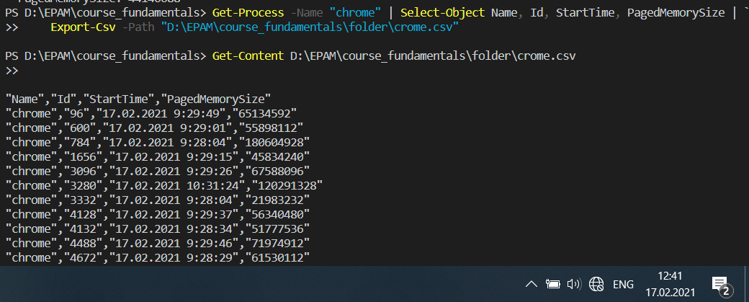

Export To JSON

Get-Process -Name "chrome" | Select-Object Name, Id, StartTime, PagedMemorySize | `

    ConvertTo-Json | Out-File "D:\EPAM\course_fundamentals\folder\crome.json"

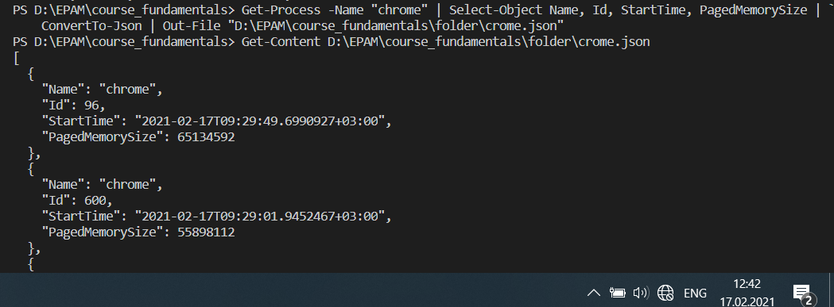

Export To XML

Get-Process -Name "chrome" | Select-Object Name, Id, StartTime, PagedMemorySize | `

    ConvertTo-Xml | Out-File "D:\EPAM\course_fundamentals\folder\crome.xml"

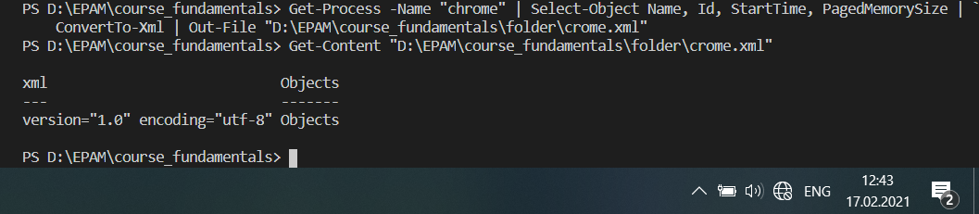

Export To YAML

Get-Process -Name "chrome" | Select-Object Name, Id, StartTime, PagedMemorySize | `

    ConvertTo-Yaml | Out-File "D:\EPAM\course_fundamentals\folder\crome.yaml"

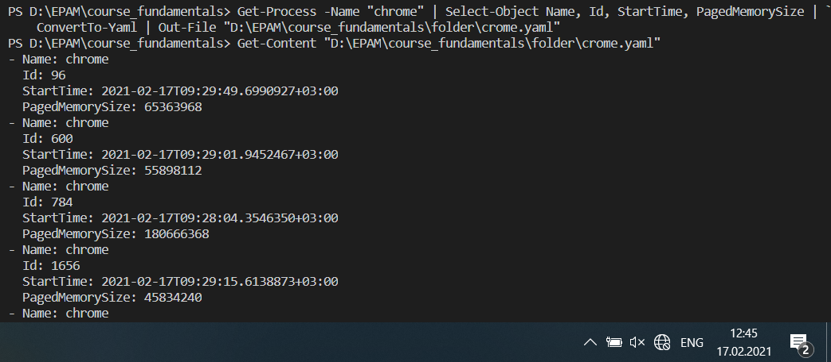

#-------------------------------

Write a script to create hash-tables based on data that stored in files from task 1.

$h=@{}

Import-Csv D:\EPAM\course_fundamentals\folder\crome.csv | %{

    $h.Add($_.Id, $_.Name)

}

$h

