# Create a function that will get a string and one of several switch parameters and return the text from string with the color passed with switch parameter.

function Write-ColoredMessage {

    [CmdletBinding()]

    param (

        [string[]]$Text,

        [switch]$Blue,

        [switch]$Red,

        [switch]$Green,

        [switch]$Yellow

    )

    if($Blue -eq $true){

        $color = 'Blue'

    }elseif ($Red -eq $true) {

        $color = 'Red'

    }elseif ($Green) {

        $color='Green'

    }elseif ($Yellow) {

        $color='Yellow'

    }

    return(Write-Host $Text -ForegroundColor $color)

}

Write-ColoredMessage -Text "Hi" -Red

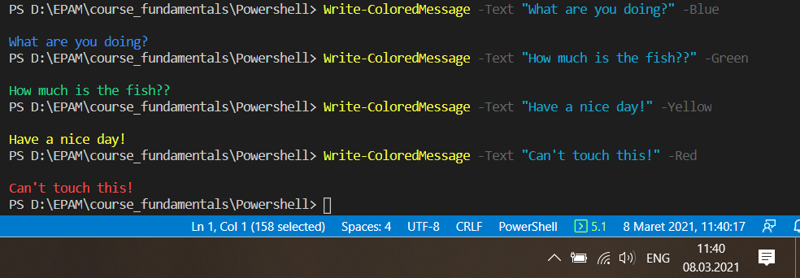

# Create a function that will get any array from the pipeline. Function output should be formatted according to the example below

function Get-ValueFromPipe{

    param(

        [Parameter(ValueFromPipeline=$true)]

        $Text

    )

    Process{

        Write-Host "Value from pipe: $Text"

    }

}

