# Write an advanced function to show the size of files in specific folder and sort all of them by size.

function searchFolder {

    param (

        [string[]]$Path

    )

    Get-ChildItem -Path $Path -File | Select-Object Name, Length | Sort-Object Length

}

searchFolder -Path E:\Обучение\EPAM\course_fundamentals\

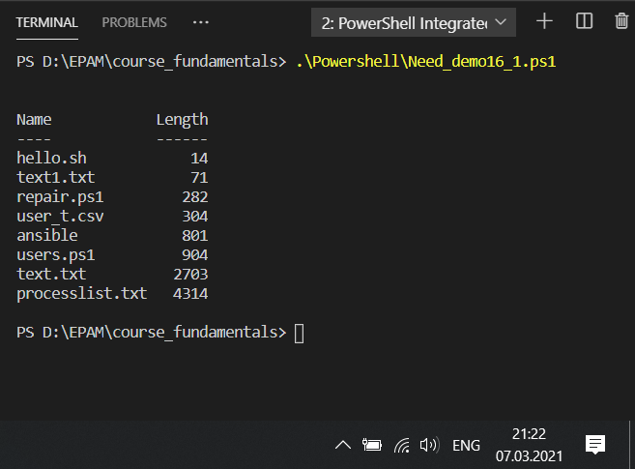

# Write an advanced function to delete file from a specific folder if file size greater then specified size in Kb.

function deleteFiles {

    param (

        [string[]]$Dest,

        $Size

    )

    foreach($item in (Get-ChildItem -Path $Dest -File)){

        if ($item.Length/1024 -gt $Size){

            Remove-Item $item

        }

    }

}

deleteFiles -Dest D:\EPAM\course_fundamentals\Powershell\folder -Size 300

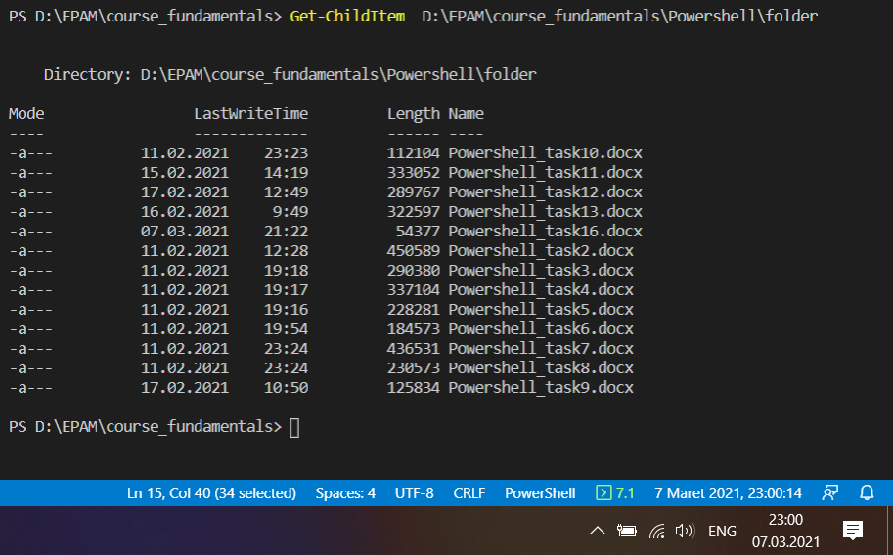

#Запускаем скрипт и проверяем

