Create ****string**** variable with 19790525 value in it

[string]$s='19790525'

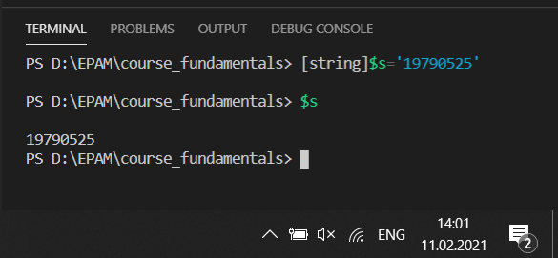

#-----------------------------------------------------

 List user’s home directory file path and get datatype for it.

Get-ChildItem -Path "c:\Users\Aleksej\Documents\"

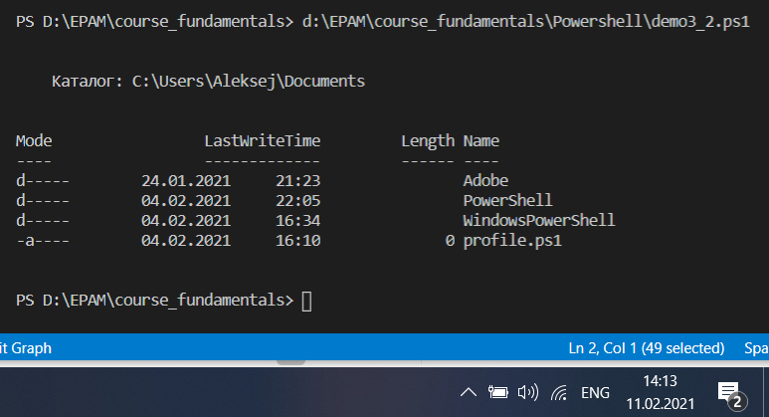

#----------------------------------------------

List some ****single file**** in user’s home directory and get datatype for it.

Get-ChildItem -Path "c:\Users\Aleksej\Documents\" -File

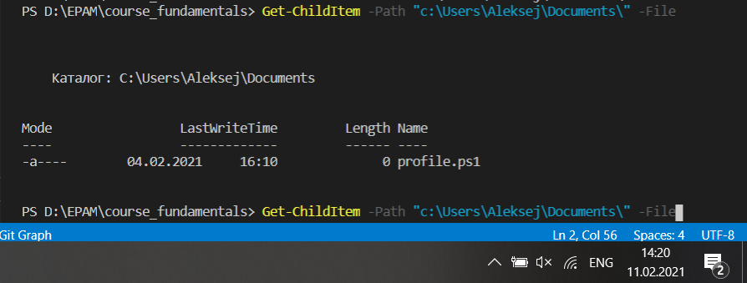

#--------------------------------------------------------------

List some ****single directory**** in user’s home directory and get datatype for it.

Get-ChildItem -Path "c:\Users\Aleksej\Documents\" -Directory

