Create two-dimensional strong defined string array.

Вариант1:

$a=@(

    ("Hi","Hello","Bye","Good Night"),

    ("Lake","River","WaterFall","Sea")

)

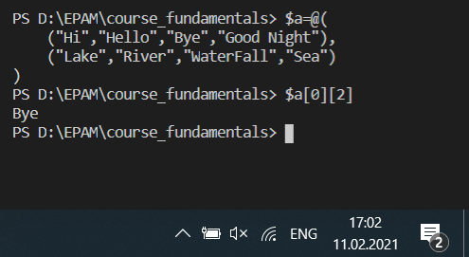

Вариант 2:

$a = New-Object 'object[,]' 2,4

$a[0,0]="Hi"; $a[0,1]="Hello"; $a[0,2]="Bye"; $a[0,3]="Good Night";

$a[1,0]="Lake"; $a[1,1]="River"; $a[1,2]="WaterFall"; $a[1,3]="Sea";

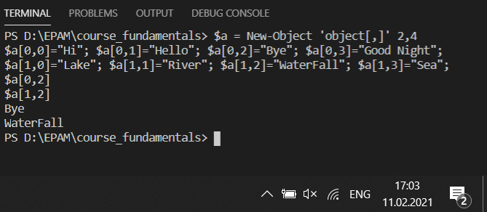

#----------------------------------------------------------------

Put three different hash-tables in array. Retrieve value from the second key in third hash table in array.

$h1=@{"BY" = "Belarus"; "DE" = "Deutchland"; "PL" = "Poland"}

$h2=@{"three" = "3"; "five" = "5"; "seven" = "7"; "eight" = "9"}

$h3=@{"A" = "Alpha"; "B" = "Beta"; "G" = "Gamma"; "D" = "Delta"}

$a=@()

$a += $h1; $a += $h2; $a += $h3;

$i=0;

foreach($aa in $a[2].Values){

    if($i -eq 1){

        Write-Output $aa

    }

    $i++

}

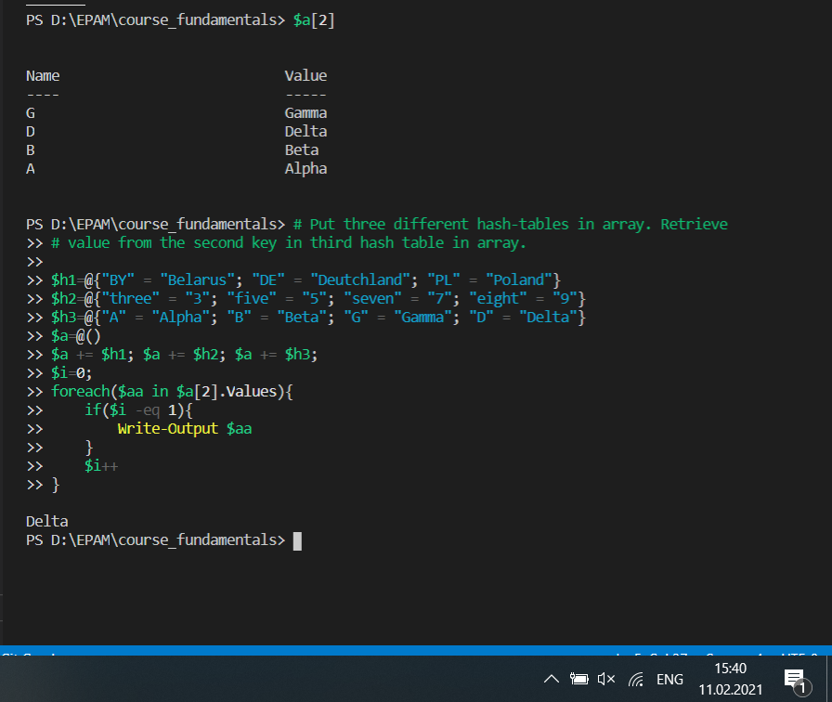

#--------------------------------------------------------------------------

Create nested hash-table and retrieve values by keys from it.

$person=@{

    Name = "Alex"

    age = 34

    location = @{

        country = "Belarus"

        city = "Gomel"

    }

}

$person.location.country

$person.location.city

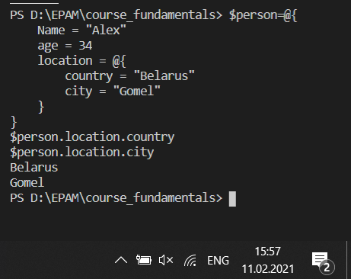

#-----------------------------------------------

Transform hash-table into ordered hash-table sorted by value.

$hashTable = @{a = 12; g = 4; h = 1; t = 7; d = 8}

$hashTable.GetEnumerator() | Sort-Object -Property Value

