Write a PowerShell class to implement pow(x, n) that is returns the base to the exponent power (baseexponent).

class CustomObj{

    [int]$x=5

    [int]$y=10

    CustomObj() {

    }

    [int]Pow( [int]$x, [int]$y ){

        return [math]::Pow( $x, $y )

    }

}

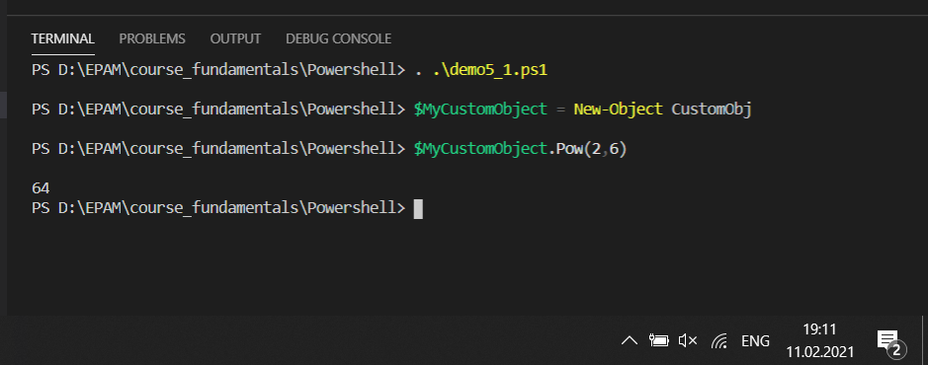

#------------------------------------------------------------------

Write a PowerShell class which has two methods SetString() and PrintString(). SetString() accept a string from the user and PrintString() print the string in upper case.

class CustomObj {

    [string]$str

    CustomObj(){

    }

    SetString( [string]$str ){

        $this.str = $str

    }

    [string]PrintString(){

        return $this.str.ToUpper()

    }

}

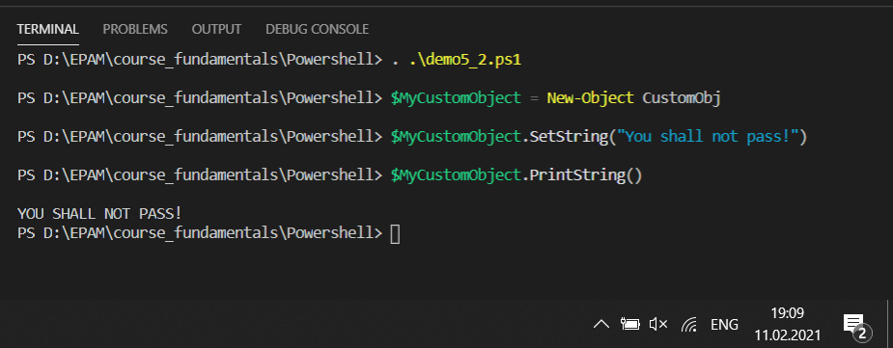

#------------------------------------------------

Write a PowerShell class to reverse a string word by word.

class CustomObj {

    CustomObj(){

    }

    [string]Reverse( [string]$str ){

        [int]$t = $str.length

        [string]$str1 = ""

        for($t; $t -gt 0; $t--){

            $str1 += $str[$t-1]

        }

        return $str1

    }

}

