Write a script to find sequences of lowercase letters joined with underscore or dash.

Вариант 1:

param ($s)

$str = Select-String '([a-z]+(-|_)[a-z]+)' `

    -InputObject $s -AllMatches | foreach-object {$_.matches}

$str.value

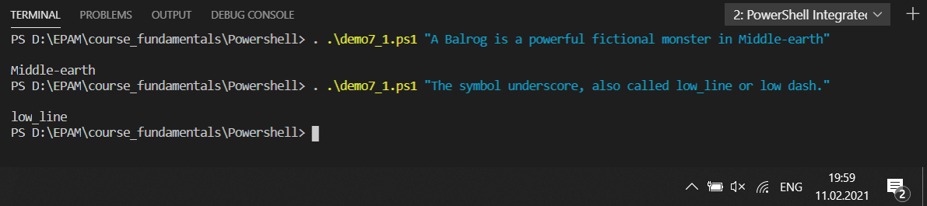

Вариант 2:

param ($s)

[array]$a = $s.Split(' ')

for([int]$i=0; $i -lt $a.length; $i++){

    if ($a[$i] -match '([a-z]+-|_[a-z]+)'){

        echo $a[$i]

    }

}

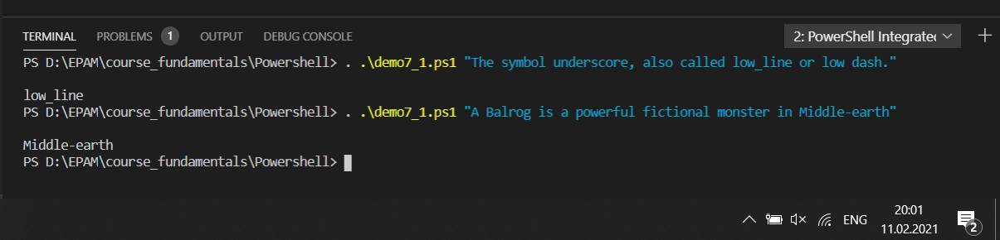

#----------------------------------------------------

Write a script that matches a word at the end of string.

param ($s)

$str = Select-String '\s[a-z]+$' -InputObject $s `

    -AllMatches | foreach-object {$_.matches}

$str.value

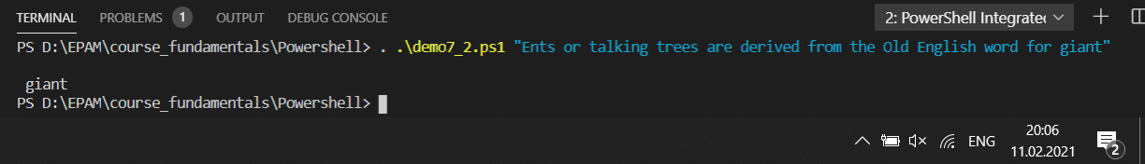

#--------------------------------------------------

Write a script that matches an IP address.

param ($s)

$str = Select-String '([0-9]{1,3}\.){3}([0-9]{1,3})' `

    -InputObject $s -AllMatches | foreach {$_.matches}

$str.value

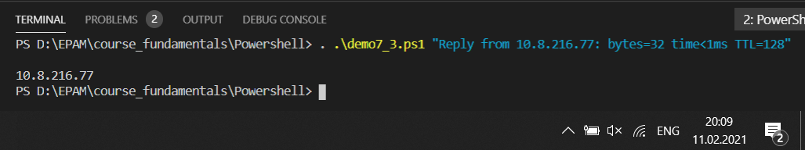

#------------------------------------------------------------------

Write a script to convert a date of mm-dd-yyyy format to dd-mm-yyyy format.

param ($s)

$s = (Select-String "(\d{2})-(\d{2})-(\d{4})" `

    -InputObject $s -AllMatches | foreach-object {$_.matches}).value

$d=[DateTime]::ParseExact($s, "MM-dd-yyyy", $null).ToString("dd-MM-yyyy")

write-output($d)

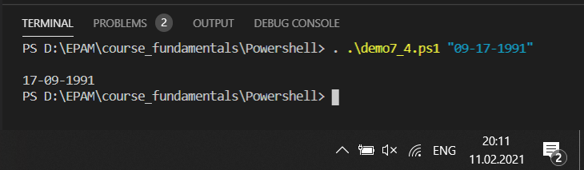

#----------------------------------------------

Write a script to find all words which are at least 6 characters long in a string.

param ($s)

$str = Select-String '[a-z]{6,}' -InputObject $s `

    -AllMatches | foreach-object {$_.matches}

$str.value

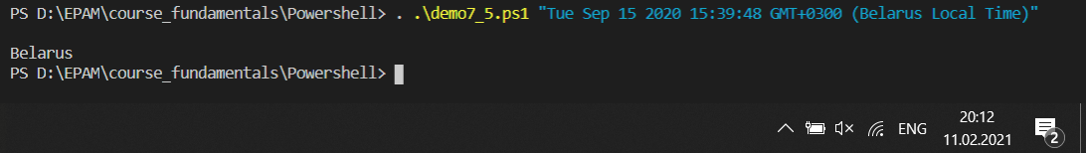

#------------------------------------------------------------------------

Write a script to remove multiple spaces in a string.

param($s)

write-output ( $s -replace "\s+", " " )

