Write a script to list directory that contain files. Output is the same with Get-ChildItem cmdlet. Print file size in megabytes (Mb).

Get-ChildItem D:\Photo\Minolta_beercan -File | Select-Object `

Name, @{Label="Size"; Expression={ '{0:N3}' -f ($_.Length/1MB)}}

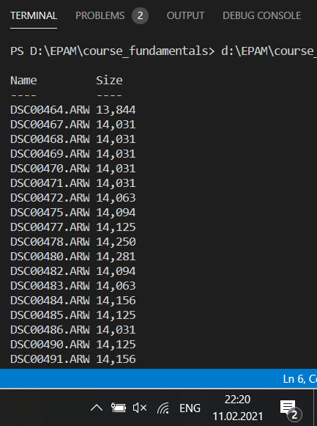

#--------------------------------------------------------

Write a script to sort a list of elements using the bubble sort algorithm. Make output in console for each sort steps and could be controlled by **Verbose** parameter (user can choose if he would like to see output).

[int[]]$a=@(1, 5, 6, 2, 3, 4, 8, 0)

function SortBuble {

    param (

        $aa

    )

    $max=0;

    for ($i = 0; $i -lt $aa.length; $i++) {

        for ($j = 0; $j -lt $aa.length-1; $j++) {

            if($aa[$j] -gt $aa[$j+1]){

                $max=$aa[$j];

                $aa[$j]=$aa[$j+1];

                $aa[$j+1]=$max

                Write-Output "Change $($aa[$($j+1)]) by $($aa[$j]), from position $j to position $($j+1)"

            }

        }

    }

}

SortBuble $a

