Write a script to convert temperatures to and from Celsius, Fahrenheit.

param($s)

if ($s[-1] -eq "F"){

    $s=Select-String '\d+' -InputObject $s -AllMatches | foreach-object {$_.matches};

    $i=($s.value-32)*5/9

    Write-output("$s is $i in Celsius")

}elseif ($s[-1] -eq "C") {

    $s=Select-String '\d+' -InputObject $s -AllMatches | foreach-object {$_.matches};

    $i=[int]$s.value*9/5 + 32

    Write-output("$s is $i in Fahrenheit")

}

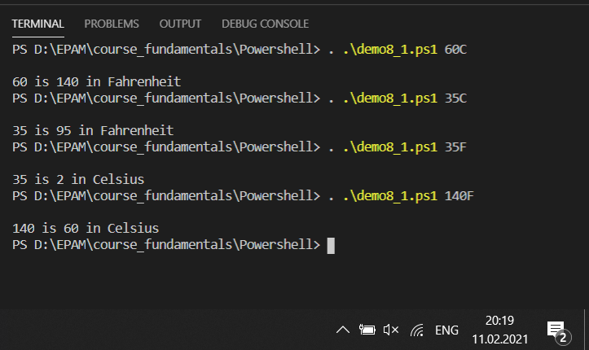

#------------------------------------------------

Write a script to get the Fibonacci series between 0 to N.

param($s)

[array]$f=(1, 1)

[int]$i=2

Do{

    $f +=$f[$i-1]+$f[$i-2]

    $i++

}while($f[$i-1]+$f[$i-2] -lt $s)

write-output($f -join " ")

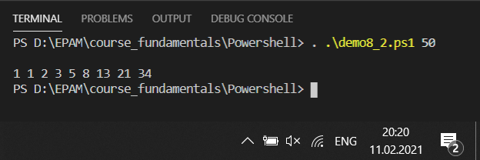

#---------------------------------------------------

Write a script to calculate a dog's age in human years: for the first two years, a dog year is equal to 10.5 human years. After that, each dog year equals 4 human years.

param($s)

$sum=0

[string]$a=''

$i=0

do{

    if ($i -lt 2 ){

        $sum += 10.5

        $a += $sum.ToString()

        $a += ' ';

    }else{

        $sum += 4

        $a += $sum.ToString()

        $a += ' '

    }

    $i++

}while($i -lt $s)

$a

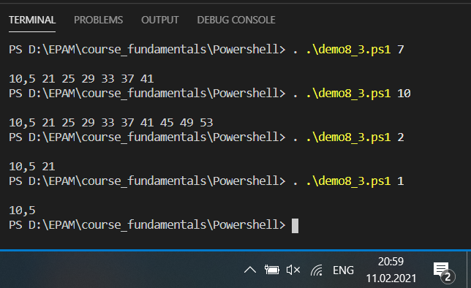

#-----------------------------------------------

Write a script to create the multiplication table (from 1 to 10) of a number.

param($s)

for($i=1; $i -le 10; $i++){

    $p=$s*$i

    write-output("$p = $s x $i")

}

