 Write a script that it makes association with running services and process in Windows. Put result in hash table. Use pipelines as match as possible.

$p = Get-Process | Group-Object Name | Select-object Name

$s = Get-Service | Select-Object Name, DisplayName

$maxp=0; $maxs=0; $line = '';

foreach ($pn in $p.Name) {

    if ($pn.Length -gt $maxp) {

        $maxp = $pn.Length

    }

}

$maxp += 3

foreach ($sn in $s.Name) {

    if ($sn.Length -gt $maxs) {

        $maxs = $sn.Length

    }

}

$maxs += $maxp;

for ($i = 0; $i -lt $maxs; $i++) {

    $line += "_"

}

$line += "`n"

$line

foreach($pn in $p){

    foreach ($sn in $s) {

        $pnn = $pn.Name -replace '(_)?(-)?', ''

        $snn = $sn.Name -replace '(_)?(-)?', ''

        if ( $snn -eq $pnn ) {

            for ($i = $pnn.Length; $i -lt $maxp; $i++) {

                $pnn += " "

            }

            Write-Host  $pnn, $sn.DisplayName | Format-Table

        }

    }

}

$line

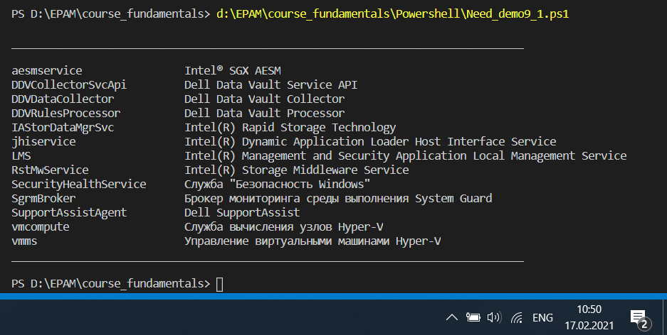

#-----------------------------------------

Write a script to find the occurrences of 10 most common words in a given text. Use any article from Wikipedia as given text. Use pipelines as match as possible.

Get-Content D:\EPAM\course_fundamentals\text.txt `

    -Delimiter ' ' | Group-Object | Sort-Object `

    Count -Descending | Select-Object Name, Count -First 10

