We have VM1 with Ubuntu Linux. IP 192.168.100.200/24

First of all we installed postgresql, and NGINX as a web server.

After that we installed zabbix on main - VM1.

VM2 and VM3 - Linux Ubuntu (192.168.100.201, 192.168.100.202/24). On those VM's installed zabbix-agent.

After install and set some settings we add VM2 and VM3 as host with some metrics.

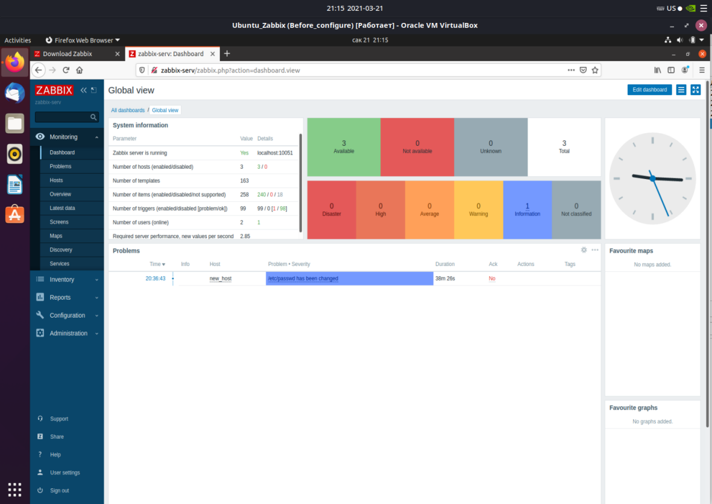

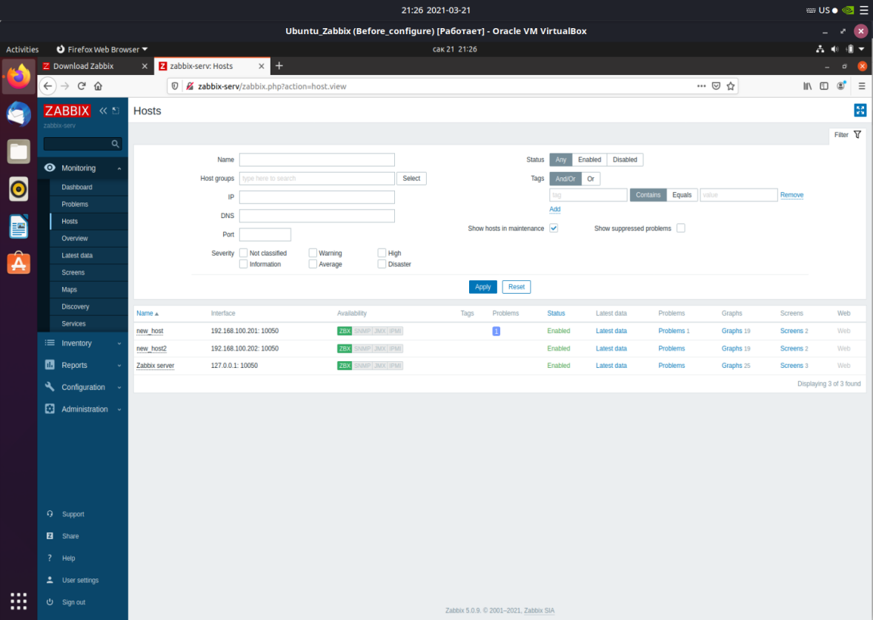

VM2

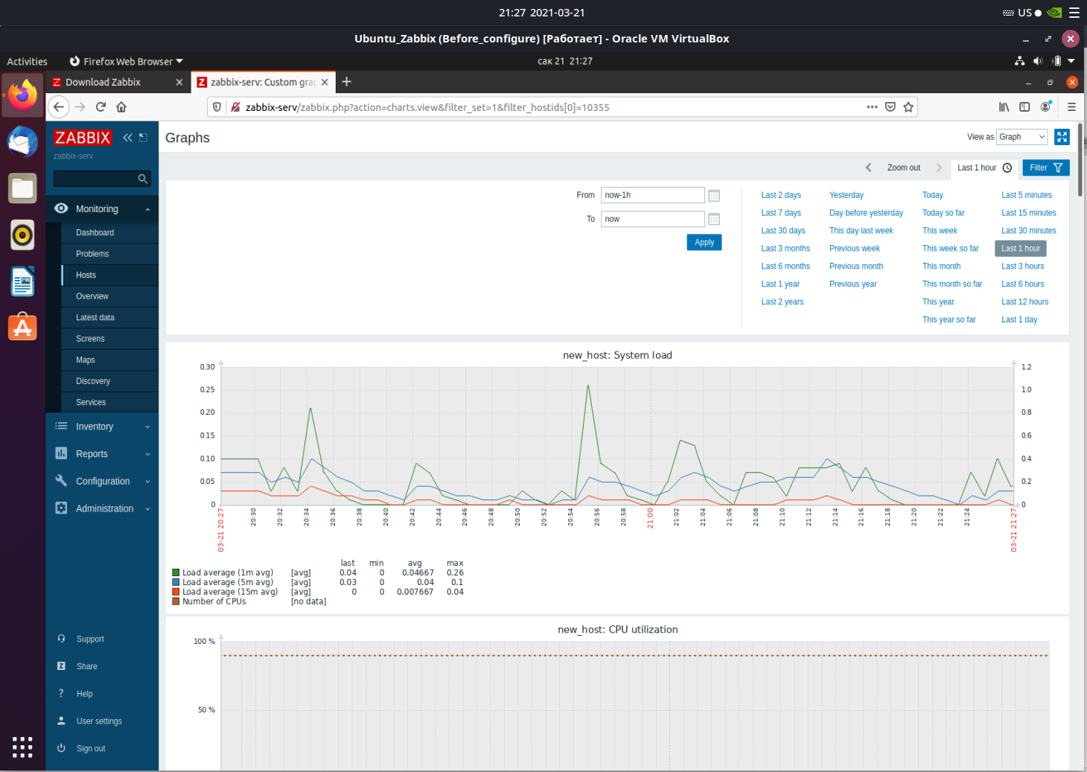

VM3



VM1 - server-zabbix

