#### # Exercise 1

#### Write a shell script that prints “Hello World!” on the screen

date_now=$(date)

echo [$date_now] "Hello, Task2!"

#### 

# Exercise 2

#### Please fix following scripts:

1. #!/bin/bash
2. Wrong echo "Hello World!'
3. need get permission to execute file for all users

chmod 777 ./file_script.sh

chmod +rwx ./file_script.sh

#Exercise 3

#### Working with strings

echo 'Lorem ipsum dolor sit amet, consectetur adipiscing elit, sed do eiusmod tempor incididunt ut labore et dolore magna aliqua.' > lorem

cat ./lorem | grep dolore

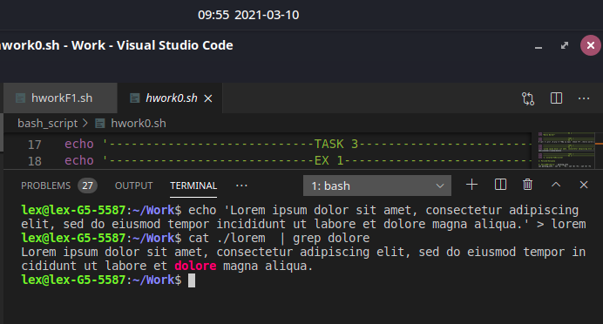

cut allows you to select the needed information from line with custom formatting.

cat /etc/passwd | awk -F":" '{ print $6 }' | awk -F"/" '{ print $NF }'

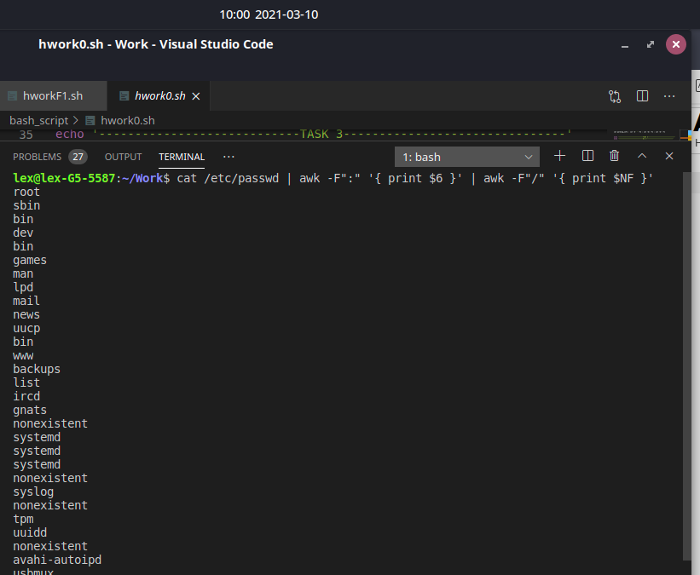

You’re given a file with the content (see below). Using sed perform:

remove all lines with word Linux

replace first appearance word xterm to word Bash

(extra) try to combine two tasks above in one-line command

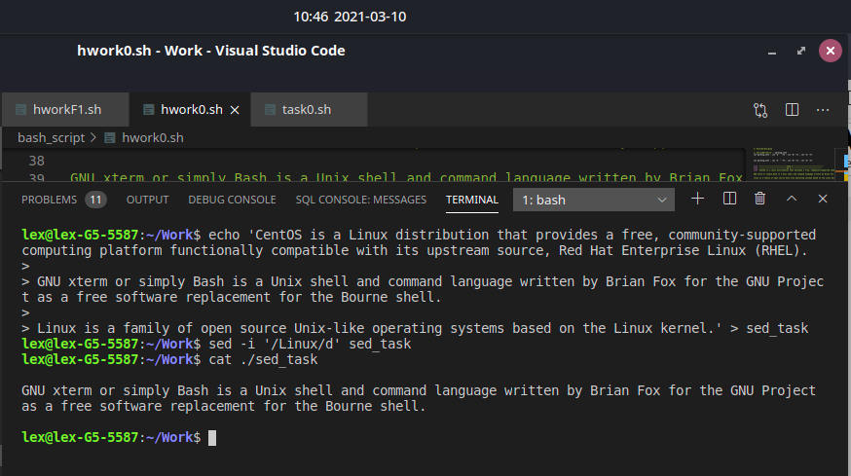

#Exercise 4

#### **Develop “User Info” Script**

echo Home dir: $HOME

echo User Name: $(whoami)

echo User ID: $UID

echo Group Information: $GROUPS

echo Terminal: $TERM

echo Current directory: $(pwd)

echo System date/time: $(date)

