#### #Exercise 1

#### Write a shell script which prints current date and message:

date_now=$(date)

echo [$date_now] "Hello, Task2!"

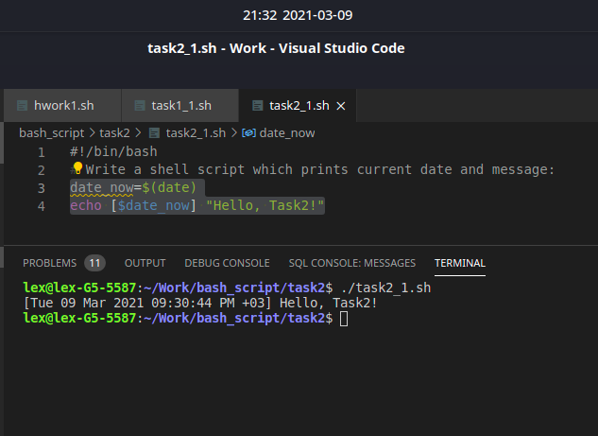

#Exercise 2

#### Run following script and fix errors

var1='Hello, '

var2='broken'

var3='script'

echo $var1 $var2 $var3

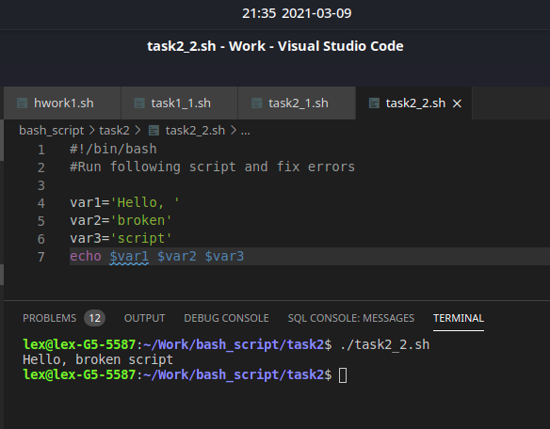

#Exercise 3

#### Write a shell script which prints out value of global variable MY_VAR:

MY_VAR=${MY_VAR=default}

echo MY_VAR=$MY_VAR

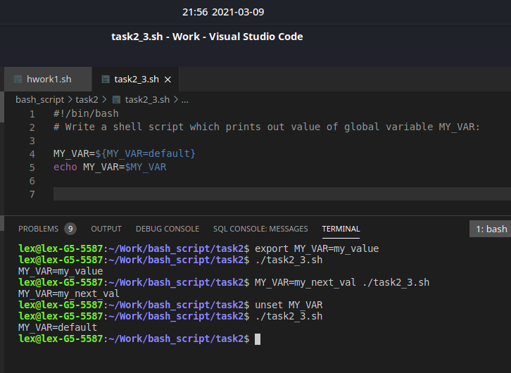

#Exercise 4

##### output 5 characters of substring from mystring at position=2 with one-line command

mystring='abcdefghijklmn'

echo ${mystring:2:5}

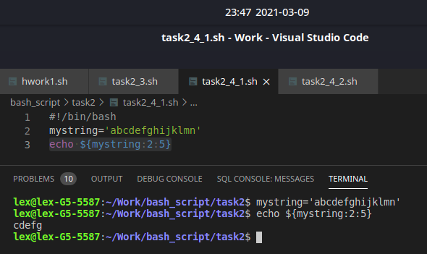

##### output hello variable with replacement word hello->goodbye with one-line command

hello="Hello world!"

echo ${hello/Hello/Goodbye}

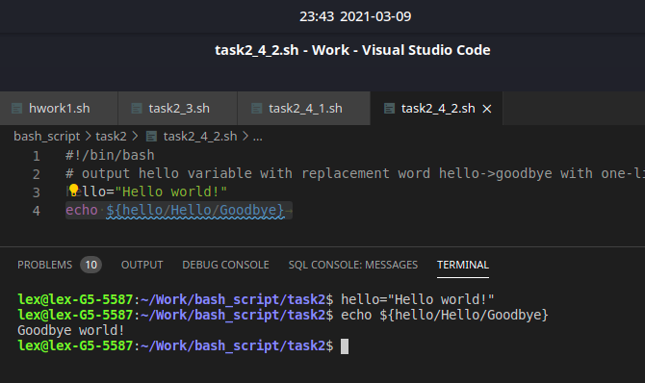

##### output jesus variable with replacement all words from water to wine with one-line command

jesus="water wine water wine water wine"

echo ${jesus//water/wine}

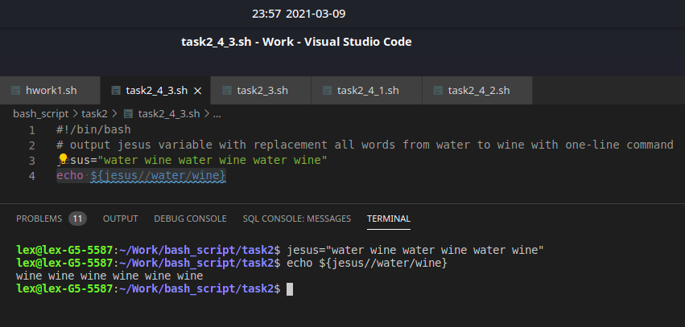

##### you’re given a variable with some path. Get parent path using string manipulating

mypath=$(pwd) #определение переменной

echo ${mypath} #вывод значения на экран

/home/lex/Work/bash_script #полученное значение

# way 1

echo ${mypath/'lex/Work/bash_script/task2'/devops} #вариант подастановки вместо известной строки

# way 2

echo ${mypath/*//home/devops}

