Effect of MO₆ Bond Angle on Metal Oxygen Bonding in Single-Atom Catalysts

Yingkai Wu,¹ Jiangyang Liu,^{1,}* Yuta Tsuji,^{2,}* Takeshi Yanagida,^{1,}*
¹ Department of Applied Chemistry, Graduate School of Engineering, The University of Tokyo, Bunkyo-ku, Tokyo 113-8656, Japan.
² Interdisciplinary Graduate School of Engineering Sciences, Kyushu University, Kasuga-shi, Fukuoka 816-8580, Japan.
*Corresponding Author: tsuji.yuta.955@m.kyushu-u.ac.jp, yanagida@g.ecc.u-tokyo.ac.jp

Iridium oxide is one of the benchmark catalysts for the oxygen evolution reaction (OER), and its catalytic activity is strongly influenced by the local coordination environment of the metal center. In our previous first principles study of monoclinic, orthorhombic, and tetragonal IrO₂ polymorphs, the calculated OER activity followed the order C2/m > Pbcn > P4₂/mnm. Further electronic structure analysis showed that variations in the O–Ir–O bond angle regulate the interactions between surface Ir sites and adsorbed oxygen groups, thereby altering the free energy change of OER mechanism.[1] This interpretation is also consistent with operando studies of IrOₓ catalysts, which have revealed distorted local octahedral environments and coordinatively unsaturated Ir sites in highly active structures.[2]
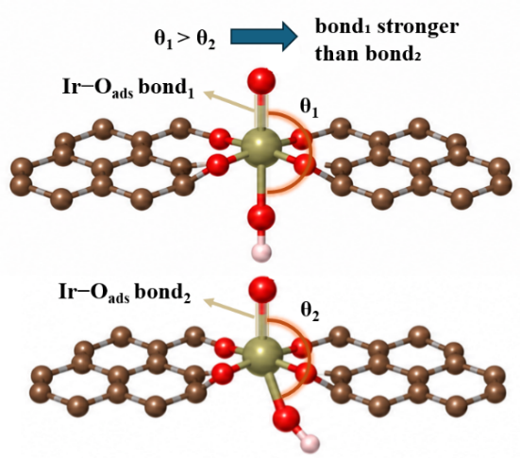
Based on these findings, we further extend the relationship between geometry and chemical bonding from bulk metal oxides to single-atom catalysts (SACs), in which the coordination geometry of the metal center can be distorted by the support. Experimentally, various oxygen-coordinated single-atom sites, including Ni sites, have been successfully synthesized on graphene based materials. [3,4] Because MO₆ coordination units (M = Ir, Ni, or Co) allow geometric effects to be examined at fixed coordination, we construct MO₆ SAC models embedded in a graphene framework and systematically vary the O–M–O angle defined by two trans O atoms across the metal center. Density functional theory (DFT) calculations combined with projected crystal orbital Hamilton population (pCOHP) analysis are performed to compare M–O bonding among different geometries. For Ir, Ni, and Co based MO₆ units, decreasing the O–M–O angle consistently weakens the M–O bonding interaction, demonstrating that bond angle variations can directly regulate metal oxygen bonding in oxygen coordinated single atom sites. These results suggest that tuning the coordination geometry provides a strategy for optimizing the adsorption free energies of reaction intermediates in SACs.
Fig. 1. Influence of O–Ir–O bond angle on Ir–O_{ads} bonding interactions.

References:
- Y. Wu, N. Thakur, M. Kumar, et al., Langmuir, 42, 17541–17552 (2026).
- N. Thakur, Y. Ren, M. Kumar, et al., J. Am. Chem. Soc., 147, 30613–30625 (2025).
- Y. Li, Z. S. Wu, P. Lu, et al., Adv. Sci., 7, 1903089 (2020).
- Y. Li, Y. Li, J. Lu, et al., Adv. Mater., 37, 2415026 (2025).

