# Fusion tool : How to install it and use it

Program written by Aleksey Zhukov <[alekseyig@hotmail.com](mailto:alekseyig@hotmail.com)> to find Pfam fusions with input sequence

## Instructions for both MAC and PC

Copy the toolz folder from the dropbox project to any folder of your computer.

Remember where it is, as we need the path for the MAC use of the software.

## Make the fusion tool work on a PC

First, you have to install python.

Install python **2.7.5** from here :

<http://www.python.org/download/>

Default installation is fine.

Let’s set the program work for the PC.

In the folder bin from your toolz folder, right click on fusions (it can appears as fusions.py, in that case do the right click on it as it is the same file), and create a shortcut for that file.

Right click on the shortcut, go to properties and in the “target” field, add at the end of the line :

“ input.txt sum\_input det\_input”, not the space to add at the beginning.

See image :

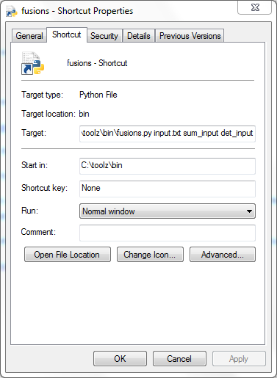

Once this has been done, it will be good and does not need to be done again.

How to run the program ?

In the bin folder,

Add your FASTA file, and change it’s name to: input.txt

This has to be a FASTA format file, with a .txt extension.

Double clic on the **shortcut** to launch the program, not the program itself.

You should have something like that appearing :

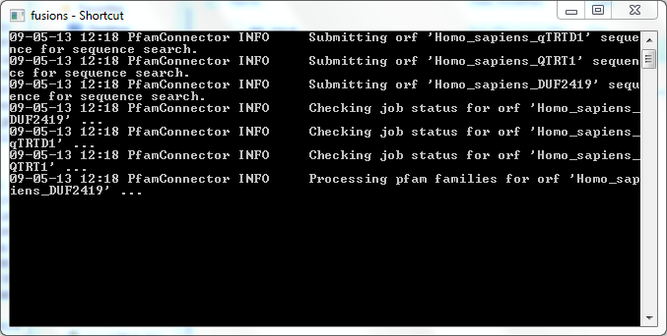

Leave it run (30 it takes a little time) and it will close itself while done.

Go to the last paragraph of that document to see how to open the result files.

## Make the fusion tool work on a MAC

First, you have to update python.

MACS have python installed, but install the lastest 2.7.5 version on your mac (but not 3.3?) .

You can update your python software here: [http://www.python.org/download/](http://www.python.org/download/" \t "_blank)

I used this link

<http://www.python.org/ftp/python/2.7.5/python-2.7.5-macosx10.6.dmg>

Run the program on a MAC

Open the Unix terminal

Navigate to the bin folder.

To navigate using unix :

Type ls to have a list of all the folders and files in the folder you are in.

To go to a folder, type : cd folder\_name

Use ls again to see where to go next.

Example of my path: cd /Users/remizallot/Documents/data/Projets/tool/toolz/bin

Create a text document (.txt) that contains you sequences in the FASTA format. Place this file in the toolz/bin folder.

I create my FASTA files directly in a text editor. I Use Sublime Text 2, which is free. It is available here: http://www.sublimetext.com/2

In the Unix terminal run the command

./fusions.py input.txt sum\_input det\_input

In this example, the input.txt is the FASTA file, but another name will work.

If you have an error saying that you were time out it is a problem at Pfam try again.

I had permission problems.

So I gave permissions to the toolz folder :

Allow permissions for the folder : sudo chmod a+rw toolz when you are in the folder that contains the toolz folder.

To run the program, I use:

sudo python ./fusions.py input.txt sum\_input det\_input

When you use the sudo command, you have to enter your administrator password in order to make it work.

See below for opening the result files

## Results for both PC and MAC

In your bin folder, you will have 2 more files created by the program :

det\_input for a presentation of detailed results

sum\_input for a presentation of summarized results

You have to use excel, and import these documents manually to open these: with excel open, just go to

File, open. From here, choose all files from the drop down menu, instead of excel files.

Import the file using the delimited by tabulation format.

Please note that you have to manually remove the input.txt file and the associated 2 result files after each analysis, or before you want to run another analysis with a new input file or you will overwrite of the previous analysis results. Make copies of these files all together in a new folder and give them and easier name to remember.

**\* \* \* \* \* \***