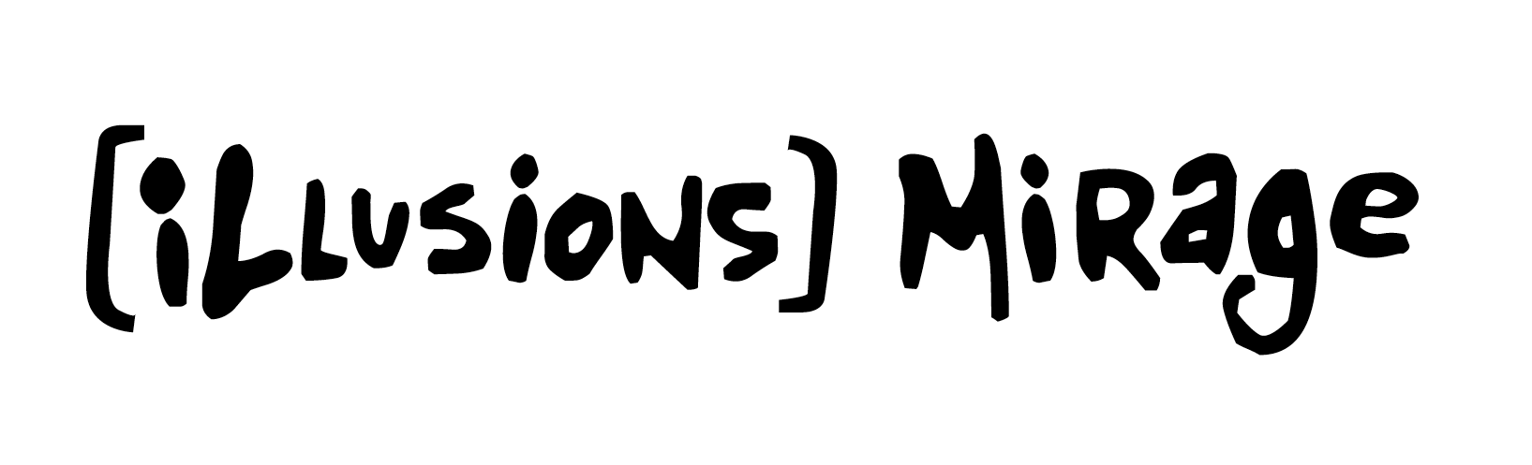

Marc Copland Trio
„And I Love Her“
[Illusions] Mirage / CD IM4004 / EAN 0 757926 452719
Release date October 4th 2019
Contact: NRW Vertrieb, E-Mail: info@nrwvertrieb.de, Phone +49 (0) 3841 30353-05

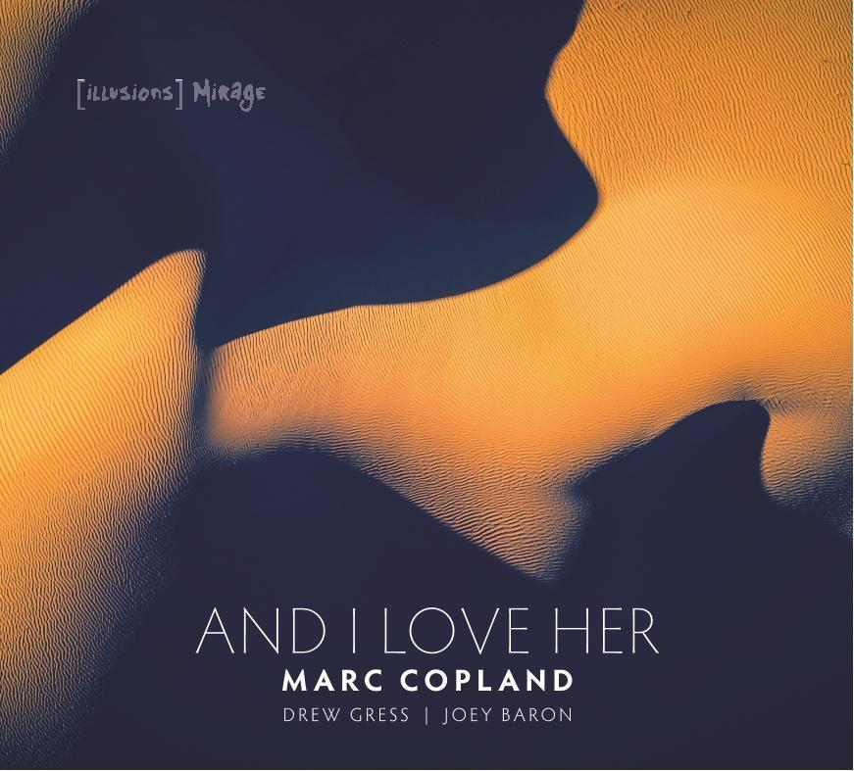  Copland (p), Drew Gress (b), Joey Baron (d) | 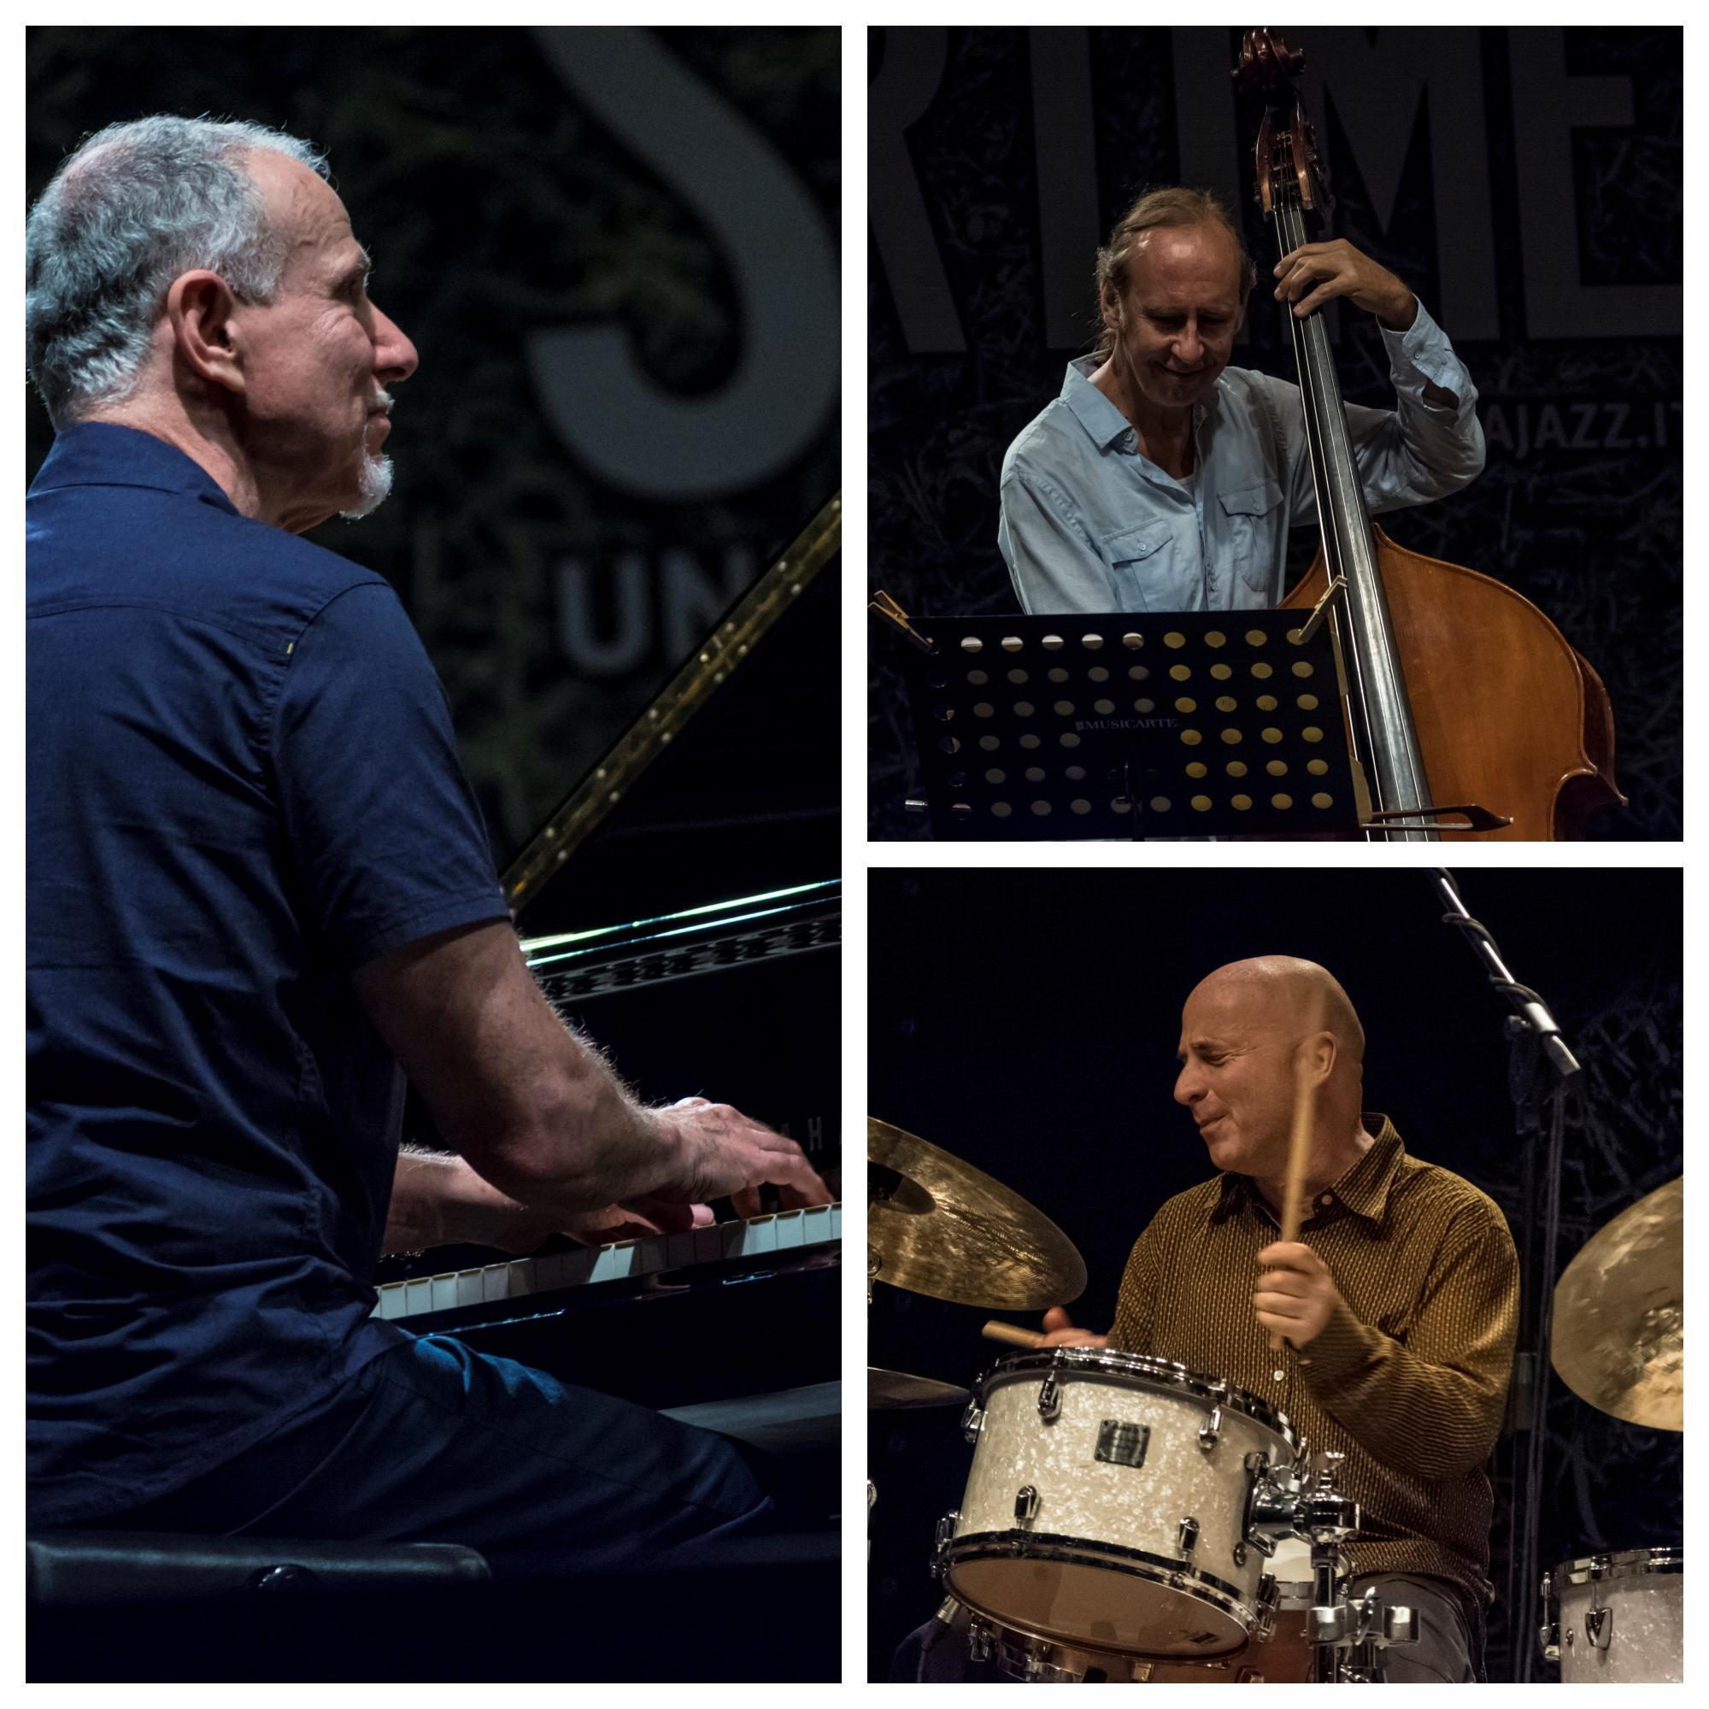  Photos: Fabrizio Sodani
- Afro Blue / 6:22 / Mongo Santamaria QMEU31916348
- Cantaloupe Island / 8:20 / Herbie Hancock QMEU31916349
- Figment / 7:21 / Drew Gress QMEU31916350
- Might Have Been / 5:46 / Marc Copland QMEU31916351
- Love Letter / 8:11 / John Abercrombie QMEU31916352
- Day and Night / 10:42 / Marc Copland QMEU31916353
- And I Love Her / 6:44 / Lennon-McCartney QMEU31916354
- Mitzi & Jonny / 4:29 / Copland-Gress-Baron QMEU31916355
- You Do Something to Me / 9:16 / Cole Porter QMEU31916356
When legendary guitarist John Abercrombie passed away after a long illness in 2017, he left behind the rich legacy of a lifetime's worth of music making---and one of jazz's most cohesive rhythm sections. Marc Copland, Drew Gress, and Joey Baron, each a unique and in-demand stylist, habitually busy with different projects, had found themselves working together more and more in the past few years—sometimes two of them in a band, sometimes all three. Their musical empathy really settled in, of course, when Abercrombie hired them to form the quartet of his last few years. So it seems only natural that they should continue making music together---not only as a rhythm section, but also as a trio.

What sets this unit apart is the musicians' unusual ability to listen and play spontaneously together. They make a habit of improvising on the spur of the moment as a cohesive unit, trading roles and handing off ideas as if the trio were a smooth-running engine composed of three interchangeable parts. There might be no clearer example of this than Afro Blue, the first tune played at the session, and the album's opener.

“Marc Coplands Trio mit Drew Gress und Joey Baron ist ein individualistischer Zusammenschluss von drei mühelos virtuosen, und konzentriert experimentierfreudigen Meisterimprovisatoren - und zugleich ist es scheinbar ein ganzes Orchester das mit großem Klangfarbenreichtum den Jazz der Geschichte, der Gegenwart und der Zukunft kollektiv immer wieder neu erkundschaftet. Ich kenne kein Trio das heute mit solcher Sensibilität, Interaktion, und ego-freier Ausdrucksstärke operiert. Das ist das Gefühl des Jazz das zeitlos im Herzen wohnen will.” ---Hans Koller, composer, arranger, pianist, winner of the Joey prize for jazz composers, head of Jazz at the Trinity Laban Conservatoire (London)

1. Afro Blue / 6:22 / Mongo Santamaria
Worth noting is that this piece was nowhere to be found inside the heads of the musicians or the producer prior to their arrival at the studio. “We were warming up,” Copland says, “and as so often happens, Joey started a groove, in this case a 6/8 thing....and I heard Afro Blue in my head, which I'm not sure I'd ever played before.” Never afraid to go with the moment, Copland jumped in, playing with an organic approach that's airier than the norm for this tune. When the actual take started a few minutes later, bassist Gress--who's been playing with Copland since the late seventies--jumped in with a strong statement to get things rolling.

2. Cantaloupe Island / 8:20 / Herbie Hancock
Cantaloupe Island has been a Copland favorite for some years, and characteristically, the pianist spontaneously reworks the classic left-hand rhythmic/harmonic accompaniment of the
melody. “It's not my first rodeo with this one,” he says, but sheepishly admits “the accompaniment and harmonies seem to come out a little different each time” --which is, of course, the mark of a real improviser. The track mixes an interesting brew of the funky flavor
of the original with a looseness and interplay that characterizes this trio's approach to almost everything they touch. Check out the unplanned coda that veers without warning into another key and feel.

3. Figment / 7:21 / Drew Gress
Gress's Figment is, in Copland's words, “a really important tune, and unlike anything else I've come across. It's tricky at first, but as you get in deeper it starts to feel comfortable, and there's so much material to play off of.....in that respect it reminds me of the challenging pieces that have helped steer this music, for example some of the tunes Miles' quintet composed and played in the early 60s.”

4. Might Have Been / 5:46 / Marc Copland
At drummer Baron's suggestion, Copland's Might Have Been starts with a nod to Sonny Rollins and Jim Hall---the tune begins slower and out of time before hitting its stride, similar to Rollins' and Hall's treatment of the saxophonist's John S. Like many Copland compositions, it has an easily singable melody that sticks in one's head, deftly supported by a liberal dose of polytonal chordal movements and colors.

5. Love Letter / 8:11 / John Abercrombie
The relatively recent composition Love Letter, here in its first recorded performance, is a beautiful Abercrombie waltz that was a regular part of the guitarist's gig repertoire. Copland muses, “It didn't even have a name, and as beautiful as it is, what a shame John never recorded it.” The pianist supplied the title for this piece as a tribute to his departed colleague and friend.

6. Day and Night / 10:42 / Marc Copland
Fans of Better By Far, the second recording of this rhythm section in quartet with trumpeter Ralph Alessi, will recognize Day and Night, Copland's second contribution to this album. It's a deceptively simple piece, but “musicians I play with seem to like it, as it's comfortable to blow on.” Gress's solo here is a melodic tour de force. Copland reaches back for some real swinging in his harmonically sophisticated improvisation, and Gress and Copland maintain the tune's form as Baron steps out with a solo that practically explodes with joy.

7. And I Love Her / 6:44 / Lennon-McCartney
And I Love Her might be smooth-jazz pablum in the hands of other musicians, but this rendition of the Beatles tune is handled with sense and sensibility. Copland's improvised reharmonization of the opening melody makes clear that the tune will be approached like everything else the trio plays—with an eye towards a fresh, loose, improvised interpretation.

8. Mitzi & Jonny / 4:29 / Copland-Gress-Baron
Copland leads in this trio by example---he rarely explains anything verbally. “If I can't show what I'm hearing by the sound I'm producing out of the piano, then I'm not doing my job.” He also wants the full participation of his musical partners: “Any one of us is free to start an idea and see where it goes. Joey's really good at throwing down a groove that opens a door.” Mitzi and Jonny is a perfect example of that; it's a totally improvised track that Baron kicked off on the spur of the moment. One can't help but notice throughout this track--and especially at its end--the trio's almost uncanny ability to hit accents together. Do the three look at each other as they're barreling along, to co-ordinate this visually? “Maybe once in a while,” Copland says, “but honestly, most of the time either my eyes are closed or I'm looking at the keyboard to see where my fingers should go next. We feel each other even if we don't see each other.”

9. You Do Something to Me / 9:16 / Cole Porter
To close this set, the trio swings beautifully in a rendition of You Do Something to Me, another nod to Copland's friend Abercrombie and their mutual love of the Rollins/Hall album The Bridge. Here, as throughout the set, a remark of Abercrombie's from the documentary video Open Land bears repeating. He's discussing himself, but he could be talking about his bandmates Copland, Gress, and Baron: “I guess I'd like to be remembered as someone who respects the tradition of the music, but tried to build on and expand it.”

So he did, and so they do.

recorded August, 2017 at The Samurai Hotel, NYC, by David Stoller
Mixed and mastered September, 2018 at Bass Hit recording, NYC, by David Darlington
Producer and ears / Robin Verheyen
Advice / Bettina Rossi
Studio Photographs / John Rogers
Cover Photo / Ian Plant
Poem / Bill Zavatsky
Graphics / Elmar Zillgen

Label Contact:
[Illusions] Mirage, Pelham, NY
+1-914-433-5711
+49-172-927-5252
Email: info@illusionsmirage.com

