Университет ИТМО

Факультет ПИиКТ

Дисциплина: программирование

Лабораторная работа №3

Вариант 33207

Выполнил: Григорьев Александр Алексеевич,

группа Р3130

Преподаватель: Блохина Елена Николаевна

г. Санкт-Петербург, 2021 год

**Задание к лабораторной работе:**

**Описание предметной области, по которой должна быть построена объектная модель:**

**Программа должна удовлетворять следующим требованиям:**

1. Доработанная модель должна соответствовать [принципам SOLID](https://en.wikipedia.org/wiki/SOLID_(object-oriented_design)).
2. Программа должна содержать как минимум два интерфейса и один абстрактный класс (номенклатура должна быть согласована с преподавателем).
3. В разработанных классах должны быть переопределены методы equals(), toString() и hashCode().
4. Программа должна содержать как минимум один перечисляемый тип (enum).

**Порядок выполнения работы:**

1. Доработать объектную модель приложения.
2. Перерисовать диаграмму классов в соответствии с внесёнными в модель изменениями.
3. Согласовать с преподавателем изменения, внесённые в модель.
4. Модифицировать программу в соответствии с внесёнными в модель изменениями.

**Выполнение:**

**Объектная модель:**

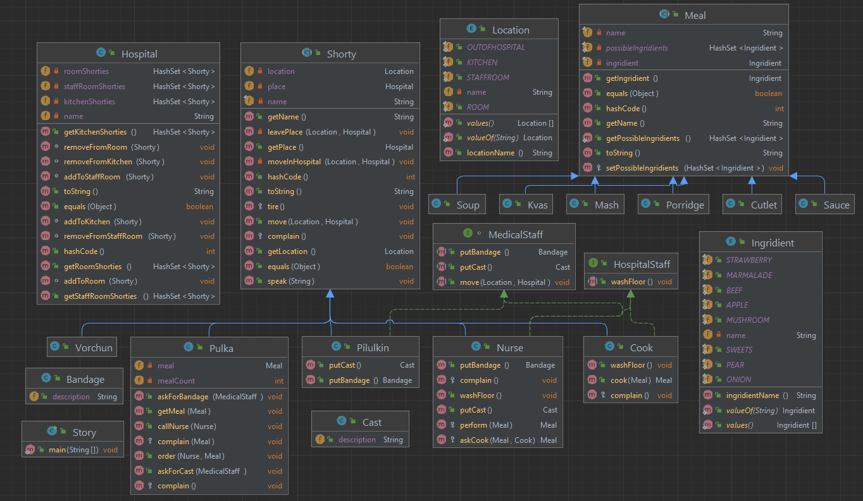

**Исходный код:**

Shorty.java

public class Story {

public static void main(String[] args) {

Hospital durka = new Hospital("durka");

Vorchun vorchun = new Vorchun(Location.ROOM, durka);

Pilulkin pilulkin = new Pilulkin(Location.STAFFROOM, durka);

vorchun.move(Location.OUTOFHOSPITAL, durka);

pilulkin.move(Location.OUTOFHOSPITAL,durka);

Nurse nurse = new Nurse(Location.STAFFROOM, durka);

Pulka pulka = new Pulka(Location.ROOM, durka);

pulka.callNurse(nurse);

Cook cook = new Cook(Location.KITCHEN, durka);

pulka.order(nurse, new Soup(Ingridient.SWEETS));

pulka.order(nurse, new Porridge(Ingridient.MARMALADE));

pulka.order(nurse, new Cutlet(Ingridient.STRAWBERRY));

pulka.order(nurse, new Mash(Ingridient.APPLE));

}

}

Hospital.java

import java.util.HashSet;

import java.util.Objects;

public class Hospital {

private String name;

private HashSet<Shorty> kitchenShorties = new HashSet<>();

private HashSet<Shorty> roomShorties = new HashSet<>();

private HashSet<Shorty> staffRoomShorties = new HashSet<>();

public Hospital(String hospName) {

name = hospName;

}

void addToKitchen(Shorty shorty) {

kitchenShorties.add(shorty);

}

void removeFromKitchen(Shorty shorty) {

kitchenShorties.remove(shorty);

}

void addToStaffRoom(Shorty shorty) {

staffRoomShorties.add(shorty);

}

void removeFromStaffRoom(Shorty shorty) {

staffRoomShorties.remove(shorty);

}

void addToRoom(Shorty shorty) {

roomShorties.add(shorty);

}

void removeFromRoom(Shorty shorty) {

roomShorties.remove(shorty);

}

public HashSet<Shorty> getKitchenShorties() {

return kitchenShorties;

}

public HashSet<Shorty> getRoomShorties() {

return roomShorties;

}

public HashSet<Shorty> getStaffRoomShorties() {

return staffRoomShorties;

}

@Override

public boolean equals(Object o) {

if (this == o) return true;

if (!(o instanceof Hospital)) return false;

Hospital hospital = (Hospital) o;

return Objects.equals(name, hospital.name);

}

@Override

public int hashCode() {

return Objects.hash(name);

}

@Override

public String toString() {

return name;

}

}

Shorty.java

import java.sql.SQLOutput;

import java.util.Objects;

public abstract class Shorty {

private final String name;

private Location location;

private Hospital place;

public Shorty(String n) {

name = n;

location = Location.OUTOFHOSPITAL;

}

// public Shorty(String n, Location notDefault) {

// name = n;

// LOCATION = notDefault;

// }

public Shorty(String n, Location notDefault, Hospital hosp) {

name = n;

location = notDefault;

if (!(notDefault == Location.OUTOFHOSPITAL)) {

place = hosp;

moveInHospital(notDefault, hosp);

}

}

public void move(Location newLocation, Hospital hosp) {

if (newLocation != location) {

if (newLocation == Location.OUTOFHOSPITAL) {

System.out.println(getName() + " escapes from Hospital");

if (place != null) {

leavePlace(newLocation, hosp);

place = null;

}

} else {

place = hosp;

// System.out.println(name + " moves from " + location.locationName() + " to " + newLocation.locationName());

leavePlace(newLocation, hosp);

moveInHospital(newLocation, hosp);

}

location = newLocation;

}

}

private void leavePlace(Location locat, Hospital hosp) {

switch (locat) {

case KITCHEN:

hosp.removeFromKitchen(this);

case ROOM:

hosp.removeFromRoom(this);

case STAFFROOM:

hosp.removeFromStaffRoom(this);

}

}

private void moveInHospital(Location locat, Hospital hosp) {

switch (getLocation()) {

case KITCHEN:

hosp.addToKitchen(this);

case ROOM:

hosp.addToRoom(this);

case STAFFROOM:

hosp.addToStaffRoom(this);

}

}

public void speak(String text) {

System.out.println(text);

}

public String getName() {

return name;

}

public Location getLocation() {

return location;

}

public Hospital getPlace() {

return place;

}

protected void complain() {

System.out.print(this.getName() + ": I can't stand it no more. ");

}

protected void tire(){

System.out.println(this.getName() + ": I'm incredibly tired!");

}

@Override

public boolean equals(Object o) {

if (this == o) return true;

if (!(o instanceof Shorty)) return false;

Shorty shorty = (Shorty) o;

return Objects.equals(name, shorty.name);

}

@Override

public int hashCode() {

return Objects.hash(name);

}

@Override

public String toString() {

return getName();

}

}

Pulka.java

public class Pulka extends Shorty {

private Meal meal;

private int mealCount = 0;

public Pulka() {

super("Pulka");

}

public Pulka(Location notDefault, Hospital hosp) {

super("Pulka", notDefault, hosp);

}

public void callNurse(Nurse nurse) {

nurse.move(Location.ROOM, this.getPlace());

}

public void order(Nurse nurse, Meal meal) {

System.out.println("Pulka: Cook me " + meal);

getMeal(nurse.perform(meal));

if (mealCount == 5) {

nurse.complain();

nurse.tire();

}

if (mealCount == 4) {

order(nurse, new Kvas(Ingridient.PEAR));

}

//complain(this.meal);

}

public void getMeal(Meal meal) {

System.out.println("Pulka gets " + meal);

this.meal = meal;

mealCount++;

if (mealCount == 4 || mealCount == 5) {

complain(meal);

}

}

public void askForBandage(MedicalStaff medic) {

medic.move(Location.ROOM, this.getPlace());

medic.putBandage();

}

public void askForCast(MedicalStaff medic) {

medic.move(Location.ROOM, this.getPlace());

medic.putCast();

}

@Override

protected void complain() {

super.complain();

System.out.println("This hospital is awful.");

}

protected void complain(Meal meal) {

super.complain();

if (mealCount == 5) {

System.out.println("This " + meal.getName() + " stinks of onion");

}

if (mealCount == 4) {

System.out.println("I asked for Pear Kvas");

}

}

}

Nurse.java

public class Nurse extends Shorty implements HospitalStaff, MedicalStaff {

public Nurse() {

super("Nurse");

}

public Nurse(Location notDefault, Hospital hosp) {

super("Nurse", notDefault, hosp);

}

protected Meal perform(Meal meal) {

boolean f = false;

move(Location.KITCHEN, this.getPlace());

for (Shorty shorty : getPlace().getKitchenShorties()) {

if (shorty instanceof Cook) {

f = true;

askCook(meal, (Cook) shorty);

}

}

move(Location.ROOM, this.getPlace());

if (!f) {

move(Location.ROOM, this.getPlace());

//System.out.println(this.getName() + ": We have no cook!");

return null;

} else {

return meal;

}

}

protected Meal askCook(Meal meal, Cook c) {

// System.out.println("Nurse: Cook "+ meal.getIngridient().ingridientName() + " " + meal.getName());

return c.cook(meal);

}

@Override

public void washFloor() {

move(Location.STAFFROOM, getPlace());

System.out.println(this.getName() + " washes the floor in StaffRoom");

}

@Override

public Bandage putBandage() {

return new Bandage();

}

@Override

public Cast putCast() {

return new Cast();

}

@Override

protected void complain(){

super.complain();

System.out.println("What a terrible patient! He'd rather get well soon");

}

}

Cook.java

public class Cook extends Shorty implements HospitalStaff{

public Cook() {

super("Cook");

}

public Cook(Location notDefault, Hospital hosp) {

super("Cook", notDefault, hosp);

}

public Meal cook(Meal meal){

if (!(meal.getPossibleIngridients().contains(meal.getIngridient()))){

this.complain();

}

return meal;

}

@Override

protected void complain() {

super.complain();

System.out.println("This meal doesn't exist");

}

@Override

public void washFloor(){

move(Location.KITCHEN, getPlace());

System.out.println(this.getName() + " washes the floor in Kitchen");

}

}

Pilulkin.java

public class Pilulkin extends Shorty implements MedicalStaff{

public Pilulkin() {

super("Pilulkin");

}

public Pilulkin(Location notDefault, Hospital hosp) {

super("Pilulkin", notDefault, hosp);

}

@Override

public Bandage putBandage(){

return new Bandage();

}

@Override

public Cast putCast(){

return new Cast();

}

}

Vorchun.java

public class Vorchun extends Shorty {

public Vorchun() {

super("Vorchun");

}

public Vorchun(Location notDefault, Hospital hosp) {

super("Vorchun", notDefault, hosp);

}

}

Location.java

public enum Location {

KITCHEN("Kitchen"), ROOM("Room"), STAFFROOM("StaffRoom"), OUTOFHOSPITAL("OutOfHospital");

private String name;

Location(String locationName) {

this.name = locationName;

}

public String locationName() {

return name;

}

}

Ingridient.java

public enum Ingridient {

STRAWBERRY("Strawberry"), SWEETS("Sweets"), MARMALADE("Marmalade"),

MUSHROOM("Mushroom"), APPLE("Apple"),

PEAR("Pear"), ONION("Onion"), BEEF("Beef");

private String name;

Ingridient(String ingridientName) {

this.name = ingridientName;

}

public String ingridientName() {

return name;

}

}

Cast.java

public class Cast {

public String description = "гипс";

public Cast(){

description = "Гипс";

}

}

Bandage.java

public class Bandage {

public String description = "бинт";

public Bandage() {

description = "Бинт";

}

}

Meal.java

import java.util.HashSet;

import java.util.Objects;

public abstract class Meal {

private final Ingridient ingridient;

private final String name;

private static final HashSet<Ingridient> possibleIngridients = new HashSet<>();

public Meal(String n, Ingridient ing) {

name = n;

ingridient = ing;

}

public String getName() {

return name;

}

public Ingridient getIngridient() {

return ingridient;

}

protected void setPossibleIngridients(HashSet<Ingridient> ingridients){

for (Ingridient ing: ingridients){

possibleIngridients.add(ing);

}

}

public static HashSet<Ingridient> getPossibleIngridients() {

return possibleIngridients;

}

@Override

public boolean equals(Object o) {

if (this == o) return true;

if (!(o instanceof Meal)) return false;

Meal meal = (Meal) o;

return ingridient == meal.ingridient && Objects.equals(name, meal.name);

}

@Override

public int hashCode() {

return Objects.hash(name);

}

@Override

public String toString() {

return getIngridient().ingridientName() + " " +getName();

}

}

Cutlet.java

import java.util.HashSet;

public class Cutlet extends Meal {

public Cutlet(Ingridient ing) {

super("Cutlet", ing);

HashSet<Ingridient> ingridients = new HashSet<>();

ingridients.add(Ingridient.BEEF);

setPossibleIngridients(ingridients);

}

}

Soup.java

import java.util.HashSet;

public class Soup extends Meal {

public Soup(Ingridient ing) {

super("Soup", ing);

HashSet<Ingridient> ingridients = new HashSet<>();

ingridients.add(Ingridient.SWEETS);

setPossibleIngridients(ingridients);

}

}

Porridge.java

import java.util.HashSet;

public class Porridge extends Meal {

public Porridge(Ingridient ing) {

super("Porridge", ing);

HashSet<Ingridient> ingridients = new HashSet<>();

ingridients.add(Ingridient.MARMALADE);

setPossibleIngridients(ingridients);

}

}

Mash.java

import java.util.HashSet;

public class Mash extends Meal {

public Mash(Ingridient ing) {

super("Mash", ing);

HashSet<Ingridient> ingridients = new HashSet<>();

ingridients.add(Ingridient.APPLE);

ingridients.add(Ingridient.PEAR);

setPossibleIngridients(ingridients);

}

}

MedicalStaff.java

interface MedicalStaff {

public Bandage putBandage();

public Cast putCast();

public void move(Location newLocation, Hospital hosp);

}

HospitalStaff.java

public interface HospitalStaff {

public void washFloor();

}

**Результат выполнения программы:**

Vorchun escapes from Hospital

Pilulkin escapes from Hospital

Pulka: Cook me Sweets Soup

Pulka gets Sweets Soup

Pulka: Cook me Marmalade Porridge

Pulka gets Marmalade Porridge

Pulka: Cook me Strawberry Cutlet

Cook: I can't stand it no more. This meal doesn't exist

Pulka gets Strawberry Cutlet

Pulka: Cook me Apple Mash

Pulka gets Apple Mash

Pulka: I can't stand it no more. I asked for Pear Kvas

Pulka: Cook me Pear Kvas

Pulka gets Pear Kvas

Pulka: I can't stand it no more. This Kvas stinks of onion

Nurse: I can't stand it no more. What a terrible patient! He'd rather get well soon

Nurse: I'm incredibly tired!

**Вывод:** Во время выполнения данной лабораторной работы я научился применять принципы SOLID на практике, изучил понятия абстрактного класса, интерфейса и перечисления, а так же столкнулся с основными плюсом и минусом SOLID: очень сложно начать проект без предварительной разработки архитектуры и представления необходимых зависимостей, однако гораздо легче расширять и дополнять готовый проект, в котором используются принципы SOLID.