**Internal Note Date: 2018-07-18 Version: 0.5**

Monte-Carlo simulations for high pressure multiwire chamber test experiment

Alexey Dzyuba (PNPI)

Using Monte-Carlo technique the spatial resolution for cathode strip chamber filled by 96% Ar + 4% CH4 of 20 bars pressure has been investigated.

# Introduction

High pressure Cathode strip chamber (CSC) is under development in Petersburg Nuclear Physics institute for detection of the elastically scattered electrons.

# Experimental setup

Proton beam with 1 GeV kinetical energy is used. The CSC prototype consists of 50 mm stainless steel walls and gas volume filled by 96% Ar + 4% CH4 gas mixture of 20 bars pressure (see Fig.1). Anode wires of 30 μm diameter are aligned at the center of the gas volume parallel to the *x*-axis. The step between anode wires are 3 mm. Two planes of cathode strips are constructed from wires aligned in parallel to the *y*-axis. The distance between cathode strips is 0.5 mm. Cathode wires are joined to strips (5 wires in each strip). Strips are 2 mm width with 0.5 mm gap in between.

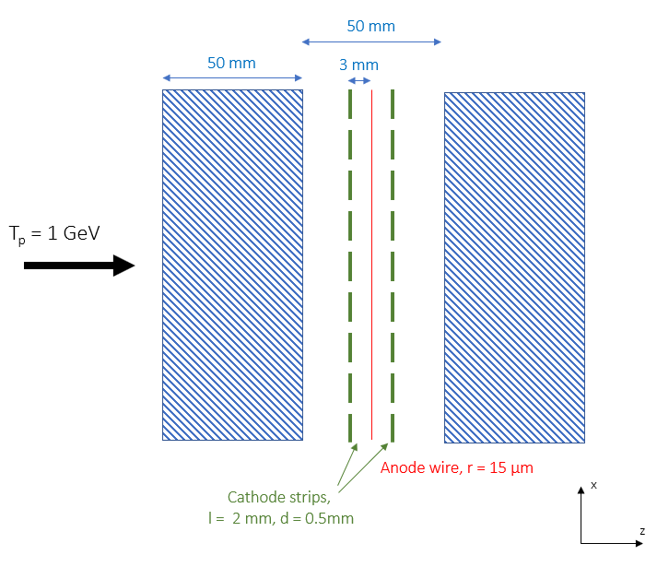

**Fig.1 Proposed experimental setup**

For the Monte-Carlo simulations GEANT-4.10.4.2 package is used [1]. The parameters of protons passed one wall of the test chamber is presented on Fig.2. The spike at *x* = 0 mm, which is visible on the distribution of proton position on *x*-axis after steel wall (central panel), is GEANT-4 artefact corresponding to the protons, which have no large angle scattering. For them only ionization process changes kinematical distributions (they have transverse momentum component and the polar angle of their momentum is not zero; maximum is about 20 mrad). To consider the effect of the step size a large sample has been generated. With the maximal step size of 10 mm the artifact disappears (see lower panel of Fig.2).

To preserve all possible information the **SteppingAction** class is used. Each simulation step with ionization energy deposit in the sensitive volumes (between cathodes and anode) is recorded. Electrons from ionization drift to the anode wire along electric field lines. They create avalanches near anode wire. The ions produced during avalanche process induce signal on cathodes, which are recorded.

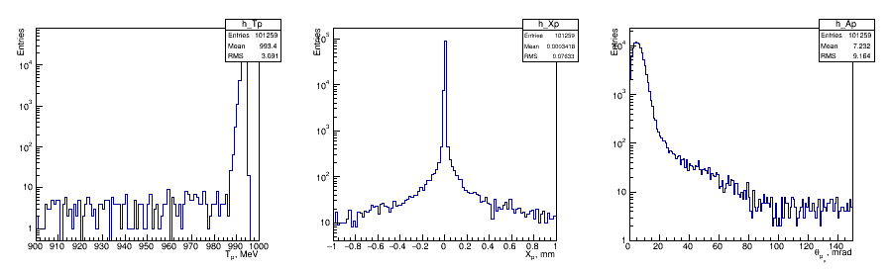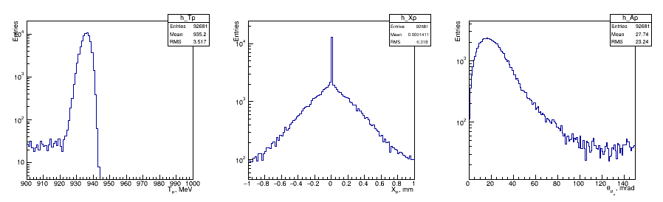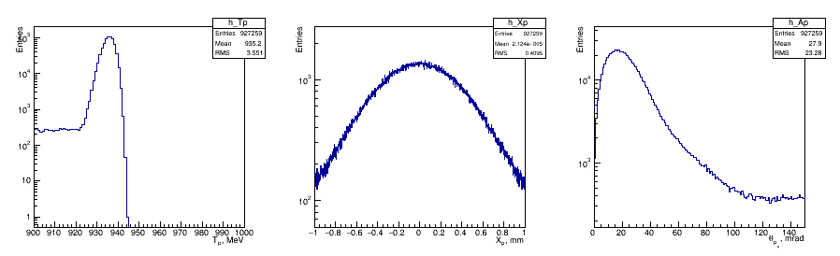

**Fig.2 Proton parameters after 5 mm (upper set of figures) and 50 mm (central and lower set) wall made from stainless steel. In each set: proton kinetic energy (left), proton position on the *x*-axis (center), polar angle of proton momentum (right). Distributions are produced for all protons (including ones, which are produced in the wall). Central and lower set differ in the number of protons on the wall and maximal GEANT step size, which is 50 mm for central and 10 mm for lower panel.**

Energy distributions for the particles of different type are presented on Fig.2a. The electromagnetic part of the spectrum is dominated by photons (1.67 photons per incoming protons). The hadronic part consists from protons, neutrons, and pions (both positively and negatively charged ones).

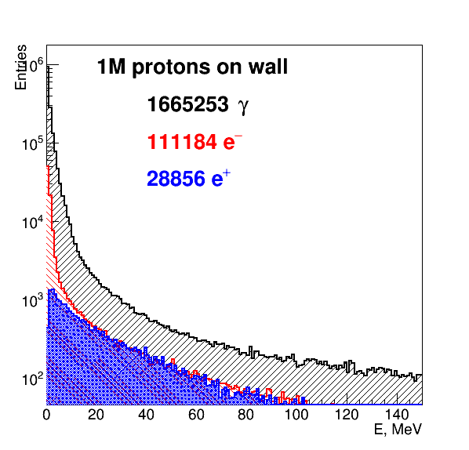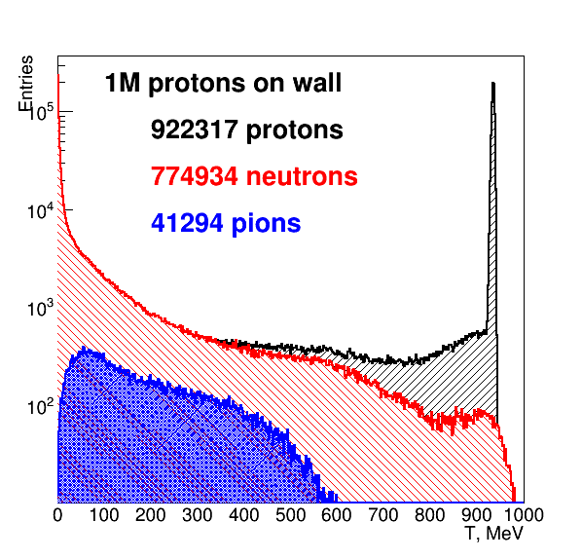

**Fig.2a Energy of particles after 50 mm steel wall and 22 mm gas gap. Left panel: total energy for leptons and photons; right panel: kinetic energy of hadrons.**

# Detector response simulation

The charge from ions induced on cathodes is parametrized using single parameter Gatti formula [2].

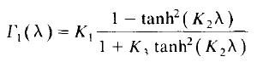

The parameters of the formula are presented in [2] and on Fig.3.

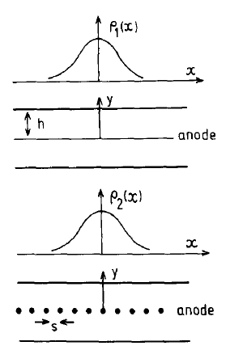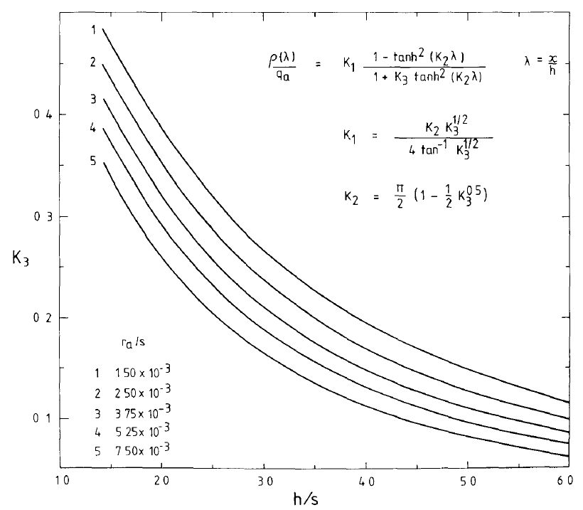

**Fig.3 Parameters for Gatti formula (figure from [2]).**

Extrapolation of calculations presented on Fig.3 for the parameters of the test experiment the default value of *K3 = 0.45* has been used. To study result dependency on the CSC parameters two alternative value of the *K3 = 0.50* and *K3 = 0.40* were used. As presented on Fig.4 used values provide quite similar shape for the detector response function.

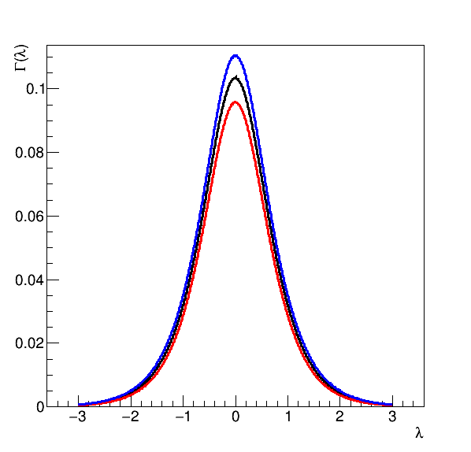

**Fig.4 Shape of the cathode distributions obtained with Gatti parametrization with *K3* to be equal to 0.4 (red line), 0.45 (black), and 0.5 (blue).**

Obtained distributions have been used to calculate detector response on event-by-event basis. Next procedure has been used:

1. Each GEANT-4 step in the sensitive volume of the CSC was divided on the equal sub-steps with 30 eV energy deposit for each (one atom ionized). *Note that ionization energy for argon is 15.75962, for carbon 11.26030, and for hydrogen 13.59844 [3], but some energy is used to excite atom without emitting electrons so effectively 30 eV is needed to create electron-ion pair.*
2. The unit response was smeared on the Gatti function (normalized to unity).
3. To obtain cathode signal this response function was split according its position over cathode strips and the integrals were summarized.

Thus, for each event the distribution on cathode was obtained. The center of gravity for obtained histogram is taken as an estimator for the particle coordinate. As for the test experiment two 24-channels readout modules will be used the sensitive area for the *x*-coordinate will be 60 mm.

# Track multiplicity and parameters

Tracks are identified as gaps in the energy deposit projection onto *x*-axis. The track multiplicities for thin and thick steel wall are presented at Table 1.

**Table 1: Track multiplicity for the sensitive volume of CSC.**

|  |  |  |  |  |  |
| --- | --- | --- | --- | --- | --- |
| Number of tracks | 0 | 1 | 2 | 3 | >3 |
| 5 mm wall | <0.4% | 95.3% | 3.3% | 1.4% | <0.1% |
| 50 mm wall | 7.2% | 81.5% | 7.1% | 1.0% | <0.5% |

The standard deviation for the output signal distribution can be used to reject events with several tracks. As an example, the standard deviation of signal for two-track events is plotted versus the distance between two tracks at Fig.5. The distance is defined as gap width on *x* axis between GEANT-4 steps with ionization energy deposit. The calculations are done for 50 mm steel wall in front of chamber. Clear close-to-linear dependence is observed.

The standard deviation distribution for one track events obtained with the same conditions are calculated to be of 2.4 mm, which mainly corresponds to the standard deviation of the distributions plotted on Fig.4.

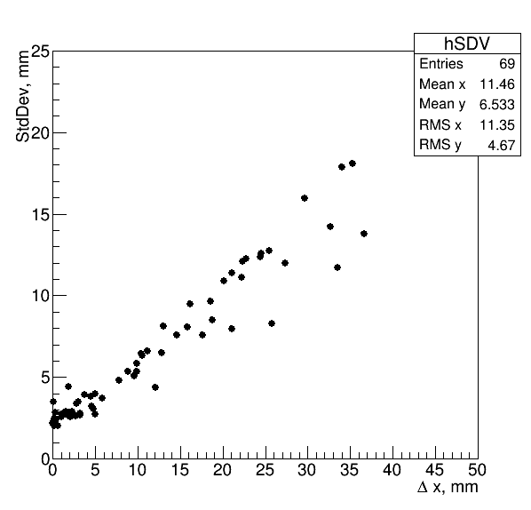

**Fig.5 Standard deviation (*σ*) of the signal for two-track events vs. *Δx* gap between tracks.**

# Resolution of CSC

For the presented model the spatial resolution depends mainly on the signal processing. The lower limit is defined by the shape of cathode distribution. Thought the steel wall placed in front of the CSC affect ideal resolution (signal width becomes wider due to scattering) the effect is one order of magnitude less than the influence of the detector response function.

**Table 2: Obtained resolution in μm.**

|  |  |  |  |
| --- | --- | --- | --- |
|  | No wall | 5 mm wall | 50 mm wall |
| Average ideal resolution (mean uncertainty) | 0.25 | 0.43 | 1.77 |
| Average single plane (mean uncertainty) | 17.0 | 17.0 | 17.0 |

The lower limit for the spatial resolution of 0.017 mm is predicted to be measured in the test experiment for one track evens. Note that some assumptions (such as ideal electronics) were made to achieve the results. Standard deviation of the detector response can be used to suppress signal from events with several particles produced in the wall.

# Scintillator counters

To have some background rejection the test stand can be equipped with two (3×3 cm2 each) scintillation counters. The Monte-Carlo simulations were performed to obtain coincidence rate between these counters and rate in sensitive volume of CSC. In these simulation 5 mm thick of the plasic scintillators (C9H10, density of 1.032 g/cm3) were placed 30 mm in front and 30 mm behind test chamber. Next results were obtained:

* The probability for initial proton (fixed by the track id) to hit both scintillators as well as sensitive area of CSC is **50%**.
* The probability of any triple coincidence (any steps with energy deposit are required) is **66%**.
* The probability to have both scintillators fired, but no ionization energy deposit in the sensitive volume of CSC was calculated to be **0.5%**.

# Analysis reproducibility

The analysis code is stored publicly [4].

# Bibliography

1. GEANT-4, Nuclear Instruments and Methods in Physics Research A 506 (2003) 250-303; IEEE Transactions on Nuclear Science 53 No. 1 (2006) 270-278; Nuclear Instruments and Methods in Physics Research A 835 (2016) 186-225.
2. E. Matheison, J.S. Gordon, Nucl. Inst. Meth. 227 (1984) 277-282
3. <https://en.wikipedia.org/wiki/Ionization_energies_of_the_elements_(data_page)>
4. <https://github.com/aleksha/G4-Models>