**Internal Note Date: 2018-08-23 Version: 0.2**

Monte-Carlo simulation of multi wire chamber radiation damage

Alexey Dzyuba (PNPI)

Using GEANT-4 package the dose in the multi wire chamber was investigated.

The sketch of the model is presented on Fig. 1. This sketch was obtained from the simulation itself – the logical volumes was marked as sensitive ones and the hits were visualized. G10 layers are not presented on the sketch. Blue line in the center of the Air volumes corresponds to the GEANT steps, which cover full layer thickness. For visualization plot high energy electrons were used.

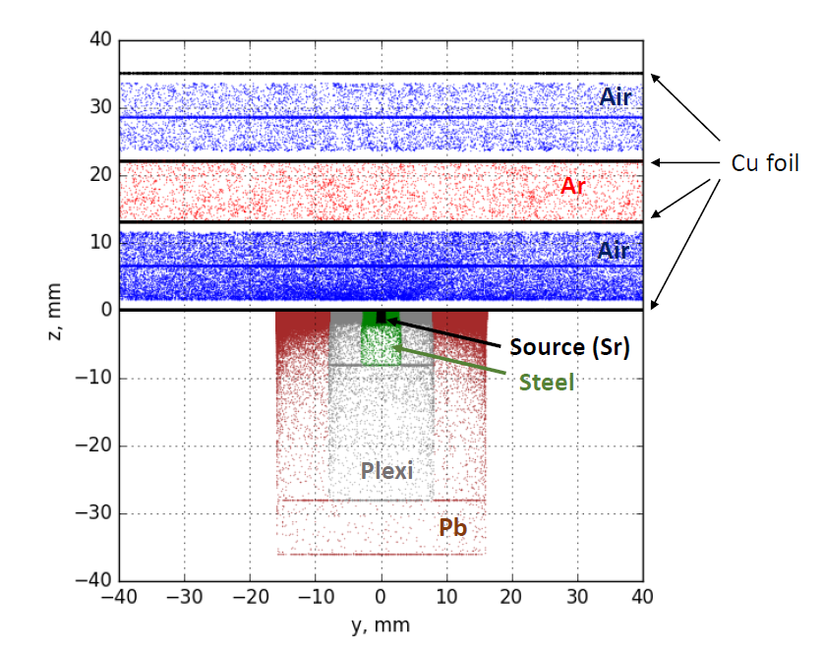

**Fig.1 Model visualization.**

An alternative geometry, in which whole source setup was placed on top of second G10 layer, was also studied and the result is referred as Model 2.

For the investigations a Sr-Y-90 source was used. The ***БИС-МНА-2*** source has nominal activity of 750 MBq (or 0.0203 Ci). The chain of decays started with Sr-90 decay into Y-90 (half-life time 28.6 years), which later (T1/2 = 64 hours) decay into stable Zr-90 isotope.

Source spectrum is presented on Fig.2 and 3. It is obtained from [2]. The spectrum was scanned, interpolated with **ROOT:TSpline3** class, then spitted on 100k points pdf used in rejection method. Gamma radiation appears rarely but was included into simulation. The decays were simulated randomly inside the source volume.

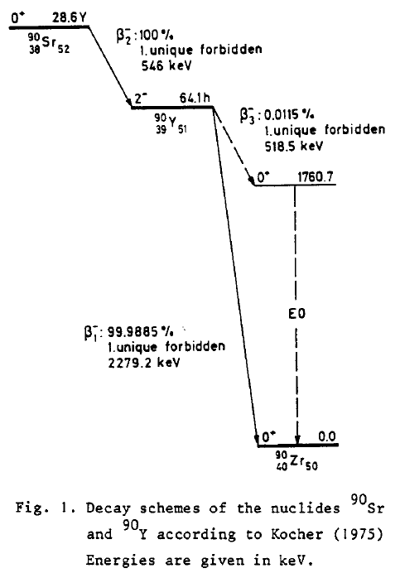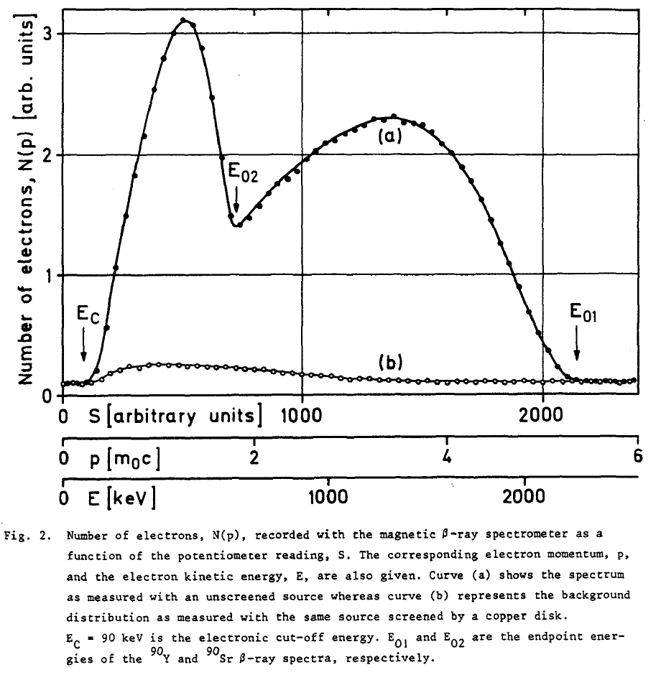

**Fig.2 Spectrum of the Sr-Y source [2].**

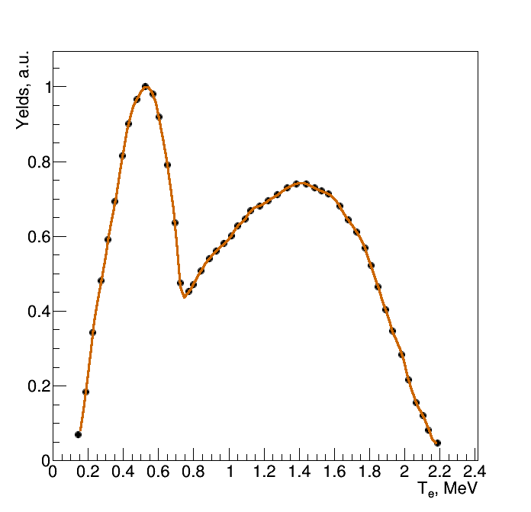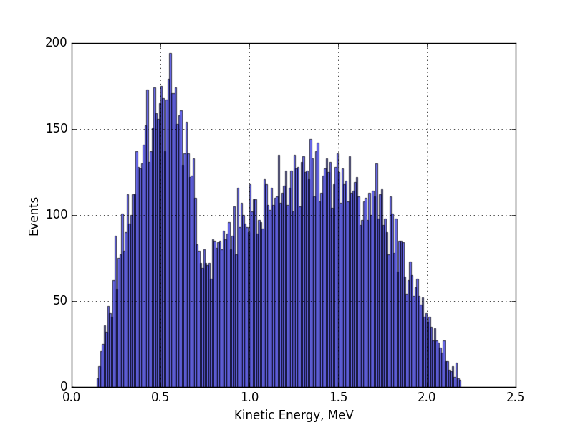

**Fig.3 Scan of spectrum and its interpolation by TSpline3 (left). Generated spectrum (right).**

The dose distributions in thin copper layers 2 and 3 are presented on Fig. 4. They have similar tails. The most difference occurs near source axis.

The doses in the copper layers per one second are:

* Layer 2: 137.7 ± 2.5 μGy
* Layer 3: 102.3 ± 2.1 μGy

The dose distributions for Model 2 is presented on Fig. 5. The distribution differs slightly. The doses in the copper layers per one second are:

* Layer 2: 1068.5 ± 7.8 μGy
* Layer 3: 712.2 ± 6.3 μGy

The dose was integrated over the copper disk with 30 cm radius.

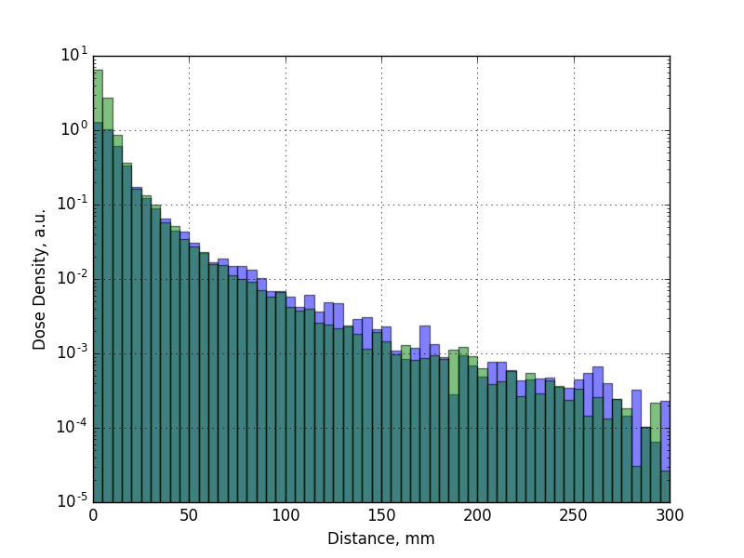

**Fig.4 Distribution of the dose as function of distance from *z*-axis for the model presented on Fig.1. Green distribution corresponds to the dose on layer 2, blue one – on layer 3; their overlap is marked as dark green.**

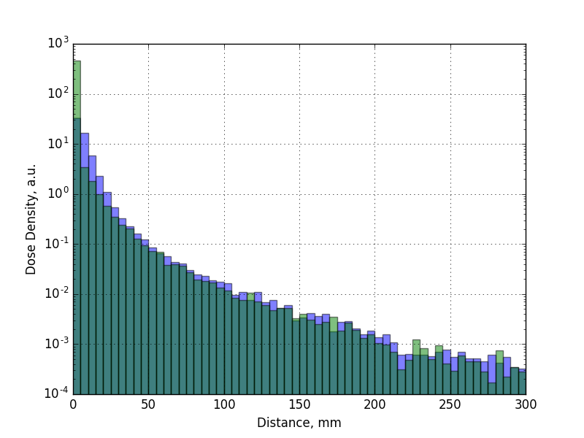

**Fig.5 Distribution of the dose as function of distance from *z*-axis (Model 2). Green distribution corresponds to the dose on layer 2, blue one – on layer 3; their overlap is marked as dark green.**

The analysis code is stored publicly [3].

# References

1. GEANT-4, Nuclear Instruments and Methods in Physics Research A 506 (2003) 250-303; IEEE Transactions on Nuclear Science 53 No. 1 (2006) 270-278; Nuclear Instruments and Methods in Physics Research A 835 (2016) 186-225.
2. Int. J. Appl. Radiat. Isot. 34 (1983) 1241
3. <https://github.com/aleksha/G4-Models>