**Internal Note Date: 2018-08-15 Version: 0.1**

On electronic noise in the TPC

Alexey Dzyuba (PNPI)

Using the data obtained with the hydrogen Time Projection Chamber (TPC) the electronic noise has been investigated. Data suggests no significant time or frequency correlation for existing setup. The way how to implement electronic noise into simulation.

# Introduction and Experimental setup

High pressure Time Projection Chamber (TPC) is under development in Petersburg Nuclear Physics Institute for detection of the elastically scattered protons. The TPC prototype called ACTAF was used for several test runs with electron and muon beams. The sketch of ACTAF is presented on Fig. 1

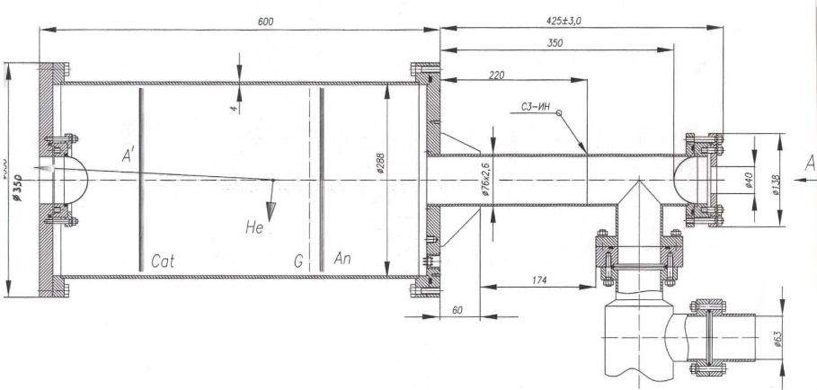

**Fig.1 Sketch of ACTAF detector (left).**

Anode segmentation scheme as well as typical signals from several anodes are presented on Fig. 2. Signal is placed on the fluctuating noise pedestals, which must be taken into account during procedure of the signal extraction. Each channel in the time spectra corresponds to 40 ns.

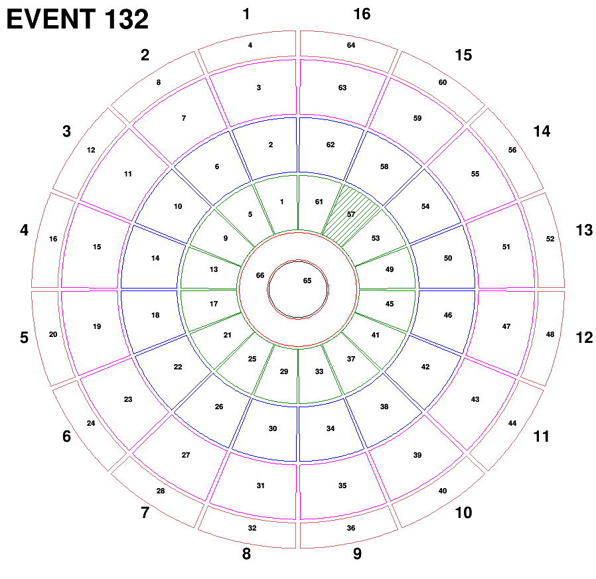 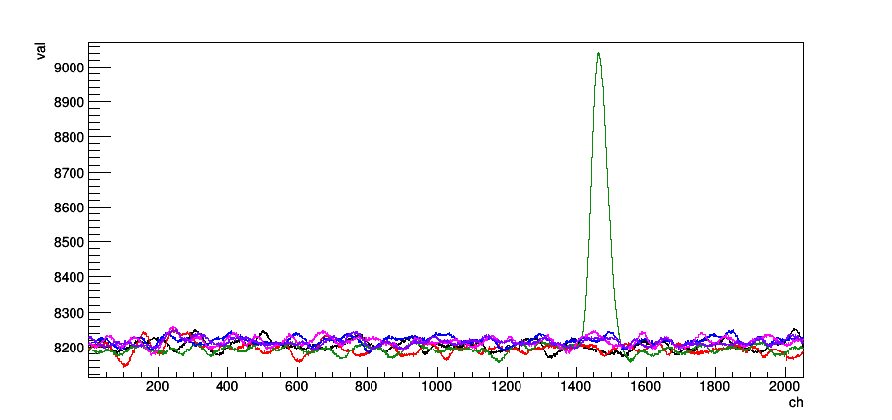

**Fig.2 Anode segmentation scheme (left). Typical signals from event (right). Sector 15 is shown.**

The shape of the signal function represents the electronic response function (response time spectra on the delta-function like signal), which has 1400 ns time to reach maximum and duration of 5000 ns.

A source of alpha-particles is placed on anode 7 (sector 2) and allows to make calibration. Around 5000 of such events were collected. Events triggered from the signal from alpha particles (with absence of any beam) provide ideal data to study electronic noise. In this internal note the analysis of noise from central anode ring (anode 66) is presented. The time spectra were examined to have no signal inside with the criterium no excess on averaged signal in the 10-channel-width moving time window over the baseline scaled with factor of 1.02. The distribution of the selected events on the maximal absolute value of difference with respect to the baseline is presented on the left panel of Fig. 3. For further studies only events with this variable less than 65 were used.

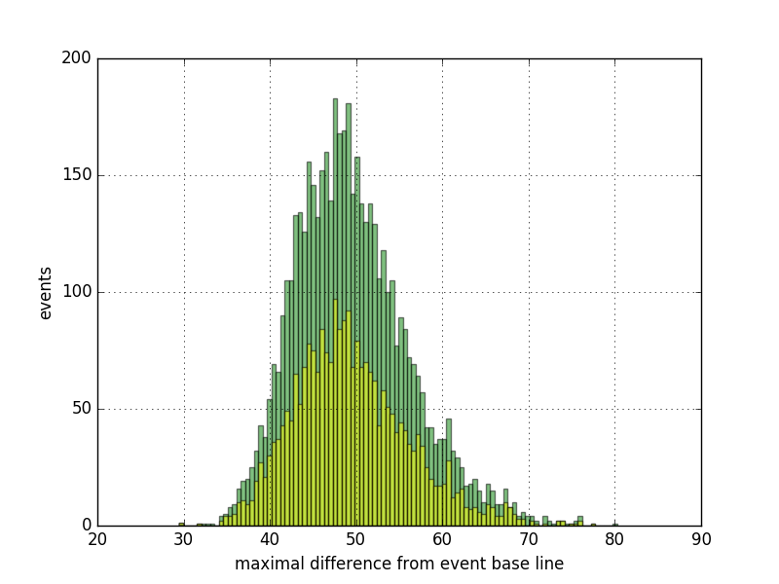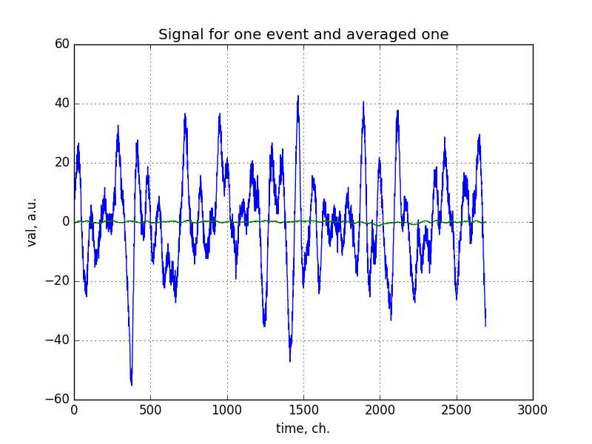

**Fig.3 Left panel: distribution on absolute value of maximal difference of the ADC response with respect to the baseline. Green histogram corresponds to the full sample, yellow one to the part of sample, for which difference is negative. Right panel: typical baseline-corrected ADC response for one event (blue) and averaged for the sample (green).**

Typical baseline-corrected time spectrum is presented at the right panel of Fig. 3. When compared with the average one over the selected sample it demonstrates much large fluctuations. This is an evidence of absence of any low signals invisible for individual event, as well as absence of any periodic contribution synchronized (somehow) with the trigger system.

# Fourier analysis

To study frequency characteristics of the noise fast-Fourier analysis has been performed using **fft** function from **scipy.fftpack** package [1], which is available for Python programming language. The packing of the result is “standard”; if **A = fft(a)**, then **A[0]** contains the zero-frequency term, **A[1:n/2]** contains the positive-frequency terms, and **A[n/2:]** contains the negative-frequency terms, in order of decreasingly negative frequency (where **n** is number of input values). As input spectrum contains only real values, then **A[j]** is equal of conjugated **A[n-j]**. The **A[i]** frequency corresponds to the period **107680 / i** ns.

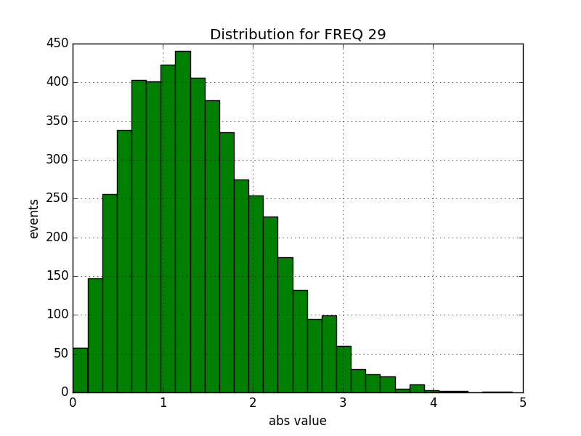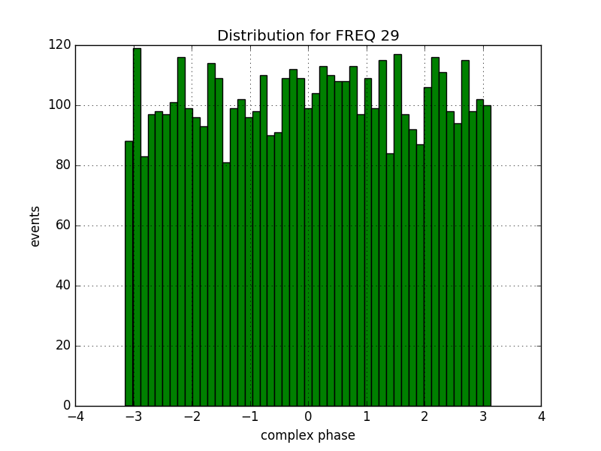

**Fig.4 Distribution of absolute value and complex phase for one of frequency channels.**

The distributions of the absolute value and phase for one of the channels are presented on Fig. 4. The mean (over the event sample) absolute values as a function of frequency, as well as Fourier transform for the averaged time spectrum are presented on the Fig. 5 (note, that only first 200 channels are shown). There are several frequency channels with higher mean value with respect to the channels nearby. The result of Fourier transformation for the averaged time spectrum also is a clear evidence that frequency channels are independent.

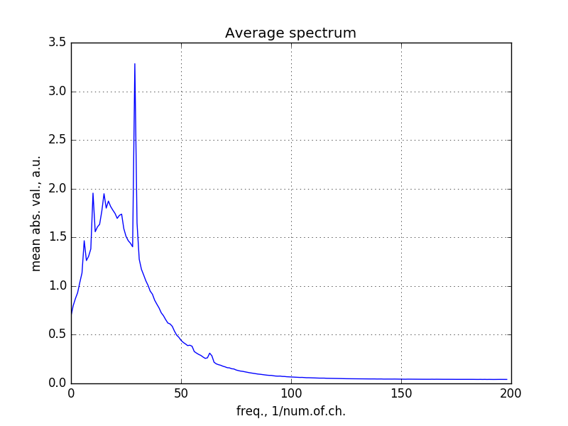 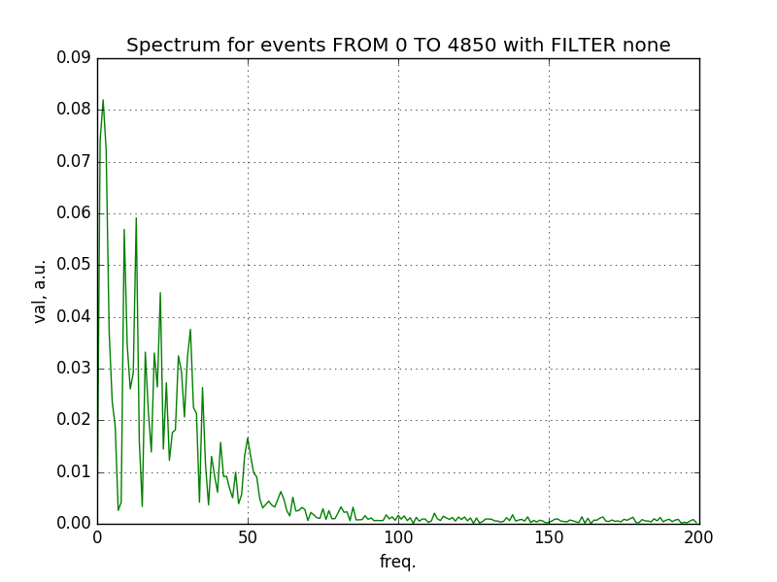

**Fig.5 Left panel: mean absolute value for the sample. Right panel: result of Fourier transformation for the averaged spectrum (see Fig.3 right panel).**

The phase distributions for all frequency channels were examined to be consistent with constant hypothesis. The χ2 test was performed with the coincidence level of 99.7% (3 sigma). First tree channels as well as wide range from channel 80 to 250 demonstrate inconsistency with flat hypothesis. The different patterns were observed for these two regions (see Fig. 6). The reasons of such behavior was not understood.

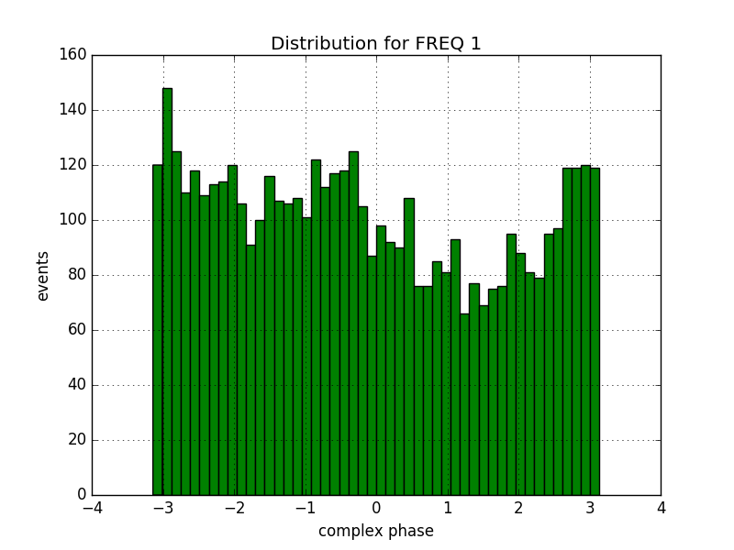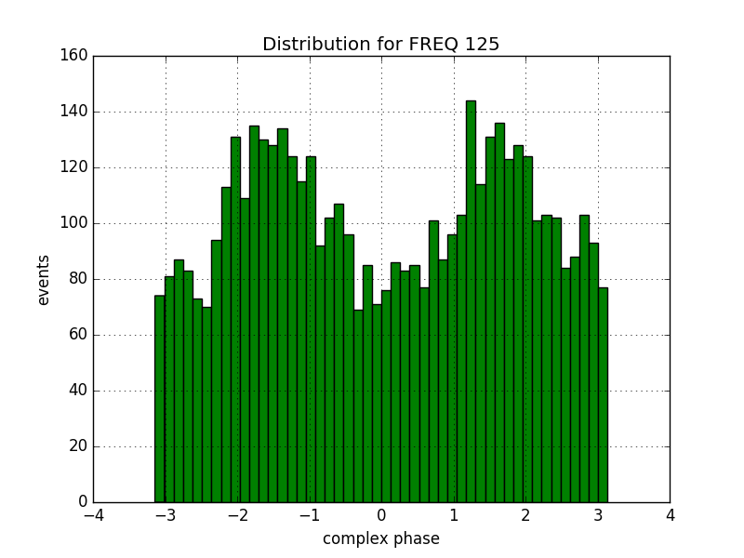

**Fig.6 Distribution of complex phase for 1st and 125th frequency channels.**

# Monte-Carlo simulation of the noise

To simulate noise time distribution next procedure is proposed:

1. Obtain distribution for real and imaginary part of frequency spectra using Fourier transformation;
2. Fit these distributions using two gaussian hypotheses;
3. Generate random spectrum out of these distributions;
4. Use inverse Fourier transformation to obtain spectrum of generated events.

Figures below demonstrate that such procedure generate same (as data plotted in green) spectrum on absolute value, as well as argument one for all cases (these yellow spectra corresponds to the generated events). The fitted curves are presented by red line.

The example of generated event is presented below.

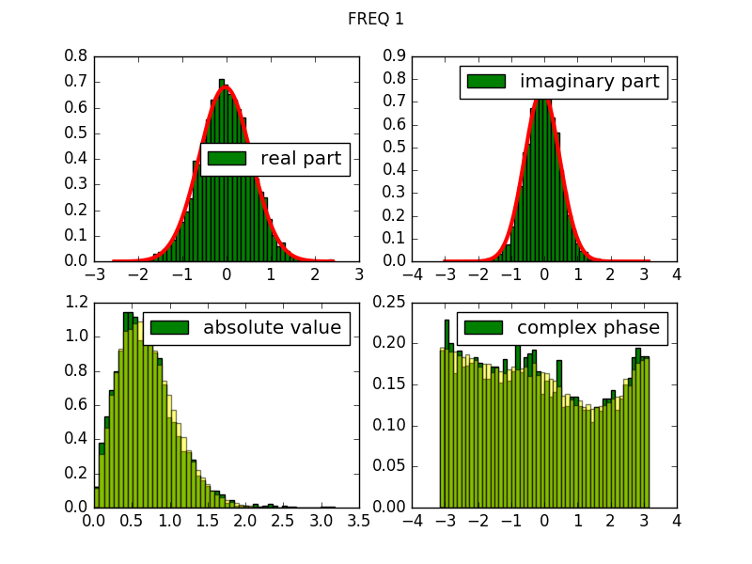

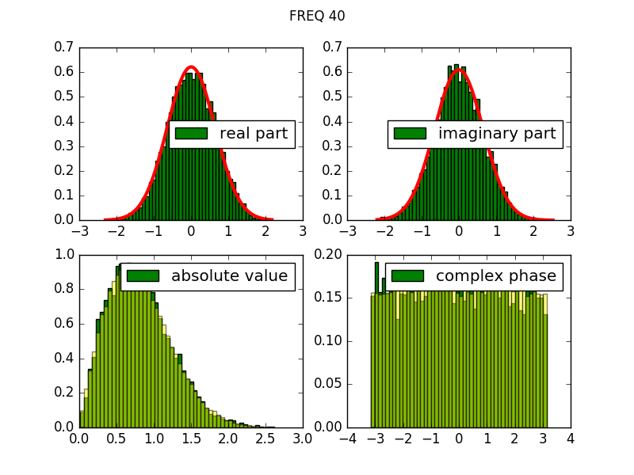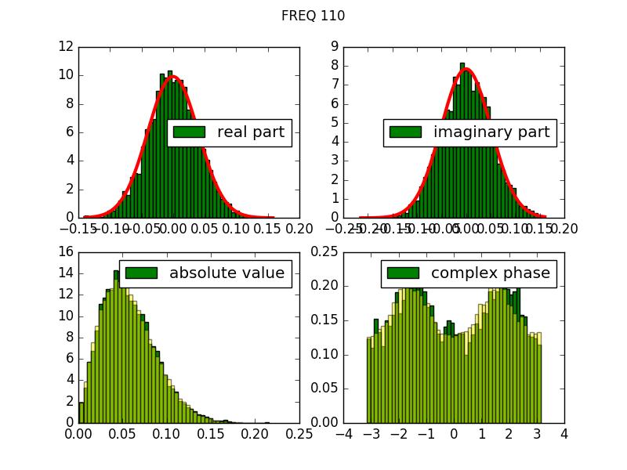

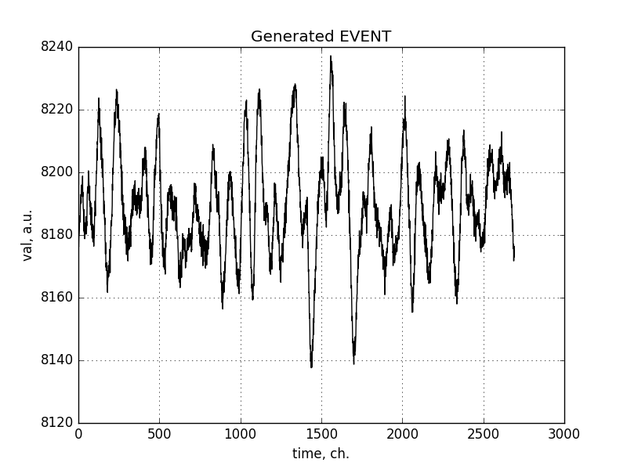

# Analysis reproducibility

The analysis code is stored publicly [2].

Note that code have to and will be refactored in future.

# References

1. <https://docs.scipy.org/doc/scipy/reference/generated/scipy.fftpack.fft.html#scipy.fftpack.fft>
2. <https://github.com/aleksha/G4-Models>