AI REPUTATION ANALYZER: A MULTILINGUAL, MULTI-SOURCE SYSTEM FOR REAL-TIME SOCIAL-MEDIA SENTIMENT AND EMOTION ANALYSIS
By
Drini Nazëraj
Shefqet Meda, PhD

A THESIS
Submitted to
KOLEGJI UNIVERSITAR "Instituti Kanadez i Teknologjisë"
University College "CANADIAN INSTITUTE OF TECHNOLOGY"
Faculty of Engineering
Department of Software Engineering
In partial fulfillment of the requirements for the degree of:
Bachelor of Science in Software Engineering

Bachelor of Science in Software Engineering
Submitted on June 15, 2026.

Approved:

_________________________________________ | Shefqet Meda, PhD
(signature)

_________________________________________ | [Chair or Head of Department]
(signature)

I understand that my thesis will become part of the collection of Canadian Institute of Technology. My signature below authorizes release of my thesis to any reader upon request. I also affirm that the work represented in this thesis is my own work.

_________________________________________ | Drini Nazëraj, Author
(signature)

Title of thesis:
AI Reputation Analyzer: A Multilingual, Multi-Source System for Real-Time Social-Media Sentiment and Emotion Analysis.
Abstract:
Public opinion increasingly forms on social-media platforms, where thousands of short, multilingual comments accumulate around a single public figure, brand, or topic within hours. Reading this material manually is infeasible, and most off-the-shelf sentiment tools are tuned for English and fail on the mixed Albanian-English text that dominates the local online sphere. This thesis presents the design, implementation, and evaluation of the AI Reputation Analyzer, a full-stack web application that automatically collects comments about a queried person or topic from four social-media sources (YouTube, Instagram, TikTok, and Facebook), analyses each comment with a multilingual transformer, and aggregates the results into an interpretable reputation report. The system pairs a fine-tuned XLM-RoBERTa sentiment model with a TextBlob lexicon baseline, adds a 28-class multilingual emotion classifier, and combines the results with a custom 0 to 100 reputation-scoring algorithm and a confidence estimate. Collection runs concurrently across all sources, with progress streamed live to the browser. The system was exercised on 71 public figures (51 international and 20 Albanian), producing a corpus of 26,109 analysed comments across 84 reports stored in a relational database. A controlled comparison of the two sentiment models, holding the pipeline constant and varying only the language of the comments, shows that the lexicon baseline's agreement with the transformer falls from 50.4 % on international comments to 38.0 % on Albanian comments, and that it collapses 87 % of Albanian comments into "neutral" (versus 57 % for English). This is concrete, quantified evidence that a multilingual transformer is necessary for analysing Albanian social-media text. The thesis contributes a reproducible architecture for real-time, multi-source, multilingual reputation analysis and an honest evaluation of its components.
Keywords:
sentiment analysis, emotion detection, XLM-RoBERTa, multilingual NLP, online reputation, social-media mining, opinion mining, Albanian language, FastAPI, transformers.

Acknowledgment
I would like to express my sincere gratitude to my thesis advisor, Shefqet Meda, for the guidance, patience, and constructive feedback that shaped this work from an idea into a working system. I am grateful to the faculty of the Canadian Institute of Technology for the knowledge and the academic environment that made this project possible.
I also thank my family and friends for their constant support and encouragement throughout my studies, and especially during the long days of building and testing this system.
Finally, I acknowledge the open-source community, whose libraries and pre-trained models (FastAPI, Hugging Face Transformers, React, yt-dlp, and many others) form the foundation on which this thesis is built.

Table of Contents
Right-click → Update Field to build the Table of Contents.

List of Figures and Tables
Right-click → Update Field to build the List of Figures.
Right-click → Update Field to build the List of Tables.

List of Appendices
Right-click → Update Field to build the List of Appendices.

Chapter I: Introduction

I.1 Background and Motivation
Over the past decade, social media has become the dominant arena in which public opinion is formed, expressed, and contested. When a public figure makes a decision, a company launches a product, or a controversial event unfolds, the immediate reaction appears not in newspapers but in the comment sections of YouTube, Instagram, TikTok, and Facebook. For a single trending topic, these reactions can number in the thousands within a few hours, written in informal, abbreviated, emoji-laden, and frequently code-switched language.
This volume and velocity make manual analysis impractical. A journalist, political analyst, brand manager, or researcher who wants to understand "what people actually think" about a subject has no realistic way to read, classify, and summarise tens of thousands of comments by hand. There is therefore a clear need for automated tools that can collect this material at scale and distil it into an interpretable summary of public sentiment.
The stakes of this need are not merely academic. Newsrooms increasingly gauge public reaction to political events through social-media response; brands monitor sentiment to detect a reputational crisis before it escalates; and researchers in the social sciences treat large-scale online commentary as a window onto public attitudes. In each case the analyst needs both breadth (many platforms, since audiences fragment across YouTube, Instagram, TikTok, and Facebook) and correctness in the local language. A tool that covers only one platform sees a biased slice of the conversation, and a tool that mishandles Albanian produces confident but meaningless verdicts. These two pressures, breadth and linguistic correctness, jointly motivate the design choices made throughout this thesis.
The challenge is sharper in the Albanian context. The majority of widely available sentiment analysis tools (including the popular lexicon-based libraries) are built and validated for English. Albanian online discourse mixes Albanian and English freely, uses non-standard spelling, and is poorly represented in the lexicons these tools depend on. As this thesis will demonstrate empirically, such tools systematically fail on Albanian text, collapsing most comments into a meaningless "neutral" verdict. A modern, multilingual approach based on transformer language models is required to handle this material correctly.

I.2 Problem Statement
There is currently no accessible, integrated tool that allows a non-technical user to enter a person's name or a topic and receive, in near-real-time, a trustworthy summary of public sentiment drawn from multiple social-media platforms and capable of correctly handling Albanian-language comments. Existing solutions are fragmented (each platform requires its own scraping approach), English-centric (lexicon tools misclassify Albanian text), opaque (they report a single number with no explanation), or commercially gated behind expensive enterprise APIs. The problem this thesis addresses is the design and construction of a single system that overcomes all four limitations at once.

I.3 Research Questions
This thesis is guided by the following research questions:
- RQ1. Can comments about an arbitrary person or topic be collected automatically and at
scale from several heterogeneous social-media platforms within a single, unified pipeline?
- RQ2. Does a multilingual transformer model (XLM-RoBERTa) produce meaningfully better
sentiment classifications on mixed Albanian-English social-media text than a widely used lexicon-based baseline (TextBlob)?
- RQ3. Can per-comment sentiment and emotion be aggregated into a single, interpretable
reputation score together with a defensible measure of confidence?
- RQ4. Can such an analysis be delivered through a responsive web interface that reports
progress in real time and remains usable by a non-technical audience?

I.4 Objectives
The concrete objectives derived from the research questions are to:
- Design and implement collectors for YouTube, Instagram, TikTok, and Facebook that retrieve
posts and their comments for a given query, with optional time-range and search-mode filtering.
- Run these collectors concurrently to minimise total collection time.
- Implement a sentiment-analysis pipeline combining a transformer model and a lexicon
baseline, and a multilingual emotion classifier.
- Define and implement a reputation-scoring algorithm that converts per-comment results into
an aggregate score, percentage breakdown, and confidence value.
- Generate a human-readable, bilingual (Albanian/English) narrative report.
- Build a responsive single-page web application that streams progress live and presents the
results visually.
- Evaluate the system on real data and critically compare the two sentiment models.

I.5 Scope and Limitations
The system targets publicly available comments only and performs read-only collection; it neither posts content nor stores private data. Four social-media sources are in scope. As documented in detail in Chapters III and VII, Facebook collection is constrained by platform-level restrictions: Meta has deprecated the anonymous mobile-web endpoint on which open-source scrapers rely, so Facebook frequently returns no data. This limitation is reported honestly rather than concealed, and the system is designed to degrade gracefully when a source fails. The thesis focuses on Albanian and English; although the models used are multilingual, no claims are made about other languages. Finally, the reputation score is a
relative indicator of online sentiment, not an absolute or scientific measure of a subject's real-world reputation, and is subject to the well-known self-selection bias of online commentary.

I.6 Significance of the Study
The study contributes a working, reproducible reference architecture for multi-source, multilingual, real-time reputation analysis built entirely from open-source components. Its empirical comparison of a transformer model against a lexicon baseline on Albanian text provides concrete, quantified evidence (from a corpus of more than eight thousand real comments) for a methodological choice that is often merely asserted. For practitioners in the Albanian-speaking region, it demonstrates a practical path to sentiment tooling that actually works on local-language content.

I.7 Thesis Organization
The remainder of this thesis is organised as follows. Chapter II reviews the relevant literature on sentiment analysis, transformer models, emotion detection, and online opinion mining. Chapter III describes the methodology: requirements, data sources, preprocessing, the analysis models, the scoring algorithm, and ethical considerations. Chapter IV presents the system design and architecture. Chapter V details the implementation. Chapter VI reports and analyses the results, including the model comparison and a case study. Chapter VII concludes with contributions, limitations, and future work.

Chapter II: Literature Review

II.1 Sentiment Analysis: Foundations and Approaches
Sentiment analysis, also called opinion mining, is the computational study of opinions, sentiments, and emotions expressed in text (Liu, 2012; Pang & Lee, 2008). At its most common, the task is polarity classification: assigning a piece of text to one of a small set of classes, typically positive, negative, and neutral. The field has historically followed three broad methodological paths, each of which informs the design of this system. Figure 1 situates these three approaches as a progression in capability.
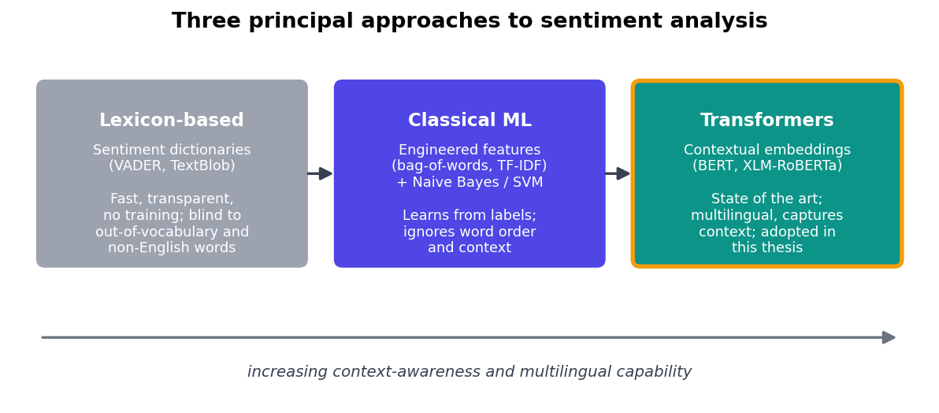
Figure 1. The three principal approaches to sentiment analysis, from lexicon-based methods through classical machine learning to deep-learning transformers, ordered by their growing ability to capture context and handle multilingual text. This thesis adopts the transformer approach and benchmarks it against a lexicon baseline.
Lexicon-based approaches rely on dictionaries that associate words with sentiment scores. The polarity of a text is computed by aggregating the scores of its constituent words, optionally adjusting for negation and intensifiers. Tools such as VADER (Hutto & Gilbert, 2014) and the pattern-based analyzer underlying TextBlob (Loria, 2020) exemplify this approach. Their strengths are speed, transparency, and the absence of any training requirement; their central weakness is that they are only as good as their lexicon. A word absent from the dictionary contributes nothing, so a lexicon built for English is effectively blind to Albanian text, a limitation this thesis quantifies directly in Chapter VI.
Classical machine-learning approaches treat sentiment as a supervised classification problem over engineered features such as bag-of-words or TF-IDF vectors (Ramos, 2003), using classifiers like Naïve Bayes, logistic regression, or support vector machines. These methods improved on lexicons by learning associations from labelled data, but they discard word order and struggle with context, sarcasm, and out-of-vocabulary terms (Medhat, Hassan, & Korashy, 2014).
Deep-learning and transformer approaches represent the current state of the art. Rather than relying on hand-crafted features, they learn contextual representations of language directly from massive corpora. This thesis adopts a transformer model and benchmarks it against a lexicon baseline, mirroring comparative studies such as SentiBench (Ribeiro et al., 2016) and recent surveys (Tan, Lee, & Lim, 2023).

II.2 Transformer Models and Multilingual NLP
The transformer architecture (Vaswani et al., 2017) replaced recurrence with a self-attention mechanism that allows every token in a sequence to attend to every other token, capturing long-range context efficiently and in parallel. BERT (Devlin et al., 2019) demonstrated that a transformer pre-trained on a masked-language-modelling objective could be fine-tuned to achieve state-of-the-art results across many NLP tasks. RoBERTa (Liu et al., 2019) refined the pre-training recipe for stronger performance.
Crucially for this work, XLM-RoBERTa (Conneau et al., 2020) extends RoBERTa to a cross-lingual setting, pre-training a single model on 2.5 TB of filtered CommonCrawl data covering 100 languages, including Albanian. Because the model shares representations across languages, it can classify text in languages for which little or no task-specific labelled data exists. Barbieri, Anke, and Camacho-Collados (2022) released XLM-T, a family of XLM-RoBERTa models further adapted to Twitter-style social-media text and fine-tuned for multilingual sentiment classification. The model employed in this thesis, cardiffnlp/twitter-xlm-roberta-base-sentiment-multilingual, belongs to this family and is specifically suited to short, informal, multilingual comments, exactly the data this system collects.

II.3 Emotion Detection in Text
Whereas sentiment analysis reduces opinion to polarity, emotion detection aims at a richer, categorical description of affect. Two psychological frameworks underpin most computational work: Ekman's (1992) six basic emotions (joy, sadness, anger, fear, surprise, disgust) and Plutchik's (1980) wheel of eight primary emotions arranged in opposing pairs. Lexical resources such as the NRC Emotion Lexicon (Mohammad & Turney, 2013) extended emotion association to thousands of words. Modern systems instead fine-tune transformer classifiers over emotion-labelled corpora. This thesis uses a multilingual transformer emotion classifier covering a fine-grained set of 28 emotion categories, allowing the system to report not only
whether reactions are negative but which negative emotions (anger, contempt, disgust) dominate, a distinction that proves analytically valuable in Chapter VI.

II.4 Opinion Mining and Online Reputation
Aggregating individual opinions into a measure of collective sentiment toward an entity is the core of online reputation management. Cambria et al. (2017) and Liu (2012) frame this as entity-level sentiment aggregation. A recurring methodological question is how to combine many per-item classifications into a single, interpretable indicator while accounting for confidence: a verdict drawn from five comments is far less reliable than one drawn from a thousand. Naïve aggregation (for example, reporting the bare percentage of positive comments) hides this uncertainty and treats a tiny, lopsided sample as if it were as trustworthy as a large, balanced one. A defensible reputation indicator must therefore be accompanied by a confidence measure that grows with both the number of comments and the degree of agreement among them. The reputation-scoring algorithm in Chapter III addresses this explicitly by weighting the aggregate score by both sample size and inter-comment agreement, so that the system communicates not only what the verdict is but how much that verdict can be trusted, an aspect that commercial dashboards frequently omit.

II.5 Sentiment Analysis for Low-Resource Languages
Albanian is a low-resource language in NLP terms: it has comparatively few annotated datasets, lexicons, and dedicated models. Most progress in sentiment analysis has concentrated on high-resource languages (above all English) for which large labelled corpora, mature lexicons, and fine-tuned models are abundant. For low-resource languages, two broad strategies exist. The first is to build language-specific resources from scratch, which is accurate but expensive and slow, requiring substantial annotation effort. The second, and now dominant, strategy is cross-lingual transfer, in which a single multilingual model trained jointly on many languages is applied directly to the low-resource target (Conneau et al., 2020); because the model shares sub-word representations across languages, knowledge learned from high-resource languages partially transfers to those with little data of their own. This thesis is, in effect, a practical case study in cross-lingual transfer for Albanian social-media text. Rather than asserting that the multilingual approach is superior, it measures the gap between a transfer-based transformer and a monolingual English lexicon on the same Albanian comments, providing direct, quantified evidence for why monolingual English tools are inadequate here and why cross-lingual transfer is the pragmatic choice for the Albanian-speaking context.

II.6 Related Tools and Gap Analysis
Commercial social-listening platforms (e.g., Brandwatch, Hootsuite Insights) offer multi-platform monitoring but are proprietary, costly, English-centric in their analytics, and opaque about their methods. Their pricing places them out of reach for individual journalists, students, and small organisations, and their closed analytics make it impossible to inspect or validate how a sentiment verdict was reached, a serious drawback for academic or journalistic use, where method transparency matters. Single-platform open-source scrapers exist for individual sites but solve only the collection problem for one source and provide no analysis, leaving the user to stitch tools together manually. Generic sentiment libraries provide analysis but no collection and, as shown later, fail on Albanian. No existing solution, in short, combines all four of the capabilities this problem requires at once. The gap addressed by this thesis is therefore the absence of a single, open, transparent system that unifies multi-platform collection, multilingual transformer-based analysis, interpretable aggregation, and a real-time user interface, and does so in a way that works on Albanian as well as English.

Chapter III: Methodology

III.1 Research and Development Approach
The project follows an iterative, prototype-driven engineering methodology. Rather than specifying the entire system up front, functionality was built in vertical slices (collect, analyse, score, present), each made to work end-to-end before being broadened. This approach suited a project whose principal risks were external and empirical: whether each platform could be collected from at all, and whether the chosen models would behave acceptably on Albanian text. Early prototypes de-risked these unknowns before effort was invested in the user interface and aggregation logic. The research component is quantitative and comparative: the two sentiment models are evaluated against each other on a real corpus.

III.2 System Requirements

III.2.1 Functional Requirements
The functional requirements describe what the system must do. At the input boundary, the system must accept a free-text query (a person's name or a topic) together with a selection of one or more sources (FR1), and from those sources it must collect both posts and their associated comments across YouTube, Instagram, TikTok, and Facebook (FR2). To make collection precise, the user must be able to choose a search mode, automatic, person/page, or topic/hashtag (FR3), and a time range, spanning the last twenty-four hours, week, month, three months, year, or any time (FR4). These four requirements together define a flexible, user-controlled acquisition stage.
Once comments are gathered, the analytical requirements take over. Each comment must be classified for sentiment by both a transformer model and a lexicon baseline so the two can be compared (FR5), and the emotions expressed in each comment must be detected (FR6). The per-comment results must then be aggregated into a single reputation score together with a percentage breakdown across positive, neutral, and negative classes and a confidence value (FR7), and the system must generate a human-readable narrative summary in the user's chosen language, Albanian or English (FR8). Finally, several interaction and persistence requirements shape the user experience: collection and analysis progress must be streamed to the user in real time (FR9); the user must be able to stop a running analysis at any point (FR10); every report must be persisted and reopenable from a history view (FR11); and the results must be exportable as CSV (FR12).

III.2.2 Non-Functional Requirements
The non-functional requirements describe how well the system must behave and largely drive the architectural decisions of Chapter IV. For performance (NFR1), the sources must be collected concurrently rather than one after another, so that total wait time approaches that of the slowest single source. For responsiveness (NFR2), the interface must remain interactive throughout and continuously show live progress rather than freezing during a minutes-long job. For robustness (NFR3), the failure of any one source (most notably the frequently blocked Facebook collector) must not abort the whole analysis. Multilingual support (NFR4) requires correct handling of both Albanian and English text, which is the central technical motivation of the thesis, while usability (NFR5) requires that the tool be operable by a non-technical user through a fully bilingual interface. Maintainability (NFR6) requires that collectors and analysers sit behind common interfaces so that a source or a model can be replaced in isolation, and thread safety (NFR7) requires that shared, expensive model resources be safe under concurrent access, a requirement whose violation produced a concrete defect described in §V.3.

III.3 Data Sources and Collection Strategy
The system collects from four platforms, each requiring a different technique because each exposes its data differently. Table 1 summarises the strategy per source.
Table 1. Data sources and collection methods.
Source | Library / tool | Strategy
YouTube | yt-dlp (subprocess) | Search videos for the query (plus Albanian variants), then extract up to 100 comments per video.
Instagram | instagrapi | Resolve the person's account or search hashtags, fetch recent posts, then fetch up to 50 comments per post.
TikTok | Playwright + yt-dlp | Render the search page headlessly to extract video IDs, then extract comments via yt-dlp; fall back to YouTube search if blocked.
Facebook | facebook-scraper | Resolve a page slug or hashtags. Constrained by Meta's restrictions (see §III.3.1 and Chapter VII).

Collection is parameterised by search mode (auto, person, or topic) and an optional time range, which is resolved once into a (start, end) window and passed to every collector; YouTube and TikTok additionally pass --dateafter/--datebefore flags to yt-dlp, while Instagram and Facebook filter post timestamps in code. Each collector returns a uniform structure of posts and comments, isolating the rest of the pipeline from platform-specific details.
To meet NFR1, the collectors run in parallel. A thread pool dispatches one worker per selected source, and results are merged as each worker finishes, so the total collection time approaches that of the slowest single source rather than the sum of all of them. Figure 2 illustrates this fan-out.
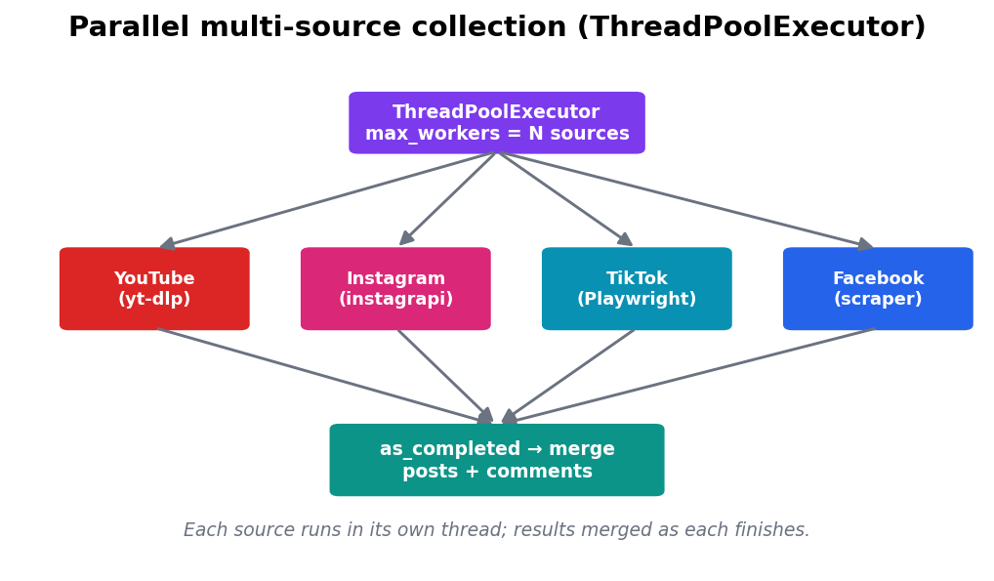
Figure 2. Parallel multi-source collection using a thread pool. Each source runs in its own worker thread; results are merged as each one completes.

III.3.1 The Facebook Constraint
Facebook deserves explicit methodological note. The open-source facebook-scraper library operates by parsing the legacy mobile web site m.facebook.com. Meta has since deprecated that endpoint: it now redirects to a JavaScript-rendered application and returns an HTTP 400 "Error" page to logged-out requests. Consequently the library receives an unparseable page, yields no posts, and raises no exception. This is an external platform restriction, not a defect in the system; it is reported transparently to the user as a failed source and revisited in the limitations of Chapter VII.

III.4 Data Preprocessing
Raw social-media comments are among the noisiest forms of natural-language data: they contain URLs, mentions, hashtags, emojis, markup fragments, repeated punctuation, and frequent code-switching between Albanian and English within a single sentence. Before analysis, each comment therefore passes through a cleaning pipeline that removes URLs, e-mail addresses, and @-mentions; converts #hashtags to plain words so that a tag such as #mirupafshim still contributes its lexical content; strips HTML tags and stray special characters; and normalises whitespace. The order of these steps matters: mentions and URLs are removed before special characters are stripped, so that the @ and / symbols do not leave orphaned tokens behind.
A deliberate design choice is that cleaning is conservative: it does not lower-case aggressively, remove diacritics, or correct spelling. This is important for the multilingual transformer, which was pre-trained on natural text and whose sub-word tokenizer benefits from the original casing and Albanian diacritics (ë, ç) rather than a stripped-down form. A comment is retained only if it is meaningful (defined as containing at least three words after cleaning), which discards empty reactions, single emojis, and one-word noise such as "❤️" or "ok" that would distort the aggregate without contributing genuine opinion. This minimum-length filter is a simple but effective quality gate: it raises the signal-to-noise ratio of the corpus while remaining language-agnostic, applying identically to Albanian and English text and thereby avoiding any bias that a language-specific stop-word list might introduce into the controlled comparison of Chapter VI.

III.5 Sentiment Analysis Models
The system computes sentiment with two models in parallel so that a modern transformer can be compared against a classical baseline (RQ2).
Transformer (primary). The model cardiffnlp/twitter-xlm-roberta-base-sentiment-multilingual (Barbieri et al., 2022) classifies each comment as positive, neutral, or negative and returns a probability for each class. This particular checkpoint was chosen for three reasons. First, it is built on XLM-RoBERTa (Conneau et al., 2020), whose pre-training corpus covers one hundred languages including Albanian, so it has genuine lexical and syntactic knowledge of the target language rather than relying on translation. Second, it was fine-tuned specifically on Twitter-style data, which closely resembles the short, informal, emoji-laden register of the comments this system collects. Third, returning a full probability distribution rather than a bare label allows the confidence of each prediction to flow into the downstream reputation score. Because the model accepts at most 512 tokens, long comments are split into chunks of 500 tokens and the per-class probabilities are averaged across chunks, which keeps even unusually long comments analysable without truncation. The model's labels are normalised to a canonical lower-case {positive, neutral, negative} vocabulary so that the rest of the pipeline is independent of the model's raw output format.
Baseline (TextBlob). As a comparison point, the lexicon-based TextBlob analyzer (Loria, 2020) computes a polarity value in [−1, 1], mapped to a label by thresholds (> 0.1 positive, < −0.1 negative, otherwise neutral) and to a comparable three-class score distribution. The purpose of this baseline is not to be competitive but to be representative: TextBlob is one of the most widely used off-the-shelf sentiment libraries in teaching, prototyping, and applied projects, precisely the kind of tool a practitioner might naïvely reach for. It is deliberately English-centric, so contrasting it against the transformer on the same comments isolates the effect of language and yields the controlled experiment that answers RQ2 in Chapter VI. Running both models on every comment, rather than only sampling, means the comparison rests on the full corpus and not on a convenience subset.

III.6 Emotion Detection
In parallel with polarity, each comment is passed to the multilingual transformer emotion classifier tabularisai/multilingual-emotion-classification, which scores a fine-grained set of 28 emotions (joy, sadness, anger, fear, surprise, disgust, contempt, love, gratitude, frustration, and others). This catalogue extends the small, classic inventories of Ekman (1992) and Plutchik (1980) into the finer categories that social-media reactions actually exhibit, where the analytically useful distinction is often which negative emotion dominates (cold contempt, hot anger, or disappointment) rather than mere negativity. Emotion detection is treated as a multi-label problem because a single comment can legitimately express more than one feeling: emotions scoring at least 0.15 are kept, each annotated with an icon and an Albanian label for display, and if none clears the threshold the comment defaults to neutral. The 0.15 cut-off was chosen empirically as a balance between recall and precision, low enough to surface secondary emotions in mixed comments, but high enough to suppress the long tail of near-zero scores the classifier assigns to every class. Storing the surviving emotions as JSON alongside the sentiment result means the affective breakdown can later be rendered, filtered, or aggregated without re-running the model.

III.7 Reputation Scoring Algorithm
The per-comment transformer results are aggregated into a ReputationScore by the algorithm below. Let N be the number of analysed comments. Each comment contributes its transformer confidence with a sign: +score if positive, −score if negative, and 0 if neutral. The mean of these signed contributions lies in [−1, 1] and is rescaled to a 0–100 overall score:
overall_score = clamp( (mean_signed + 1) / 2 * 100 , 0, 100 )

The percentage breakdown is simply the share of comments in each class. A confidence value combines sample size and agreement:
sample_confidence = min(1.0, N / 30) # saturates at 30 comments
agreement_factor = 0.5 + 0.5 * dominant_share # 0.5 .. 1.0
confidence = sample_confidence * agreement_factor

This makes the confidence honest: a verdict from very few comments, or one drawn from a badly split distribution, is reported as less confident. The design deliberately weights each comment's contribution by the transformer's own confidence rather than treating every comment as an equal vote; this means that a comment the model is sure is strongly negative moves the score more than one it labels negative only weakly, which better reflects the strength of opinion in the corpus and dampens the influence of borderline cases. Neutral comments contribute zero rather than pulling the score toward the midpoint, so a subject discussed in largely neutral terms is not artificially rated "average" but simply produces a lower-confidence result. Finally, the overall score is mapped to a qualitative summary (≥ 70 predominantly positive; ≥ 55 slightly positive; ≥ 45 mostly neutral; ≥ 30 slightly negative; otherwise predominantly negative), giving a non-technical reader an immediate, words-based interpretation of the numeric score.

III.8 AI Narrative Generation
To make the numbers interpretable, the system generates a structured narrative. Comments are grouped by sentiment and by primary emotion; recurring content words are extracted (excluding Albanian and English stop-words) to surface themes; the most confident positive and negative comments are selected as representative quotations; and comments expressing controversial emotions (anger, contempt, disgust, frustration, disapproval, annoyance) or sarcasm (contempt) are highlighted. These elements are assembled into a multi-section Markdown report in the user's chosen language. The full pipeline from query to stored report is shown in Figure 3.
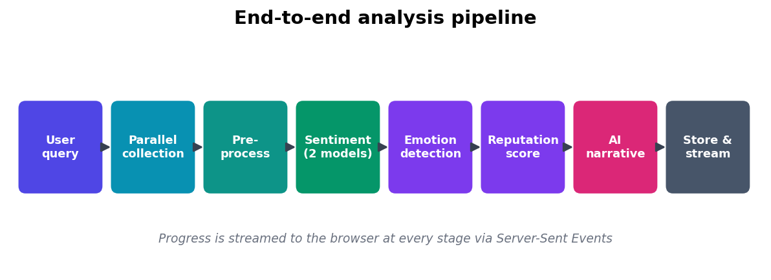
Figure 3. The end-to-end analysis pipeline, from user query to stored, streamed report.

III.9 Evaluation Metrics
Because no gold-standard Albanian sentiment labels were available for this corpus, evaluation is comparative and descriptive rather than against ground truth. The principal metric is the inter-model agreement rate between the transformer and the baseline (the proportion of comments on which they assign the same label), accompanied by a full 3×3 confusion matrix that reveals the structure of their disagreement. The central evaluation is a controlled comparison: the dataset is split into an Albanian subset (20 Albanian public figures collected in Albanian mode) and an international subset (51 global figures collected in English mode), and the agreement rate and "neutral-collapse" rate are measured on each. Because the models and pipeline are identical and only the comment language differs, any systematic gap between the two subsets is attributable to language. Supporting descriptive statistics include the sentiment-class distribution, per-source comment yields, the emotion-frequency distribution, and the distribution of reputation scores across reports.

III.10 Ethical Considerations
The system collects only publicly visible comments and operates strictly read-only. No private messages or non-public data are accessed, and no personal data beyond the public author handle attached to a public comment is stored. This reflects the principle of data minimisation: the system retains only what is strictly necessary for aggregate analysis, and the analytical output is statistical (distributions, scores, and representative quotations) rather than a dossier on any individual commenter. The tool is intended for legitimate analytical purposes (research, journalism, brand monitoring) and not for harassment or profiling of private individuals. Because the subjects analysed are public figures and topics, and because reactions are aggregated rather than attributed, the analysis aligns with the expectation that public discourse about public figures may be studied in aggregate while the privacy of ordinary commenters is respected. Two further points are treated honestly elsewhere in the thesis: collection must respect platform Terms of Service (motivating the decision not to pursue authenticated Facebook scraping, Chapter VII), and online comments are a self-selected, non-representative sample, so reputation scores are explicitly framed as indicators of online sentiment rather than of true public opinion.

Chapter IV: System Design and Architecture

IV.1 System Architecture Overview
The application follows a classic client-server design with a clear separation between a React single-page frontend and a Python backend, communicating over HTTP and Server-Sent Events. The backend itself is layered: an API layer (FastAPI routes), a service layer (orchestration of collection and analysis), a collector layer (one module per platform), an analysis layer (sentiment, emotion, scoring, narrative), and a storage layer (SQLite). Figure 4 shows the high-level structure.
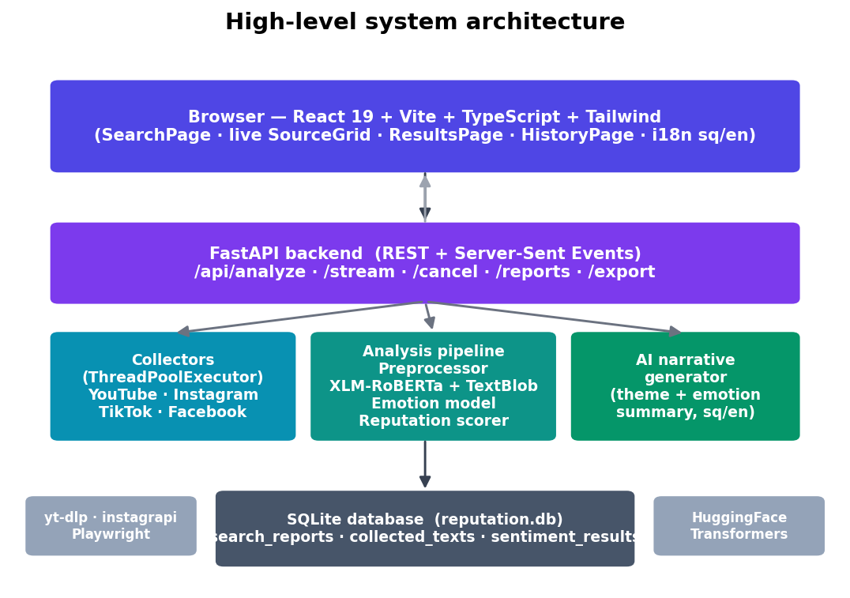
Figure 4. High-level system architecture of the AI Reputation Analyzer.
This layering directly serves the maintainability requirement (NFR6): every collector implements a common interface and every analyser is a self-contained module, so a source or a model can be added or replaced without disturbing the rest of the system.

IV.2 Technology Stack
The technology stack was chosen to be modern, open-source, and well matched to the system's requirements. The frontend is a single-page application written in React 19 with Vite, TypeScript, and Tailwind CSS, giving a fast, type-safe, component-based interface with a modern build pipeline; internationalisation is handled by react-i18next, which provides runtime switching between Albanian and English and thereby satisfies the multilingual and usability requirements (NFR4, NFR5). The backend is built on FastAPI, an asynchronous Python framework with native streaming support, and live updates are pushed to the browser through sse-starlette, a lightweight Server-Sent-Events implementation chosen over WebSockets because the application only needs one-way server-to-client streaming, for which SSE is simpler and more robust.
The analysis layer rests on the Hugging Face Transformers library: the primary sentiment model is the XLM-RoBERTa multilingual transformer, the baseline is the TextBlob lexicon analyzer kept deliberately as a transparent point of comparison, and emotion is detected by a separate multilingual 28-class transformer. Collection uses the best-available open tool for each platform (yt-dlp for YouTube, instagrapi for Instagram, Playwright together with yt-dlp for TikTok, and facebook-scraper for Facebook), unified behind a common collector interface. Finally, concurrency is provided by Python's concurrent.futures.ThreadPoolExecutor, which parallelises the I/O-bound collection work (NFR1), and storage uses SQLite, a zero-configuration embedded relational database that keeps the whole system self-contained and easy to deploy.

IV.3 Backend Design
A single analysis request flows as follows. The client issues POST /api/analyze; the backend registers a task, launches run_analysis on a background executor thread, and immediately returns a report_id. The client then opens an EventSource to GET /api/analyze/{id}/stream and receives a stream of progress events until a terminal event arrives. This design keeps the HTTP request short and non-blocking while a potentially minutes-long job runs in the background, satisfying the responsiveness requirement (NFR2).

IV.4 Concurrency Model and Thread Safety
Concurrency appears at two levels. First, collection fans out across a ThreadPoolExecutor with one worker per source. Second, the analysis loop shares a single, expensive transformer pipeline across requests. The latter introduced a real defect during development: the Rust-backed Hugging Face tokenizer is not re-entrant, and concurrent access raised a RuntimeError: Already borrowed. The fix was to guard the tokenizer and pipeline calls with a threading.Lock, serialising inference on the shared model while leaving the independent collectors fully parallel. This is discussed further in §V.3.

IV.5 Database Design
Results are persisted in three related SQLite tables, shown in Figure 5. A search_reports row holds the aggregate result of one analysis (query, scores, percentages, confidence, narrative, and the collected posts as JSON). Each report has many collected_texts (the individual comments), and each text has many sentiment_results, one per model (transformer and TextBlob), with the transformer row additionally storing the detected emotions as JSON.
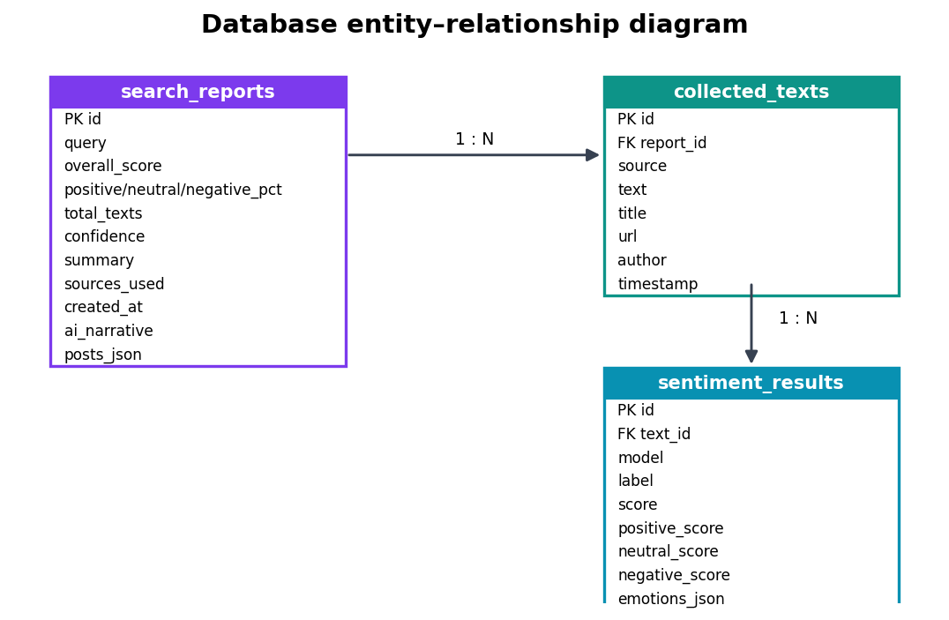
Figure 5. Database entity-relationship diagram (one report → many texts → many sentiment results).

IV.6 Frontend Design
The frontend comprises three main views (a Search page, a Results page, and a History page) wrapped in a shared analysis context so that a running analysis survives navigation between them. A floating global progress bar and a live source grid present the state of each collector. The interface is fully bilingual through react-i18next, with all strings drawn from Albanian and English translation files.

IV.7 API and SSE Event Protocol
The backend exposes a small REST surface (/api/analyze, /api/analyze/{id}/stream, /api/analyze/{id}/cancel, /api/reports, /api/export) and a streaming protocol of typed events that drives the live interface; the temporal sequence of these events is shown in Figure 6.
The streaming protocol consists of seven event types. A collecting_start event, carrying the list of {key, label} sources, announces that collection has begun. As each collector finishes, the backend emits either a source_done event (reporting the source name, the comment and post counts, and the overall percent complete) or a source_error event carrying the source name and the error, which is exactly how a blocked Facebook source surfaces to the user without aborting the run. A general progress event (stage, percent, message, and optional current/total counts) reports fine-grained advancement within a stage, such as analysing comment 400 of 1,200. The run ends with one of three terminal events: cancelled (with a message) when the user stops the analysis, error (with a message) on a fatal condition such as no meaningful comments being found, or complete carrying the report_id once the results are stored and ready to display.
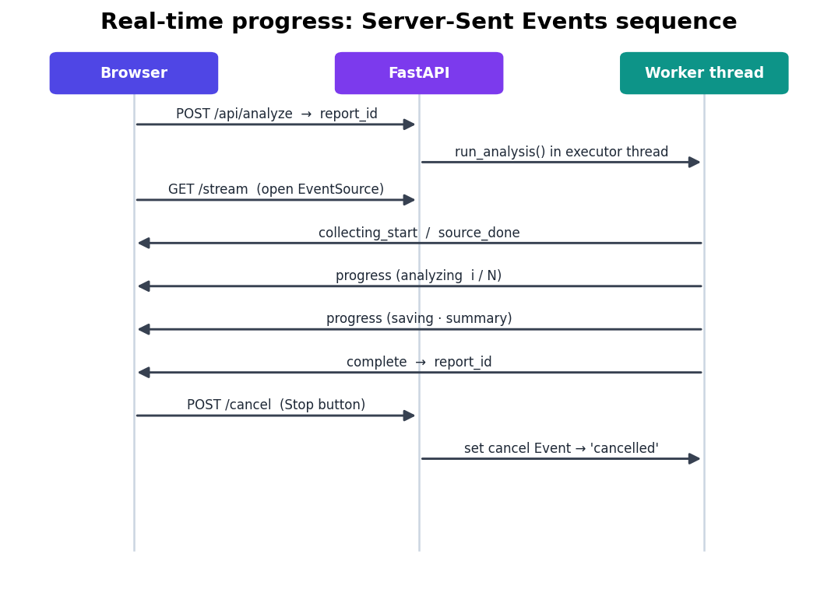
Figure 6. Sequence of Server-Sent Events between the browser, the API, and the worker thread, including cancellation.

Chapter V: Implementation

V.1 Development Environment
The backend is written in Python and the frontend in TypeScript. Development used a local FastAPI server (Uvicorn on port 8000) and the Vite dev server (port 5173) with an API proxy. Dependencies are pinned in requirements.txt (backend) and package.json (frontend). The codebase is organised into api/ (routes, schemas, services), app/ (collectors, analysis, storage), and frontend/src/ (pages, components, context, i18n).

V.2 Parallel Multi-Source Collection
The service layer maps each selected source to its collector and dispatches them concurrently. The essential structure is shown in Listing 1.
with ThreadPoolExecutor(max_workers=total_sources) as ex:
futures = {ex.submit(_collect_one, s, query, max_results, start, end, mode): s
for s in valid_sources}
for future in as_completed(futures):
label, posts, comments = future.result()
all_posts.extend(posts)
all_comments.extend(comments)
_push(queue, loop, "source_done", source=label,
count=len(comments), posts=len(posts), percent=pct)

Listing 1. Parallel dispatch of the per-source collectors with a thread pool.
The code works as follows. A ThreadPoolExecutor is opened with one worker per selected source, and ex.submit schedules each source's _collect_one call, returning a future, a handle to a result that will exist later. The dictionary comprehension maps every future back to its source so the source can be identified when the future completes. The key line is the for loop over as_completed(futures): rather than waiting for the collectors in submission order, it yields each future the instant that collector finishes, so the fastest source is reported first and the slowest does not hold up the rest. Each completed future's posts and comments are merged into the running totals, and a source_done event is pushed to the live stream. Because each _collect_one wraps its own collection in a try/except, a single source raising an exception is caught and reported as source_error without aborting the others, directly satisfying the robustness requirement (NFR3).

V.3 Sentiment Pipeline and the Concurrency Fix
The transformer pipeline is loaded once and reused. Token-aware chunking handles long comments, and a module-level lock makes inference thread-safe, as shown in Listing 2.
_lock = threading.Lock()

def analyze(text: str) -> dict:
cleaned = clean_text(text)
with _lock: # tokenizer is not re-entrant
chunks = _chunk_by_tokens(cleaned, MAX_TOKENS)
scores = [pipe(chunk) for chunk in chunks]
# average per-class probabilities across chunks ...

Listing 2. Thread-safe transformer inference using a module-level lock.
The function first cleans the text, then enters the with _lock block before touching the model. _lock is a single module-level threading.Lock, so only one thread can be inside the block at a time; the others wait. Inside the protected region the comment is split into token-bounded chunks by _chunk_by_tokens and each chunk is scored by the shared pipeline pipe, after which the per-class probabilities are averaged (outside the lock) to yield the comment's final distribution. The lock is necessary because the underlying Rust-backed Hugging Face tokenizer is not re-entrant: without it, the application crashed intermittently with RuntimeError: Already borrowed whenever two comments were tokenised at once on the shared model. Serialising only the inference call (and not the surrounding collection) resolves the defect while preserving the collector-level parallelism of Listing 1, because collection and inference are separate phases that do not contend for the same resource.

V.4 Emotion Detection Implementation
The emotion classifier is invoked per comment, its raw scores filtered at the 0.15 threshold, and each surviving emotion enriched with a display icon and an Albanian label. The result is serialised to JSON and stored alongside the transformer sentiment row, so emotions can later be rendered without re-running the model.

V.5 Reputation Scoring Implementation
The scorer iterates once over the transformer results, accumulating class counts and the signed-confidence sum, then applies the formulas of §III.7 to produce the overall score, percentage breakdown, confidence, and qualitative summary, all collected into a single dataclass that is persisted to search_reports.

V.6 Real-Time Progress and Cancellation
Progress events are pushed from the worker thread onto an asyncio queue using loop.call_soon_threadsafe, and the SSE endpoint drains that queue to the browser. Each task is associated with a threading.Event; the Stop button issues POST /cancel, which sets the event. The worker checks the event at natural checkpoints (before collection, after collection, and on every comment during analysis) and exits cleanly with a cancelled event when it is set. This gives the user responsive control over long-running jobs (FR10).

V.7 Frontend Implementation
The Search page lets the user enter a query, toggle sources, choose a search mode, and pick a time range (Figure 13, Appendix B). On submission it opens the SSE stream through a shared React context. A live source grid renders one card per collector, transitioning from a running spinner to a success or failure state as source_done/source_error events arrive, making the parallel collection visible to the user (Figure 14, Appendix B). When the complete event arrives, the app navigates to the Results page, which renders the reputation score, the sentiment and emotion distributions, the AI narrative, the model comparison, and a filterable table of individual comments. To keep the body of the thesis focused on the system's design and findings, the interface screenshots are collected together in Appendix B.

Chapter VI: Results and Analysis

VI.1 Experimental Setup and Dataset
To evaluate the system, a dataset was collected systematically over 71 public figures: 51 international figures (politicians, athletes, musicians, actors, and entrepreneurs) queried in English mode, and 20 Albanian public figures (politicians and musicians) queried in Albanian mode. Together with earlier reports retained in the database, this yields the corpus summarised in Table 2. All figures and statistics in this chapter are computed directly from the system's own SQLite database; no values are synthetic.
Table 2. Dataset summary (from `reputation.db`).
Quantity | Value
Stored reports | 84
Analysed comments (collected_texts) | 26,109
Sentiment results (2 models × comments) | 40,952
International figures (English mode) | 51
Albanian figures (Albanian mode) | 20
Collection sources used for the dataset | YouTube, TikTok

The systematic dataset was collected from YouTube and TikTok only. Instagram, although the richest source in earlier ad-hoc testing, was deliberately excluded from large-scale batch collection: it requires an authenticated personal account, and issuing dozens of automated requests through a single login risks the account being rate-limited or banned (see §VII.3). YouTube and TikTok require no login and therefore carry no such risk.

VI.2 Collection Performance and Per-Source Yield
Figure 7 shows the number of comments collected per source across the whole database. YouTube is the most productive source, followed by TikTok; Instagram and the small legacy sources reflect earlier testing. The parallel collection strategy (§V.2) means total wall-clock collection time is governed by the slowest source rather than the sum of all sources, turning a sequence of minute-scale waits into a single one.
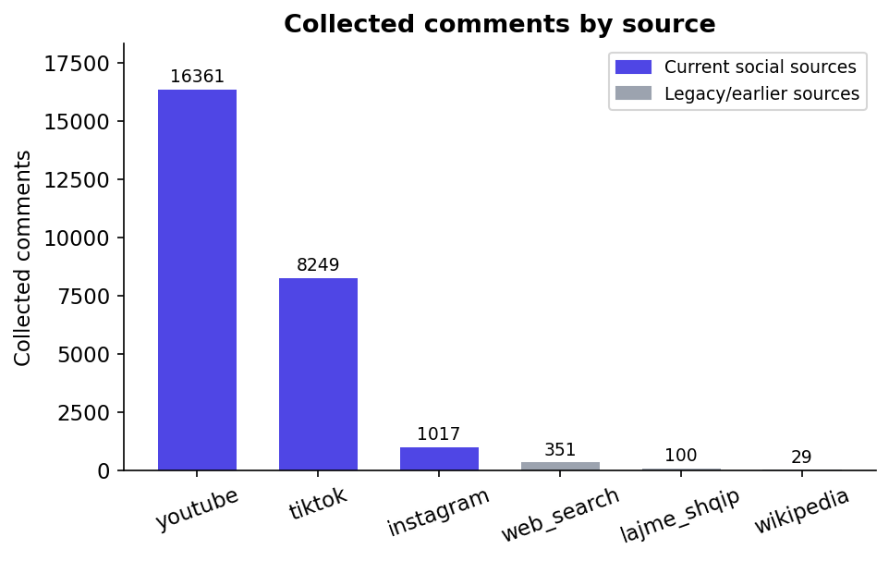
Figure 7. Collected comments by source across the database. Current social sources are highlighted; smaller bars correspond to earlier/legacy sources.

VI.3 Sentiment Distribution
Across the analysed comments, the transformer assigns the distribution shown in Figure 8: roughly balanced between negative (9,267), positive (8,790), and neutral (8,052). This balance is a direct consequence of the deliberately diverse subject set, which spans universally admired figures (e.g. Tom Cruise, Roger Federer, Dhurata Dora) and highly polarising ones (e.g. Donald Trump, Vladimir Putin, Ilir Meta), and contrasts sharply with the negative skew that single-subject political datasets typically exhibit.
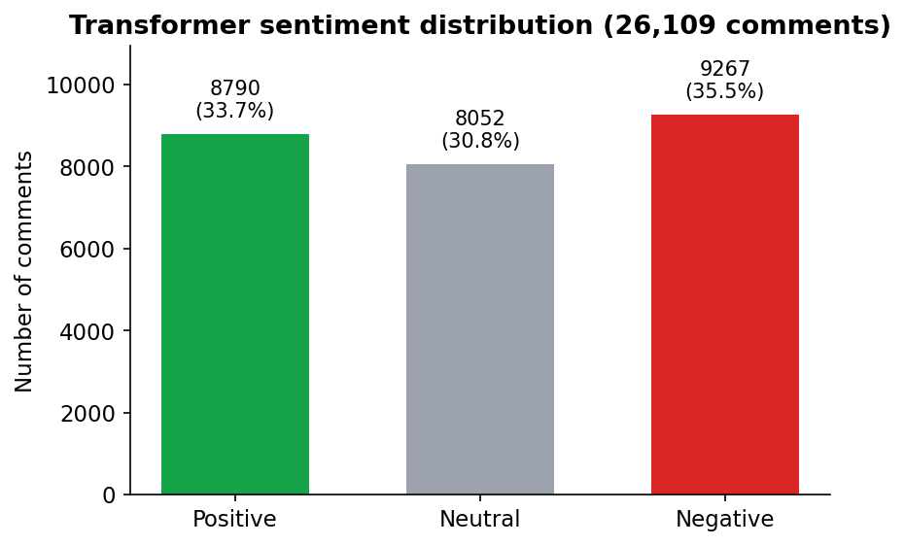
Figure 8. Sentiment distribution assigned by the XLM-RoBERTa transformer across all analysed comments.

VI.4 The Central Result: A Controlled Albanian vs. International Comparison
The core empirical result of this thesis (RQ2) is a controlled comparison of the transformer against the lexicon baseline. The pipeline, models, and parameters are held constant; the only variable is the language of the comments. The dataset's two subsets, Albanian (the 20 Albanian figures, n = 5,633 paired comments) and international (the 51 global figures, n = 17,689), are compared on two measures: how often the two models agree, and how often TextBlob falls back to "neutral". The result is shown in Figure 9 and Table 3.
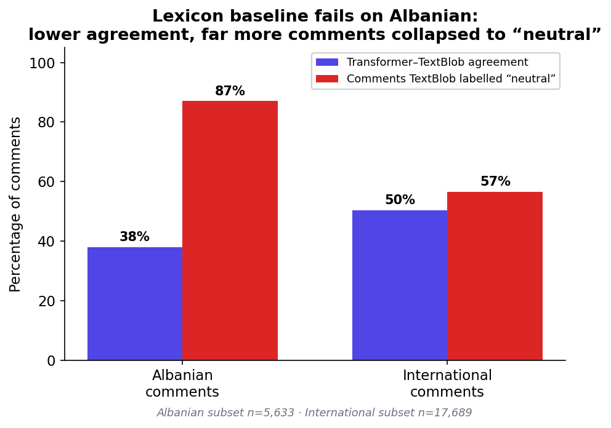
Figure 9. The central finding: on Albanian comments the lexicon baseline agrees with the transformer far less often and collapses far more comments to "neutral" than on international comments. Only the language differs between the two groups.
Table 3. Controlled language comparison (only the comment language differs).
Measure | Albanian subset | International subset
Transformer-TextBlob agreement | 38.0 % | 50.4 %
Comments TextBlob labelled "neutral" | 87 % | 57 %
Transformer-negative comments TextBlob called neutral | 1,919 | 3,249

The pattern is unambiguous. On Albanian text the lexicon baseline's agreement with the transformer falls by over twelve percentage points, and it labels 87 % of all Albanian comments "neutral", almost nine in ten. The explanation is structural, not incidental: TextBlob's lexicon is English, so Albanian words, including the very words that carry sentiment, are absent, contribute zero polarity, push the text score toward zero, and are labelled neutral by default. The lexicon baseline is, in effect, blind to Albanian sentiment, and the controlled design isolates language as the cause: the same baseline performs visibly better on the same pipeline when the comments are English.
This is precisely the evidence sought by RQ2, and it is far stronger than a single agreement number could be. It demonstrates, on tens of thousands of real comments and as a controlled experiment, that a lexicon tool built for English is unfit for Albanian social-media analysis, and that a multilingual transformer is not a convenience but a necessity for this task.
The structure of the disagreement across the whole dataset is summarised in the confusion matrix of Figure 10 (overall agreement 46.9 %), which shows the same signature: a heavy concentration of comments in the "TextBlob = neutral" column regardless of the transformer's verdict.
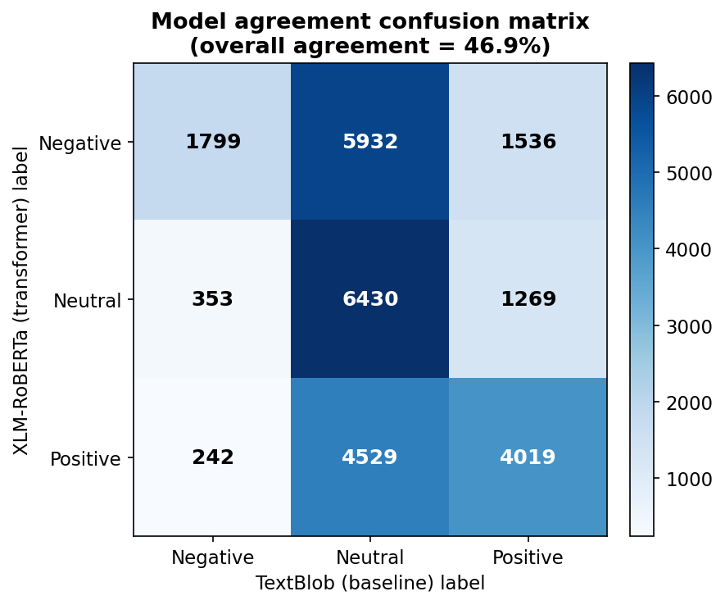
Figure 10. Confusion matrix of transformer (rows) versus TextBlob (columns) labels across the whole dataset. The dominant "TextBlob = neutral" column is the baseline's neutral-collapse failure mode.
It is worth explaining why the lexicon baseline behaves this way, since the neutral column is the single most important feature of the matrix. TextBlob computes the polarity of a sentence as an aggregate of the polarity scores its English lexicon assigns to the individual words; words that are not in the lexicon contribute exactly zero. Albanian comments are, from the lexicon's point of view, almost entirely out-of-vocabulary, and, crucially, the very words that carry the sentiment (i shkëlqyer, i tmerrshëm, mashtrues) are precisely the ones absent from an English dictionary. Informal spellings, slang, and emoji compound the problem even in English comments. With most or all tokens scoring zero, the averaged polarity is dragged toward 0.0, and because the labelling rule maps any value in the band (−0.1, 0.1) to "neutral", the comment is classified neutral by default rather than by genuine judgement. This is not random error but a
systematic failure mode: the baseline is not mildly inaccurate on Albanian, it is structurally blind to it, which is why the neutral column is so dominant and why it grows from 57 % of comments on English text to 87 % on Albanian. A transformer avoids this trap because it represents words as contextual sub-word embeddings learned from Albanian text during pre-training, so it still "sees" sentiment even in words no dictionary lists.

VI.5 Emotion Analysis
Beyond polarity, the emotion classifier reveals which affects drive the reactions. Figure 11 shows the most frequent primary emotions. After neutral, the leading emotion is love (3,419 comments), followed closely by contempt (2,947) and anger (2,729), then joy (1,767). The near-balance of love against contempt and anger mirrors the balanced polarity distribution and reflects the dataset's mix of adored and reviled figures; it also shows the value of emotion detection over polarity alone, distinguishing warm admiration (love, joy) from high-arousal hostility (contempt, anger) that a three-class sentiment label would merge.
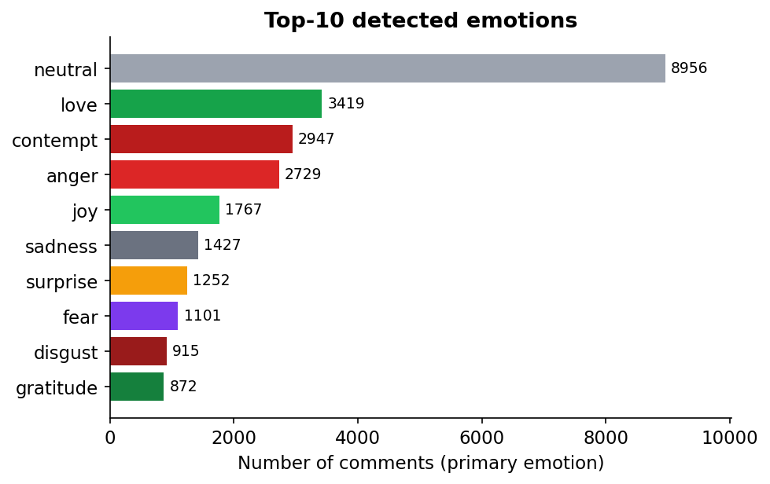
Figure 11. The most frequently detected primary emotions across the corpus.

VI.6 Case Study: Discriminating Loved from Reviled, in Both Languages
A good reputation tool must separate admired figures from disliked ones, and do so in both languages. Table 4 contrasts the highest- and lowest-scoring figures in each subset. The system cleanly distinguishes them: beloved entertainers and athletes score near 70 with positive shares around 60 %, while polarising politicians score in the 20s with negative shares around 70 %, and the separation is just as sharp for the Albanian figures as for the international ones, despite Albanian being the harder, lower-resource language.
Table 4. Most-liked vs. most-disliked figures in each language subset.
Subject | Language | Comments | Score | Pos/Neu/Neg %
Tom Cruise | International | 151 | 69.8 | 57 / 28 / 15
Donald Trump | International | 432 | 22.4 | 12 / 17 / 71
Dhurata Dora | Albanian | 310 | 70.1 | 61 / 24 / 15
Ilir Meta | Albanian | 201 | 27.4 | 11 / 20 / 69

The reputation-score distribution across all 84 reports (Figure 12) is correspondingly broad, spanning the full range from the low 20s to around 70 rather than clustering at one end, a direct reflection of the diverse subject set and evidence that the score is discriminative rather than uniformly pessimistic.
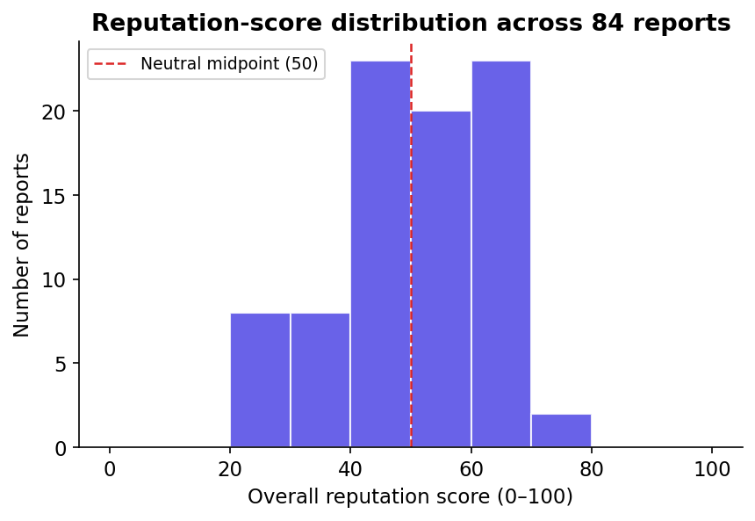
Figure 12. Distribution of overall reputation scores across all 84 stored reports.
The Results dashboard presents these outputs to the user as an at-a-glance score, charts, and the generated narrative; the corresponding interface screenshots are shown in Appendix B (Figures 15 and 16).

VI.7 Discussion of Findings
The results answer the research questions directly. RQ1 is satisfied: comments were collected automatically and at scale (26,109 across multiple platforms and 71 subjects) within one unified pipeline. RQ2 is answered decisively in favour of the transformer: the controlled comparison shows the lexicon baseline's agreement dropping from 50.4 % to 38.0 % and its neutral-collapse rising from 57 % to 87 % purely as a function of switching to Albanian. RQ3 is satisfied by the reputation-scoring algorithm, whose scores are discriminative across a wide range and whose confidence values behave sensibly (rising with sample size and agreement). RQ4 is satisfied by the live, bilingual web interface.
Several threats to validity deserve explicit acknowledgement so that the findings are not over-claimed. The most important is the absence of human-labelled ground truth: because no gold-standard Albanian sentiment annotations were available for this corpus, the evaluation is comparative (transformer versus lexicon) rather than absolute, and it cannot state the transformer's raw accuracy in percentage-correct terms. What the controlled design can establish is a relative, causal claim: holding the pipeline, models, and parameters fixed and varying only language, the lexicon's behaviour degrades sharply, and language is therefore the cause. A second consideration is that the agreement rate is a symmetric measure of concordance, not of correctness; in principle two models could agree and both be wrong. This risk is mitigated by the structure revealed in the confusion matrix, which shows that the disagreement is not random but concentrated in exactly the neutral-collapse pattern predicted by the lexicon's English vocabulary, a qualitative signature consistent with the transformer, not the baseline, being right. A third consideration is sampling: comments were drawn from YouTube and TikTok and from a particular set of public figures, so the absolute class balance reflects that selection. The controlled comparison is robust to this because both language subsets are drawn the same way; only the conclusions about overall sentiment levels, not about the model gap, would be affected. These threats are revisited as concrete limitations in §VII.3.

Chapter VII: Conclusions and Future Work

VII.1 Summary
This thesis designed, implemented, and evaluated the AI Reputation Analyzer, a full-stack system that collects social-media comments about a person or topic across four platforms, analyses them with a multilingual transformer and a lexicon baseline plus a fine-grained emotion classifier, aggregates the results into an interpretable reputation score, and presents everything through a real-time bilingual web interface. The system was validated on a real corpus of 26,109 comments across 84 reports, spanning 51 international and 20 Albanian public figures.

VII.2 Contributions
The work makes three contributions. First, a reproducible reference architecture for real-time, multi-source, multilingual reputation analysis built entirely from open-source components, including a parallel-collection design and a Server-Sent-Events progress protocol. Second, a controlled empirical demonstration (on tens of thousands of real comments) that a multilingual transformer substantially and structurally outperforms a lexicon baseline on Albanian, quantified by the agreement rate falling from 50.4 % on international comments to 38.0 % on Albanian and the baseline's neutral-collapse rising from 57 % to 87 %, with language isolated as the cause. Third, a reputation-scoring formulation that pairs an aggregate polarity score with an explicit, sample- and agreement-aware confidence measure.

VII.3 Limitations
Several limitations are acknowledged candidly. (1) Facebook collection is unreliable because Meta has closed the anonymous endpoint that open-source scrapers depend on; the system reports this as a failed source rather than concealing it. (2) No human-labelled ground truth was available for the Albanian corpus, so evaluation is comparative rather than absolute. (3) The Instagram collector's minimum-follower filter was set to zero during testing to permit small-account validation and must be restored to its production threshold before deployment. (4) Instagram was excluded from large-scale collection to protect the single personal account from rate-limiting or bans, so the systematic dataset draws on YouTube and TikTok only; a production system would need official APIs or a pool of authorised accounts to add Instagram safely at scale. (5) Online comments are self-selected and not representative of the general public, so reputation scores measure online sentiment, not true public opinion. (6) Collection is subject to platform Terms of Service and rate limits, which constrain volume and longevity.

VII.4 Future Work
Future work could establish a human-annotated Albanian sentiment benchmark to enable absolute accuracy measurement and possible fine-tuning of the transformer on local data; add an official, authorised data source for Facebook (e.g., the Graph API for owned pages) rather than scraping; introduce sarcasm and irony detection, which remain difficult for current models; extend the system with topic clustering and time-series tracking so reputation can be followed as it evolves; and harden the deployment with caching, authentication, and rate-limit management for production use.

VII.5 Final Remarks
The AI Reputation Analyzer shows that a capable, transparent, multilingual reputation-analysis tool can be assembled from open components and made usable by non-technical users. Its most important lesson is empirical and cautionary: the choice of model is not a formality. On Albanian social-media text, the difference between a lexicon baseline and a multilingual transformer is the difference between a tool that is effectively blind and one that can see.

References
Barbieri, F., Anke, L. E., & Camacho-Collados, J. (2022). XLM-T: Multilingual language models in Twitter for sentiment analysis and beyond. Proceedings of the 13th Language Resources and Evaluation Conference (LREC), 258–266.
Bird, S., Klein, E., & Loper, E. (2009). Natural language processing with Python. O'Reilly Media.
Cambria, E., Das, D., Bandyopadhyay, S., & Feraco, A. (Eds.). (2017). A practical guide to sentiment analysis. Springer. https://doi.org/10.1007/978-3-319-55394-8
Conneau, A., Khandelwal, K., Goyal, N., Chaudhary, V., Wenzek, G., Guzmán, F., Grave, E., Ott, M., Zettlemoyer, L., & Stoyanov, V. (2020). Unsupervised cross-lingual representation learning at scale. Proceedings of the 58th Annual Meeting of the Association for Computational Linguistics (ACL), 8440–8451. https://doi.org/10.18653/v1/2020.acl-main.747
Devlin, J., Chang, M.-W., Lee, K., & Toutanova, K. (2019). BERT: Pre-training of deep bidirectional transformers for language understanding. Proceedings of NAACL-HLT 2019, 4171–4186. https://doi.org/10.18653/v1/N19-1423
Ekman, P. (1992). An argument for basic emotions. Cognition and Emotion, 6(3–4), 169–200. https://doi.org/10.1080/02699939208411068
Hutto, C. J., & Gilbert, E. (2014). VADER: A parsimonious rule-based model for sentiment analysis of social media text. Proceedings of the International AAAI Conference on Web and Social Media, 8(1), 216–225.
Liu, B. (2012). Sentiment analysis and opinion mining. Morgan & Claypool Publishers. https://doi.org/10.2200/S00416ED1V01Y201204HLT016
Liu, Y., Ott, M., Goyal, N., Du, J., Joshi, M., Chen, D., Levy, O., Lewis, M., Zettlemoyer, L., & Stoyanov, V. (2019). RoBERTa: A robustly optimized BERT pretraining approach. arXiv preprint arXiv:1907.11692. https://arxiv.org/abs/1907.11692
Loria, S. (2020). TextBlob: Simplified text processing (Version 0.17) [Computer software]. https://textblob.readthedocs.io/
Medhat, W., Hassan, A., & Korashy, H. (2014). Sentiment analysis algorithms and applications: A survey. Ain Shams Engineering Journal, 5(4), 1093–1113. https://doi.org/10.1016/j.asej.2014.04.011
Meta Platforms. (2024). Graph API documentation. https://developers.facebook.com/docs/graph-api/
Microsoft. (2024). Playwright: Fast and reliable end-to-end testing for modern web apps [Computer software]. https://playwright.dev/
Mohammad, S. M., & Turney, P. D. (2013). Crowdsourcing a word-emotion association lexicon. Computational Intelligence, 29(3), 436–465. https://doi.org/10.1111/j.1467-8640.2012.00460.x
Pang, B., & Lee, L. (2008). Opinion mining and sentiment analysis. Foundations and Trends in Information Retrieval, 2(1–2), 1–135. https://doi.org/10.1561/1500000011
Plutchik, R. (1980). A general psychoevolutionary theory of emotion. In R. Plutchik & H. Kellerman (Eds.), Emotion: Theory, research, and experience (Vol. 1, pp. 3–33). Academic Press.
Ramírez, S. (2018). FastAPI [Computer software]. https://fastapi.tiangolo.com/
Ramos, J. (2003). Using TF-IDF to determine word relevance in document queries. Proceedings of the First Instructional Conference on Machine Learning, 133–142.
React Team. (2024). React: The library for web and native user interfaces [Computer software]. https://react.dev/
Ribeiro, F. N., Araújo, M., Gonçalves, P., Gonçalves, M. A., & Benevenuto, F. (2016). SentiBench: A benchmark comparison of state-of-the-practice sentiment analysis methods. EPJ Data Science, 5(1), 23. https://doi.org/10.1140/epjds/s13688-016-0085-1
Subramanian, R. R., & contributors. (2023). instagrapi: Fast and effective Instagram Private API wrapper [Computer software]. https://github.com/subzeroid/instagrapi
Tan, K. L., Lee, C. P., & Lim, K. M. (2023). A survey of sentiment analysis: Approaches, datasets, and future research. Applied Sciences, 13(7), 4550. https://doi.org/10.3390/app13074550
Vaswani, A., Shazeer, N., Parmar, N., Uszkoreit, J., Jones, L., Gomez, A. N., Kaiser, Ł., & Polosukhin, I. (2017). Attention is all you need. Advances in Neural Information Processing Systems, 30, 5998–6008.
Wolf, T., Debut, L., Sanh, V., Chaumond, J., Delangue, C., Moi, A., Cistac, P., Rault, T., Louf, R., Funtowicz, M., Davison, J., Shleifer, S., von Platen, P., Ma, C., Jernite, Y., Plu, J., Xu, C., Le Scao, T., Gugger, S., … Rush, A. M. (2020). Transformers: State-of-the-art natural language processing. Proceedings of the 2020 Conference on Empirical Methods in Natural Language Processing: System Demonstrations, 38–45. https://doi.org/10.18653/v1/2020.emnlp-demos.6
yt-dlp project. (2024). yt-dlp: A feature-rich command-line audio/video downloader [Computer software]. https://github.com/yt-dlp/yt-dlp

Appendix A: Selected Code Listings
Representative implementation excerpts are reproduced and explained in Chapter V: the parallel-collection dispatch (Listing 1, §V.2) and the thread-safe transformer inference with the threading.Lock fix (Listing 2, §V.3); the reputation-scoring formulas are given in §III.7. The complete source code is organised into the api/, app/, and frontend/ directories of the project repository.

Appendix B: Additional Interface Screenshots
This appendix collects the interface screenshots referenced from Chapters V and VI. Figure 13 shows the Search page and Figure 14 the live parallel-collection view (both §V.7); Figure 15 shows the Results dashboard and Figure 16 the AI-generated narrative (both §VI.6). Figures 17–19 show three further panels of the Results experience.
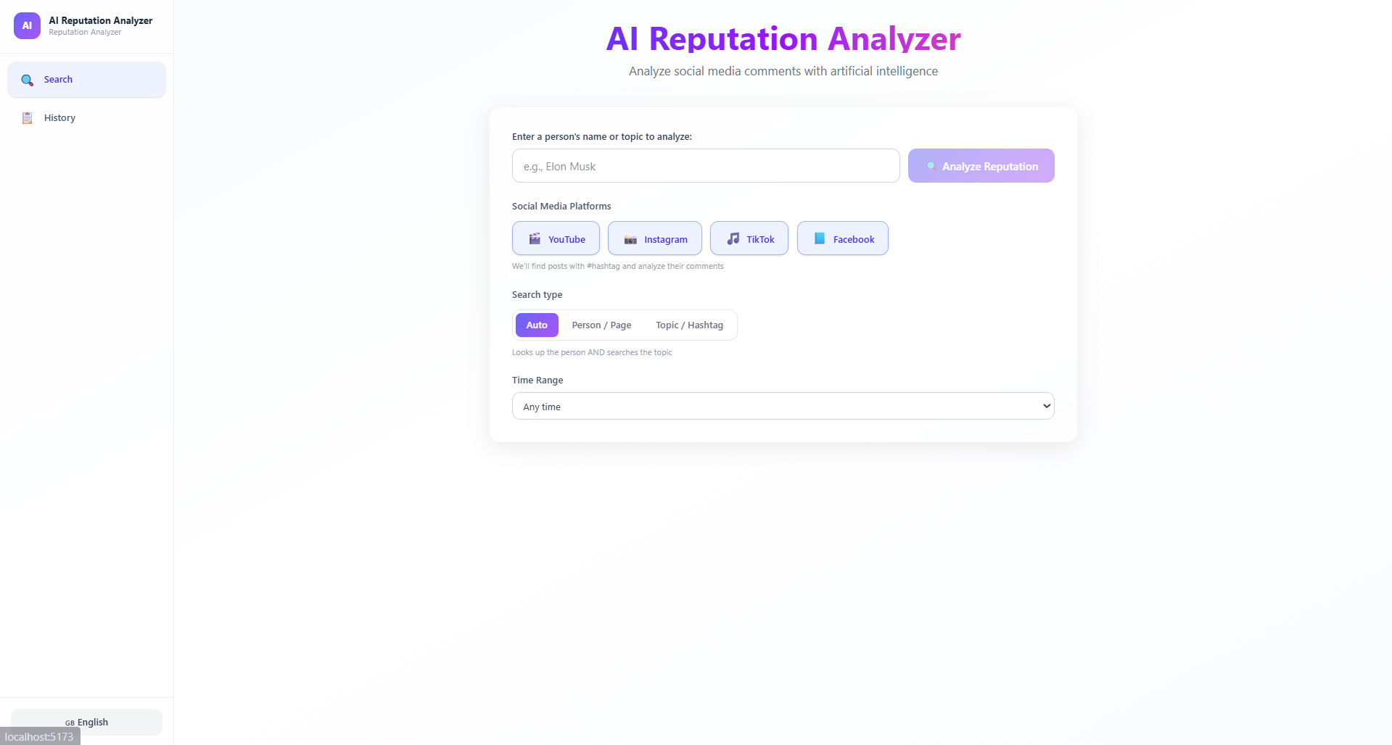
Figure 13. The search interface: query input, source selection, search mode, and time range.
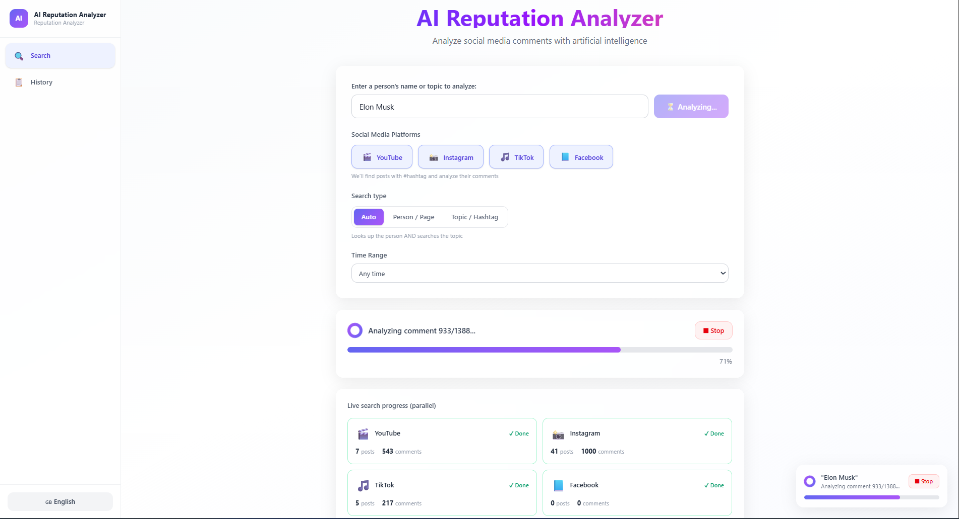
Figure 14. Live view of the four collectors running in parallel, each reporting posts and comments as it completes.
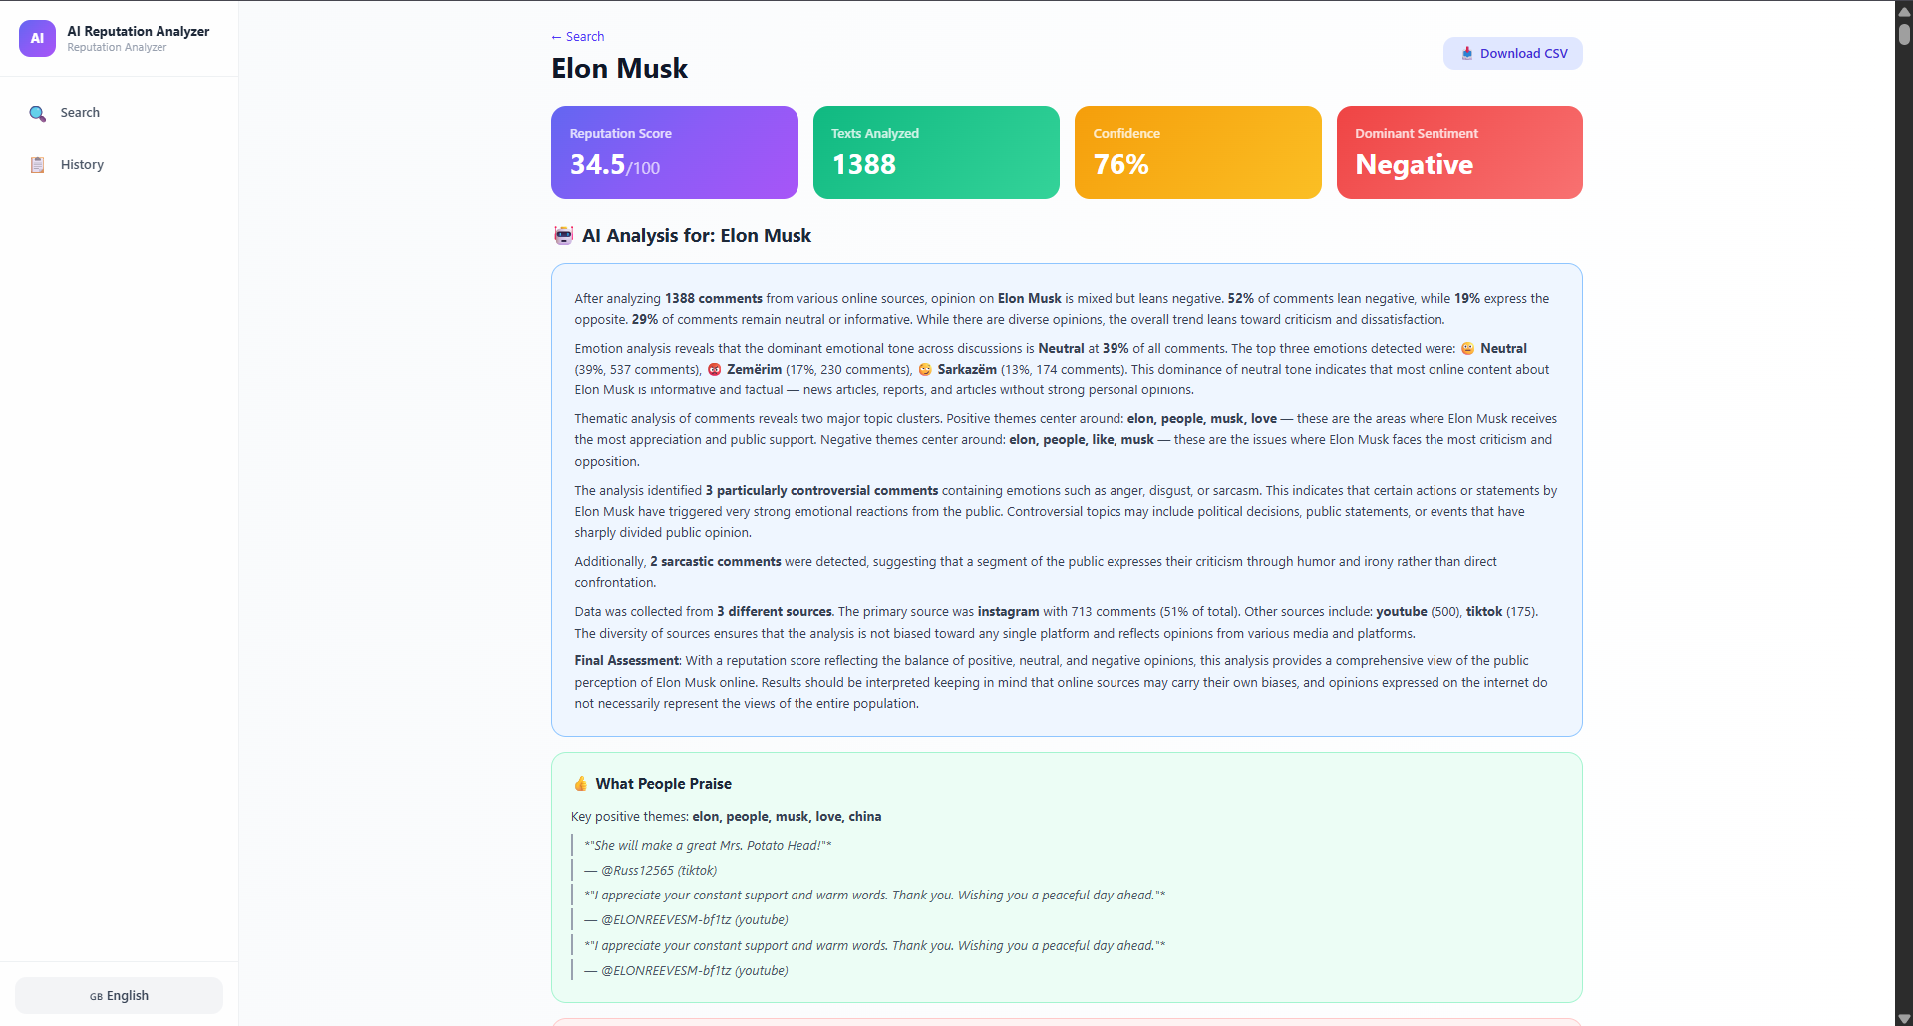
Figure 15. The Results dashboard: overall reputation score with sentiment and emotion visualisations.
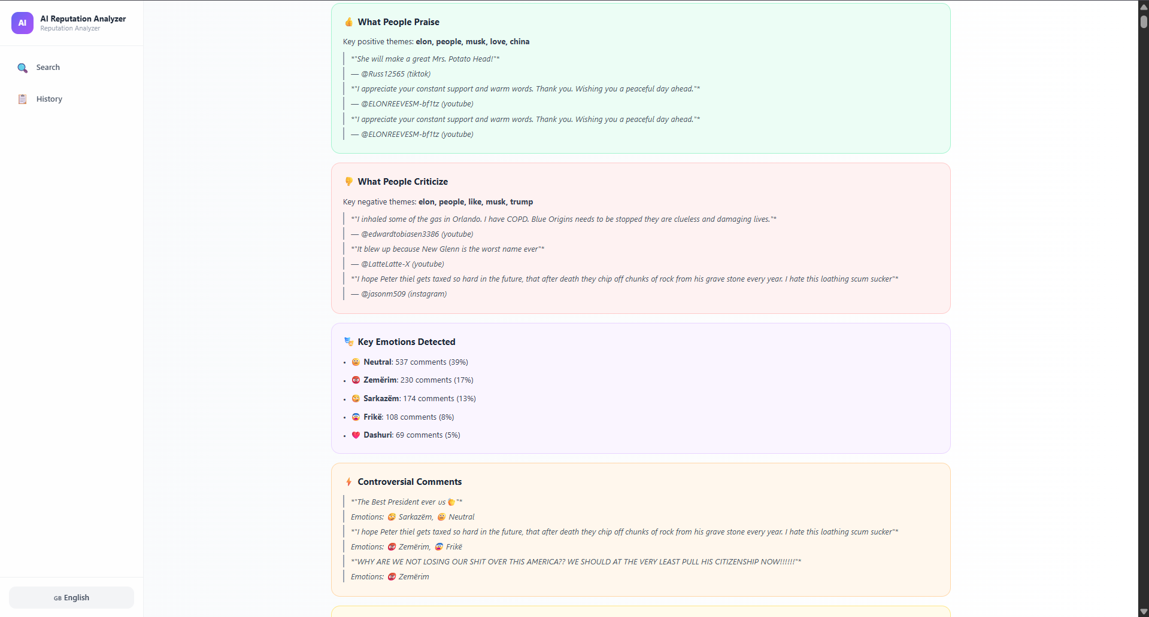
Figure 16. The AI-generated narrative summary, highlighting praise, criticism, dominant emotions, and representative comments.
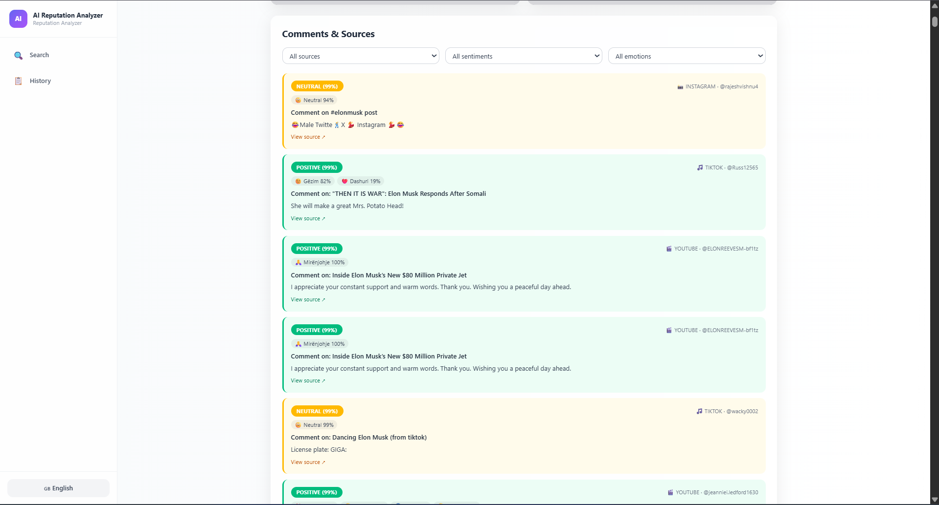
Figure 17. The filterable table of individual comments with per-comment sentiment and emotion tags.
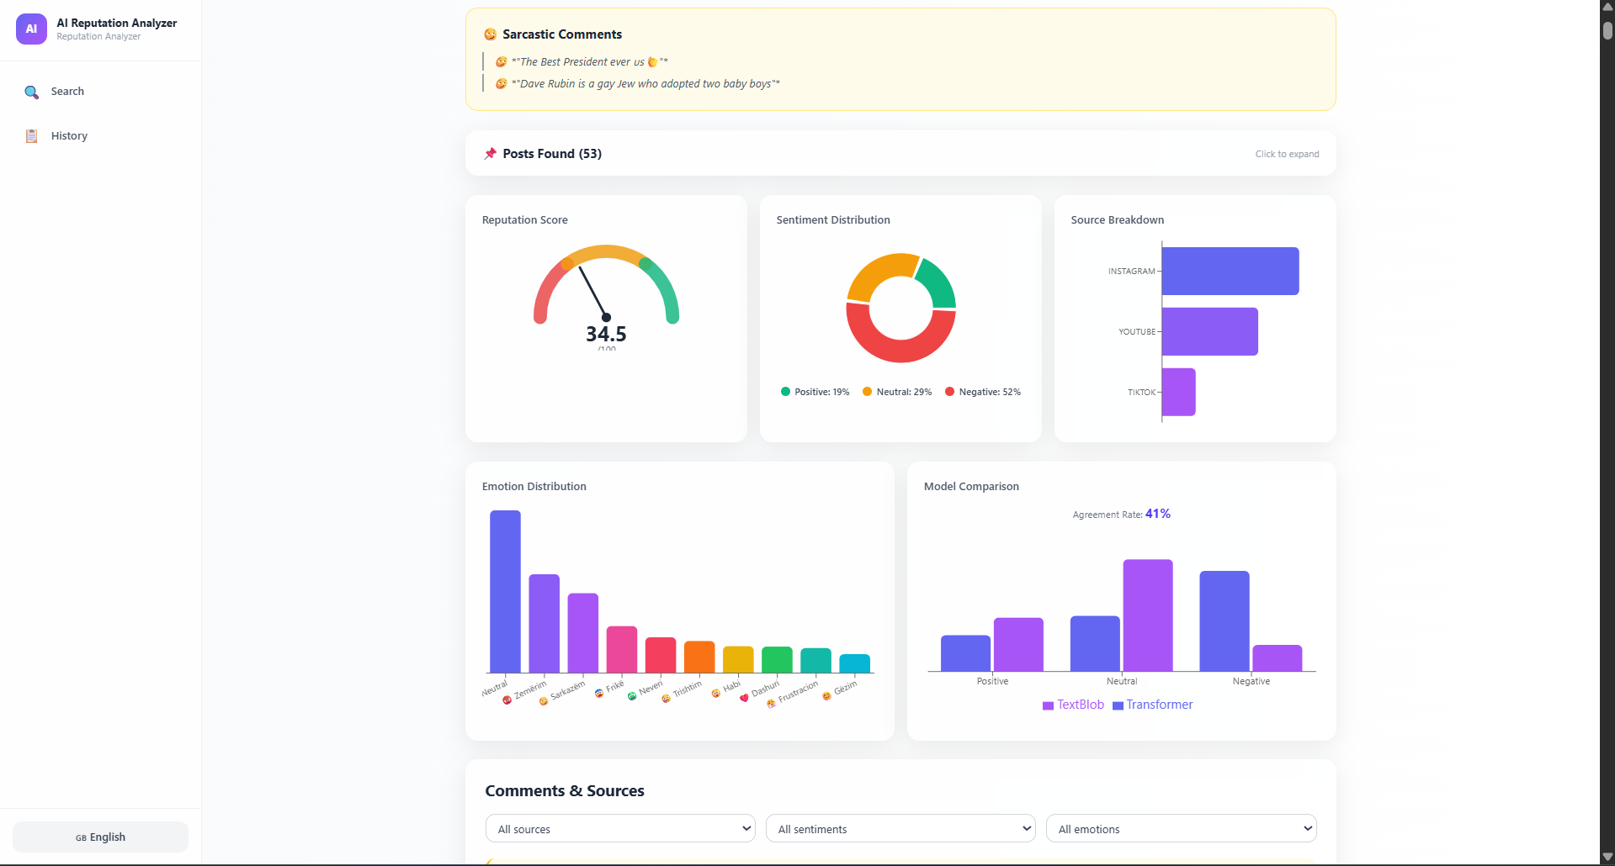
Figure 18. The model-comparison panel (transformer vs. TextBlob agreement).
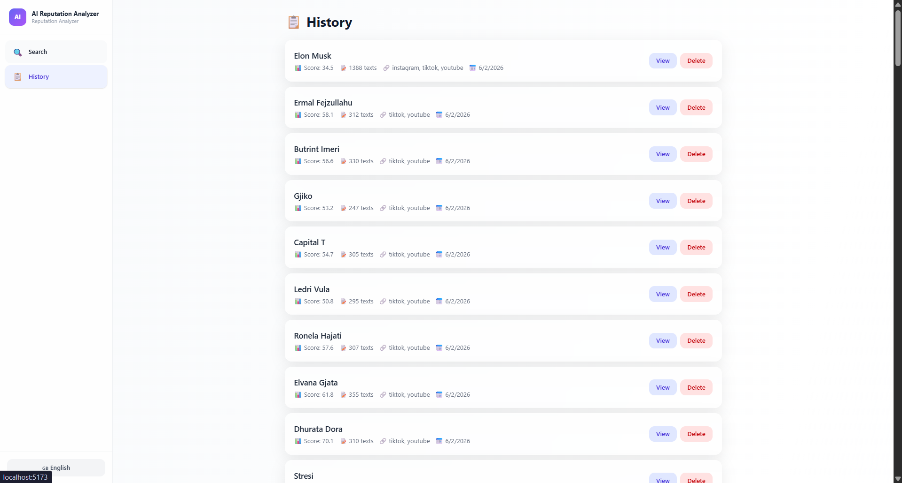
Figure 19. The History page, listing previously generated reports for re-opening.

