Reproducibility in R

Table of Contents

# Introduction

This is an introduction to reproducibility in R.

## Starting with RStudio

Information about RStudio Opening R Studio

You can add **bold text** or **bold text** You can add *italic text* or *italic text with underscores*

Adding superscript is not so easy Adding subscript using tilde

If you add inline code use the backtick to write code

We have covered this in the Introduction section. You can also create [links to Google](https://www.google.com) for example. But you might have some link to the footnote [1].

## Lists

Ordered lists take numbers

1. Item A
2. Item B
3. Item C
   1. Sublist 1 #indented with 4 spaces
   2. Sublist 2

You also have unordered lists:

* Item A
* Item B

Tasks - if uploaded to github will create tickboxes (doesn’t show up in html) - [ ] - [x]

Linking an image

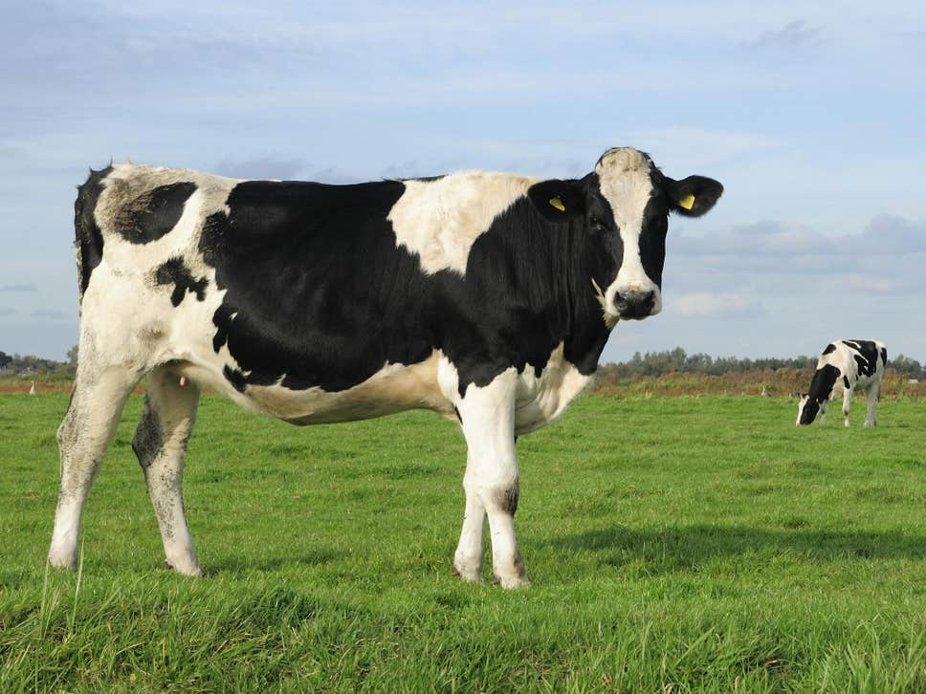 Can also copy local image location

## Tables

You can create tables using | -

|  |  |
| --- | --- |
| Column header | Another column |
| First row | With info |
| More rows | With more info |

A greater than sign creates blocks

How does that look? How would we highlight code?

Single backticks are used inline to highlight

To write a block of code start with three backticks (this does not get executed):

print("hello")  
read.csv("data.txt")

Can also do this by Code > Insert Chunk or by Ctrl-Alt-I (this does get executed):

print("hello")

## [1] "hello"

75 * 8

## [1] 600

#load tidyverse library  
library(tidyverse) # used for data manipulation  
library(rmarkdown) # used for paged_table function  
library(kableExtra) # used for table  
  
download.file(url="https://raw.githubusercontent.com/cambiotraining/reproducibility-training/master/data/gapminder_data.csv", destfile="gapminder_data.csv")  
  
pop_data <- read_csv("gapminder_data.csv")  
euro_data_tbl <- pop_data %>%   
 filter(continent == "Europe" & year == 2007) %>%   
 select(-continent, -year) %>%   
 arrange(desc(lifeExp)) %>%   
 rename(Country = country, "Population Size" = pop, "Life Expectancy" = lifeExp, "GDP" = gdpPercap)

1. This is my first footnote.