Design Document

**Design Document for Access Control System Visualization**

FONTYS UNIVERSITY OF APPLIED SCIENCES

**HBO-ICT: English Stream**

|  |  |
| --- | --- |
| Data Students | |
| Family name, initials | Aleks Petrov, Steven Verberne, Georgi Dimitrov & Sytse Walraven |
| Project period (from-until) | From 05.03.2021 To 25.06.2021 |
| Data Company | |
| Name company/institution | Simac IDS (represented by Christian van Deuren) |
| University tutors | |
| Family name, initials | Georgios Metaxas |
| Project Plan | |
| Date | 25.06.2021 |
| Version | **1.1** |

Table of Contents

Description 3

UML 4

High-Level Architecture 5

UX/UI Sketches 6

Tech Stack 16

# Description

This document contains the architectural design of Simac Access Control visualization solution developed by Group 1. This project is part of group assignment organized by Fontys University of Applied Science as part of ICT and Software semester 3.

# User stories

|  |  |  |  |  |
| --- | --- | --- | --- | --- |
| Title | Story | Actor | Acceptance criteria | MoSCoW |
| Create maps | I want to be able to create maps such that the users have a simple overview of the area, and know where they are. | Admin | Given that the Admin has the permissions to do so and filled all of the required fields: - Title of the map  - File of the map  When the admin is logged in to the system and clicks on create a map then ensure when he enter the requirement fields, a map will be created. | Must have |
| Create floorplans | I want to be able to create floorplans such that the users have a simple overview of the building, and know where they are. | Admin | Given that the Admin has the permissions to do so and filled all of the required fields: - Title of the floorplan  - File of the floorplan  When the admin is logged in to the system and clicks on create a floorplan then ensure when he enter the requirement fields, a floorplan will be created. | Must have |
| Create zones | I want to be able to create zones such that people only get access to the areas they are allowed to get in to. | Admin | Given that the Admin has the permissions to do so and filled all of the required fields:  -Title  - Select the floorplan that you want to attach the zone to  - Select 2D dimensions where the zone is in the selected floorplan  When the admin is logged in to the system and clicks on create a zone then ensure when he enter the requirement fields, a zone will be created. | Must have |

|  |  |  |  |  |
| --- | --- | --- | --- | --- |
| Title | Story | Actor | Acceptance criteria | MoSCoW |
| Create controllers | I want to be able to create controllers on the map or floorplan such that I can later find them again on the map. | Admin | Given that the Admin wants to create a controller he must enter the required fields:  - Should be attached to a zone  - Title  - Access to the specific zone  When the admin is logged in to the system then ensure he will have the permission to create a controller. | Must have |
| Create readers | I want to be able to create readers on the map or floorplan such that I can later find them. | Admin | Given that the Admin wants to create a reader he must enter the required fields:  - Title  - Access for which controller is this reader is about  When the admin is logged in to the system then ensure he will have the permission to create a reader. | Must have |
| Support multiple languages | I want to be able to support multiple languages in the system so that the users have the option to read the system in the language of their choice. | Admin/ receptionist/ maintainer | Given that the Admin wants to support more languages he must import the new language into the system.  When the admin is logged in to the system then ensure he will have the permission to add a new language. | Could have |

|  |  |  |  |  |
| --- | --- | --- | --- | --- |
| Title | Story | Actor | Acceptance criteria | MoSCoW |
| Search for zone or controller | I want to be able to search for zones and controllers so that I have more in-depth information. | Receptionist | Given that the Receptionist wants to search for zones and controllers he must specify at least one of the following:  -The zone  -Map/floorplan  -Title of the zone/controller  When the receptionist is logged in the system then ensures he has access to all zones/controllers | Must have |
| Configure settings for readers | I want to be able to change specific readers such that they can act differently than others. | Maintainer | Given that the Maintainer wants to change the settings on the reader and he was some way to interface with the system, he must specify the following:  -What parameters he wants to change  -What the new values of these parameters are  When he is done and stops using the interface, the new settings should be configured. | Must have |
| Configure settings for controllers | I want to be able to change specific controllers such that they can act differently than others. | Maintainer | Given that the Maintainer wants to change the settings on the controller and he was some way to interface with the system, he must specify the following:  -What parameters he wants to change  -What the new values of these parameters are  When he is done and stops using the interface, the new settings should be configured. | Must have |

|  |  |  |  |  |
| --- | --- | --- | --- | --- |
| Title | Story | Actor | Acceptance criteria | MoSCoW |
| View mode | I want to have a version of the main window allowing me to see where how many people are last checked in. | Admin/ receptionist | Given that the Admin/Receptionist wants to retrieve information from a zone, reader or controller, they must be able to see a map of the area/building and select the one of their choice. Required: - Map/floorplan Actions: - The map is opened up - The admin/receptionist selects the device of their choice on the map - The properties of the device are shown to the admin/receptionist | Must have |
| Edit mode | I want to have a version of the main window allowing me to change the readers’ settings, displayed map and more. | Admin/ receptionist | Given that the Admin/Receptionist wants to change properties of a map/floorplan or their zones, readers and controllers, and has access to the system, they should be able to the following:  -Open/find a map/floorplan  -Select a certain device/zone they want to change  -Implement those changes  When they are done, they changes should be changed to the system. | Must have |

# Tech Stack

For our project we are going to use the following stack:

Back-End:

* Java – programming language
* Spring Boot – framework for Java
* Gradle – building tool
* IntelliJ – integrated development environment

Front-End:

* Vue – framework for JavaScript
* Bootstrap Vue – framework for responsive web development
* Vue Leaflet – library for interactive maps

Project Management & Quality Assurance

* GitLab issue board – manage issues across the project
* GitLab CI/CD – continuous integration and deployment
* SonarQube – inspection of code quality

|  |  |
| --- | --- |
| **Initial DoD** | **Mature DoD** |
| All acceptance criteria met | All acceptance criteria met |
| Project plan up to date | 10 UX heuristics met |
| Backlog up to date | Project plan up to date |
| Design document(s) up to date | Backlog up to date |
| At least 70% unit test coverage | Design document(s) up to date |
| GDPR compliant | At least 85% unit test coverage |
| Code/commit peer reviewed before merge | GDPR compliant |
| No known bugs/issues | Code/commit peer reviewed before merge |
|  | No known bugs/issues |
|  |

# Definition of Done

# UML

# High-Level Architecture

# UX/UI Sketches

Register Page:

Login Page:

Home Page:

View all Page(Admin):

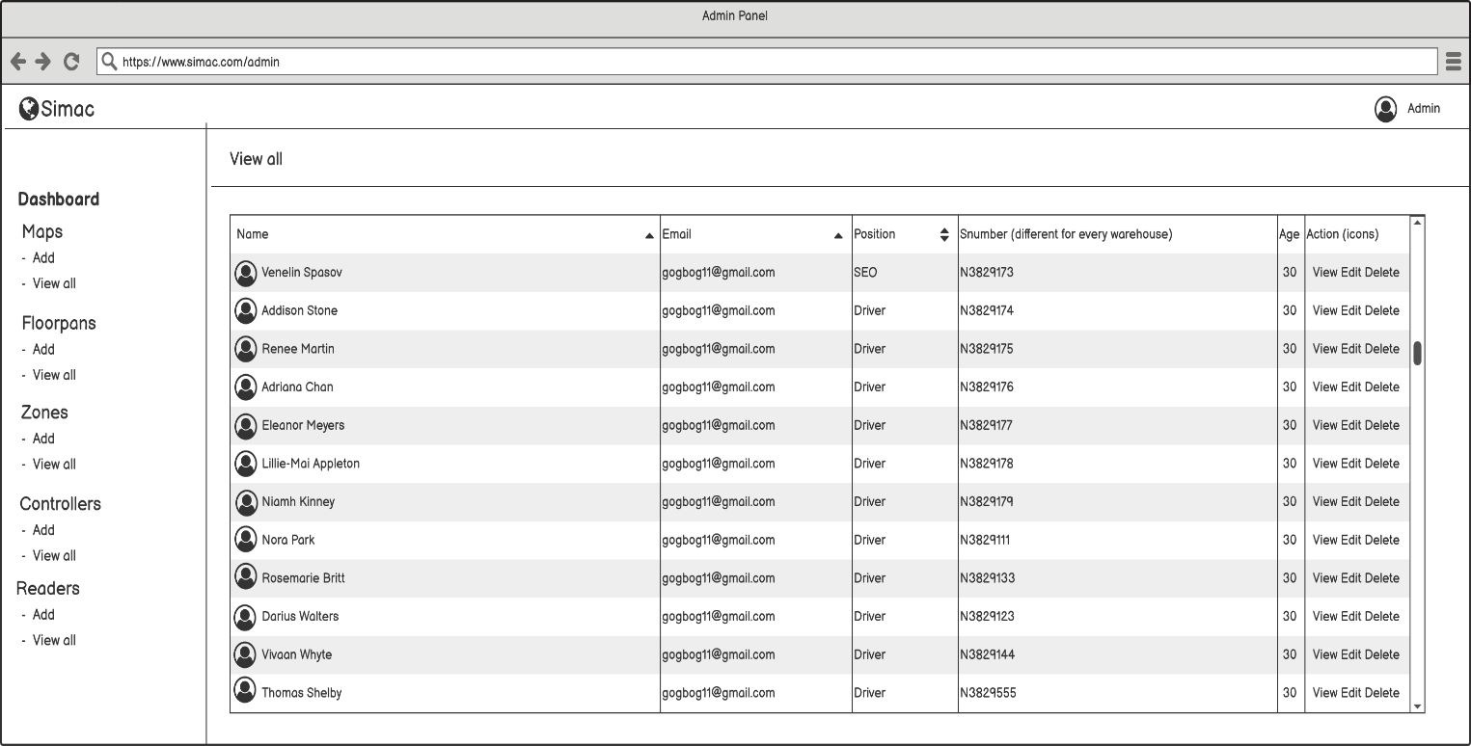

Dashboard Page(Admin):

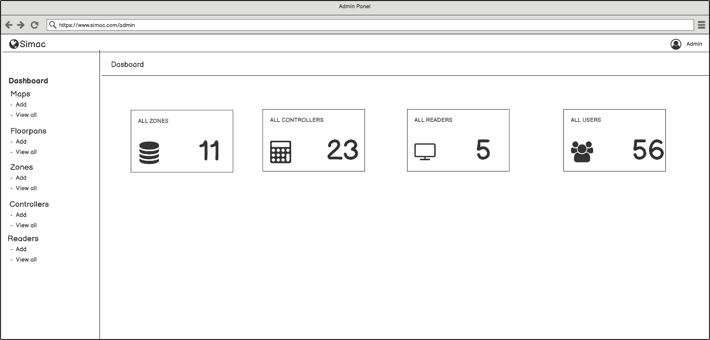

Add Zone Page(Admin):

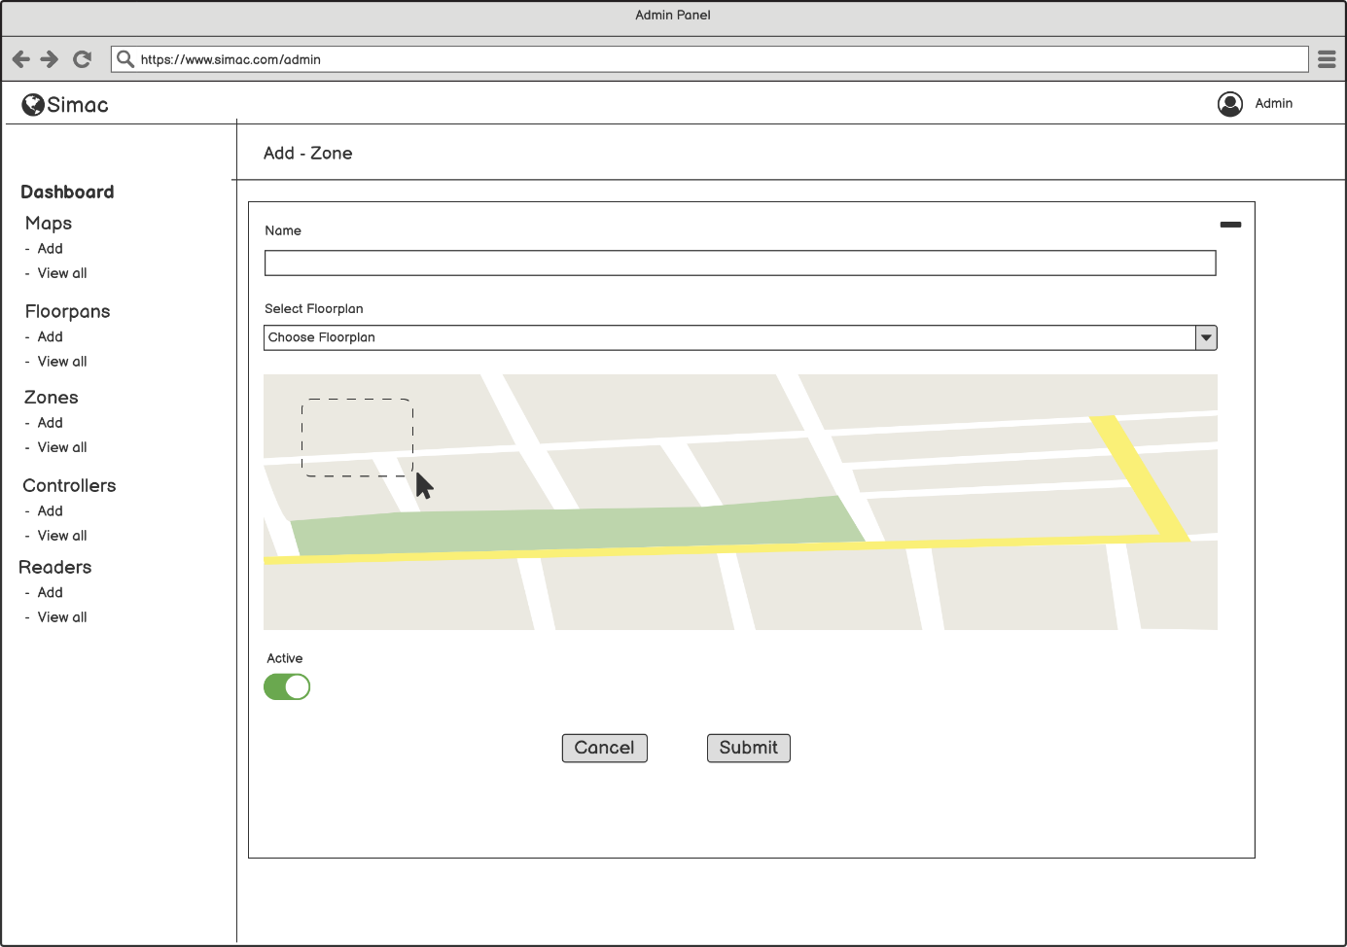

Add Reader Page(Admin):

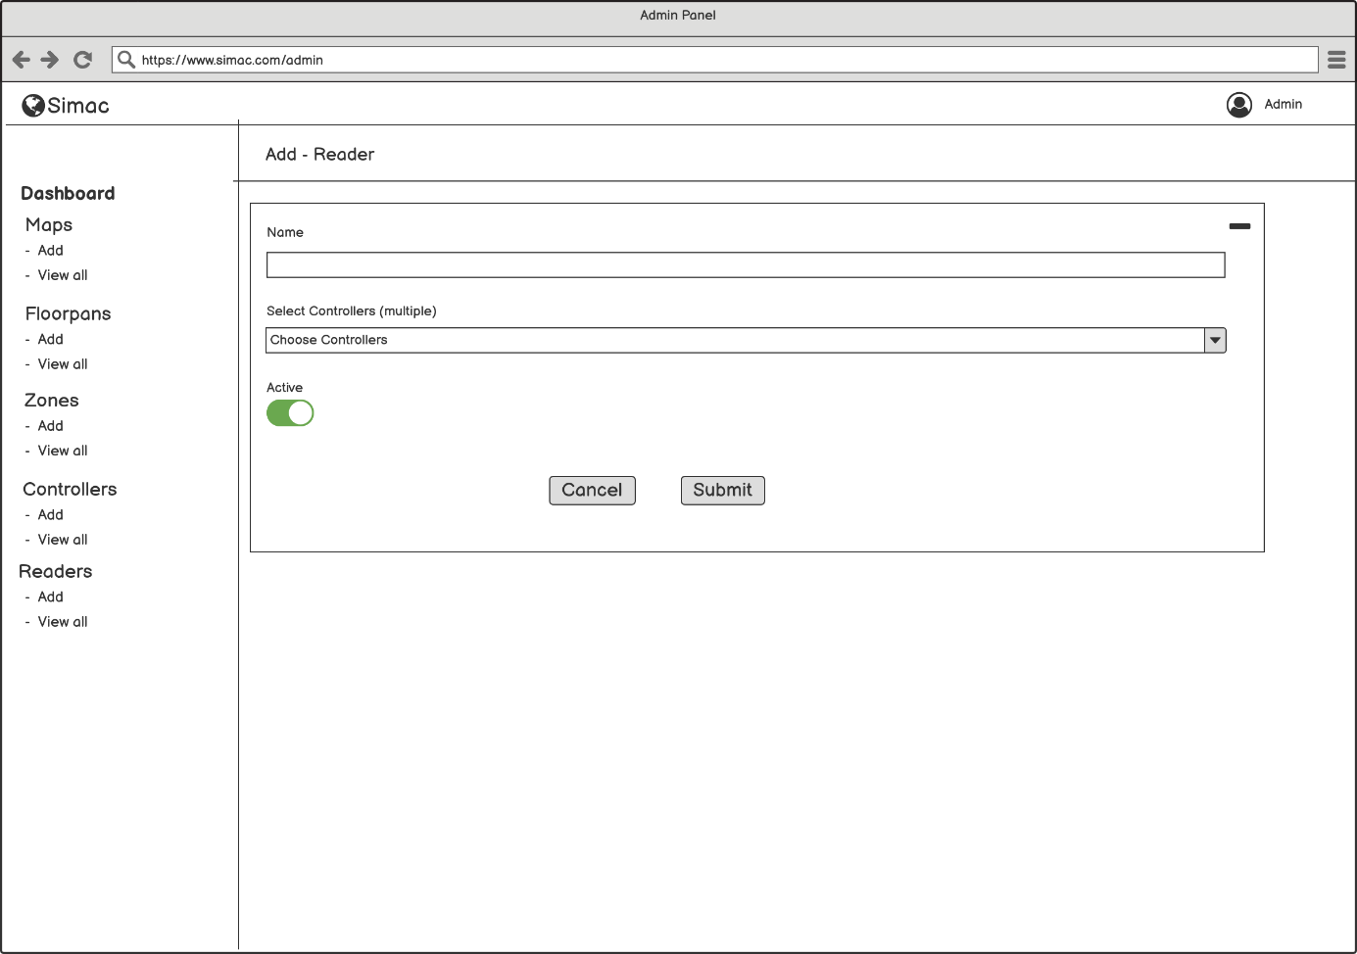

Add Map Page(Admin):

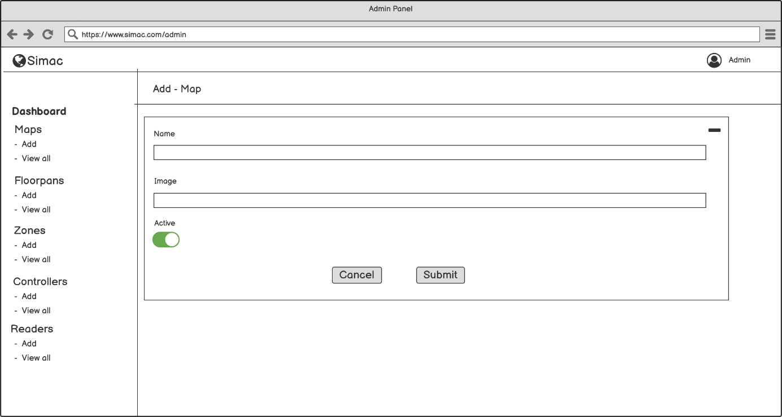

Add Floorplan Page(Admin):

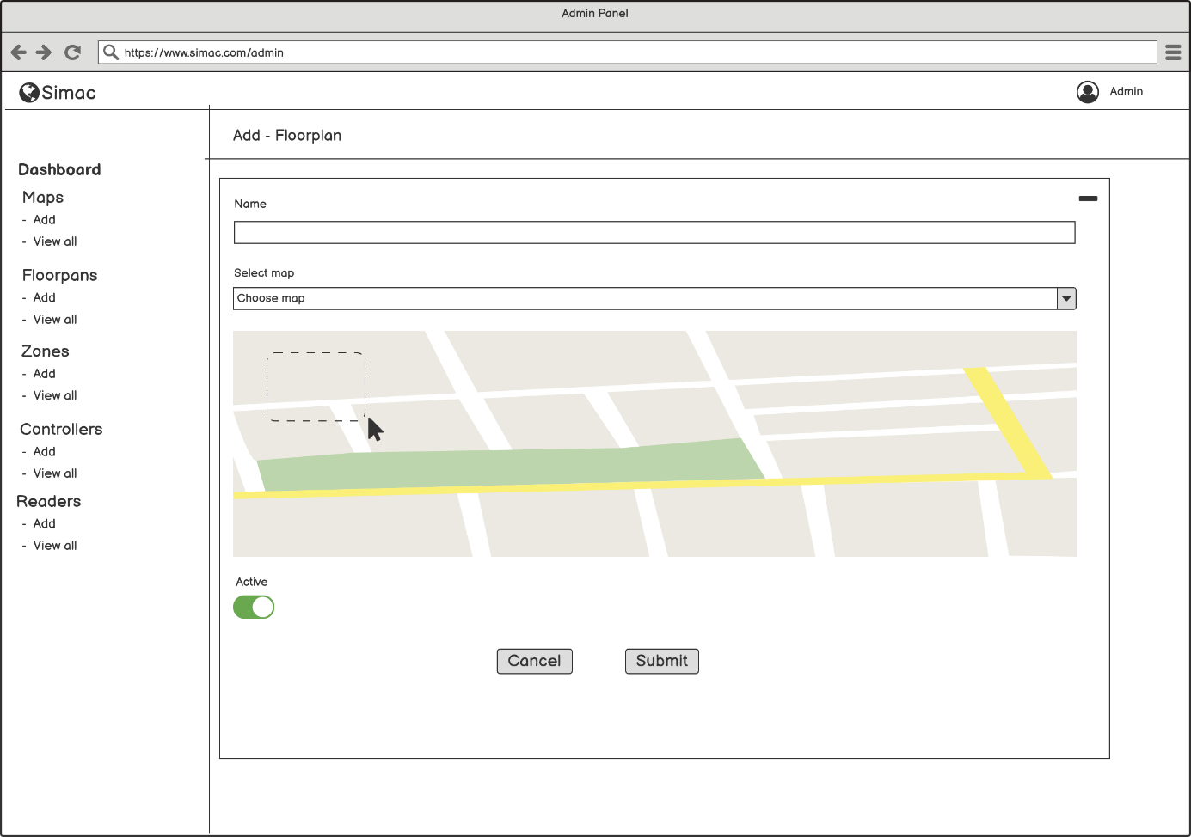

Add Controller Page(Admin):

