**Modular tests for database functionality**

It is assumed that you have already followed all the instructions in the LDMS_DB.docx file.

All the functionality stated in the task is implemented by functions and procedures of the PKG_EMP_SRV package, which you have already created.

All the functions and procedures listed below can be accessed using SQL and PL/SQL. In my case, using the Oracle REST Data Services (ORDS) environment and APEX, I opened the PKG_EMP_SRV package for access via the REST API.

Be careful and accurate when testing functionality via REST API, as in this case all functionality restricting user actions is disabled.

**--Inserting new row into EMP_DATA**

-- using PL/SQL function

**declare** v_ret **number**; **begin** v_ret := PKG_EMP_SRV.f_add_emp(**null**,'Alex Worker', 'Employee',**null**,**sysdate**,148000,1); **end**;

-- using procedure

**begin** PKG_EMP_SRV.p_add_emp(**null**,'Alex Newman', 'Employee',**null**,**sysdate**,148000,1); **end**;

-- using REST API from browser

https://apex.**oracle**.com/pls/apex/alekstar/pkg_emp_srv.p_add_emp?p_ename=Test **Record**&p_job=homeless&p_sal=0&p_dept_id=1

**-- Displaying the DEPTs report**

-- if p_dept_id is null then you'll get all list EMP_DATA

-- using PL/SQL

**begin** PKG_EMP_SRV.p_dept_rep(p_dept_id => **null**); **end**;

**begin** PKG_EMP_SRV.p_dept_rep(p_dept_id => 1); **end**;

-- Using REST API report

https://apex.**oracle**.com/pls/apex/alekstar/pkg_emp_srv.p_dept_rep?p_dept_id=

[https://apex.**oracle**.com/pls/apex/alekstar/pkg_emp_srv.p_dept_rep?p_dept_id=1](https://apex.oracle.com/pls/apex/alekstar/pkg_emp_srv.p_dept_rep?p_dept_id=1)

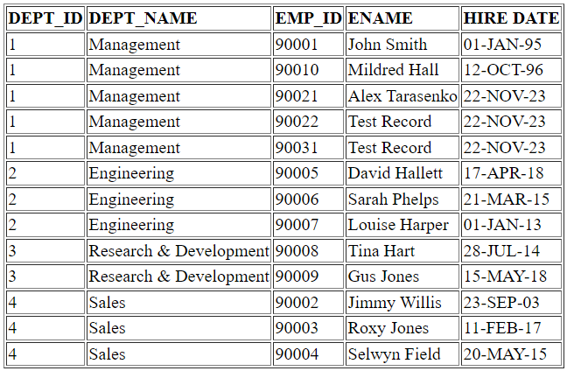

**-- Displaying the employee's salary**

-- using PL/SQL

**begin** PKG_EMP_SRV.p_return_sal(p_emp_id => 90001); **end**;

------------------

*Employee EMP_ID = 90001 Salary = 100000*

--================

--Using REST API

https://apex.**oracle**.com/pls/apex/alekstar/pkg_emp_srv.p_return_sal?p_emp_id=90001

*Employee EMP_ID = 90001 Salary = 100000*

**-- Changing employees salary by a percentage**

**begin** PKG_EMP_SRV.p_change_sal(p_emp_id => 90001,p_percent => 20); **end**;

------------------

*EMP salary updated. EMP_ID = 90001* ***New*** *salary = 120000*

------------------

**begin** PKG_EMP_SRV.p_change_sal(p_emp_id => 90001,p_percent => -25); **end**;

------------------

*EMP salary updated. EMP_ID = 90001* ***New*** *salary = 90000*

-- This functionality can also be accessed from the REST API

https://apex.**oracle**.com/pls/apex/alekstar/pkg_emp_srv.p_change_sal?p_emp_id=90001&p_percent=20

**-- Transfering to another DEPT**

**begin** PKG_EMP_SRV.p_emp_transfer(p_emp_id => 90001,p_new_dept => 2); **end**;

------------------

*Employee transfered. EMP_ID = 90001* ***New*** *DEPT_ID = 2*

--=====================

-- back to origin DEPT

**begin** PKG_EMP_SRV.p_emp_transfer(p_emp_id => 90001,p_new_dept => 1); **end**;

------------------

*Employee transfered. EMP_ID = 90001* ***New*** *DEPT_ID = 1*

-- This functionality can also be accessed from the REST API

https://apex.**oracle**.com/pls/apex/alekstar/pkg_emp_srv.p_emp_transfer?p_emp_id=90001&p_new_dept=2

**-- Displaying the total of Employee Salary for a Department**

-- if p_dept_id is null then you'll get all list EMP_DATA

-- using PL/SQL

**begin** PKG_EMP_SRV.p_sal_rep(p_dept_id => **null**); **end**;

**begin** PKG_EMP_SRV.p_sal_rep(p_dept_id => 1); **end**;

-- Using REST API report

https://apex.**oracle**.com/pls/apex/alekstar/pkg_emp_srv.p_sal_rep?p_dept_id=

https://apex.**oracle**.com/pls/apex/alekstar/pkg_emp_srv.p_sal_rep?p_dept_id=1

