**SPATIAL ANALYTICS PROJECT**

**Visualizing three decades of urbanization in Denmark**

Aleksander Moeslund Waela

a Corresponding author.

Student no. 202005192

Email: 202005192@post.au.dk

Stud. BSc. Cognitive Science

School of Communication and Culture  
 Faculty of Arts, Aarhus University

Adela Sobotkovab

b Course teacher.

Email: adela@cas.au.dk

School of Culture and Society

Faculty of Arts, Aarhus University

**Abstract:** This project examines the urbanization process in Denmark over the past three decades using spatial analysis and visualization techniques. Municipal population data and topographical features are utilized to create altered maps that depict the changes in urbanization patterns. Choropleth maps and cartograms represent population distribution and size, while a time series approach visualizes the changes over time. The findings highlight population concentration around major cities like Copenhagen, Aarhus, Odense, and Aalborg, emphasizing the dominance of Copenhagen. The visualizations provide insights into a process of ongoing, moderate urbanization in Denmark.

#### Keywords: spatial analytics, urbanization, cartogram, choropleth, time series

**Link to GitHub repository:**<https://github.com/alekswael/visualizing-urbanization>

# Introduction

## Urbanization

Urbanization is the process in which an increasing proportion of the population migrates from rural areas to urban centers (cities), resulting in the growth and expansion of the urban centers. (Vlahov & Galea, 2002). It also involves the transformation of rural or undeveloped areas into urban environments characterized by a concentration of population, infrastructure, economic activities, and cultural institutions, although an exact definition of an urban area varies across the world (Ritchie & Roser, 2018).

Urbanization is a rather recent phenomenon, mostly limited to the past 200 years (Ritchie & Roser, 2018). It is caused by industrialization, economic opportunities, improved living standards, and access to better social amenities and services. As a result of urbanization, the physical landscapes, social structures, and economic systems of cities are changed. These areas often become hubs of economic growth, innovation, and cultural exchange, but they also face challenges related to infrastructure, accommodation, sustainability, and social inequality (Black & Henderson, 1999; Bloom et al., 2008).

## Urbanization in Denmark

In the years 1840 to 1914, Denmark experienced significant economic growth and industrialization. Agriculture's importance declined as industries and service sectors grew, leading to a specialized economy focused on sales. This shift represented a departure from the traditional agrarian economy, with trade and services gaining significance in a modern capitalist system, paving the way for urbanization to take place (Jørgensen, 2020). Recent decades have also been marked by urbanization. From 2010 to 2020, more people have migrated from rural areas to cities, especially major cities like Copenhagen, Aarhus, and Odense (Grevsen, 2021). Urban development projects focused on creating sustainable and livable urban environments, with investments in public transportation, green spaces, and cultural institutions.

The period also witnessed the revitalization of urban neighborhoods, such as Vesterbro in Copenhagen, which transformed from neglected areas into vibrant and sought-after districts (Larsen & Hansen, 2008). However, urbanization also posed challenges, including increased pressure on housing markets and rising property prices. Efforts were made to address these issues through affordable housing initiatives, urban planning strategies, and the promotion of mixed-income communities (Larsen & Hansen, 2008).

## The current project

The aim of this project is to visualize the process of urbanization in Denmark in the last three decades. The method of visualizing this phenomenon relies on spatial analysis, using topographical features and municipal population data in a time series to create an altered map of Denmark.

# Methods

## Hardware & Prerequisites

All code was written and computed on an Intel based Dell XPS 13 16 GB RAM running Windows 11 Pro. Data processing was done with R (4.0.2) and RStudio (2021.09.0, Build 351).

## Data

### Municipal data

The municipal population data is acquired from noegletal.dk[1], which is a free database provided by the Danish Ministry of Interior and Health. It contains municipal data regarding tax, debt, social relations, institutions and structural relations. The raw population count for each municipality from 1993 to 2023 was obtained through the web interface. The data is corrected for the Municipal Reform of 2007 (*Kommunalreformen i 2007*, n.d.), wherein 271 municipalities were combined into 98, so all years include data in the 98-municipality format. The data is available at the project GitHub repository.

### Spatial data

The spatial map of Denmark with municipalities is acquired from the GADM-database[2] through the raster package for R (Hijmans, 2023). GADM is a project which seeks to map the administrative areas of all countries. The acquired data is structured as a SPDF (SpatialPolygonsDataFrame), meaning it combines geometric information (the polygons) with attribute data associated with each polygon, each polygon pertaining to a municipality.

## Methods of visualization

### Coordinate reference system (CRS)

The spatial data comes as geographic coordinates (longitudes and latitudes), but to create 2D visualizations it is necessary to project the data with a coordinate reference system (CRS). A CRS contains a coordinate system, specifying how coordinates are expressed in space, and a datum, which defines the model of the earth as reference for the coordinate system (QGIS Documentation, 2023). For this data, it is appropriate to use ETRS89 / UTM zone 32N, which is a CRS that uses the European Terrestrial Reference System (ETRS) 1989 datum and the Universal Transverse Mercator (UTM) projection. The zone indicates the longitudinal range covered by the UTM projection, in this case 32N (northern hemisphere), which is appropriate for northern Europe.

### Choropleth

A choropleth map is a thematic map that uses color or shading to represent data values across different geographic areas. It shows patterns and variations in data by coloring or shading areas based on specific variables. The intensity of color or shading corresponds to the magnitude of the data. Choropleth maps are useful for visualizing demographics, socioeconomic indicators, and other quantitative data associated with geographic locations (*Choropleth Maps*, n.d.). When visualizing urbanization, the ratio between the total population and the municipality population is chosen as an appropriate variable to map.

### Cartogram

A cartogram is a map in which the geographic areas, such as neighborhoods or districts, are distorted or resized based on a specific variable of interest. Cartograms offer several benefits for visualizing urbanization and its associated spatial patterns. Whereas choropleths alter the color of areas, cartograms can radically alter map geometry to create more abstract representations of map and variable (Field, 2017). This allows viewers to grasp the extent and scale of urbanization more easily, providing a clear sense of which areas have experienced the most significant shift. The municipality size is distorted based on population to area size as a contributing factor in understanding urbanization.

### Time series

The approach of this project is to create a representation of urbanization by combing a choropleth and cartogram map, whilst displaying change over time using time series data. The final result is a animated plot of Denmark, where each municipality is colored according to total population ratio and size is distorted by population to area size for each year in the period 1993-2023. Each frame of the animation corresponds to a year in the time series, which changes every .15 seconds.

## Implementation

### Pipeline

The data pipeline is available in the `urbanization_denmark.Rmd` file, located in the ‘src’ folder in the GitHub repository for this project. It contains code for data import, processing, map creation, plotting and saving the visualizations. The pipeline has the following structure:

1. Load necessary R packages

2. Import spatial data from GADM

3. Import population data

4. Join the spatial data with the municipal population data

5. Project geographic coordinates to ETRS89 / UTM zone 32N

6. Create choropleth map for Danish municipalities in 2023

7. Create cartogram/choropleth maps from 1993-2023

8. Animate plot and save .GIF

When the .Rmd is run, the animated visualization is saved as ‘animation.gif’ in the ‘out’ folder, along side the choropleth/cartogram map for each year and the choropleth map for 2023. The cartograms are created with the cartogram package for R (Jeworutzki, 2020). All plots are displayed with the ggplot2 package for R (Wickham, 2016), and the animation is made with the gifski package for R (Ooms, 2022).

# Results & discussion

To view the cartogram/choropleth map of Danish municipalities animation GIF, go to the project GitHub and navigate to the ‘out’ folder, or access it through a direct link[3]. For quick viewing, the last frame of the animation is inserted here as figure 2.

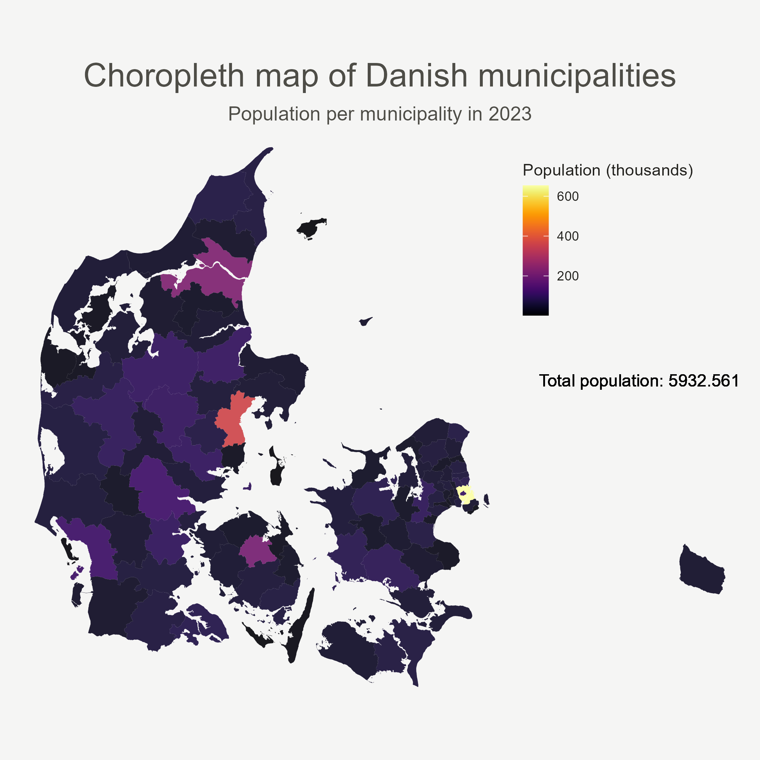

*Figure 1. Choropleth map of Danish municipalities, colored by total population ratio, using data from year 2023.*

When looking at the choropleth map of Danish municipalities (figure 1), it is quite clear that the population is grouped around the biggest cities – Copenhagen, Aarhus, Odense and Aalborg. In fact, because of the color scale, it becomes difficult to gauge the difference in population between less populated municipalities, because they are skewed towards the lower end of the color scale.

Adding the cartogram element gives a better idea of the relationship between municipality area size and population. When looking at the last frame of the animation GIF (figure 2), Zealand is almost as dense as Jutland, and Copenhagen (including Frederiksberg) are bigger than all of Djursland. Likewise, Odense and Aarhus have tripled in size, and Aalborg (although already a large area) has increased in size as well.

The last dimension, time, is added when looking at the animation GIF. This shows the combined cartogram/choropleth map of Danish municipalities from 1993-2023. In this figure, it seems that as time progresses, Aarhus sees a large increase in relative size. Aalborg and Odense also expand a bit, but to a lesser degree. Zealand also gets bigger, but it is difficult to pinpoint which municipalities are growing. A note here is that the total population also increases, which is why raw population counts are not a useful metric for visualizing urbanization. Even though there is general increase in population for all municipalities, there is such a high increase in population in the biggest municipality, Copenhagen, that the color shades get increasingly darker in almost all other municipalities – including those of Aarhus, Odense and Aalborg, although these expand in size. This is because the ratio of the population which live in these municipalities decreases over time compared to Copenhagen. In other words; although Aarhus, Odense and Aalborg are growing compared to their area size, they are not growing as much in population ratio as Copenhagen.

The rural areas of Jutland (mid and west) show a clear darkening of color shade, although the size is somewhat stable throughout. This would indicate that the relative population per size is somewhat consistent, but with a larger increase in population elsewhere. Since the total population increases, this would indicate that people are moving away from these areas.

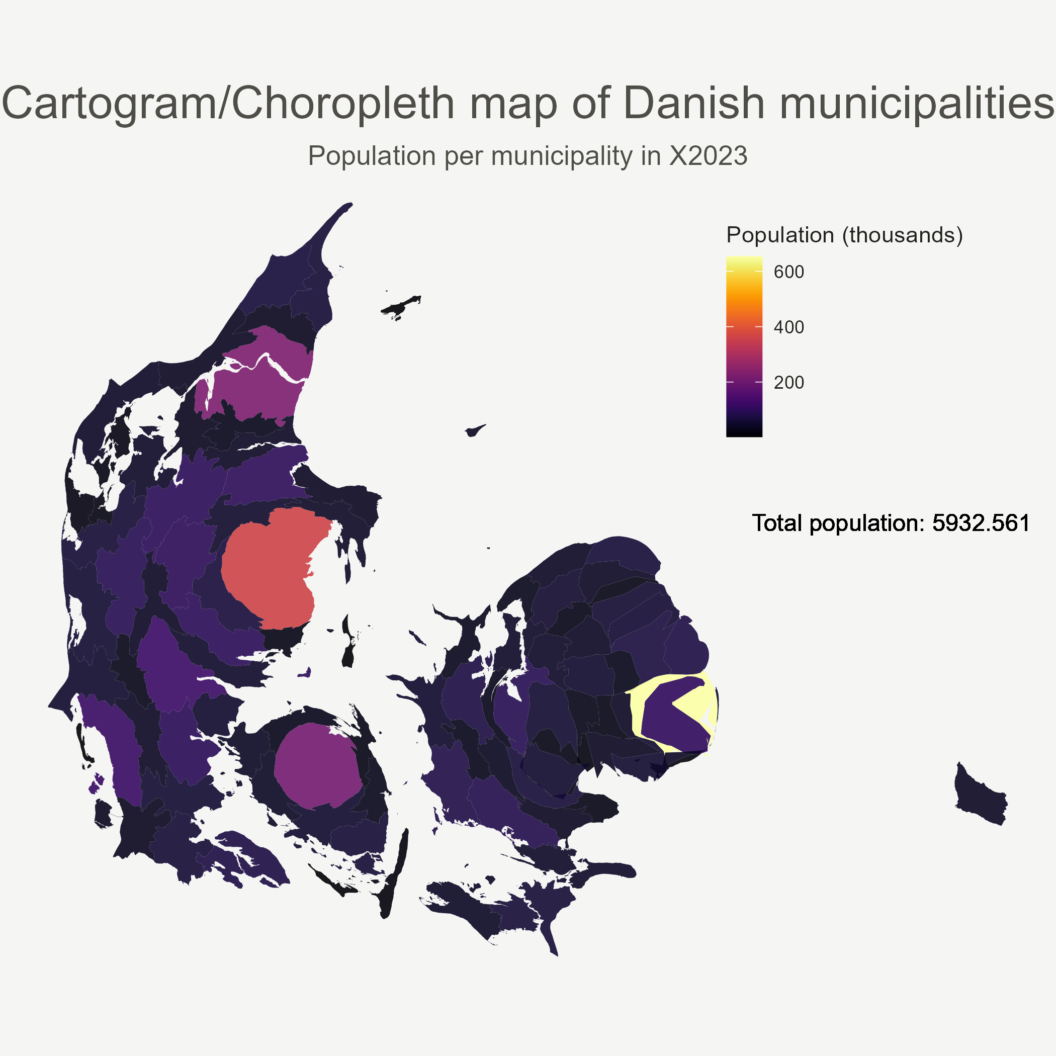

*Figure 2. Last frame (year = 2023) of the Cartogram/Choropleth animated map of Danish municipalities.*

# Conclusion

These visualisations show us that Denmark is experiencing an ongoing urbanization process, although this does not seem to be in a radical sense. People seem to be moving away from the more rural areas; the already large cities seem to expand in size, especially Aarhus, and Copenhagen continues to claim an increasingly larger fraction of the population.

# References

Black, D., & Henderson, V. (1999). A Theory of Urban Growth. *Journal of Political Economy*, *107*(2), 252–284. https://doi.org/10.1086/250060

Bloom, D. E., Canning, D., & Fink, G. (2008). Urbanization and the Wealth of Nations. *Science*, *319*(5864), 772–775. https://doi.org/10.1126/science.1153057

*Choropleth Maps*. (n.d.). Retrieved May 28, 2023, from https://www.axismaps.com//guide/choropleth

Field, K. (2017). Cartograms. *The Geographic Information Science & Technology Body of Knowledge*, *2017*(Q3). https://doi.org/10.22224/gistbok/2017.3.8

Grevsen, A. (2021). *Flere bor i byerne – på landet vokser andelen af ældre—DI*. https://www.danskindustri.dk/arkiv/analyser/2021/9/flere-bor-i-byerne--pa-landet-vokser-andelen-af-aldre/

Hijmans, R. (2023). *raster: Geographic Data Analysis and Modeling* (R package version 3.6-14). https://CRAN.R-project.org/package=raster

Jeworutzki, S. (2020). *cartogram: Create Cartograms with R*. https://CRAN.R-project.org/package=cartogram

Jørgensen, C. (2020). *Modernisering, internationalisering og urbanisering*. https://danmarkshistorien.dk/perioder/fra-enevaeldig-helstat-til-nationalstat-1814-1914/modernisering-internationalisering-og-urbanisering

*Kommunalreformen i 2007*. (n.d.). Retrieved May 31, 2023, from https://im.dk/arbejdsomraader/kommunal-og-regionaloekonomi/kommunale-opgaver-og-struktur/kommunalreformen-i-2007

Larsen, H. G., & Hansen, A. L. (2008). Gentrification—Gentle or Traumatic? Urban Renewal Policies and Socioeconomic Transformations in Copenhagen. *Urban Studies*, *45*(12), 2429–2448. https://doi.org/10.1177/0042098008097101

Ooms, J. (2022). *gifski: Highest Quality GIF Encoder*. https://CRAN.R-project.org/package=gifski

QGIS Documentation. (2023). In *8. Coordinate Reference Systems*. https://docs.qgis.org/3.28/en/docs/gentle_gis_introduction/coordinate_reference_systems.html

Ritchie, H., & Roser, M. (2018). Urbanization. *Our World in Data*. https://ourworldindata.org/urbanization

Vlahov, D., & Galea, S. (2002). Urbanization, Urbanicity, and Health. *Journal of Urban Health: Bulletin of the New York Academy of Medicine*, *79*(90001), 1S – 12. https://doi.org/10.1093/jurban/79.suppl_1.S1

Wickham, H. (2016). ggplot2: Elegant Graphics for Data Analysis. *Springer-Verlag New York*. https://ggplot2.tidyverse.org

# Required Metadata

## Table 1 – Software metadata

|  |  |  |
| --- | --- | --- |
| **Nr** | **Software metadata description** | ***Please fill in this column*** |
| S1 | Current software version | R (4.0.2), RStudio (2021.09.0, Build 351) |
| S2 | GitHub repository link | https://github.com/alekswael/visualizing-urbanization |
| S3 | Legal Software License | Creative Commons 4.0 |
| S4 | Computing platform / Operating System | Intel based laptop running Microsoft Windows 11 Pro, 16 GB RAM |
| S5 | R packages used in project | raster (3.6.14)  stringi (1.7.4)  plyr (1.8.6)  sf (1.0.7)  cartogram (0.2.2)  tidyverse (1.3.1)  viridis (0.6.2)  gifski (1.6.6.1) |
| S6 | Support email for questions | 202005192@post.au.dk |

## Table 2 – Data metadata

|  |  |  |
| --- | --- | --- |
| **Nr** | **Metadata description** | ***Please fill in this column*** |
| S1 | indbygger_data.csv | Data from noegletal.dk. Consists of population data for all Danish municipalities in the years 1993-2023. |
| S2 | urbanization_denmark.Rmd | The Rmarkdown file which contains the code pipeline for data processing and creating visualizations. |

1. <https://www.noegletal.dk/noegletal/>
2. <https://gadm.org/>
3. <https://github.com/alekswael/visualizing-urbanization/blob/main/out/animation.gif>