**hexaRelax grid**

In this document the layout of the variables used in hexaRelax is explained and illustrated.

We denote:

* $B_{x}, B_{y}, B_{z}$ with bbx, bby, bbz.
* $j_{x}, j_{y}, j_{z}$ with ccx, ccy, ccz.
* $v_{x}, v_{y}, v_{z}$ with vx, vy, vz.
* $E_{x}, E_{y}, E_{z}$ with eex, eey, eez.

At the cell corners, the variables are denoted with bx, by, bz, cx, cy, cz, ex, ey, ez.

The location at which the variables are defined for each cell is shown in Figure 1. Note that they are defined as close to the bottom left-corner as possible.

The indices of each cell are shown in Figure 2. It follows then that the shape of each variable is given by:

* bbx(1:nx+1, 0:ny+1, 0:nz+1)
* bby(0:nx+1, 1:ny+1, 0:nz+1)
* bbz(0:nx+1, 0:ny+1, 1:nz+1)
* ccx(0:nx+1, 1:ny+1, 1:nz+1)
* ccy(1:nx+1, 0:ny+1, 1:nz+1)
* ccz(1:nx+1, 1:ny+1, 0:nz+1)
* vx(1:nx+1, 1:ny+1, 1:nz+1)
* vy(1:nx+1, 1:ny+1, 1:nz+1)
* vz(1:nx+1, 1:ny+1, 1:nz+1)
* eex(1:nx , 1:ny+1, 1:nz+1)
* eey(1:nx+1, 1:ny , 1:nz+1)
* eez(1:nx+1, 1:ny+1, 1:nz )

Here are equations showing how the variables are calculated:

$$j_{x}=\frac{B_{z}^{j+1}-B_{z}^{j}}{Δy}-\frac{B_{y}^{k+1}-B_{y}^{k}}{Δz}$$

$$j_{y}=\frac{B_{x}^{k+1}-B_{x}^{k}}{Δz}-\frac{B_{z}^{i+1}-B_{z}^{i}}{Δx}$$

$$j_{z}=\frac{B_{y}^{i+1}-B_{y}^{i}}{Δx}-\frac{B_{x}^{j+1}-B_{x}^{j}}{Δy}$$

$$\text{bx}=\frac{1}{4}\left(B_{x}^{j,k}+B_{x}^{j+1,k}+B_{x}^{j,k+1}+B_{x}^{j+1,k+1}\right)$$

$$\text{b}\text{y}=\frac{1}{4}\left(B_{y}^{i,k}+B_{y}^{i+1,k}+B_{y}^{i,k+1}+B_{y}^{i+1,k+1}\right)$$

$$\text{b}\text{z}=\frac{1}{4}\left(B_{z}^{i,j}+B_{z}^{i+1,j}+B_{z}^{i,j+1}+B_{z}^{i+1,j+1}\right)$$

$$\text{bb = }\text{bx}\text{ * }\text{bx}\text{ + by * by + }\text{bz}\text{ * }\text{bz}$$

$$\text{c}\text{x}=\frac{1}{2}\left(j_{x}^{i}+j_{x}^{i+1}\right)$$

$$\text{cy}=\frac{1}{2}\left(j_{y}^{j}+j_{y}^{j+1}\right)$$

$$\text{cz}=\frac{1}{2}\left(j_{z}^{k}+j_{z}^{k+1}\right)$$

$${νv}_{x}=\frac{\text{cy * bz - }\text{cz}\text{ * by}}{\text{bb}}$$

$${νv}_{y}=\frac{\text{cz}\text{ * }\text{bx}\text{ - }\text{cx}\text{ * }\text{b}\text{z}}{\text{bb}}$$

$${νv}_{z}=\frac{\text{cx * by}\text{ - }\text{cy}\text{ * }\text{b}\text{x}}{\text{bb}}$$

$$\text{ex = }\text{vz}\text{ * by - }\text{vy}\text{ * }\text{bz}$$

$$\text{ey}\text{ = }\text{vx}\text{ * }\text{bz}\text{ - }\text{vz}\text{ * }\text{bx}$$

$$\text{ey}\text{ = }\text{vy}\text{ * }\text{bx}\text{ - }\text{vx}\text{ * by}$$

$$E_{x}=\frac{1}{2}\left(\text{ex(1:nx,:,:) + ex(}\text{2:nx+1,:,}\text{:}\text{)}\right)$$

$$E_{y}=\frac{1}{2}\left(\text{ey}\text{(}\text{:}\text{,}\text{1}\text{:ny}\text{,:)}\text{ + }\text{ey}\text{(}\text{:,2:ny+1,}\text{:)}\right)$$

$$E_{y}=\frac{1}{2}\left(\text{ez}\text{(}\text{:}\text{,}\text{:,1:nz}\text{)}\text{ + }\text{ez}\text{(}\text{:,:,2:nz+1}\text{)}\right)$$

$$\frac{B_{x}^{n+1}-B_{x}^{n}}{Δt}=\frac{E_{y}^{k+1}-E_{y}^{k}}{Δz}-\frac{E_{z}^{j+1}-E_{z}^{j}}{Δy}$$

$$\frac{B_{y}^{n+1}-B_{y}^{n}}{Δt}=\frac{E_{z}^{i+1}-E_{z}^{i}}{Δx}-\frac{E_{x}^{k+1}-E_{x}^{k}}{Δz}$$

$$\frac{B_{z}^{n+1}-B_{z}^{n}}{Δt}=\frac{E_{x}^{j+1}-E_{x}^{j}}{Δy}-\frac{E_{y}^{i+1}-E_{y}^{i}}{Δx}$$

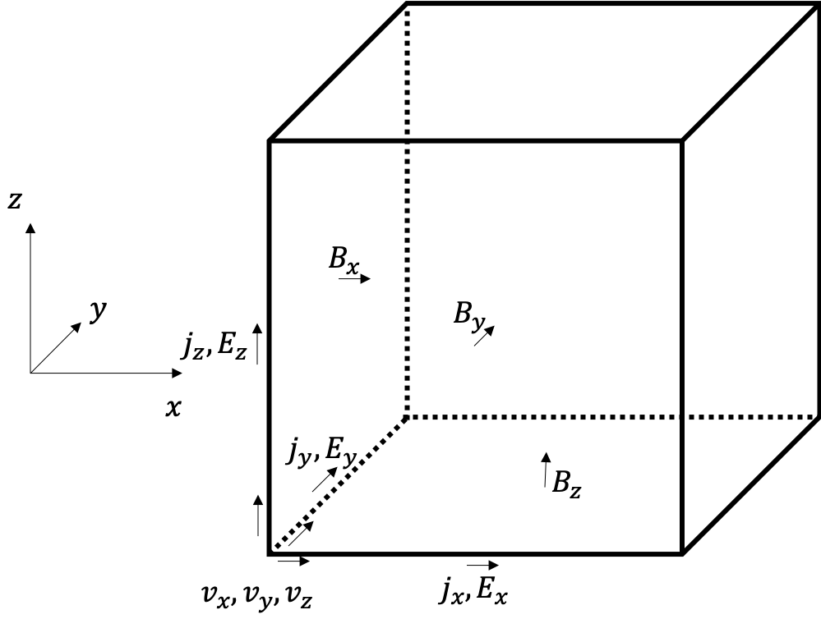

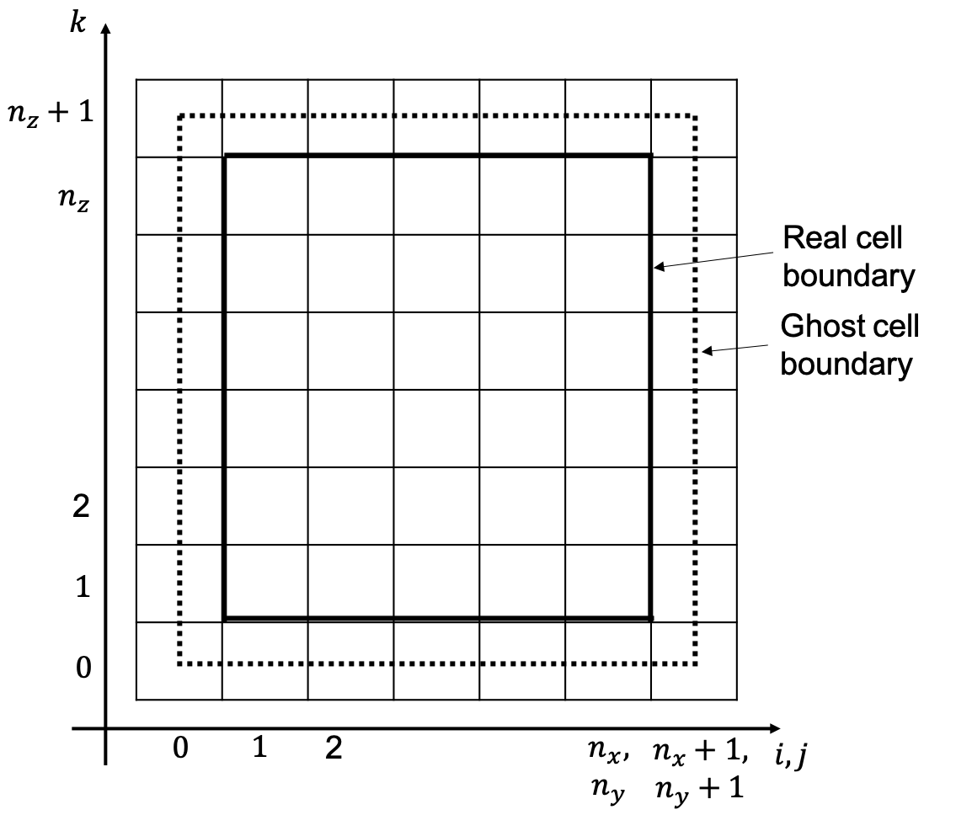

Figure 1: This figure shows where the variables are defined in 3D for a given cell.

Figure 2: This figure shows the index of each cell (i, j, k). It also shows which cells are labelled as real cells and which are labelled as ghost cells. Note that the ghost cell boundary passes through the middle of the cells since the code does not store values for the variables on the outer surface of the ghost cells