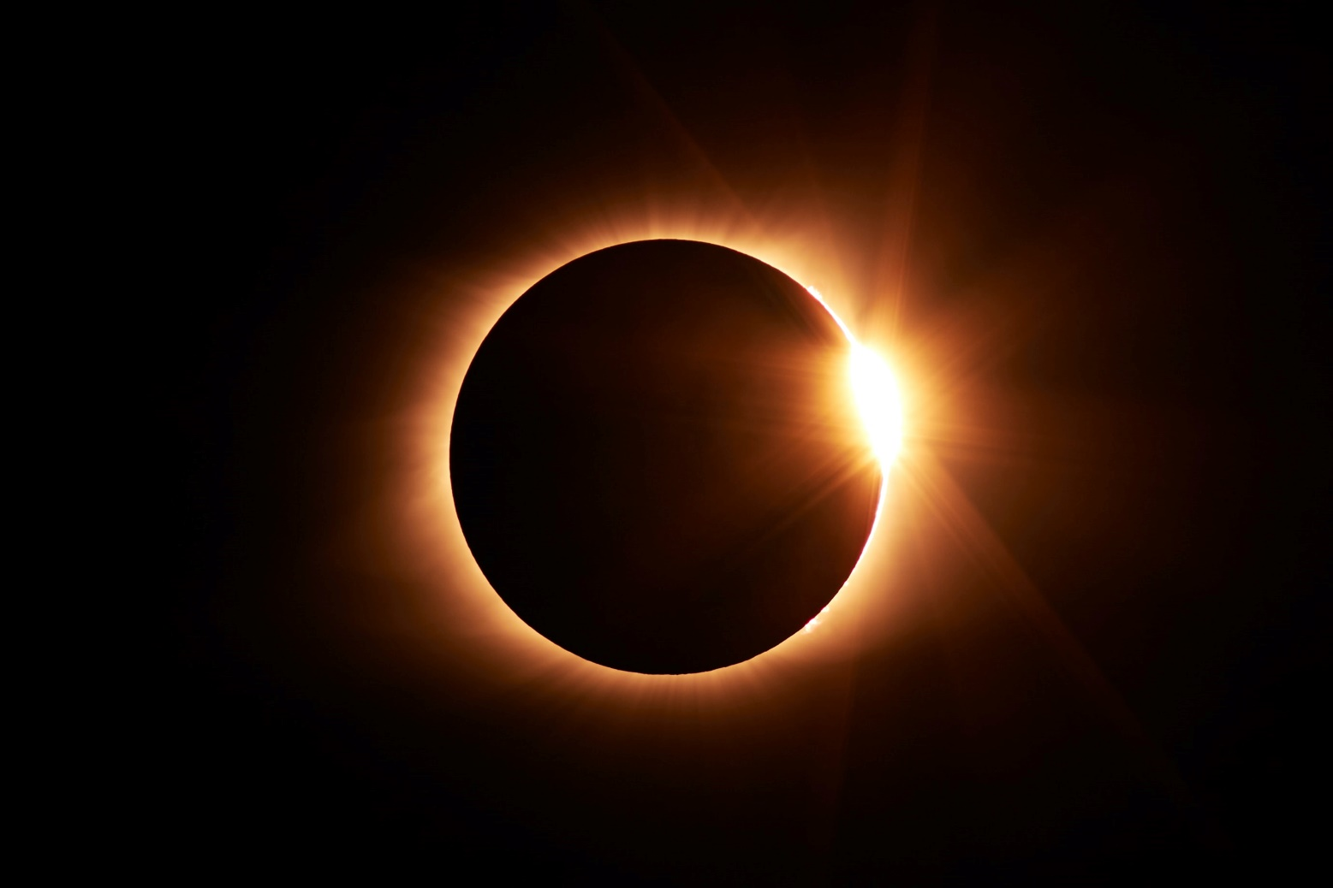

This thesis is submitted in partial fulfilment for the degree of Doctor of Philosophy (PhD)

June 2021

Alexander Philip Kofi Prokopyszyn

A mathematical investigation of the role of resonant absorption and phase mixing in coronal heating

Magnetohydrodynamic waves in the solar corona