Cypress Notes

Documentation to set up can be found at this link
https://docs.cypress.io/guides/getting-started/installing-cypress.html#Opening-Cypress
API documentation
https://docs.cypress.io/api/api/table-of-contents.html
Briefly, install cypress in the terminal.

To run tests, you must open the terminal and type: npx cypress open

This will open the cypress app, from which you can select your test files, run them, and view the snapshot at each step

Advantages vs Capybara
-For setting up state, can skip interacting with UI by setting it up directly using cy.request
-Debugging much easier as can look at screenshots step by step

Disadvantages vs Capybara
-Difficult to do conditional testing (eg. If A, then do B)... Cypress has written a whole page about why this causes flakiness. Cypress says there are workarounds, so let's see...
-The workarounds require the tester to have direct control over behaviour of the app – this will not work for us. For example, forcing elements to always have a certain behavior, reading the database directly to get app's 'state' etc.
-At the very end, the document shows an example of doing conditional testing just by looking for absence/presence of dom elements, just like I would do in Capybara. However, it seems more complicated to set up than in Capybara. It can also get the text of an element, and you can use that in conditional testing. You CANNOT get other info about the element, like styles, other attributes, and store those values separately to be used in if...then conditions. You can make assertions for styles, attributes etc, but you cannot get the values themselves. This is a HUGE disadvantage which, for me, makes it unusable unless we radically change the way we test. We would have to create a different org for each different test file to absolutely ensure that environment does not change between tests.
-doesn't have hover

Same as Capybara
-Cy has customizable waits for elements to load/become visible
eg cy.get('.my-slow-selector', { timeout: 10000 })

cy .get('.mobile-nav', { timeout: 10000 }) .should('be.visible') .and('contain', 'Home')
waits 10 seconds for get, should and contain

-Setting aliases to found elements using .as('myElement').... in capybara, you can assign the result of a find() to a variable and get same result

-cypess has before, after, beforeEach, and afterEach hooks

Notes
-Option to do synchronous vs asynchronous.... cy.get etc asynchronous (wait until exist it block before running)... cy.$('selector') is synchronous, executed when line is read. If want synchronous line to execute only after asynchronous parts are executed, put the synchronous part inside a .then callback
-assertions have implicit 'should' and explicit 'expect'
eg
cy.get('#header a') .should('have.class', 'active') .and('have.attr', 'href', '/users')

cy.get('tbody tr:first').should(($tr) => { expect($tr).to.have.class('active') expect($tr).to.have.attr('href', '/users') })

-commands are retried until all assertions pass or until timeout has occurred. Not all commands are retried. For example, click is not retried

-Cypress thinks a menu link 'Client HQs' is behind its parent, but this is not true
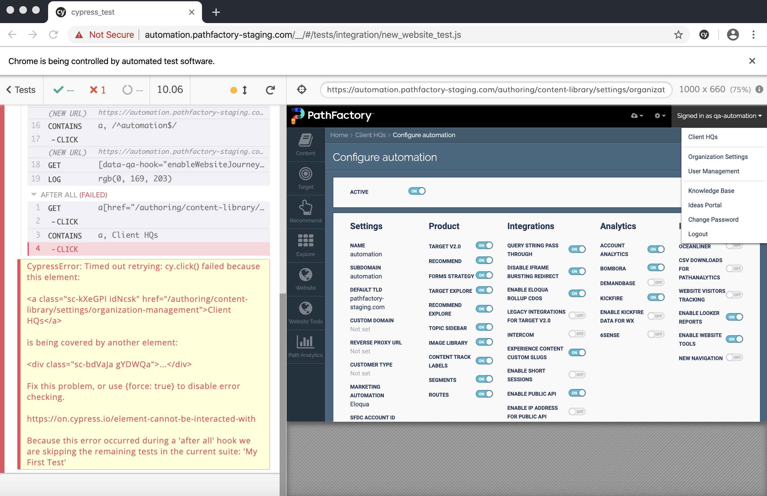
-worked fine in before hook, but not in after hook

Scraps of code

cy.document().then((doc) => {
// call whatever you want on your app's window
// so your app methods must be exposed somehow
//let x = document.querySelector('p').getAttribute('class');
//cy.log(doc.getElementById("root").getAttribute('style')) // This works
//let x = oc.querySelector('[id="root"]').getAttribute('style') // this works
//let x = doc.querySelector('[data-qa-hook="enableWebsiteJourney"]').getAttribute('class') // Element won't exist at the time this line is called due to async, must wait for doc to load first
let elem = doc.querySelector('[data-qa-hook="enableWebsiteJourney"]')
let style = getComputedStyle(elem)
cy.log(style['background-color'])
})
/*cy.get('[data-qa-hook="enableWebsiteJourney"]').invoke('text').then((text)=>{
cy.log(text) // This will log the text on that element, which is ONOFF
})*/
/*cy.get('[data-qa-hook="enableWebsiteJourney"]').invoke('attr', 'data-qa-hook').then((style)=>{
cy.log(style) // This will log the data-qa-hook
})*/
//cy.get('[data-qa-hook="enableWebsiteJourney"]').then(($toggle) => {
// cy.log(Object.keys($toggle)[4])
/*if ($toggle.its('background-color') == 'rgb(221, 221, 221)') {
cy.log("Toggle is off")
} else {
cy.log("Toggle is on")
}*/
//})
//if(cy.get('div[data-qa-hook="enableWebsiteJourney"]').find('span').first().invoke('attr', 'style', 'opacity') == 0) {
//cy.get('div[data-qa-hook="enableWebsiteJourney"]').click()
//}

/*
cy.get('a[href="/authoring/content-library/settings"]').click()
cy.contains('a', "Client HQs").click()
cy.contains('a', /^automation$/).click()
cy.wait(3000)
cy.document().then((doc) => {
let elem = doc.querySelector('[data-qa-hook="enableWebsiteJourney"]')
let style = getComputedStyle(elem)
cy.log(style['background-color'])
if(style['background-color'] == 'rgb(221, 221, 221)'){
cy.get('[data-qa-hook="enableWebsiteJourney"]').click()
}
})
*/
// This block also works
/*
cy.get('a[href="/authoring/content-library/settings"]').click()
cy.contains('a', "Client HQs").click()
cy.contains('a', /^automation$/).click()
cy.get('[data-qa-hook="enableWebsiteJourney"]').then((toggle)=>{
cy.document().then((doc) => {
let elem = doc.querySelector('[data-qa-hook="enableWebsiteJourney"]')
let style = getComputedStyle(elem)
cy.log(style['background-color'])
if(style['background-color'] == 'rgb(221, 221, 221)'){
toggle.click()
}
})
})
*/

Look at the FAQ section for hints about how to get element properties like background-color
Cypress elements wrapped in jquery, so can use jquery, rather than vanilla javascript, to get and manipulate element properties

https://docs.cypress.io/faq/questions/using-cypress-faq.html

https://www.tutorialrepublic.com/jquery-tutorial/jquery-get-and-set-css-properties.php

Tidbits of Knowledge
Cypress is Asynchronous
Cypress runs every 'cy' line asynchronously, so must be careful about assigning values to variables where you do something like let variable_name = cy.whatever.
If you want to store an element in a variable to be used later, the element must be passed in as an argument to a .then function. eg)
cy.get('[data-qa-hook="enableWebsiteJourney"]').then((toggle)=>{
//toggle is the element which you can now use inside the callback function
}
})

You cannot do
let toggle = cy.get('[data-qa-hook="enableWebsiteJourney"]')
Because cy will not execute at the same time that the variable is assigned, so toggle will be undefined.

Cypress wraps elements in jquery, so can use jquery functions on elements
Here's a link to a website that has jquery tutorials
https://www.tutorialrepublic.com/jquery-tutorial/jquery-get-and-set-css-properties.php
eg. Let's say you have element 'element'
element.css(“background-color”) // This will return value of background-color
//.css() is a jquery function

Conditional Testing Using Element Computed Styles (as in not declared in-line)
To do conditional checking by checking for element properties like background-color, you can get the background-color's value like this:
cy.get('[data-qa-hook="enableWebsiteJourney"]').then((toggle)=>{
let color = toggle.css("background-color")
if (color == 'rgb(221, 221, 221)'){
toggle.click()
}
})

Conditional Testing Using Element Attributes
If the style, or other attribute is declared in-line like <div style='blah' class='blah' data-qa-hook='blah'>, then you can get the value of that attribute like so:
cy.get('[data-qa-hook="enableWebsiteJourney"]').invoke('attr', 'data-qa-hook').then((attr)=>{
cy.log(attr) // This will log the data-qa-hook
})

Conditional Testing Using Element Text
If you want to get the Element's text for conditional testing, you can do it like this:
cy.get('[data-qa-hook="enableWebsiteJourney"]').invoke('text').then((text)=>{
cy.log(text) // This will log the text on that element, which is ONOFF
})

Conditional Testing Using Absence/Presence of Element
If you want to something different depending on whether or not an element is present, you can do it like this:
cy.get('button').click() //This will trigger some change which could do either A or B
cy.get('body').then(($body) => {
// synchronously query from body
// to find which element was created
if ($body.find('input').length) {
// if nothing found, length would be zero/undefined, and this is a falsy in javascript
return 'input'
}
// else assume it was textarea
return 'textarea'
}).then((selector) => {
// selector is the string that was returned in previous function
cy.get(selector).type(`found the element by selector ${selector}`)
})

Using Vanilla Javascript to Manipulate the DOM
If you want to do this, you can try:
cy.document().then((doc) => {
//querySelector is vanilla javascript function to find elements
let elem = doc.querySelector('[data-qa-hook="enableWebsiteJourney"]')
// getComputedStyle is vanilla js function to get non-in-line styles
let style = getComputedStyle(elem)
cy.log(style['background-color']) // Will log background color, style is css object
if(style['background-color'] == 'rgb(221, 221, 221)'){
// Do something
}
})

