GeoMart / GeoHub — Architecture and Operation Flows
Original architecture diagram with plain-language explanation of each operation
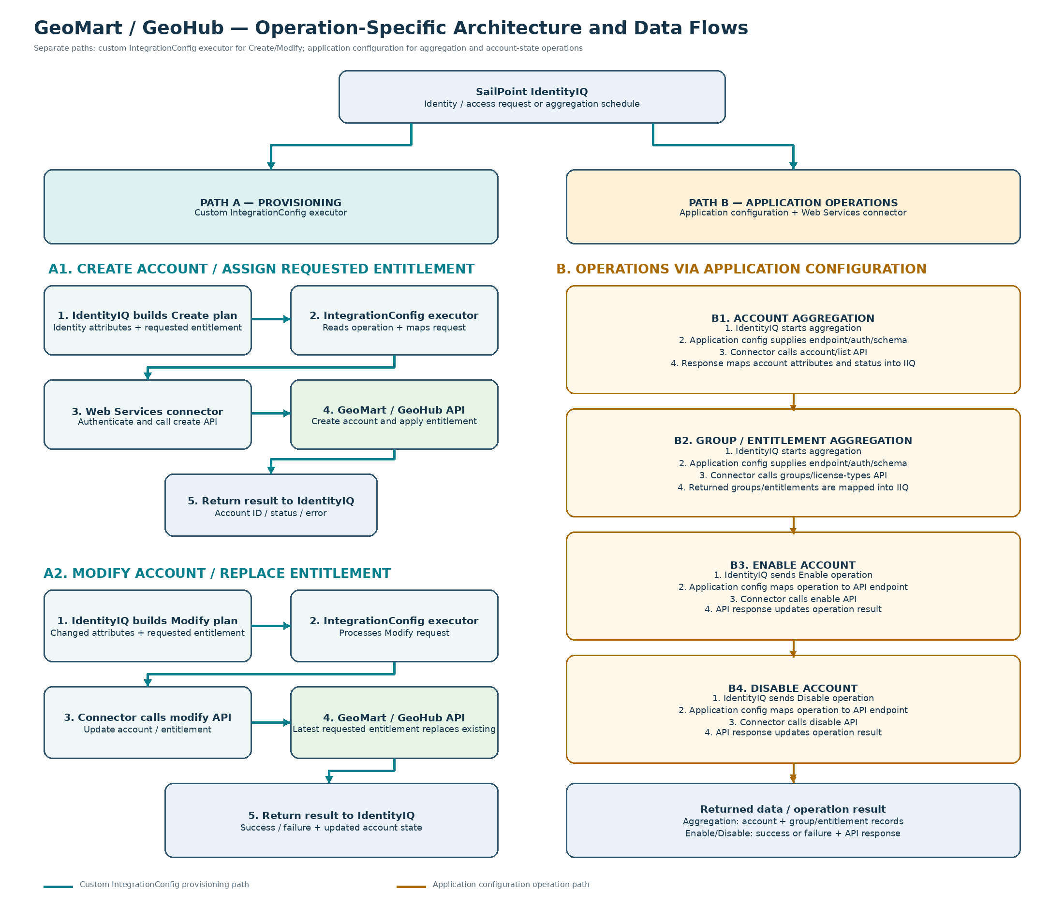
How each path works
A. Custom IntegrationConfig — Create and Modify | B. Application operations — Aggregation, Enable and Disable
CREATE ACCOUNT  Before: IIQ prepares the user's details and requested license.  Flow: The custom executor prepares the request; the Web Services connector calls GeoMart/GeoHub.  After: The account is created and the result is returned to IIQ.  MODIFY ACCOUNT / LICENSE  Before: IIQ sends changed details or a new license request.  Flow: The custom executor prepares the update and sends it through the connector.  After: Account details are updated; the latest requested license replaces the existing license. | ACCOUNT AGGREGATION  Before: IIQ starts an account refresh. Flow: The connector requests the user list. After: Account details return to IIQ and are linked to identities.  LICENSE / ENTITLEMENT AGGREGATION  Before: IIQ starts a license refresh. Flow: The connector requests available license types. After: License details refresh IIQ's entitlement list.  ENABLE / DISABLE ACCOUNT  Before: IIQ sends a state-change request. Flow: The connector calls the enable or disable API. After: The account state changes and the API result returns to IIQ.
Key behavior: Removing the final license disables the account. Adding a license to a disabled account enables it. IIQ should check the API response before recording success.

