GEOMART / GEOHUB

Provisioning Integration
Architecture & Design
Technical architecture and functional design

Document control | Value
Version | 1.0 – Revised technical design
Date | 23 October 2026
Scope | Identity provisioning for GeoMart / GeoHub through SailPoint IntegrationConfig and Web Services connector
Audience | IAM engineers, application owners, technical reviewers
Status | Revised to remove the demo plan and document the tested entitlement/account-state behavior

Important This document combines the supplied configuration with the tested runtime behavior confirmed by the implementation owner. The custom IntegrationConfigExecutor source was not included in the extract, so its internal code details are described at the functional level.

1. Executive Summary
The solution integrates SailPoint IdentityIQ (IIQ) with GeoMart / GeoHub applications using a custom IntegrationConfig executor and the Web Services connector. The IntegrationConfig named GeoMartIntegrationConfig is configured for Create and Modify operations and references five managed application resources: GeoMart-PROD, GeoMart-QA, GeoMart-Test, GeoMart-DEV, and GeoMart-TRN. The supplied GeoMart-Test application configuration shows token generation, account aggregation, user-license-type aggregation, single-user lookup, and account enable/disable endpoints.
The design centralizes provisioning orchestration while keeping environment-specific endpoint and credential settings in each application configuration. Provisioning creates or modifies a user and applies the requested license entitlement. The tested behavior is that the latest requested entitlement replaces the existing entitlement, removing the only entitlement disables the account, and adding an entitlement to a disabled account enables it.
Demo narrative Review the configuration → request/approval (if configured) → custom executor → connector endpoint → GeoMart response → IIQ result/audit flow, including account aggregation and create/modify/enable/disable behavior.

2. Goals

2.1 Goals
- Provide one integration orchestration pattern for GeoMart/GeoHub across DEV, TRN, Test, QA, and PROD.
- Support Create and Modify provisioning operations through the custom IntegrationConfig executor.
- Use the configured Web Services connector to communicate with GeoMart APIs.
- Retrieve account and user-license-type data for identity correlation and entitlement management.
- Handle account enable/disable operations and surface endpoint errors to the provisioning workflow.
- Make the design reviewable through architecture, runtime flows, functional rules, testing, and operations.

2.2 Non-goals / not evidenced in supplied material
- Defining the internal implementation of GeoMartIntegrationConfigExecutor; source code was not supplied.
- Defining approval policies, request forms beyond the visible application provisioning form, or certification campaigns.
- Guaranteeing exact retry, rollback, idempotency, or transaction semantics without executor and rule code review.
- Defining final business rules for multiple entitlements or account disablement when the last entitlement is removed.

3. Source Configuration and Observed Facts
Area | Observed in supplied extract | Design implication
IntegrationConfig | GeoMartIntegrationConfig; executor class com.xxx.integrationConfig.GeoMartIntegrationConfigExecutor; operations Create,Modify | Custom executor is the orchestration extension point; Create/Modify are the declared operations.
Managed resources | GeoMart-PROD, GeoMart-QA, GeoMart-Test, GeoMart-DEV, GeoMart-TRN | One integration configuration is associated with five environment-specific applications.
Connector | SailPoint Web Services connector; application type Web Services | API calls are configured as connector endpoints.
Authentication | Test Connection POSTs /generateToken?f=json with service username/password and referer; response maps token and expires | Token acquisition is part of connection setup; token lifetime/refresh handling needs validation.
Account aggregation | GET /portals/self/users with response root $.users | User attributes are mapped from the API response.
Entitlement aggregation | GET /portals/self/userLicenseTypes with response root $.userLicenseTypes | userLicenseTypeId is configured as a managed entitlement/group-like object.
Single object lookup | GET /community/users/$plan.nativeIdentity$ | Single-user read supports targeted lookups during provisioning.
Account state | POST /portals/self/enableUsers and /portals/self/disableUsers | Explicit enable and disable endpoint operations exist.
Provisioning form | Create Policy for GeoMart includes email, firstname, lastname, idpUsername, username, provider | Several values are populated from the IIQ identity; provider is set to enterprise.
Error handling | Endpoint mappings include error.code and error.details[0]; before/after rules are configured | Rules and response mappings participate in handling endpoint calls and results.

4. Solution Architecture
The following logical view reflects the supplied configuration and a proposed end-to-end request path. Dashed/qualified behavior must be confirmed against the executor and rule source.
Requester / IIQ Identity / Access Request
SailPoint IdentityIQ • Request plan / Provisioning plan / Workflow
IntegrationConfig  GeoMartIntegrationConfig | Custom executor  GeoMartIntegrationConfigExecutor | Application config  GeoMart-Test / QA / DEV / TRN / PROD
Provisioning rules  Before / after hooks | Web Services connector  Endpoint + response mapping | Environment properties  Base URL, service account, page size
GeoMart / GeoHub REST API → token • users • license types • enable/disable • create/modify (implementation to verify)

Logical flow: Request/plan → IntegrationConfig dispatch → custom executor and configured application → rules/connector endpoint → GeoMart API → response/error mapping → provisioning result and audit.

4.1 Operation-Specific Architecture and Data Flow
The diagram separates operations by execution path. Create and Modify are processed through the custom IntegrationConfig executor. Account aggregation, group/entitlement aggregation, Enable, and Disable are processed through the application configuration and Web Services connector. Each operation shows the request or trigger, configuration/connector processing, API interaction, and the resulting data or status returned to IdentityIQ. The diagram is a functional view based on the supplied configuration and tested behavior.
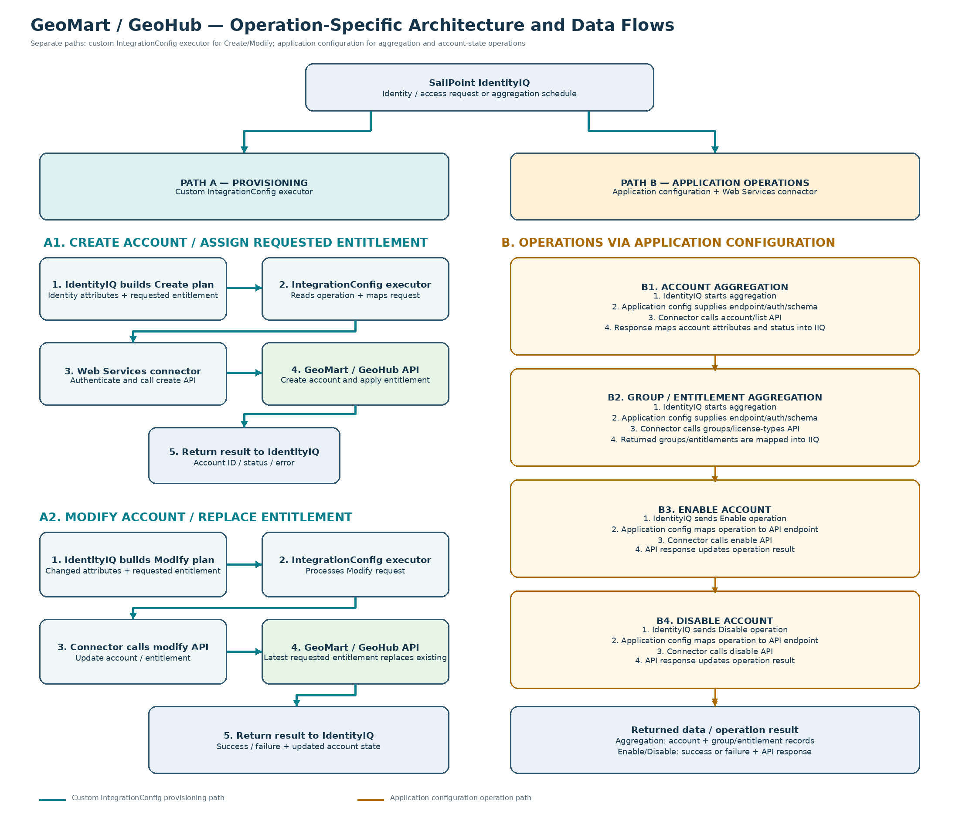
Figure 1. Operation-specific application data flow and provisioning architecture.

4.2 Operation Processing Details

A. Create account — Custom IntegrationConfig executor
1. IdentityIQ creates a provisioning plan containing the identity attributes and requested entitlement.
2. The custom IntegrationConfig executor identifies the Create operation and maps the plan into the application request format.
3. The Web Services connector obtains authentication as configured and sends the create request to the selected GeoMart/GeoHub API endpoint.
4. The API creates the account and applies the requested entitlement according to the tested application behavior.
5. The connector/executor interprets the response and returns success or failure details to IdentityIQ; returned account identifiers and status are recorded where supported.

B. Modify account / entitlement — Custom IntegrationConfig executor
1. IdentityIQ creates a Modify provisioning plan containing the changed account attributes and requested entitlement.
2. The custom executor processes the Modify operation and maps the request to the appropriate API payload.
3. The Web Services connector sends the request to the configured modify endpoint.
4. GeoMart/GeoHub updates the account. When a different entitlement is requested, the latest requested entitlement replaces the existing entitlement.
5. The API response is mapped to the provisioning result and returned to IdentityIQ.

C. Account aggregation — Application configuration
1. An IdentityIQ aggregation task starts account aggregation for the selected application.
2. The application configuration supplies the environment endpoint, authentication settings, account schema, and aggregation request details.
3. The Web Services connector calls the configured account/list endpoint.
4. The response is parsed and mapped to the IdentityIQ account schema, including supported account attributes and account status.
5. IdentityIQ correlates the returned accounts to identities and updates the application account data.

D. Group / entitlement aggregation — Application configuration
1. An IdentityIQ aggregation task starts group or entitlement aggregation.
2. The application configuration supplies the configured endpoint, authentication, and response mapping.
3. The connector calls the configured group/license-type endpoint.
4. Returned group or license-type records are parsed and mapped to the entitlement schema.
5. IdentityIQ refreshes the application entitlement catalogue based on the returned records.

E. Enable account — Application configuration
1. IdentityIQ issues an Enable operation for the target account.
2. The application configuration maps the Enable operation to the configured endpoint and request format.
3. The Web Services connector sends the authenticated request to the GeoMart/GeoHub API.
4. The API enables the account and returns a response.
5. The connector maps the response to success or failure; IdentityIQ records the provisioning result.

F. Disable account — Application configuration
1. IdentityIQ issues a Disable operation for the target account. This also occurs under the tested rule when the account's final entitlement is removed.
2. The application configuration maps the Disable operation to the configured endpoint and request format.
3. The Web Services connector sends the authenticated request to the GeoMart/GeoHub API.
4. The API disables the account and returns a response.
5. The connector maps the response to success or failure; IdentityIQ records the provisioning result.

G. Add entitlement to a disabled account — Application configuration / provisioning behavior
1. IdentityIQ submits the entitlement-add request for the disabled account.
2. The configured provisioning path sends the entitlement request to the API.
3. GeoMart/GeoHub applies the requested entitlement.
4. Under the tested behavior, adding an entitlement to a disabled account enables the account.
5. The resulting account state and provisioning status are returned to IdentityIQ.

4.3 Main components
Component | Responsibility | Notes
IdentityIQ request/provisioning engine | Builds the provisioning plan and invokes the integration path. | Exact workflow trigger and approvals depend on the IIQ deployment.
GeoMartIntegrationConfig | Declares executor, Create/Modify operations, and managed resources. | Resource list is explicit in the supplied XML.
GeoMartIntegrationConfigExecutor | Custom orchestration for supported operations. | Implementation not supplied; verify dispatch, entitlement logic, state handling, and error propagation.
GeoMart application config | Contains endpoint definitions, environment values, schemas, mappings, and rules. | GeoMart-Test is the detailed sample; other environments may differ.
Web Services connector | Performs configured HTTP calls and parses response payloads. | Endpoint mappings show JSON response fields and accepted HTTP status 200.
GeoMart / GeoHub API | External system of record for accounts and license types. | API contract and actual response semantics should be validated with application owners.

5. Environment and Configuration Model
The integration points to five managed resources. Each application should have its own endpoint/base URL and environment-specific service account/secret references. The sample is GeoMart-Test and uses substitution tokens for environment values.
Environment | Managed resource name | Configuration to validate
Production | GeoMart-PROD | Production base URL, hostname, credentials, page size, role/license IDs, change controls
QA | GeoMart-QA | QA base URL and service account; test data and API behavior
Test | GeoMart-Test | Sample configuration provided; use for demo only if approved
Development | GeoMart-DEV | Development endpoint and test identities
Training | GeoMart-TRN | Training endpoint and seeded demo data

5.1 Key configuration properties observed
- genericWebServiceBaseUrl and geomart_hostname are environment substitutions.
- geomart_username and geomart_password are sourced from environment substitutions; the encrypted-key list includes geomart_password and other token/key properties.
- The sample uses a service-account token request to /generateToken?f=json, with Content-Type application/x-www-form-urlencoded.
- The account aggregation endpoint uses a configured page-size substitution and maps the JSON users array.
- The userLicenseTypes endpoint maps license attributes such as id, name, description, level, state, maxUsers, and isEsriDefault.
- The application schema identifies username as both display and identity attribute; userLicenseTypeId is marked as an entitlement and managed attribute.

6. End-to-End Runtime Flows

6.1 Connection and token acquisition
- IdentityIQ invokes the connector's Test Connection operation.
- The configured endpoint sends POST /generateToken?f=json with username, password, and portal referer in form data.
- The response mapping extracts token, expires, error.code, and error.details[0].
- The integration/rules must ensure the token is valid for subsequent API calls and refreshed when expired.
Validation point The extract demonstrates token generation and token placeholders, but does not prove the complete refresh lifecycle. Confirm whether before/after rules replace REPLACENEWTOKEN and where token expiry is checked.

6.2 Account aggregation
- The connector calls GET /portals/self/users with the configured page-size parameter and token.
- The response root is $.users.
- Mapped fields include id, username, fullname, email, firstname, lastname, userType, idpUsername, disabled, provider, userLicenseTypeId, groups, and tags.
- Tags include derived department, manager, and lobDisplayName values.
- The configured GeoMart Correlation object and ResourceObjectCustomization rule participate in account correlation/customization.

6.3 Entitlement / license-type aggregation
- The connector calls GET /portals/self/userLicenseTypes?start=1&num=10&f=json with a token.
- The response root is $.userLicenseTypes.
- The schema represents userLicenseTypeId as a managed entitlement object, with attributes including id, name, description, level, state, maxUsers, and isEsriDefault.
- The sample endpoint starts with num=10 while pagingSize is 50; confirm how the connector handles additional pages and whether the API response can exceed the initial request.

6.4 Create / Modify provisioning
The IntegrationConfig declares Create and Modify operations. The sample create form builds account attributes from the IIQ identity: first name, last name, email, idpUsername, username, and provider=enterprise. The account schema uses username as the identity key. The precise custom executor behavior for entitlement payloads is not available in the supplied source.
- Receive the IIQ provisioning plan and determine target application/environment.
- Validate identity attributes and requested entitlement(s); reject or report missing mandatory data.
- Determine whether the target account exists and whether the operation is Create or Modify (exact logic to verify).
- Build the GeoMart/GeoHub API request using the selected application configuration and token.
- Execute the required API call(s), inspect both HTTP status and API-level error fields, and capture response details.
- Return a provisioning result to IIQ and log an auditable outcome without exposing secrets.

6.5 Enable / Disable account
The sample defines POST endpoints for /portals/self/enableUsers and /portals/self/disableUsers. Both submit a token and a users array containing the plan native identity. The presence of these endpoints does not by itself prove when the custom executor invokes them.
Trigger candidate | Expected action to approve | Status
Explicit enable request | Call enableUsers for the selected account | Endpoint configured; trigger logic to verify
Explicit disable request | Call disableUsers for the selected account | Endpoint configured; trigger logic to verify
Add entitlement to a disabled account | Should the account be enabled automatically? | Raised in screenshot; decision required
Remove the only entitlement | Should account be disabled when no entitlements remain? | Raised in screenshot; decision required

7. Entitlement and Account-State Business Rules
The chat screenshot raised four behavior questions. The tested entitlement and account-state behavior is documented below as confirmed functional behavior; the Postman collection reuse item remains implementation guidance.
Decision | Confirmed behavior | Implemented rule | Operational note
BR-01: Multiple entitlements | When another entitlement is requested, the latest request replaces the existing entitlement. | The latest requested entitlement replaces the existing entitlement. | Verify the resulting entitlement state after provisioning; do not assume multiple license types remain assigned.
BR-02: Remove final entitlement | When the user's only entitlement is removed, the account is disabled. | The account is disabled when the only entitlement is removed and no entitlements remain. | Confirm the final entitlement count/state and record the disable action in the provisioning audit.
BR-03: Add entitlement to disabled account | When an entitlement is added to a disabled account, the account is enabled. | The account is enabled when an entitlement is added. | Ensure enablement occurs as part of the successful provisioning flow and is captured in the operation result/audit.
BR-04: Postman collection | The collection can be reused for ELEVATE after environment and API-specific adaptation. | Reuse the collection after adapting it to the target application's API contract and environment. | Sanitize secrets and verify host, auth, variables, request schemas, and tests before reuse.

Confirmed behavior The behaviors listed below are treated as tested and confirmed for this design. Retain regression tests for each rule when the executor or application configuration changes.

8. Error Handling, Resilience and Audit

8.1 Error handling
- Treat HTTP 200 as transport-level success only; inspect API-level error.code/error.details[0] where returned.
- Use the configured before/after rules to validate request preparation and response interpretation; confirm their exact behavior from rule source.
- Propagate provisioning failures when a before/after provisioning rule throws an exception; the sample sets throwProvBeforeRuleException and throwProvAfterRuleException to true.
- Do not report success until the target API response has been evaluated and the operation's intended state is confirmed.
- Avoid logging passwords, tokens, private keys, or full sensitive request bodies.

8.2 Retry and idempotency
The sample lists retryable error strings including “Connection timed out” and “Exception”, plus single-character entries (“a”, “e”, “i”, “o”, “u”). Those single-character entries appear unusually broad and should be reviewed before relying on them. Retry only operations known to be safe or protected by idempotency checks. For timeouts after a write, query the account state before replaying the operation.

8.3 Audit fields to capture
- Correlation/request ID, identity identifier, application/environment, operation type, and timestamp.
- Target account native identity and entitlement before/after state where available.
- Endpoint name (not secrets), HTTP status, sanitized API error code/message, retry count, duration, and final outcome.
- Who/what initiated the request and the approval reference where applicable.

9. Security Design
- Keep credentials and private key material in the platform's approved secret/encryption mechanism; never embed real secrets in XML committed to source control.
- Use least-privilege service accounts scoped to the required account and license operations.
- Use TLS and validate certificate trust; verify whether client certificate authentication is intentionally disabled in the sample.
- Redact tokens and credentials from logs, traces, screenshots, Postman exports, and demo recordings.
- Separate environment credentials and ensure the integration cannot accidentally target production during a test/demo.
- Review token expiry, token refresh, endpoint URL allow-listing, and secure handling of the referer field.
- Use change management and approval controls for high-impact disablement or entitlement-removal actions.

10. Data Mapping
IIQ / schema field | GeoMart response field or source | Purpose / notes
id | id | External account identifier
username | username | Configured identity/display attribute
fullname | fullName | Display name
email | email | Contact/login-related attribute
firstname / lastname | firstName / lastName | Identity profile fields
idpUsername | idpUsername | Identity-provider username
userType | userType | Account classification
disabled | disabled | Account state; sample enable status expression is disabled=false
userLicenseTypeId | userLicenseTypeId | Managed entitlement reference
groups | groups[*] | Multi-valued group data
tags.department | tags filtered by department:* | Department tag extraction
tags.manager | tags filtered by manager:* | Manager tag extraction
tags.lobDisplayName | tags filtered by lobDisplayName:* | Line-of-business display tag
provider | provider | Provider value; create form defaults to enterprise
license type attributes | id, name, description, level, state, maxUsers, isEsriDefault | Entitlement catalog attributes

11. Test Strategy and Acceptance Criteria
Test ID | Scenario | Expected result / acceptance criterion
TC-01 | Test connection with valid credentials | Token endpoint returns a valid response; token/expiry are parsed; no secret is logged.
TC-02 | Test connection with invalid credentials | Failure is visible and actionable; API error is captured without leaking credentials.
TC-03 | Aggregate accounts | Users array is parsed and mapped; username/native identity and disabled state are populated.
TC-04 | Aggregate license types | userLicenseTypes array is parsed; managed entitlement attributes are visible.
TC-05 | Create account | Required attributes are sent; API outcome is evaluated; IIQ records success/failure accurately.
TC-06 | Modify account / add entitlement | The latest requested entitlement replaces the existing entitlement.
TC-07 | Remove final entitlement | Removing the final entitlement disables the account.
TC-08 | Add entitlement to disabled account | Adding an entitlement to a disabled account enables the account and the action is logged.
TC-09 | API returns application-level error with HTTP 200 | Operation is not falsely marked successful; sanitized error is propagated.
TC-10 | Timeout during write | Retry behavior avoids duplicate or conflicting changes; final state is checked.
TC-11 | Environment isolation | Test plan targets the selected non-production application; production cannot be selected accidentally.
TC-12 | Audit and secret review | Logs include operation/outcome metadata but do not contain passwords, tokens, or private keys.

12. Deployment and Rollback

13.1 Deployment sequence
- Regression-test the confirmed business rules BR-01 through BR-03 and validate the Postman collection reuse approach.
- Review custom executor and referenced before/after rules in source control.
- Validate environment-specific application XML, endpoint URLs, credentials, role/license IDs, and page-size substitutions.
- Deploy first to DEV, then Test/QA; execute the test cases and obtain application-owner sign-off.
- Promote the approved configuration to PROD through the standard change process.
- Run a controlled smoke test, monitor provisioning results, and retain the deployment/change reference.

13.2 Rollback approach
Rollback should restore the previous IntegrationConfig, application configuration, executor/rule package, and environment properties using the team's deployment process. For already-executed account or entitlement changes, configuration rollback alone does not reverse external state; define compensating API actions and obtain application-owner approval. Preserve audit evidence.

13. Operational Monitoring
Signal | Suggested monitoring / response
Provisioning failures | Trend failures by operation and environment; alert on sustained spikes.
Token/auth failures | Alert on repeated authentication failures or token refresh errors; validate credential rotation.
API latency/timeouts | Track endpoint duration and timeout frequency; check network and service health.
Application-level errors | Group by sanitized error code/message; route to GeoMart application support.
Unexpected state changes | Compare requested vs actual entitlement/account state; investigate mismatches.
Aggregation freshness | Track last successful account and entitlement aggregation times.

14. Risks, Assumptions and Open Items
Type | Item | Action / owner
Confirmed behavior | Latest requested entitlement replaces the existing entitlement | Retain regression test TC-06.
Confirmed behavior | Removing the final entitlement disables the account | Retain regression test TC-07.
Confirmed behavior | Adding an entitlement to a disabled account enables it | Retain regression test TC-08.
Implementation guidance | Reuse Postman collection for ELEVATE after adapting environment/API-specific details | API owner to provide sanitized collection and approve reuse.
Technical validation | Custom executor source is not included | Engineering to document operation dispatch, payload construction, error handling, and transaction behavior.
Technical validation | Before/after rule source is not included | Engineering to inspect token replacement, response handling, and exception behavior.
Technical validation | Retryable error list includes single-character values | Review and narrow matching criteria.
Technical validation | Token refresh and expiry handling not fully evidenced | Confirm lifecycle and test expired-token recovery.
Technical validation | Pagination behavior is not fully evidenced | Validate account and license-type paging against API limits.

15. Functional Summary
- The integration configuration declares Create and Modify operations and associates the integration with five GeoMart environments.
- The GeoMart-Test application uses the SailPoint Web Services connector and defines token, account aggregation, license-type aggregation, single-user lookup, enable, and disable operations.
- Account and license data are mapped into IIQ schemas, with userLicenseTypeId modeled as a managed entitlement.
- The custom executor is the orchestration component. The implementation owner has confirmed the create/modify entitlement and account-state behavior documented here.
- The key functional behaviors are latest-entitlement replacement, disabling after final entitlement removal, automatic enablement when an entitlement is added to a disabled account, and controlled reuse of the Postman collection.
- Production readiness depends on regression-testing these confirmed rules, validating token/error/retry handling, and passing the acceptance tests.

Appendix A. Configuration Names Referenced
Object / rule | Role in observed configuration
GeoMartIntegrationConfig | IntegrationConfig with custom executor and managed resources
com.xxx.integrationConfig.GeoMartIntegrationConfigExecutor | Custom executor class (implementation not supplied)
GeoMart Correlation | Account correlation configuration
xxx-Rule-ResourceObjectCustomization-GeoMart | Account resource customization
xxx-Rule-BeforeProvisioning-GeoHub | Before-provisioning rule
xxx-Rule-WebServiceBeforeOperationRule-GeoHub-getAllAccountsToken | Before rule for account aggregation
xxx-Rule-WebServiceAfterOperationRule-GeoMart-GetAllAccounts | After rule for account aggregation
xxx-Rule-WebServiceBeforeOperationRule-GeoHub-getToken | Before rule on selected API endpoints
xxx-Rule-WebServiceAfterOperationRule-GeoHub-TestConnection | After rule referenced by multiple endpoints
xxx-Custom-ApplicationActionCodeMapping-GeoHub | Custom action-code mapping

Appendix B. Provisioning Validation Record
Item | Record during validation
Environment tested | ____________________________________________
Test identity reference | ____________________________________________
Operations validated | ____________________________________________
Test cases passed / failed | ____________________________________________
Business rules tested | BR-01: ______ BR-02: ______ BR-03: ______ BR-04 collection reuse: ______
Issues / follow-up owners | ____________________________________________
Approver and date | ____________________________________________

