**SQL EXERCISE – STORED PROCEDURE**

**Exercise 1: Create a Stored Procedure**

**Code :-**

USE employe;

GO

CREATE TABLE Departments (

DepartmentID INT PRIMARY KEY,

DepartmentName VARCHAR(100) NOT NULL

);

CREATE TABLE Employees (

EmployeeID INT PRIMARY KEY,

FirstName VARCHAR(50) NOT NULL,

LastName VARCHAR(50) NOT NULL,

DepartmentID INT NOT NULL

REFERENCES Departments(DepartmentID),

Salary DECIMAL(10,2) NOT NULL,

JoinDate DATE NOT NULL

);

GO

INSERT INTO Departments (DepartmentID, DepartmentName) VALUES

(1, 'HR'),

(2, 'Finance'),

(3, 'IT'),

(4, 'Marketing');

INSERT INTO Employees (EmployeeID, FirstName, LastName, DepartmentID, Salary, JoinDate) VALUES

(1, 'Alekya', 'Gatu', 1, 78000.00, '2022-01-28'),

(2, 'Ammu', 'Ammu', 2, 95000.00, '2020-02-27'),

(3, 'Pranu', 'Ekbote', 3, 86000.00, '2015-09-14'),

(4, 'Keerthi', 'Reddy', 4, 55500.00, '2020-08-10');

GO

-- Query to Retrieve employees by department

DROP PROCEDURE IF EXISTS sp_GetStaffByDept;

GO

CREATE PROCEDURE sp_GetStaffByDept

@DeptID INT

AS

BEGIN

SELECT

e.EmployeeID,

e.FirstName,

e.LastName,

d.DepartmentName AS DeptName,

e.Salary,

e.JoinDate

FROM Employees AS e

JOIN Departments AS d

ON e.DepartmentID = d.DepartmentID

WHERE e.DepartmentID = @DeptID

ORDER BY e.LastName, e.FirstName;

END;

GO

-- Query to Insert a new employee with automatic ID assignment

DROP PROCEDURE IF EXISTS sp_AddNewStaff;

GO

CREATE PROCEDURE sp_AddNewStaff

@FirstName VARCHAR(50),

@LastName VARCHAR(50),

@DepartmentID INT,

@Salary DECIMAL(10,2),

@JoinDate DATE

AS

BEGIN

DECLARE @NewID INT;

SELECT @NewID = ISNULL(MAX(EmployeeID), 0) + 1 FROM Employees;

INSERT INTO Employees (

EmployeeID, FirstName, LastName, DepartmentID, Salary, JoinDate

)

VALUES (

@NewID, @FirstName, @LastName, @DepartmentID, @Salary, @JoinDate

);

SELECT @NewID AS NewEmployeeID;

END;

GO

-- Example: Retrieve staff in department 3

EXEC sp_GetStaffByDept @DeptID = 3;

**Output :-**

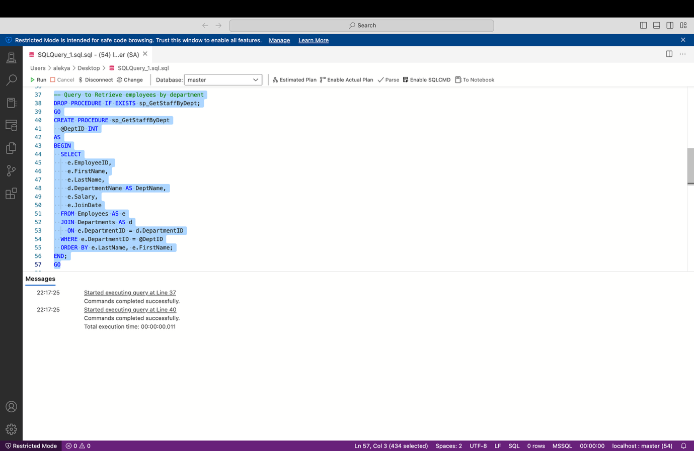

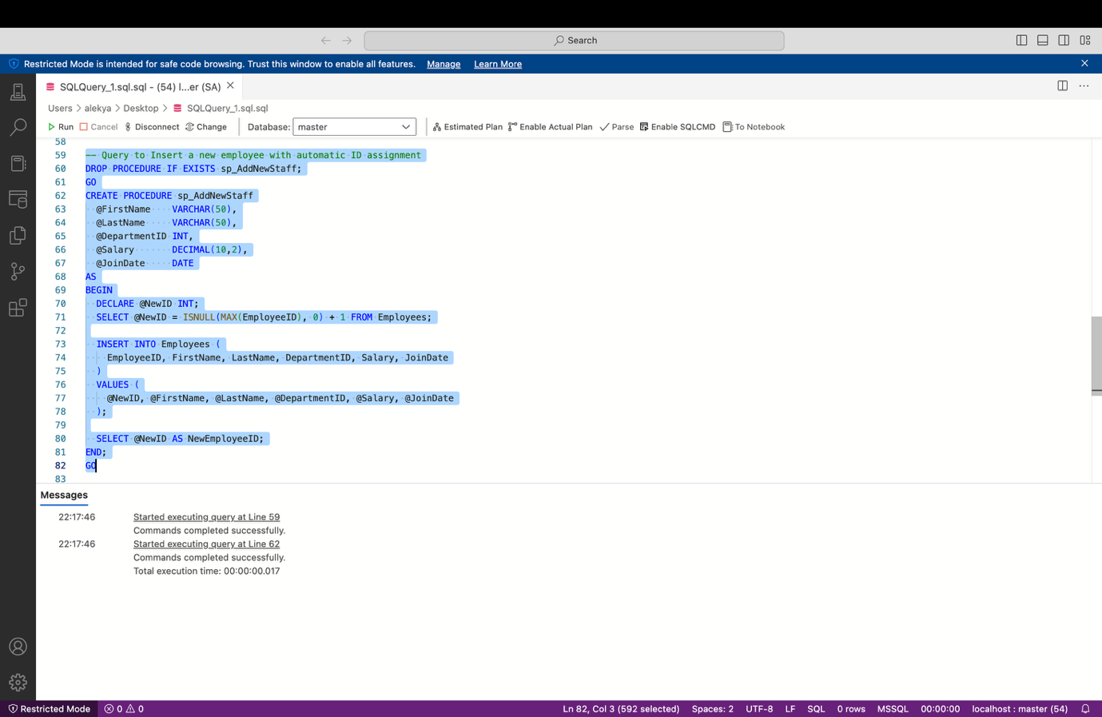

**Query Output :-**

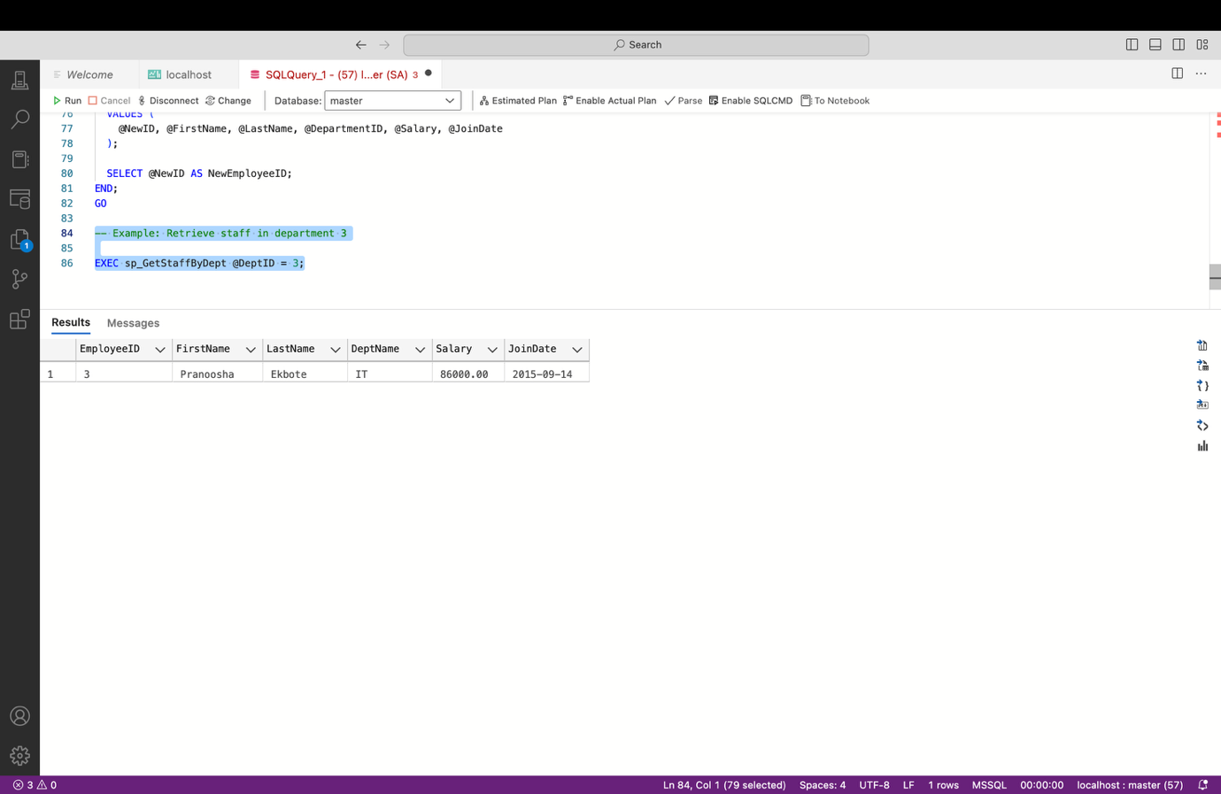

**Exercise 5: Return Data from a Stored Procedure**

**Code :-**

-- Step 1: Create Database

CREATE DATABASE CompanyDB_EmployeeCount;

GO

USE CompanyDB_EmployeeCount;

GO

-- Step 2: Create Departments Table

CREATE TABLE Departments (

DepartmentID INT PRIMARY KEY IDENTITY(1,1),

DepartmentName VARCHAR(100) NOT NULL

);

GO

-- Step 3: Create Employees Table

CREATE TABLE Employees (

EmployeeID INT PRIMARY KEY IDENTITY(1,1),

FirstName VARCHAR(50) NOT NULL,

LastName VARCHAR(50) NOT NULL,

DepartmentID INT NOT NULL,

Salary DECIMAL(10,2),

JoinDate DATE,

FOREIGN KEY (DepartmentID) REFERENCES Departments(DepartmentID)

);

GO

-- Step 4: Insert Sample Departments

INSERT INTO Departments (DepartmentName) VALUES

('Human Resources'),

('Finance'),

('Engineering'),

('Marketing');

GO

-- Step 5: Insert Sample Employees

INSERT INTO Employees (FirstName, LastName, DepartmentID, Salary, JoinDate) VALUES

('Koushi', 'Sharma', 3, 89000, '2024-05-10'), -- Engineering

('Sri', 'Laxmi', 3, 70000, '2023-11-01'), -- Engineering

('Chethana', 'Kamsali', 1, 95000, '2022-07-15'), -- HR

('Varalax', 'Reddy', 2, 75000, '2024-01-20'); -- Finance

GO

-- Step 6: Create Stored Procedure to Return Employee Count by Department

CREATE PROCEDURE sp_GetEmployeeCountByDepartment

@DepartmentID INT

AS

BEGIN

SELECT

COUNT(*) AS TotalEmployees

FROM

Employees

WHERE

DepartmentID = @DepartmentID;

END;

GO

--Example Query: Get Employee Count for Engineering Department (DepartmentID = 3)

EXEC sp_GetEmployeeCountByDepartment @DepartmentID = 3;

GO

**Output :-**

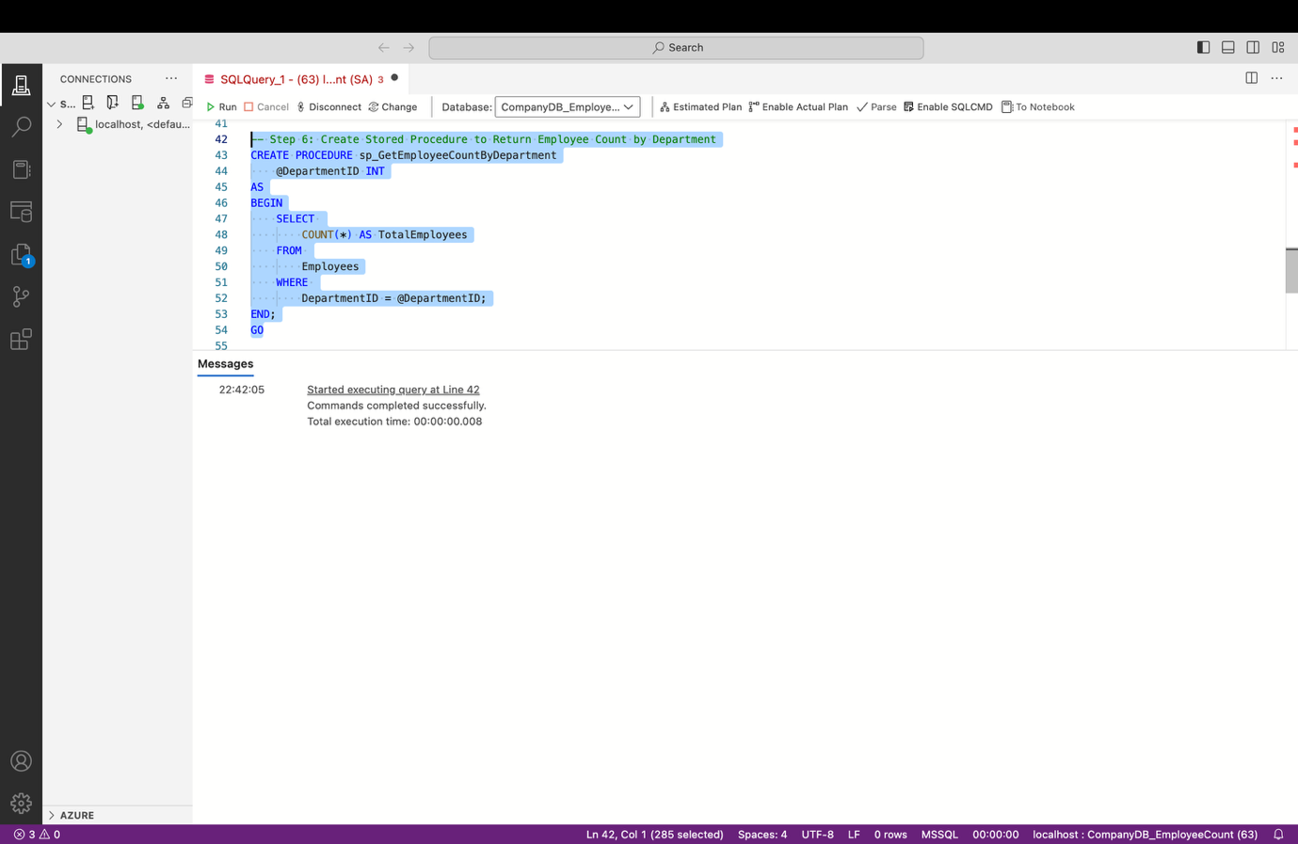

**Query Output :-**

