

IT342-G5
System Integration and Architecture

System Design Document (SDD)

Project Title: PirmaPH
Prepared By: Binagatan, Alexander Jr. Bersano

Version: 0.2
Date: 2/27/2026
Status: Draft

REVISION HISTORY TABLE
Version | Date | Author | Changes Made | Status
0.1 | 2/20/2026 | Alexander Jr. Binagatan | Initial draft | Draft
0.2 | 2/27/2026 | Alexander Jr. Binagatan | Final review and corrections | Final

TABLE OF CONTENTS
Contents
EXECUTIVE SUMMARY 4
1.0 INTRODUCTION 5
2.0 FUNCTIONAL REQUIREMENTS SPECIFICATION 5
3.0 NON-FUNCTIONAL REQUIREMENTS 8
4.0 SYSTEM ARCHITECTURE 9
5.0 API CONTRACT & COMMUNICATION 10
Authentication Endpoints 11
User Registration 11
User Login 11
6.0 DATABASE DESIGN 13
7.0 UI/UX DESIGN 14
8.0 PLAN 17

EXECUTIVE SUMMARY
1.1 Project Overview
PirmaPH is a digital service platform designed to streamline the process of requesting official barangay documents such as barangay clearance and certificate of residency. The system enables residents to submit document requests online, track request status, and receive updates without repeatedly visiting the barangay office.
The system includes a Spring Boot backend API, a React web application, and an Android mobile application, all integrated to provide seamless service access across multiple platforms. The backend manages authentication, request processing, role-based access control, and data storage, while the web and mobile applications provide user-friendly interfaces for residents and barangay officers.
This integrated architecture supports digital transformation initiatives in local government units (LGUs) by improving operational efficiency, transparency, and service accessibility.
1.2 Objectives
- Develop a fully functional barangay document request system with authentication, request submission, approval workflow, and status tracking
- Implement a three-tier architecture using Spring Boot (backend API), React (web application), and Android (mobile application)
- Create RESTful APIs to enable secure communication between the backend, web client, and mobile client
- Implement role-based access control for residents and barangay officers
- Design responsive and consistent user interfaces for both web and mobile platforms
- Deploy backend and frontend components in production-ready environments
- Ensure secure data handling using encrypted passwords and validated inputs
1.3 Scope
Included Features:
- User registration and authentication (email/password, role-based access)
- Resident dashboard displaying request status and announcements
- Profile management with request history
- Online document request submission (document type selection, purpose input, ID image upload)
- Officer panel for reviewing, approving, rejecting, and marking requests as ready for release
- Request status tracking and notification updates
- RESTful API integration between frontend applications and backend
- PostgreSQL (or MySQL) relational database with structured schema
- Responsive React web interface
- Native Android mobile application integrated with backend API
- Secure password hashing and input validation
Excluded Features:
- Online payment gateway integration
- SMS gateway integration
- Automated PDF document generation
- QR code-based document claiming
- Push notification system
- Email notification integration
- Advanced analytics and reporting dashboard
- Cloud-based auto-scaling infrastructure

1.0 INTRODUCTION
1.1 Purpose
This document serves as the design specification for the PirmaPH system. It defines the system requirements, architecture, API structure, database design, and integration approach between the Spring Boot backend, React web application, and Android mobile application.
The purpose of this document is to guide development and ensure that all system components are properly designed, integrated, and implemented in a consistent and organized manner.

2.0 FUNCTIONAL REQUIREMENTS SPECIFICATION
2.1 Project Overview
Project Name: PirmaPH
Domain: E-Government / Local Government Services
Primary Users:
- Residents
- Barangay Officers / Administrators
Problem Statement: Residents need a convenient and efficient way to request official barangay documents without repeatedly visiting the barangay office, while officers need a structured system to manage and track document requests digitally.
Solution: A digital barangay service platform that enables residents to submit document requests online, track request status, and receive updates, while providing officers with a centralized management system accessible via web and mobile platforms.
2.2 Core User Journeys
Journey 1: First-Time Resident Request
- User visits web or mobile application
- Clicks "Register" and creates an account
- Logs in using credentials
- Navigates to Submit Request
- Selects document type
- Enters purpose and uploads valid ID image
- Submits request
- Views request status as "Pending"
- Receives status update once processed
Journey 2: Returning Resident Tracking Request
- User logs in with existing credentials
- Views dashboard
- Checks request status
- Sees request marked as "Approved" or "Ready for Release"
- Views request history in profile
- Logs out
Journey 3: Officer Request Processing
- Officer logs in with admin credentials
- Navigates to request management panel
- Views list of pending requests
- Reviews submitted details and ID upload
- Approves or rejects request with remarks
- Marks approved request as "Ready for Release"
- Resident dashboard automatically updates
2.3 Feature List (MoSCoW)
MUST HAVE
- User authentication (register, login, logout)
- Role-based access control (Resident, Officer)
- Resident dashboard (status tracking, announcements)
- Document request submission (with ID upload)
- Request management panel for officers
- Request status update workflow
- Request history records
SHOULD HAVE
- Basic notification system inside dashboard
- Input validation and error feedback
- Responsive design (web and mobile)
- Search/filter for requests in officer panel
COULD HAVE
- Downloadable request summary
- Basic reporting dashboard for officers
- Profile photo upload
- Document type management by admin
WON'T HAVE
- Online payment gateway integration
- SMS notification integration
- Email notification system
- QR-based document claiming
- Multi-barangay system support
2.4 Detailed Feature Specifications
Feature: User Authentication
- Screens: Registration, Login, Forgot Password
- Fields: Full Name, Email, Password, Confirm Password
- Validation: Valid email format, Password strength requirement, Unique email per user
- API Endpoints: POST /auth/register, POST /auth/login, POST /auth/logout
- Security: JWT-based authentication, Password hashing using bcrypt, Role-based authorization
Feature: Resident Dashboard
- Screens: Dashboard
- Display: List of submitted requests, Current request status, Announcements
- API Endpoints: GET /requests/user, GET /announcements

Feature: Document Request Submission
- Screens: Submit Request Form
- Data Collected: Document type (e.g., Barangay Clearance, Residency Certificate), Purpose, Valid ID image upload
- Process: Validate input, Store request in database, Set default status to "Pending"
- API Endpoints: POST /requests, GET /requests/{id}

Feature: Request Management (Officer Panel)
- Screens: Request List, Request Detail
- Functions: View pending requests, Approve request, Reject request with remarks, Mark as "Ready for Release"
- Access Control: Officer role required
- API Endpoints: GET /admin/requests, PUT /admin/requests/{id}/approve, PUT /admin/requests/{id}/reject, PUT /admin/requests/{id}/ready

Feature: Profile & Request History
- Screens: Profile Page
- Display: User information, List of past requests, Status history
- API Endpoints: GET /users/profile, GET /users/requests

2.5 Acceptance Criteria

AC-1: Successful User Registration
- Given I am a new resident
- When I enter valid personal information and strong password
- And confirm password matches
- And click "Register"
- Then my account should be created
- And I should be redirected to the dashboard

AC-2: Document Request Submission Flow
- Given I am logged in as a resident
- When I submit a document request with valid details
- And upload a valid ID image
- Then the request status should be set to "Pending"
- And it should appear in my dashboard
- And be visible in the officer panel

AC-3: Officer Request Approval
- Given I am logged in as an officer
- When I review a pending request
- And approve the request
- Then the request status should update to "Approved"
- And the resident should see the updated status in their dashboard

3.0 NON-FUNCTIONAL REQUIREMENTS
3.1 Performance Requirements
- API response time: ≤ 2 seconds for 95% of requests
- Web page load time: ≤ 3 seconds on broadband
- Mobile app cold start: ≤ 3 seconds
- Support 100 concurrent users
- Database queries complete within 500ms
3.2 Security Requirements
- HTTPS for all communications
- JWT token authentication
- Password hashing with bcrypt (salt rounds = 12)
- SQL injection prevention
- XSS protection
- Rate limiting: 100 requests/minute per IP
- Admin endpoints require role verification
3.3 Compatibility Requirements
- Web Browsers: Chrome, Firefox, Safari, Edge (latest 2 versions)
- Android: API Level 24+ (Android 7.0+)
- Screen Sizes: Mobile (360px+), Tablet (768px+), Desktop (1024px+)
- Operating Systems: Windows 10+, macOS 10.15+, Linux Ubuntu 20.04+
3.4 Usability Requirements
- Complete first purchase within 5 minutes for new users
- WCAG 2.1 Level AA compliance for web
- Consistent navigation across all pages
- Clear error messages with recovery options
- Touch targets minimum 44x44px on mobile
- Keyboard navigation support

4.0 SYSTEM ARCHITECTURE
4.1 Component Diagram
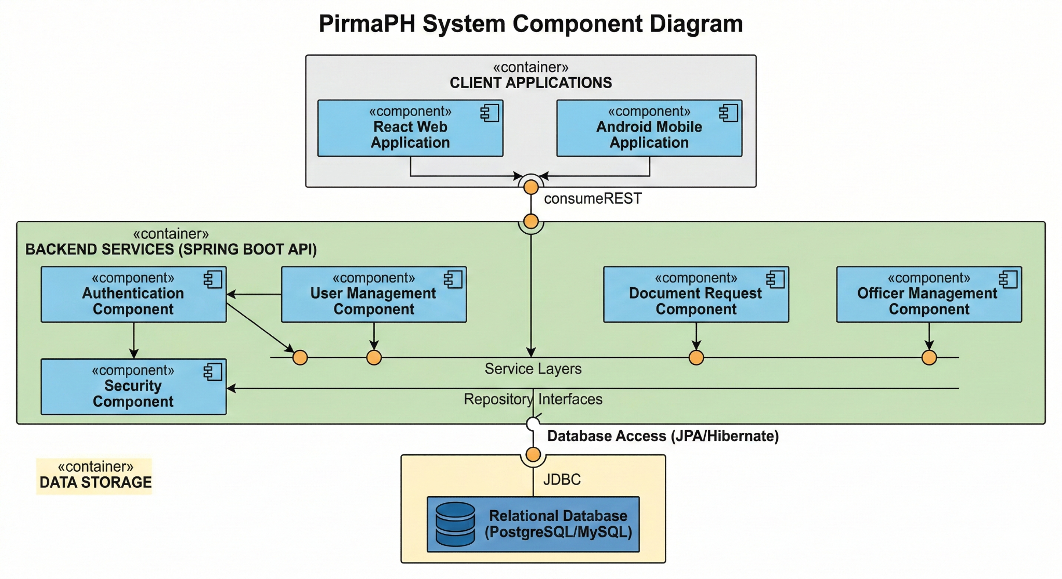
Technology Stack:
- Backend: Spring Boot (Java)
- Database: PostgreSQL
- Web Frontend: ReactJS, Tailwind CSS, Axios
- Mobile: Android Kotlin
- Build Tools: Maven (Backend), npm (Web), Gradle (Android)
- Deployment: Render

5.0 API CONTRACT & COMMUNICATION
5.1 API Standards
Base URL | https://[server_hostname]:[port]/api/v1
Format | JSON for all requests and responses
Authentication | Bearer token (JWT) in Authorization header
Response Structure | {  "token": string|null,  "user": {  "id": number,  "username": string,  "email": string,  "role": string  } | null,  "message": string,  "success": boolean  }

5.2 Endpoint Specifications

Authentication Endpoints

User Registration
Description | User Registration
API URL | /api/auth/register
HTTP Request Method | POST
Format | JSON for all requests/responses
Authentication | None
Request Payload | {  "username": "<username>",  "email": "<email>",  "password": "<password>",  "confirmPassword": "<confirmPassword>"  }
Response Structure | Success Response  {  "token": "<jwt_token>",  "user": {  "id": 1,  "username": "juan123",  "email": "juan@email.com",  "role": "RESIDENT"  },  "message": "Registration successful.",  "success": true  }  Error Response  {  "token": null,  "user": null,  "message": "Passwords do not match.",  "success": false  }

User Login
Description | User Login
API URL | /api/auth/login
HTTP Method | POST
Format | JSON for all requests/responses
Authentication | None
Request Payload | {  "email": "<email>",  "password": "<password>"  }
Response Structure | Success Response  {  "token": "<jwt_token>",  "user": {  "id": 1,  "username": "juan123",  "email": "juan@email.com",  "role": "RESIDENT"  },  "message": "Login successful.",  "success": true  }  Error Response  {  "token": null,  "user": null,  "message": "Invalid email or password.",  "success": false  }

5.3 Error Handling
HTTP Status Codes
- 200 OK - Successful request
- 201 Created - Resource successfully created
- 400 Bad Request - Invalid input or validation failure
- 401 Unauthorized - Authentication required or failed
- 403 Forbidden - Insufficient permissions
- 404 Not Found - Resource doesn't exist
- 409 Conflict - Duplicate resource (e.g., email already registered)
- 500 Internal Server Error - Unexpected server error
Error Code Examples

Example 1 | {  "success": false,  "data": null,  "error": {  "code": "AUTH-001",  "message": "Invalid credentials",  "details": "Email or password is incorrect"  },  "timestamp": "2026-02-27T10:30:00Z"  }
Example 2 | {  "success": false,  "data": null,  "error": {  "code": "VALID-001",  "message": "Validation failed",  "details": {  "email": "Email is required",  "password": "Must be at least 8 characters"  }  },  "timestamp": "2026-02-27T10:30:00Z"  }

Common Error Codes
- AUTH-001: Invalid credentials
- AUTH-002: Token expired
- AUTH-003: Insufficient permissions
- AUTH-004: Unauthorized access
- VALID-001: Validation failed
- VALID-002: Missing required field
- VALID-003: Invalid input format
- DB-001: Resource not found
- DB-002: Duplicate entry
- DB-003: Database constraint violation
- BUSINESS-001: Invalid request state
- BUSINESS-002: Request already processed
- BUSINESS-003: Unauthorized document access
- SYSTEM-001: Internal server error
- SYSTEM-002: Service unavailable

6.0 DATABASE DESIGN
6.1 Entity Relationship Diagram
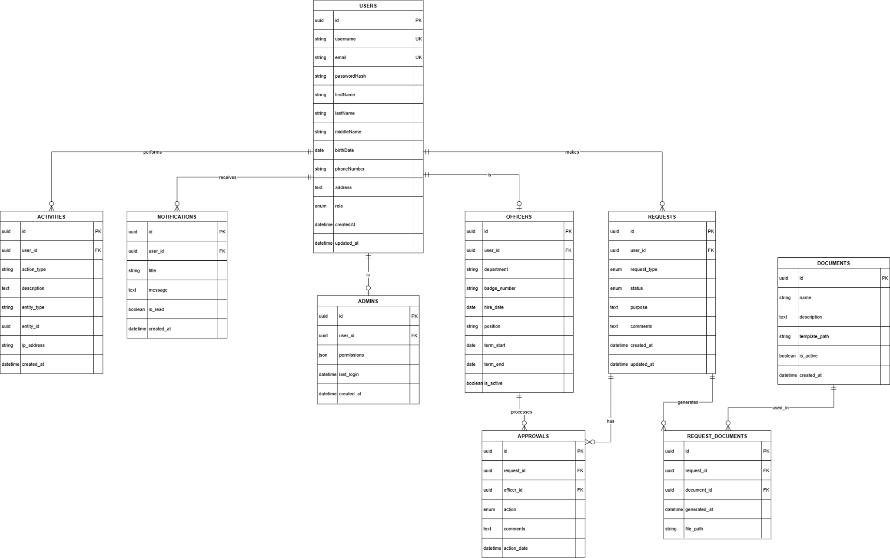
Detailed Relationships:

One-to-Many Relationships
- User → Requests (A resident can make multiple document requests)
- User → Notifications (A user can receive multiple notifications)
- User → Activities (A user can perform multiple system activities)
- Request → Approvals (A request can have multiple approval actions)
- Request → RequestDocuments (A request can generate multiple documents)
- Document → RequestDocuments (A document type can be used in multiple requests)
- Officer → Approvals (An officer can process multiple approvals)

One-to-One Relationships
- User ↔ Officer (A user may have one corresponding officer profile)
- User ↔ Admin (A user may have one corresponding admin profile)

Many-to-One Relationships
- Requests → User (Each request belongs to one user)
- Approvals → Request (Each approval is tied to one request)
- Approvals → Officer (Each approval is processed by one officer)
- RequestDocuments → Request (Each generated document belongs to one request)
- RequestDocuments → Document (Each generated document is based on one document type)
- Notifications → User (Each notification belongs to one user)
- Activities → User (Each activity record belongs to one user)
Key Tables:
- users – Stores resident, officer, and admin account information
requests – Contains document request submissions
- documents – Defines available barangay document types
- request_documents – Stores generated documents per request
- officers – Officer-specific profile information
- admins – Admin-specific profile and permissions
- approvals – Records approval or rejection actions
- notifications – System-generated alerts for users
- activities – Audit trail of user actions

Table Structure Summary:
- users: id, username, email, passwordHash, firstName, lastName, middleName, birthDate, phoneNumber, address, role, createdAt, updated_at
- requests: id, user_id, request_type, status, purpose, comments, created_at, updated_at
- documents: id, name, description, template_path, is_active, created_at
- request_documents: id, request_id, document_id, generated_at, file_path
- officers: id, user_id, department, badge_number, hire_date, position, term_start, term_end, is_active
- admins: id, user_id, permissions, last_login, created_at
- approvals: id, request_id, officer_id, action, comments, action_date
- notifications: id, user_id, title, message, is_read, created_at
- activities: id, user_id, action_type, description, entity_type, entity_id, ip_address, created_at

7.0 UI/UX DESIGN
7.1 Web Application Wireframes
https://www.figma.com/design/op2CS0V3OlmLi5gG8GnvRk/Untitled?node-id=3-1706&t=FzyTytX5S1w6gb8C-1
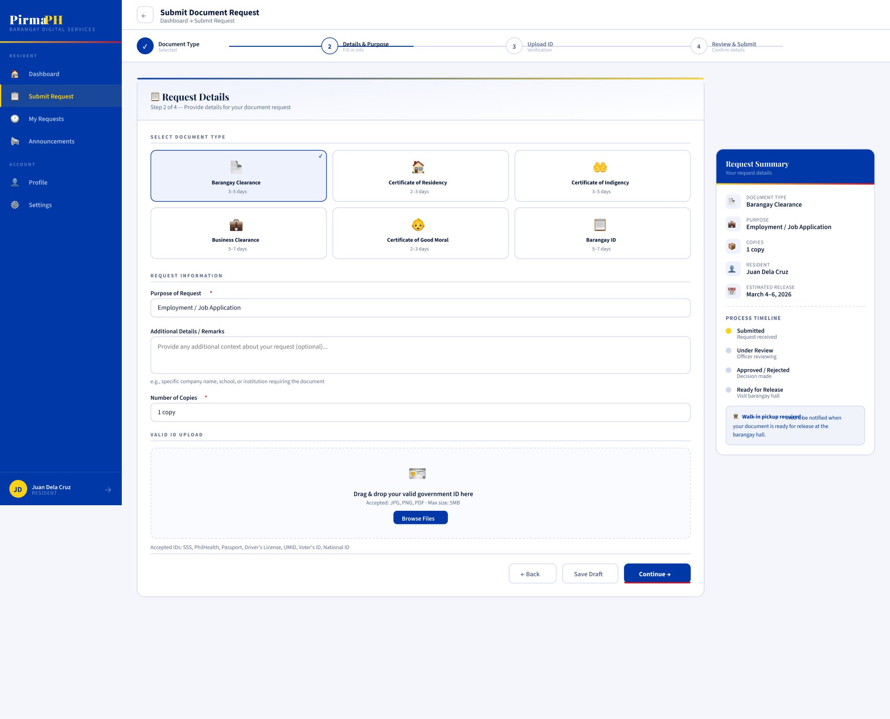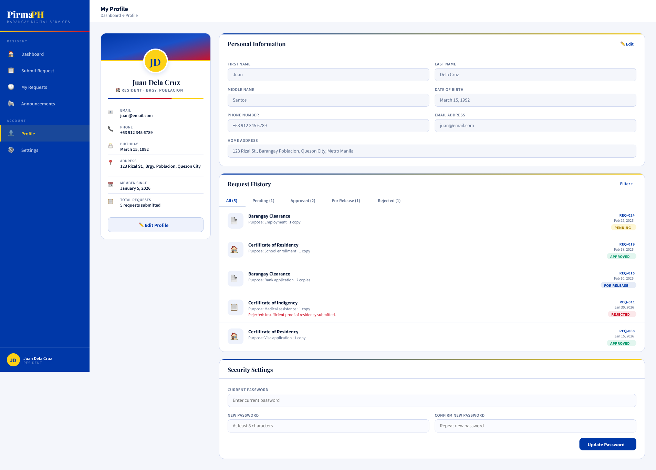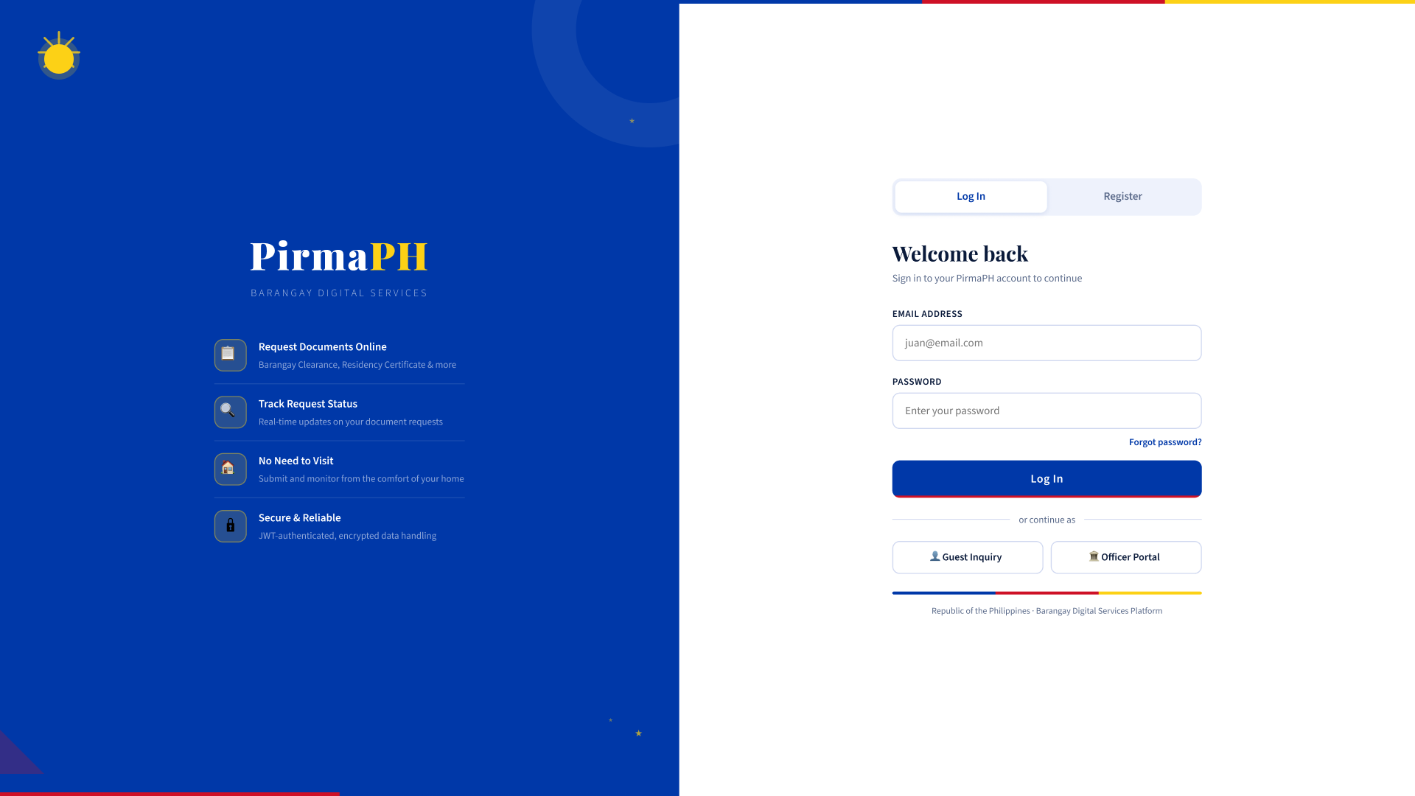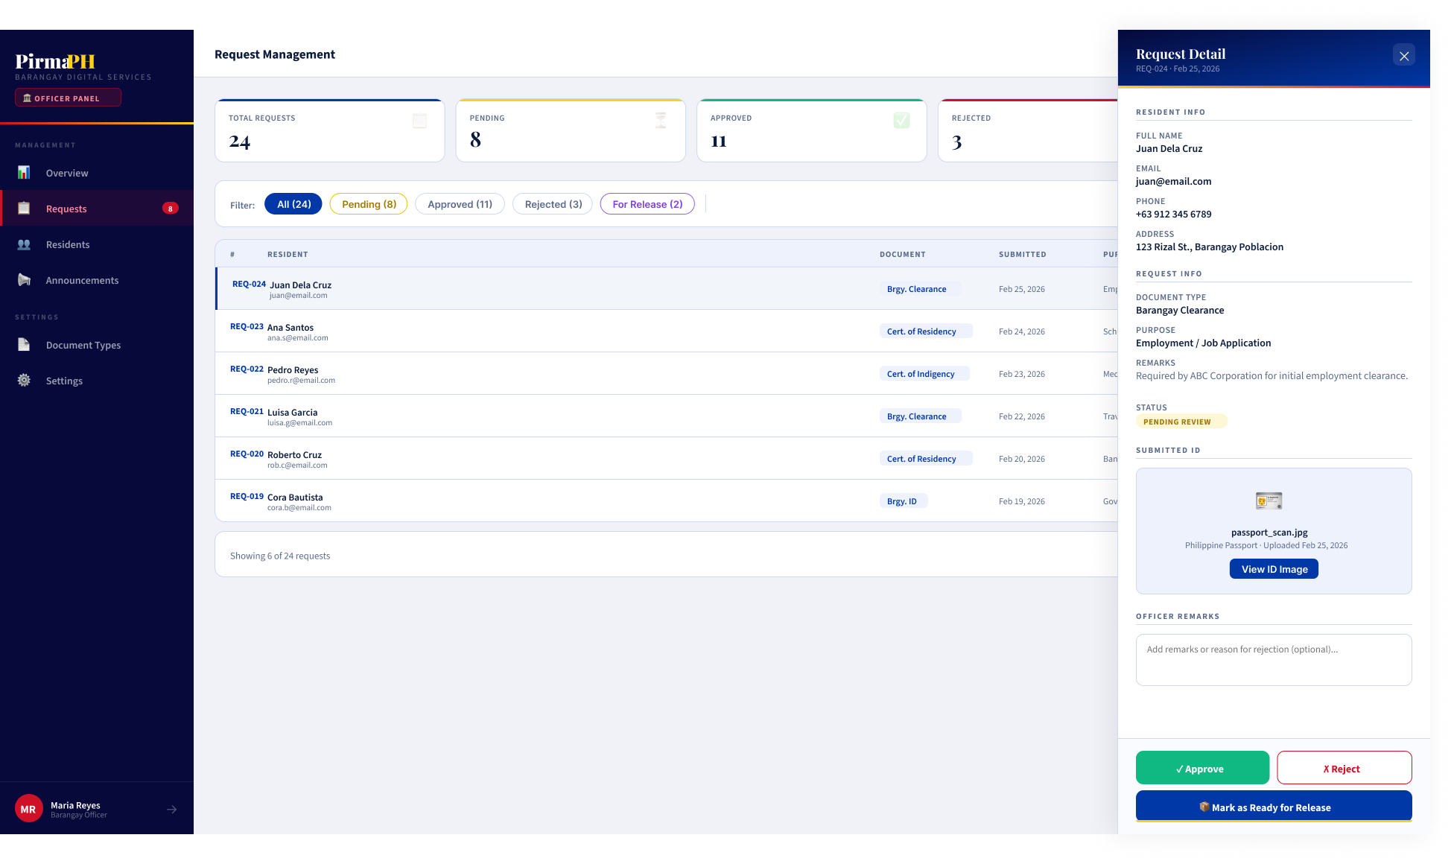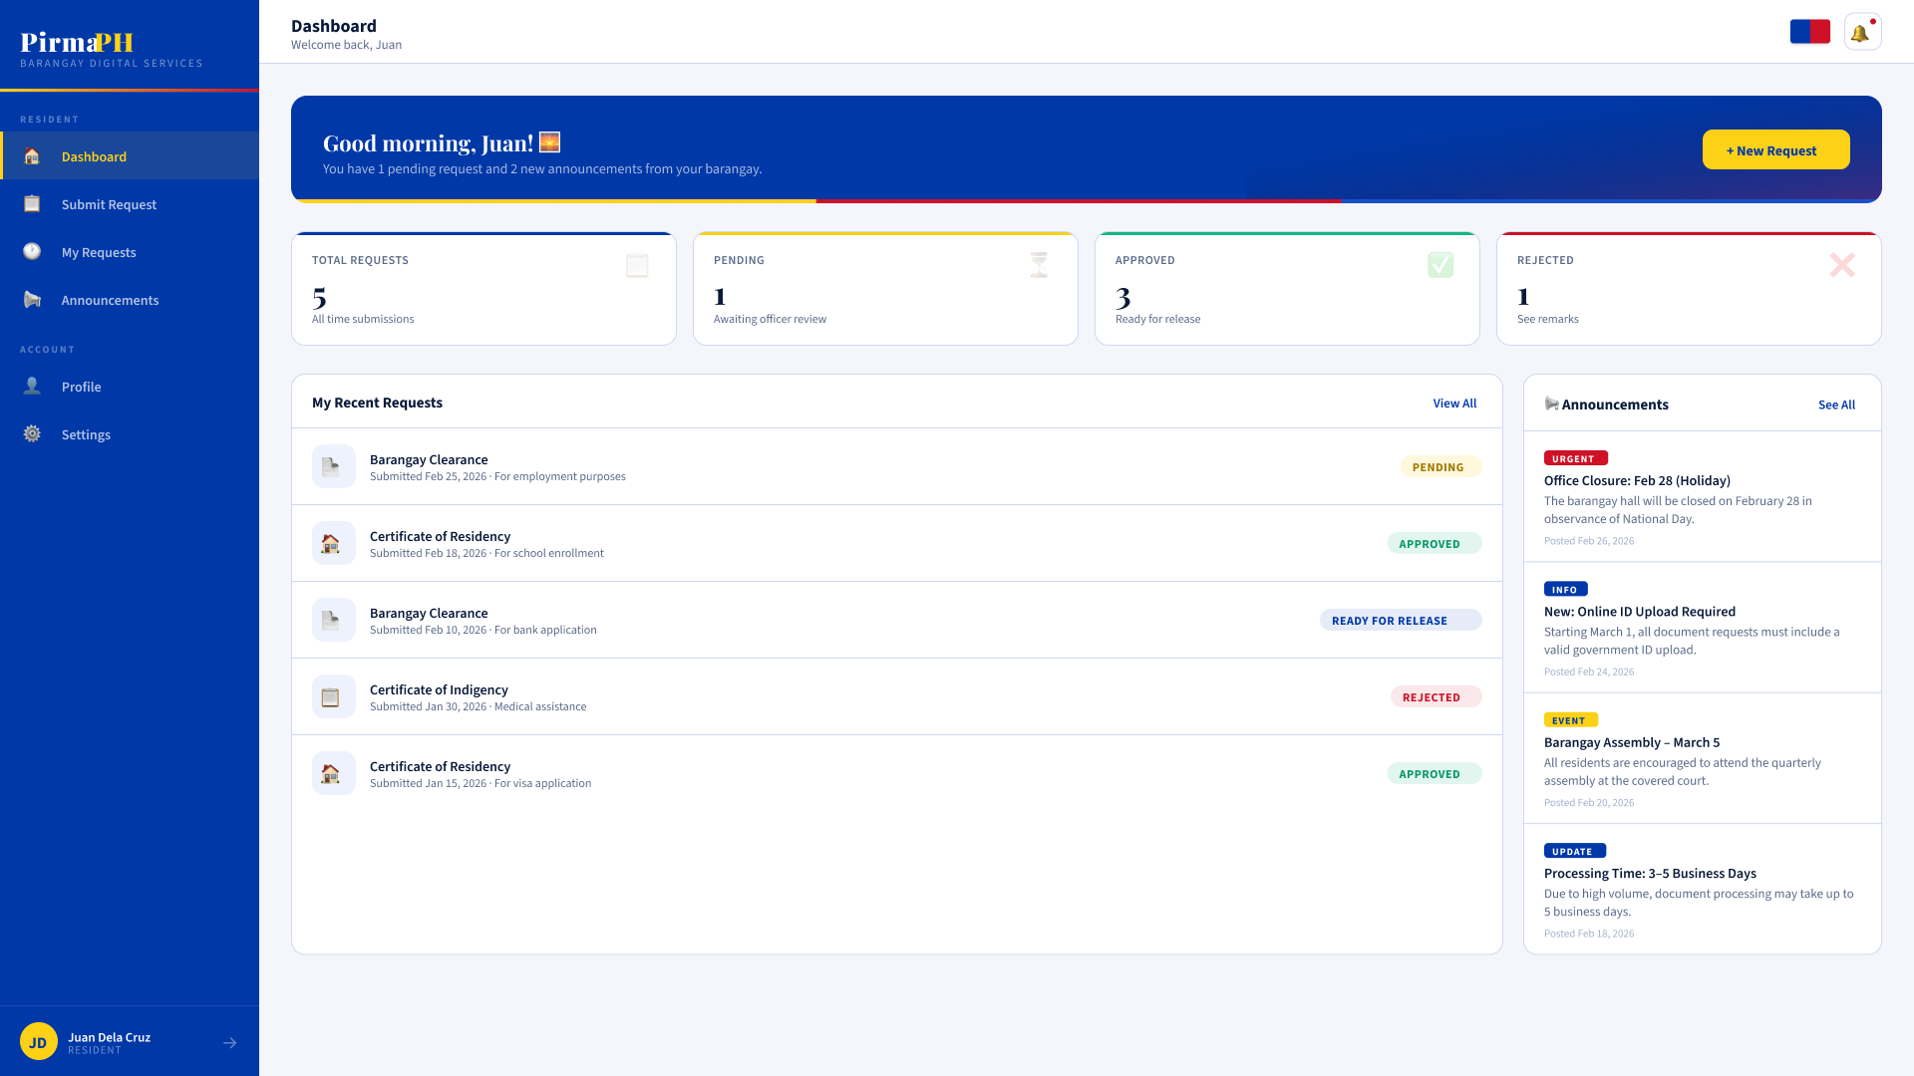
7.2 Mobile Application Wireframes
https://www.figma.com/design/op2CS0V3OlmLi5gG8GnvRk/Untitled?node-id=3-1706&t=FzyTytX5S1w6gb8C-1
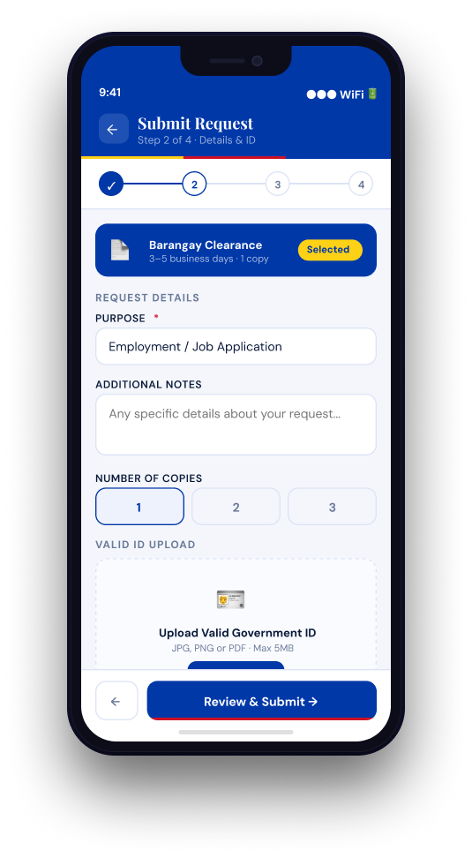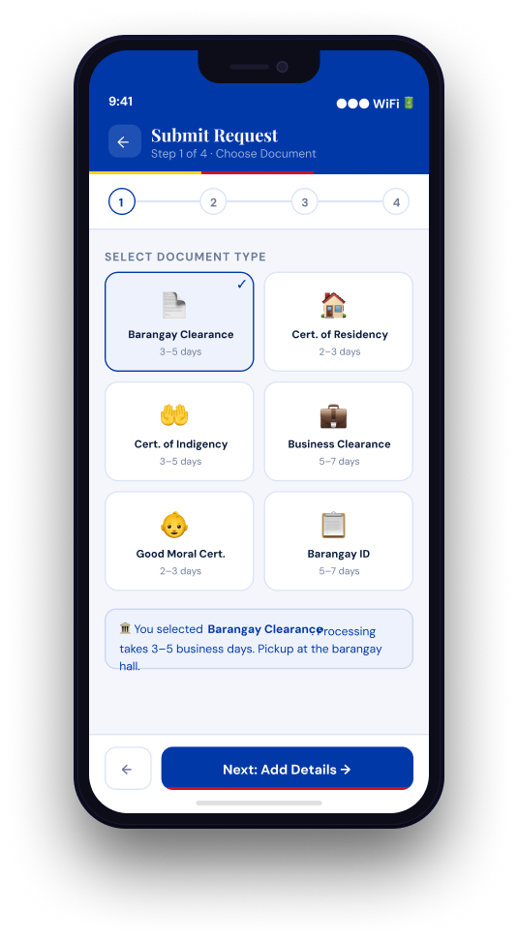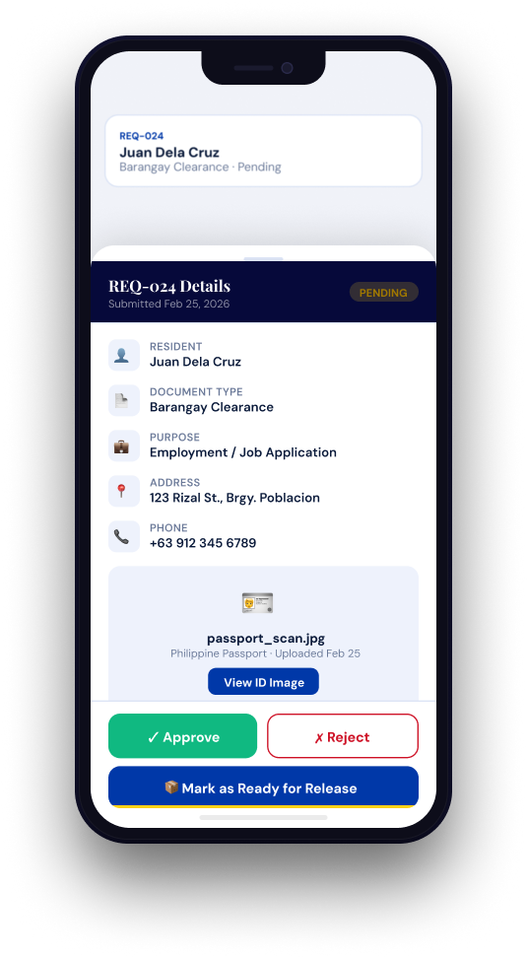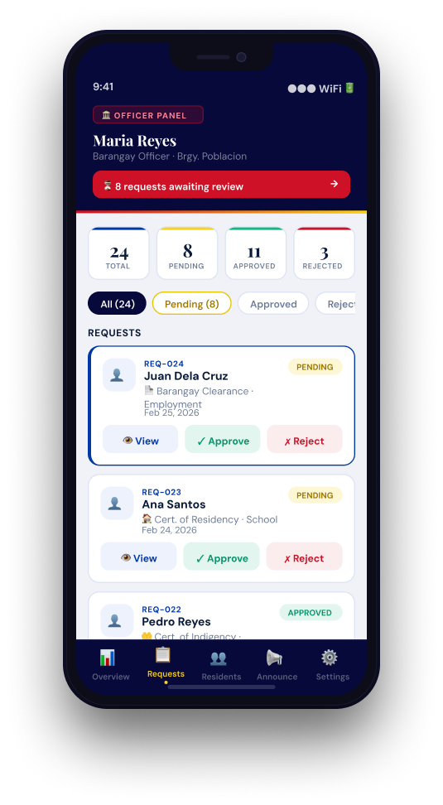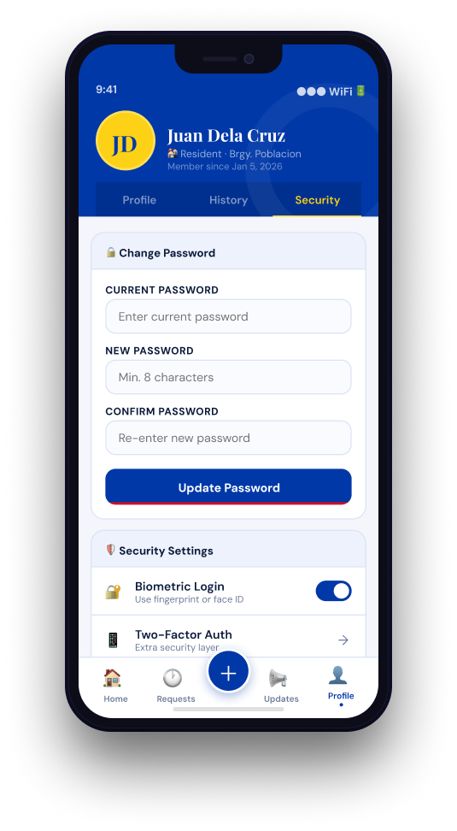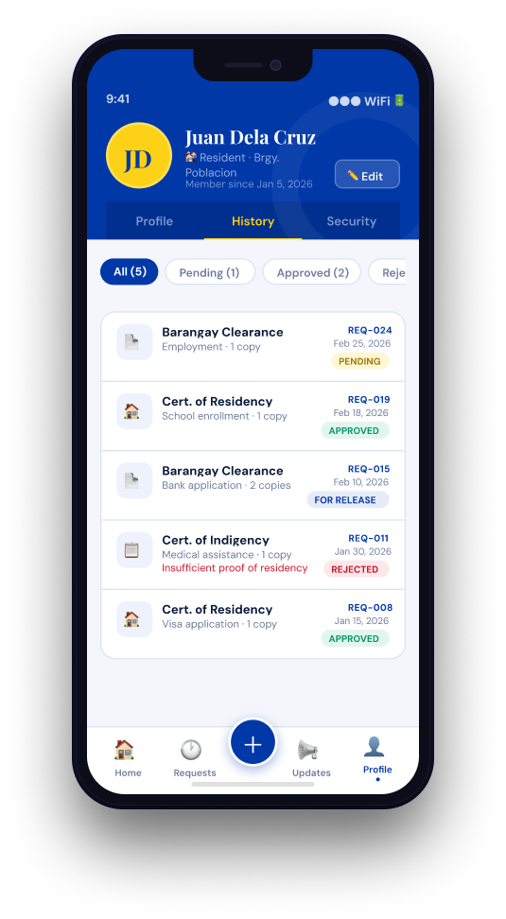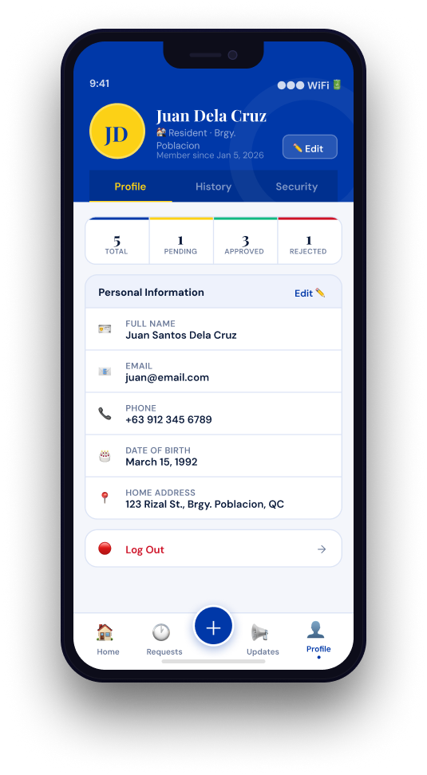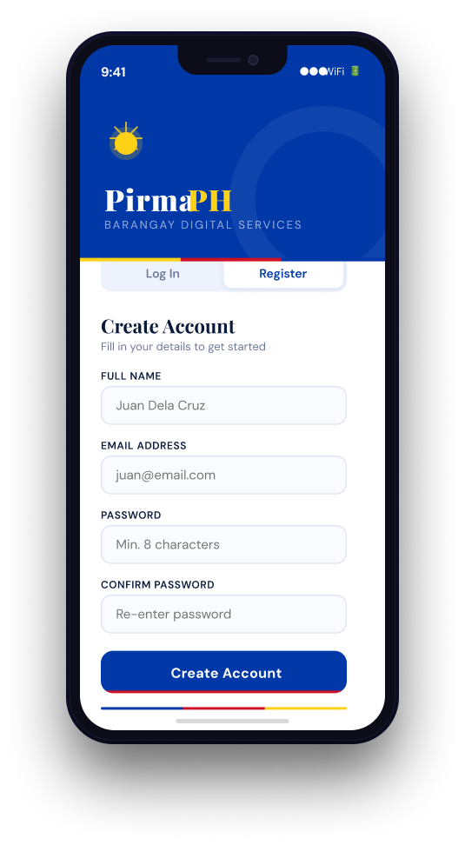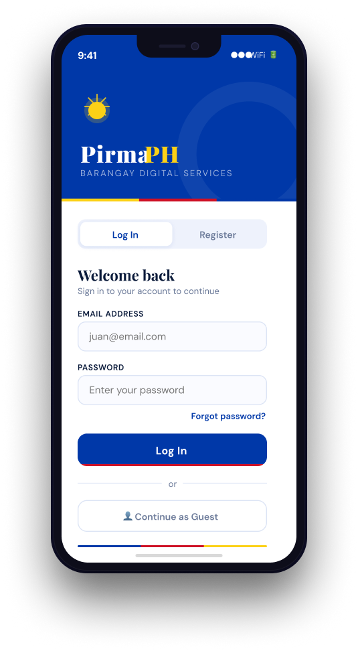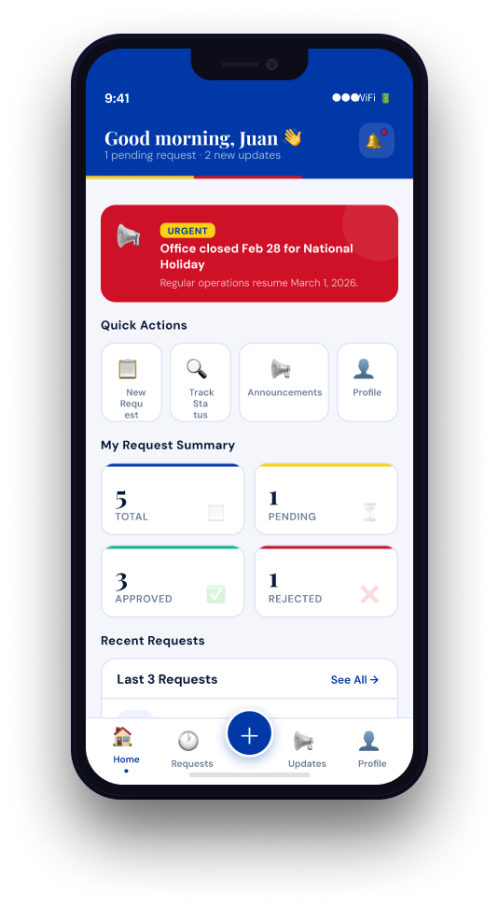
Mobile-Specific Features:
- Touch-optimized buttons (min 44x44px)
- Gesture support (swipe, pull-to-refresh)
- Offline caching for product images
- Bottom navigation for main actions
- Simplified forms for mobile input
Design System:
- Colors: Primary (#2563EB), Secondary (#7C3AED), Success (#10B981), Error (#EF4444)
- Typography: Inter font family, responsive sizing
- Spacing: 8px grid system
- Components: Consistent buttons, inputs, cards, modals
- Responsive: Mobile-first approach, breakpoints at 640px, 768px, 1024px

8.0 PLAN
8.1 Project Timeline

Phase 1: Planning & Design (Week 1–2)

Week 1: Requirements & Architecture
Day 1–2: Project setup and initial documentation
- Define project scope (PirmaPH)
- Identify system modules (Auth, Request, User, Admin)
- Setup Git repository
Day 3–4: Complete Functional and Non-Functional Requirements
- Finalize FRS
- Define NFR (security, performance, scalability)
- Define role-based access requirements
Day 5–7: System architecture design
- Three-tier architecture (Spring Boot, React, Android)
- API structure planning
- Integration flow diagram

Week 2: Detailed Design
Day 1–2: API specification
- Authentication endpoints
- User endpoints
- Request management endpoints
- Error handling standards
Day 3–4: Database design
- User table
- Document request table
- Announcement table
- Entity relationships
Day 5–6: UI/UX wireframes
- Resident dashboard
- Submit request form
- Officer request panel
- Mobile layouts
Day 7: Implementation plan finalization

Phase 2: Backend Development (Week 3–4)

Week 3: Foundation
Day 1: Spring Boot project setup with dependencies
Day 2: Database configuration and entity creation
- User entity
- Request entity
- Role configuration
Day 3: JWT authentication implementation
Day 4: User management endpoints
- Register
- Login
- Logout
- Get current user
Day 5: Document request CRUD operations (basic)

Week 4: Core Features
Day 1: Request submission logic (resident)
Day 2: Officer approval/rejection workflow
Day 3: Role-based access control enforcement
Day 4: Error handling and validation
Day 5: API documentation and backend testing

Phase 3: Web Application (Week 5–6)

Week 5: Frontend Foundation (React)
Day 1: React setup with routing and API configuration
Day 2: Authentication pages (login, register)
Day 3: Resident dashboard page
Day 4: Submit document request form
Day 5: Request status display and history

Week 6: Complete Web Features
Day 1: Officer request management panel
Day 2: Request approval/rejection integration
Day 3: Announcements section
Day 4: Responsive design improvements
Day 5: Full API integration and testing

Phase 4: Mobile Application (Week 7–8)

Week 7: Android Foundation
Day 1: Android Studio setup and project structure
Day 2: Authentication screens (login/register)
Day 3: Resident dashboard
Day 4: Submit request screen
Day 5: API service layer integration (Retrofit/HTTP client)

Week 8: Complete Mobile App
Day 1: Request tracking and status updates
Day 2: Officer request view (if applicable for mobile)
Day 3: UI polish and usability improvements
Day 4: Testing on emulator and physical device
Day 5: APK generation and documentation

Phase 5: Integration & Deployment (Week 9–10)

Week 9: Integration Testing
Day 1: End-to-end testing (Web + Mobile + Backend)
Day 2: Bug fixes and optimization
Day 3: Security review (JWT validation, role checks)
Day 4: Performance testing (API response time)
Day 5: Documentation updates

Week 10: Deployment
Day 1: Backend deployment (Railway/Render/Heroku)
Day 2: Web app deployment (Vercel/Netlify)
Day 3: Mobile APK distribution
Day 4: Final system testing
Day 5: Project submission

Milestones
M1 (End Week 2): All design documents complete
M2 (End Week 4): Backend API fully functional
M3 (End Week 6): Web application complete
M4 (End Week 8): Mobile application complete
M5 (End Week 10): Full system deployed and integrated

Critical Path
- Authentication system (Week 3)
- Document request API (Week 3–4)
- Approval workflow (Week 4)
- Web dashboard integration (Week 6)
- Cross-platform integration testing (Week 9)

Risk Mitigation
- Start with core authentication and request submission first
- Test API endpoints independently before frontend integration
- Perform integration testing after each module completion
- Maintain version control with stable backups
- Prioritize core workflow (request → review → approve → release) before enhancements

