

IT342-G5
System Integration and Architecture

System Design Document (SDD)

Project Title: PirmaPH
Prepared By: Binagatan, Alexander Jr. Bersano

Version: 1.0
Date: 5/15/2026
Status: Draft

REVISION HISTORY TABLE
Version | Date | Author | Changes Made | Status
0.1 | 2/20/2026 | Alexander Jr. Binagatan | Initial draft | Draft
0.2 | 2/27/2026 | Alexander Jr. Binagatan | Final review and corrections | Final
0.5 | 3/26/2026 | Alexander Jr. Binagatan | Backend auth + Google OAuth2 implemented | In Progress
0.8 | 4/15/2026 | Alexander Jr. Binagatan | Email OTP verification, admin/officer endpoints | In Progress
1.0 | 5/15/2026 | Alexander Jr. Binagatan | Full implementation complete | Draft

TABLE OF CONTENTS
Contents
EXECUTIVE SUMMARY 4
1.0 INTRODUCTION 5
2.0 FUNCTIONAL REQUIREMENTS SPECIFICATION 5
3.0 NON-FUNCTIONAL REQUIREMENTS 8
4.0 SYSTEM ARCHITECTURE 9
5.0 API CONTRACT & COMMUNICATION 10
Authentication Endpoints 11
User Registration 11
User Login 11
6.0 DATABASE DESIGN 13
7.0 UI/UX DESIGN 14
8.0 PLAN 17

EXECUTIVE SUMMARY
1.1 Project Overview
PirmaPH is a digital service platform designed to streamline the process of requesting official barangay documents such as barangay clearance and certificate of residency. The system enables residents to submit document requests online, track request status, and receive updates without repeatedly visiting the barangay office.
The system includes a Spring Boot backend API with comprehensive RESTful endpoints, and a React web application providing a responsive, user-friendly interface for residents, officers, and administrators. The backend manages authentication (email/password and Google OAuth2), email OTP verification, request processing, role-based access control (RESIDENT, OFFICER, BARANGAY_ADMIN, SUPER_ADMIN), and data storage on Supabase (PostgreSQL). The web application provides intuitive interfaces for document request submission, status tracking, officer request management, and admin dashboards.
This integrated architecture supports digital transformation initiatives in local government units (LGUs) by improving operational efficiency, transparency, and service accessibility.
1.2 Objectives
- Develop a fully functional barangay document request system with authentication, request submission, approval workflow, and status tracking
- Implement a three-tier architecture using Spring Boot (backend API) and React (web application)
- Create RESTful APIs to enable secure communication between the backend, web client, and mobile client
- Implement role-based access control for residents and barangay officers
- Design responsive and consistent user interfaces for both web and mobile platforms
- Deploy backend and frontend components in production-ready environments
- Ensure secure data handling using encrypted passwords and validated inputs
1.3 Scope
Included Features:
- User registration and authentication (email/password, Google OAuth2, role-based access)
- Email OTP verification for account confirmation
- Resident dashboard displaying request status and announcements
- Profile management with request history
- Online document request submission (document type selection, purpose input, file upload)
- Officer panel for reviewing, approving, rejecting, and marking requests as ready for release
- Officer verification and onboarding system
- Admin verification panel for resident/officer/admin approvals
- Barangay admin dashboard (request queue, user management, statistics)
- Super admin dashboard (nationwide statistics, barangay management)
- Request status tracking and dashboard updates
- RESTful API integration between frontend and backend
- Supabase (PostgreSQL) relational database with structured schema
- Responsive React web interface (mobile, tablet, desktop)
- Secure password hashing and input validation
- JWT authentication with 24-hour token expiry
- Google OAuth2 integration
Excluded Features:
- Android mobile application
- Online payment gateway integration
- SMS notification integration
- Automated PDF document generation
- QR code-based document claiming
- Push notification system
- Email notification integration (beyond OTP)
- Advanced analytics and reporting dashboard
- Cloud-based auto-scaling infrastructure

1.0 INTRODUCTION
1.1 Purpose
This document serves as the design specification for the PirmaPH system. It defines the system requirements, architecture, API structure, database design, and integration approach between the Spring Boot backend and React web application.
The purpose of this document is to guide development and ensure that all system components are properly designed, integrated, and implemented in a consistent and organized manner.

2.0 FUNCTIONAL REQUIREMENTS SPECIFICATION
2.1 Project Overview
Project Name: PirmaPH
Domain: E-Government / Local Government Services
Primary Users:
- Residents
- Barangay Officers / Administrators
Problem Statement: Residents need a convenient and efficient way to request official barangay documents without repeatedly visiting the barangay office, while officers need a structured system to manage and track document requests digitally.
Solution: A digital barangay service platform that enables residents to submit document requests online, track request status, and receive updates, while providing officers with a centralized management system accessible via web and mobile platforms.
2.2 Core User Journeys
Journey 1: First-Time Resident Request
- User visits web application
- Clicks “Register” and creates an account
- Logs in using email/password or Google Sign-In
- Verifies email via OTP (if using email/password)
- Navigates to Submit Request
- Selects document type
- Enters purpose and uploads valid ID image
- Submits request
- Views request status as “Pending”
- Receives status update once processed
Journey 2: Returning Resident Tracking Request
- User logs in with existing credentials
- Views dashboard
- Checks request status
- Sees request marked as “Approved” or “Ready for Release”
- Views request history in profile
- Logs out
Journey 3: Officer Request Processing
- Officer logs in with admin credentials
- Navigates to request management panel
- Views list of pending requests
- Reviews submitted details and ID upload
- Approves or rejects request with remarks
- Marks approved request as “Ready for Release”
- Resident dashboard automatically updates
2.3 Feature List (MoSCoW)
MUST HAVE
- User authentication (register, login, logout, JWT-based)
- Email-based registration with OTP verification (Resend API)
- Google OAuth2 Sign-In integration
- Role-based access control (RESIDENT, OFFICER, BARANGAY_ADMIN, SUPER_ADMIN)
- Resident dashboard (status tracking, announcements, request history)
- Document request submission (with file upload and validation)
- Officer request management panel (view, approve, reject, mark as ready)
- Request status update workflow
- Officer verification and onboarding system
- Admin verification page for resident/officer/admin approvals
- Barangay admin dashboard (request queue, user management, overview)
- Super admin dashboard (nationwide statistics, barangay management)
SHOULD HAVE
- Email OTP verification for registration
- Notification system within dashboard
- Input validation and error feedback
- Responsive design (web application)
- Search/filter for requests in admin panels
- User role management by admins
- Officer file upload for verification
COULD HAVE
- Downloadable request summary
- Advanced reporting dashboard
- Profile photo upload
- Document type management interface
- Message history between residents and officers
WON'T HAVE
- Android mobile application
- Online payment gateway integration
- SMS notification integration
- QR-based document claiming
- Multi-barangay system support (single barangay per deployment)
2.4 Detailed Feature Specifications
Feature: User Authentication
- Screens: Registration, Login, Forgot Password, OTP Verification
- Methods: Email/Password, Google OAuth2
- Fields: Full Name, Email, Password, Confirm Password, Personal Info, Address
- Validation: Valid email format, Password strength requirement, Unique email per user, OTP verification
- API Endpoints:
  - POST /api/auth/register (email/password registration)
  - POST /api/auth/login (email/password login)
  - POST /api/auth/logout (session logout)
  - POST /api/auth/email-otp/request (request OTP)
  - POST /api/auth/email-otp/verify (verify OTP code)
  - POST /api/auth/oauth2/authorization/google (Google OAuth2)
  - GET /api/auth/oauth2/callback (OAuth2 callback handler)
  - GET /api/auth/me (current authenticated user)
- Security:
  - JWT-based authentication (24-hour expiration)
  - BCrypt password hashing
  - OTP code generation and validation (5-minute expiry, 6-digit code)
  - Email verification requirement for email/password users
  - Google OAuth users auto-verified
  - Role-based authorization
  - CORS enabled for web frontend
Feature: Resident Dashboard
- Screens: Dashboard, Request Details, Profile, Request History
- Display:
  - List of submitted requests with current status
  - Request statistics and overview
  - Announcements and system updates
  - Personal profile information
  - Full request history with status timeline
- API Endpoints:
  - GET /api/requests/user (user’s requests)
  - GET /api/requests/{id} (request details)
  - GET /api/users/me (current user profile)
  - GET /api/announcements (system announcements)

Feature: Document Request Submission
- Screens: Submit Request Form, Request Confirmation, Request Details
- Data Collected:
  - Document type (e.g., Barangay Clearance, Residency Certificate)
  - Purpose of request
  - File attachments (ID image, supporting documents)
  - Additional comments or information
- Process:
  - Validate input and file format
  - Store request in database with file references
  - Set default status to “PENDING”
  - Notify officers of new request
- API Endpoints:
  - POST /api/requests (submit new request)
  - GET /api/requests/{id} (fetch request details)
  - POST /api/requests/{id}/files (upload request files)
  - GET /api/requests/{id}/files (retrieve request files)

Feature: Request Management (Officer Panel)
- Screens: Request Queue, Request Detail, Officer Dashboard
- Functions:
  - View pending/in-process requests
  - Filter and search requests by resident/status
  - Approve request
  - Reject request with remarks
  - Mark as “Ready for Release”
  - View request history
  - Manage request attachments
- Access Control: Officer role required for feature access
- API Endpoints:
  - GET /api/requests/officer/queue (pending requests)
  - GET /api/requests/officer/{id} (request details)
  - PUT /api/requests/officer/{id}/approve (approve request)
  - PUT /api/requests/officer/{id}/reject (reject request)
  - PUT /api/requests/officer/{id}/status (change request status)
  - GET /api/requests/officer/search (search requests)
Feature: Officer Verification & Onboarding
- Screens: Verification Status Page, File Upload Page
- Process:
  - Officers self-register as OFFICER role
  - Submit required documents (ID, credentials, proof of employment)
  - Barangay admins review and approve/reject in verification panel
  - Approved officers gain full access to request management
- API Endpoints:
  - GET /api/officer/verification-status (current status)
  - POST /api/officer/files/upload (submit documents)
  - GET /api/officer/files (retrieve uploaded files)
  - GET /api/admin/officers/pending (list pending officers for admin)
  - PUT /api/admin/officers/{id}/approve (approve officer)
  - PUT /api/admin/officers/{id}/reject (reject officer)
Feature: Admin Verification Panel
- Screens: Verification Dashboard with tabs (Residents, Officers, Admins)
- Functions:
  - Review pending user registrations
  - Approve/reject resident and officer accounts
  - Create barangay admins
  - Manage user roles and suspension status
- Access Control: Barangay Admin or Super Admin role required
- API Endpoints:
  - GET /api/admin/dashboard (barangay admin overview)
  - GET /api/admin/super-dashboard (super admin overview)
  - GET /api/admin/residents (list residents)
  - PUT /api/admin/users/{id}/suspend (suspend user)
  - PUT /api/admin/users/{id}/reinstate (reinstate user)
  - GET /api/admin/barangay-admins (list barangay admins)
Feature: Barangay Admin Dashboard
- Screens: Dashboard, Request Queue, User Management, Profile
- Functions:
  - View pending document requests for the barangay
  - Approve/reject document requests
  - Manage resident and officer approvals
  - Monitor barangay statistics
  - Update profile information
- API Endpoints:
  - GET /api/requests/admin/queue (pending requests queue)
  - PUT /api/requests/admin/{id}/approve (approve request)
  - PUT /api/requests/admin/{id}/status (update request status)
Feature: Super Admin Dashboard
- Screens: Dashboard, Barangay Management, Super Admin Console
- Functions:
  - View nationwide statistics
  - Create and manage barangays
  - Create barangay admins
  - Monitor system-wide metrics
  - Access administrative controls
- API Endpoints:
  - GET /api/admin/super-dashboard (nationwide overview)
  - POST /api/admin/barangays (create barangay)
  - PUT /api/admin/barangays/{id} (update barangay)
  - GET /api/admin/barangays (list barangays)

2.5 Acceptance Criteria

AC-1: Successful User Registration
- Given I am a new resident
- When I enter valid personal information and strong password
- And confirm password matches
- And click “Register”
- Then my account should be created
- And I should be redirected to the dashboard

AC-2: Document Request Submission Flow
- Given I am logged in as a resident
- When I submit a document request with valid details
- And upload a valid ID image
- Then the request status should be set to “Pending”
- And it should appear in my dashboard
- And be visible in the officer panel

AC-3: Officer Request Approval
- Given I am logged in as an officer
- When I review a pending request
- And approve the request
- Then the request status should update to “Approved”
- And the resident should see the updated status in their dashboard

3.0 NON-FUNCTIONAL REQUIREMENTS
3.1 Performance Requirements
- API response time: ≤ 2 seconds for 95% of requests
- Web page load time: ≤ 3 seconds on broadband
- Mobile app cold start: ≤ 3 seconds
- Support 100 concurrent users
- Supabase (PostgreSQL) queries complete within 500ms
3.2 Security Requirements
- HTTPS for all communications
- JWT token authentication
- Password hashing with bcrypt (salt rounds = 12)
- SQL injection prevention
- XSS protection
- Rate limiting: 100 requests/minute per IP
- Admin endpoints require role verification
3.3 Compatibility Requirements
- Web Browsers: Chrome, Firefox, Safari, Edge (latest 2 versions)
- Android: API Level 24+ (Android 7.0+)
- Screen Sizes: Mobile (360px+), Tablet (768px+), Desktop (1024px+)
- Operating Systems: Windows 10+, macOS 10.15+, Linux Ubuntu 20.04+
3.4 Usability Requirements
- Complete first request within 5 minutes for new users
- WCAG 2.1 Level AA compliance for web
- Consistent navigation across all pages
- Clear error messages with recovery options
- Touch targets minimum 44×44px on mobile
- Keyboard navigation support

4.0 SYSTEM ARCHITECTURE
4.1 Component Diagram
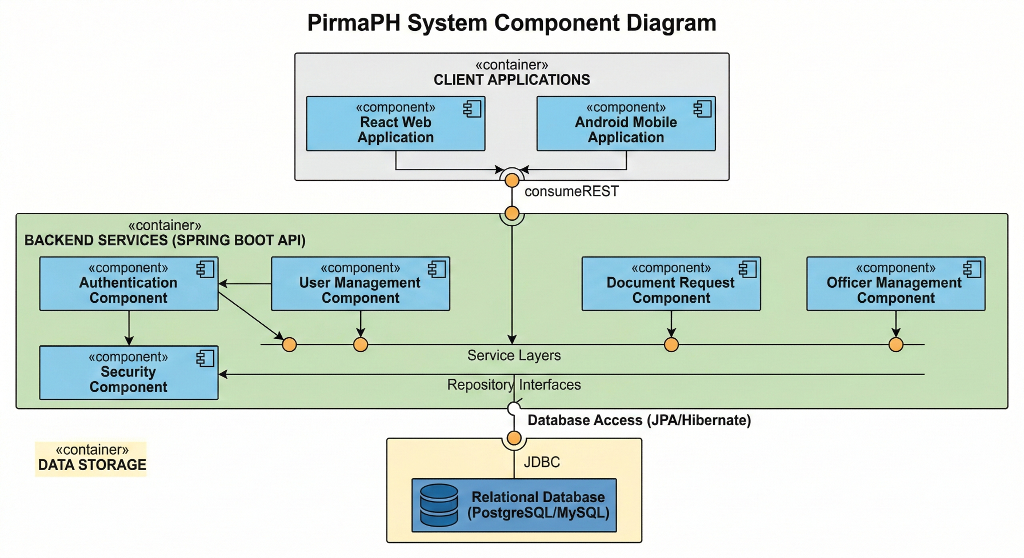
Technology Stack:
Layer | Technology | Version
Backend | Spring Boot | 3.5.11
Java Runtime | Java SE | 17 (LTS)
Database | Supabase (PostgreSQL) | Latest
Web Frontend | React | 19.2.0
Routing | React Router DOM | 7.13.1
CSS Framework | Tailwind CSS | (via Vite)
HTTP Client | Axios | (via API context)
Build Tools | Maven | (Backend), npm (Web)
Frontend Build | Vite | 7.3.1
Authentication | Spring Security + JWT + OAuth2 | -
Email Service | Resend API | (OTP)
Deployment | Render | (planned)

5.0 API CONTRACT & COMMUNICATION
5.1 API Standards
Property | Value
Base URL | http://localhost:8080/api (development)
Format | JSON for all requests and responses
Authentication | Bearer token (JWT) in Authorization header, OR OAuth2 flow
CORS | Enabled for http://localhost:5173, localhost:5174, localhost:3000
Default Token Expiry | 24 hours
Standard Response Structure:
{
"id": "string | null",
"username": "string | null",
"email": "string",
"firstName": "string",
"lastName": "string",
"role": "RESIDENT | OFFICER | BARANGAY_ADMIN | SUPER_ADMIN",
"token": "JWT token string | null",
"message": "string",
"success": "boolean",
"status": "number",
"timestamp": "ISO8601 datetime"
}
Authentication Methods:
- JWT Bearer Token (for email/password users)
  - Header: Authorization: Bearer <jwt_token>
  - Generated on registration or login
  - Valid for 24 hours
  - Contains user ID and role claims
- OAuth2 Google Sign-In
  - Google authorization flow
  - Auto-creates account or links to existing email
  - Returns JWT token for subsequent requests
  - Users skipped OTP verification if using OAuth2
- Session Management
  - Client stores JWT token in localStorage
  - Token passed with each authenticated request
  - Logout clears client-side token

5.2 Endpoint Specifications

Authentication Endpoints

User Registration
Property | Value
Description | User Registration with Email & Password
API URL | POST /auth/register
HTTP Method | POST
Format | JSON
Authentication | None
Request Payload:
{
"username": "juan123",
"email": "juan@email.com",
"password": "SecurePass123!",
"confirmPassword": "SecurePass123!",
"firstName": "Juan",
"middleName": "Santos",
"lastName": "Dela Cruz",
"birthDate": "1990-05-15",
"sex": "Male",
"phoneNumber": "+63 912 345 6789",
"street": "123 Rizal Street",
"barangay": "Poblacion",
"city": "Quezon City",
"province": "Metro Manila",
"zipCode": "1100",
"role": "RESIDENT"
}
Success Response (201 Created):
{
"id": "uuid",
"username": "juan123",
"email": "juan@email.com",
"firstName": "Juan",
"role": "RESIDENT",
"emailVerified": false,
"token": "eyJhbGciOiJIUzI1NiIs...",
"message": "Registration successful. Please verify your email.",
"success": true
}
Error Response:
{
"status": 400,
"message": "Email already registered",
"success": false,
"timestamp": "2026-05-15T10:30:00Z"
}

Request OTP Code
Property | Value
Description | Request OTP code via email for verification
API URL | POST /auth/email-otp/request
HTTP Method | POST
Format | JSON
Authentication | None
Request Payload:
{
"email": "juan@email.com"
}
Success Response (200 OK):
{
"message": "OTP sent to j****@email.com. Valid for 5 minutes.",
"success": true
}

Verify OTP Code
Property | Value
Description | Verify OTP code and complete email verification
API URL | POST /auth/email-otp/verify
HTTP Method | POST
Format | JSON
Authentication | None
Request Payload:
{
"email": "juan@email.com",
"otpCode": "123456"
}
Success Response (200 OK):
{
"message": "Email verified successfully.",
"success": true
}

User Login (Email/Password)
Property | Value
Description | User Login with Email & Password
API URL | POST /auth/login
HTTP Method | POST
Format | JSON
Authentication | None
Request Payload:
{
"email": "juan@email.com",
"password": "SecurePass123!"
}
Success Response (200 OK):
{
"id": "uuid",
"username": "juan123",
"email": "juan@email.com",
"firstName": "Juan",
"role": "RESIDENT",
"emailVerified": true,
"token": "eyJhbGciOiJIUzI1NiIs...",
"message": "Login successful.",
"success": true
}
Error Response (401 Unauthorized):
{
"status": 401,
"message": "Invalid email or password.",
"success": false,
"timestamp": "2026-05-15T10:30:00Z"
}
Error Response (403 Forbidden - Email Not Verified):
{
"status": 403,
"message": "Please verify your email before logging in.",
"success": false,
"timestamp": "2026-05-15T10:30:00Z"
}

Google OAuth2 Authorization
Property | Value
Description | Initiate Google OAuth2 Sign-In flow
Frontend URL | Redirect to Google authorization endpoint
Callback URL | GET /auth/oauth2/callback (with code parameter)
OAuth2 Callback Handler:
The frontend receives the authorization code and exchanges it for JWT on the backend.
Success Response:
{
"id": "uuid",
"username": "juan.delacruz",
"email": "juan@gmail.com",
"firstName": "Juan",
"role": "RESIDENT",
"emailVerified": true,
"token": "eyJhbGciOiJIUzI1NiIs...",
"message": "Login successful via Google.",
"success": true
}

Get Current User
Property | Value
Description | Get authenticated user’s profile
API URL | GET /auth/me
HTTP Method | GET
Format | JSON
Authentication | Bearer Token (Required)
Success Response (200 OK):
{
"id": "uuid",
"username": "juan123",
"email": "juan@email.com",
"firstName": "Juan",
"lastName": "Dela Cruz",
"birthDate": "1990-05-15",
"phoneNumber": "+63 912 345 6789",
"role": "RESIDENT",
"emailVerified": true,
"createdAt": "2026-03-06T09:46:20"
}

Document Request Endpoints

Submit Document Request
Property | Value
Description | Submit new document request
API URL | POST /requests
HTTP Method | POST
Format | JSON
Authentication | Bearer Token (Required)
Request Payload:
{
"documentType": "BARANGAY_CLEARANCE",
"purpose": "For employment purposes",
"comments": "Urgent - needed within 3 days"
}
Success Response (201 Created):
{
"id": "req-uuid",
"userId": "user-uuid",
"documentType": "BARANGAY_CLEARANCE",
"status": "PENDING",
"purpose": "For employment purposes",
"createdAt": "2026-05-15T10:30:00",
"message": "Request submitted successfully.",
"success": true
}

Get User Requests
Property | Value
Description | Get all requests for authenticated user
API URL | GET /requests/user
HTTP Method | GET
Format | JSON
Authentication | Bearer Token (Required)
Success Response (200 OK):
[
{
"id": "req-uuid-1",
"documentType": "BARANGAY_CLEARANCE",
"status": "APPROVED",
"purpose": "For employment",
"createdAt": "2026-05-10T10:00:00",
"updatedAt": "2026-05-12T14:30:00"
},
{
"id": "req-uuid-2",
"documentType": "RESIDENCY_CERTIFICATE",
"status": "PENDING",
"purpose": "For school enrollment",
"createdAt": "2026-05-15T09:00:00",
"updatedAt": "2026-05-15T09:00:00"
}
]

Get Officer Request Queue
Property | Value
Description | Get pending/pending-review document requests (Officer access)
API URL | GET /requests/officer/queue
HTTP Method | GET
Format | JSON
Authentication | Bearer Token (Officer role required)
Success Response (200 OK):
[
{
"id": "req-uuid-1",
"residentName": "Juan Dela Cruz",
"residentEmail": "juan@email.com",
"documentType": "BARANGAY_CLEARANCE",
"status": "PENDING",
"purpose": "For employment",
"createdAt": "2026-05-15T09:00:00"
}
]

Approve Document Request
Property | Value
Description | Approve a pending document request
API URL | PUT /requests/officer/{id}/approve
HTTP Method | PUT
Format | JSON
Authentication | Bearer Token (Officer role required)
Request Payload:
{
"remarks": "Approved. Ready for processing."
}
Success Response (200 OK):
{
"id": "req-uuid",
"status": "APPROVED",
"message": "Request approved successfully.",
"success": true
}

Admin Endpoints

Get Barangay Admin Dashboard
Property | Value
Description | Get barangay admin overview data
API URL | GET /admin/dashboard
HTTP Method | GET
Format | JSON
Authentication | Bearer Token (Barangay Admin role required)
Success Response (200 OK):
{
"totalRequests": 45,
"pendingRequests": 8,
"approvedRequests": 30,
"rejectedRequests": 7,
"totalOfficers": 12,
"pendingOfficers": 2,
"totalResidents": 320,
"recentRequests": []
}

Get Super Admin Dashboard
Property | Value
Description | Get system-wide overview data
API URL | GET /admin/super-dashboard
HTTP Method | GET
Format | JSON
Authentication | Bearer Token (Super Admin role required)
Success Response (200 OK):
{
"totalBarangays": 15,
"totalRequests": 1240,
"pendingRequests": 120,
"approvedRequests": 980,
"totalOfficers": 180,
"totalResidents": 8500
}
5.3 Error Handling
HTTP Status Codes
HTTP Status Codes
Code | Meaning
200 | OK — Successful request completed
201 | Created — Resource successfully created
400 | Bad Request — Invalid input, validation failure, or business logic error
401 | Unauthorized — Authentication required or token invalid/expired
403 | Forbidden — Insufficient permissions or email not verified
404 | Not Found — Resource doesn’t exist
409 | Conflict — Duplicate resource (e.g., email already registered)
422 | Unprocessable Entity — Validation errors in request payload
500 | Internal Server Error — Unexpected server error
503 | Service Unavailable — External service error (e.g., Resend API)

Error Response Format
{
"success": false,
"status": 400,
"message": "Validation failed",
"details": {
"email": "Email must be valid",
"password": "Must be at least 8 characters"
},
"timestamp": "2026-05-15T10:30:00Z"
}

Common Error Codes
Scenario | HTTP Code | Message
Email already registered | 409 | Email already registered
Username already taken | 409 | Username already taken
Passwords don’t match | 400 | Passwords do not match
Invalid credentials | 401 | Invalid email or password
Email not verified | 403 | Please verify your email before logging in
Token expired | 401 | Token has expired. Please login again.
Invalid OTP | 400 | Invalid or expired OTP code
Max OTP attempts exceeded | 429 | Too many failed attempts. Please request a new OTP.
Insufficient permissions | 403 | You do not have permission to access this resource
Request not found | 404 | Request not found
User not found | 404 | User not found
Invalid document type | 400 | Invalid document type
Officer not verified | 403 | Officer account is not yet verified
Internal server error | 500 | An unexpected error occurred. Please try again later.

6.0 DATABASE DESIGN
DBMS: Supabase (PostgreSQL)
Database: pirmaPH_db (managed via Supabase dashboard)
JPA/Hibernate: Spring Data JPA with Supabase PostgreSQL connection
Connection: Supabase project URL and service role key via environment variables
6.1 Entity Relationship Diagram
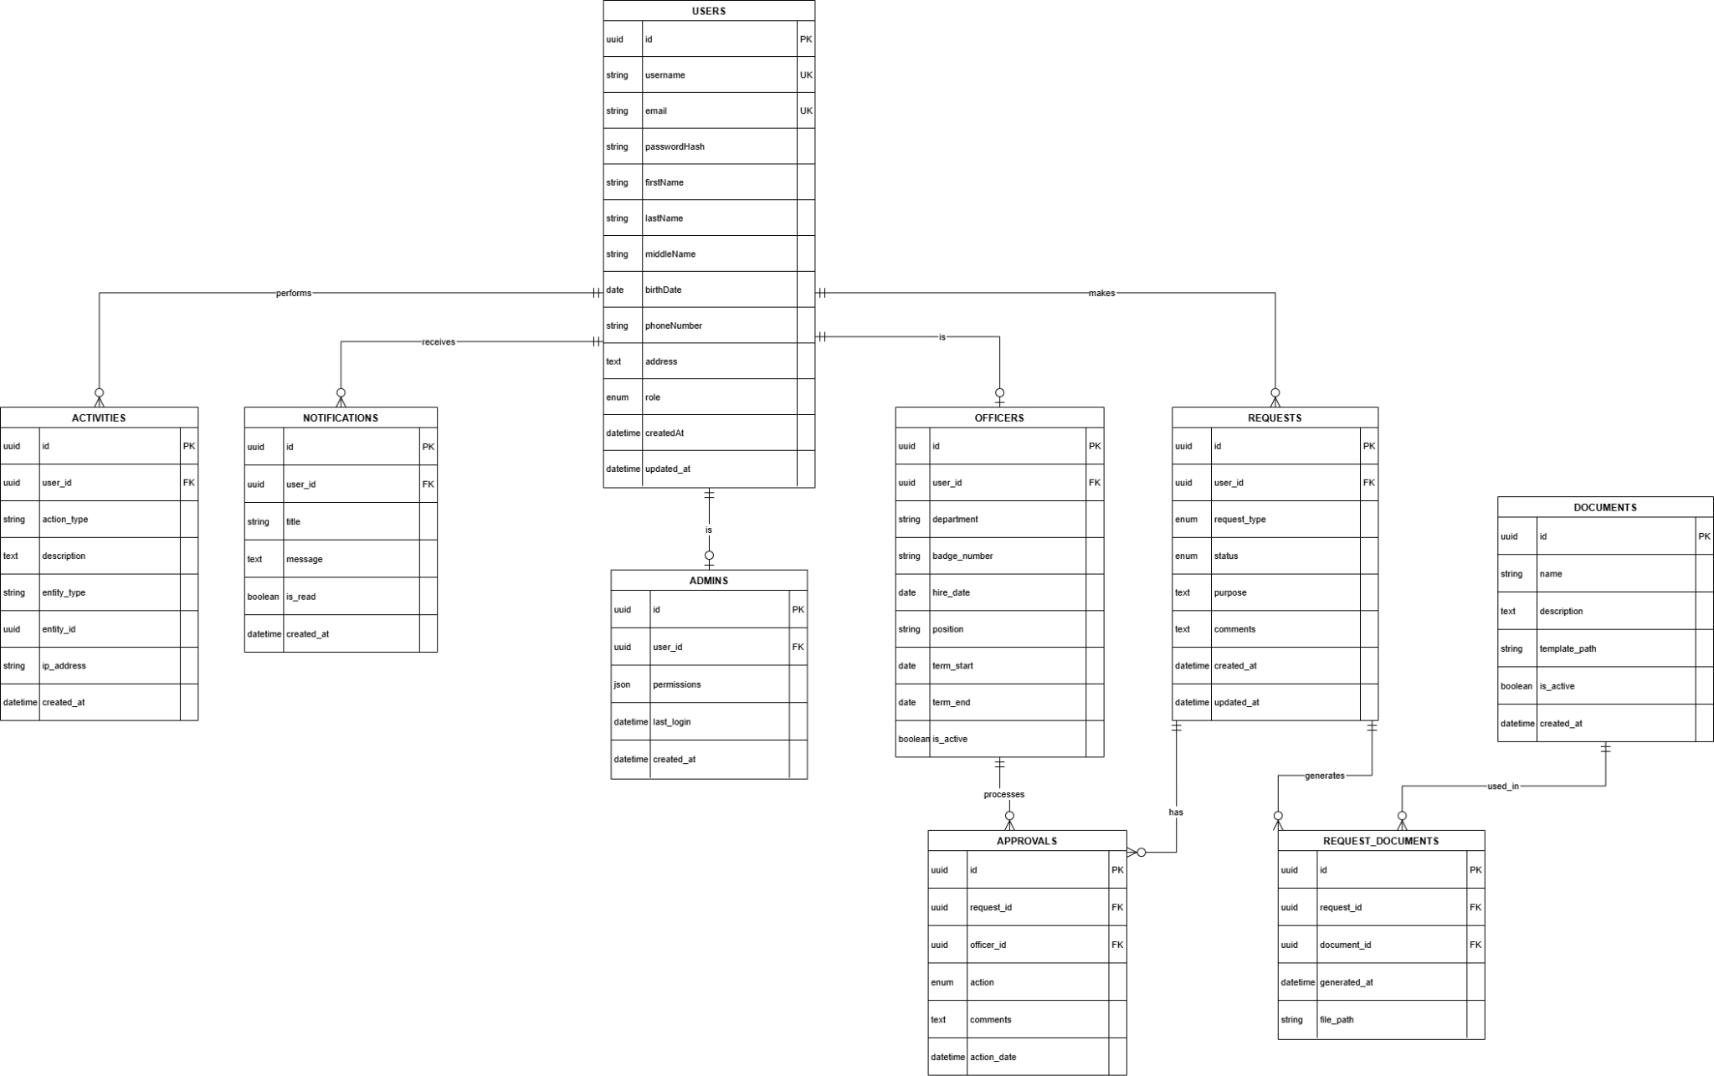

6.3 Relationships
One-to-Many Relationships
- User → Requests (A resident can make multiple document requests)
- User → Notifications (A user can receive multiple notifications)
- User → Activities (A user can perform multiple system activities)
- Request → Approvals (A request can have multiple approval actions)
- Request → RequestDocuments (A request can generate multiple documents)
- Document → RequestDocuments (A document type can be used in multiple requests)
- Officer → Approvals (An officer can process multiple approvals)
One-to-One Relationships
- User ↔ Officer (A user may have one corresponding officer profile)
- User ↔ Admin (A user may have one corresponding admin profile)
Many-to-One Relationships
- Requests → User (Each request belongs to one user)
- Approvals → Request (Each approval is tied to one request)
- Approvals → Officer (Each approval is processed by one officer)
- RequestDocuments → Request (Each generated document belongs to one request)
- RequestDocuments → Document (Each generated document is based on one document type)
- Notifications → User (Each notification belongs to one user)
- Activities → User (Each activity record belongs to one user)

6.4 Key Tables
- users — Stores resident, officer, and admin account information
- requests — Contains document request submissions
- documents — Defines available barangay document types
- request_documents — Stores generated documents per request
- officers — Officer-specific profile information
- admins — Admin-specific profile and permissions
- approvals — Records approval or rejection actions
- notifications — System-generated alerts for users
- activities — Audit trail of user actions

6.5 Core Entities
users
- id (UUID primary key)
- username (unique, up to 50 chars)
- email (unique, up to 100 chars)
- passwordHash (BCrypt hashed, never stored as plain text)
- firstName, middleName, lastName (personal identification)
- birthDate (date of birth)
- sex (Male/Female/Other)
- phoneNumber (contact information)
- street, barangay, city, province, zipCode (address details)
- role (RESIDENT, OFFICER, BARANGAY_ADMIN, SUPER_ADMIN)
- userStatus (ACTIVE, SUSPENDED, PENDING_VERIFICATION, REJECTED)
- emailVerified (boolean, default false for email/password users)
- otpCode (6-digit code for verification)
- otpExpiresAt (timestamp when OTP expires)
- emailVerificationAttempts (counter for OTP attempts, max 5)
- authProvider (LOCAL or GOOGLE)
- googleId (Google account ID if OAuth2)
- createdAt, updatedAt (timestamps)
requests
- id (UUID primary key)
- userId (foreign key → users)
- documentType (enum: BARANGAY_CLEARANCE, RESIDENCY_CERTIFICATE, etc.)
- requestStatus (PENDING, APPROVED, REJECTED, READY_FOR_RELEASE, CLAIMED)
- purpose (text, reason for request)
- comments (optional notes)
- createdAt, updatedAt (timestamps)
documents
- id (UUID primary key)
- name (document type name)
- description (what the document is for)
- isActive (boolean, whether the document type is available)
- createdAt, updatedAt (timestamps)
request_documents
- id (UUID primary key)
- requestId (foreign key → requests)
- documentId (foreign key → documents)
- fileUrl (storage path or Supabase Storage URL)
- generatedAt (timestamp)
officers
- id (UUID primary key)
- userId (foreign key → users, one-to-one)
- verificationStatus (PENDING, APPROVED, REJECTED)
- verificationFiles (linked file references)
- assignedBarangay (barangay the officer belongs to)
- createdAt, updatedAt (timestamps)
admins
- id (UUID primary key)
- userId (foreign key → users, one-to-one)
- permissions (admin-level access flags)
- assignedBarangay (barangay scope, null for SUPER_ADMIN)
- createdAt, updatedAt (timestamps)
approvals
- id (UUID primary key)
- requestId (foreign key → requests)
- officerId (foreign key → officers)
- action (APPROVED, REJECTED, READY_FOR_RELEASE)
- remarks (optional notes from officer)
- actionAt (timestamp)
notifications
- id (UUID primary key)
- userId (foreign key → users)
- title (notification heading)
- message (notification body)
- isRead (boolean, default false)
- createdAt (timestamp)
activities
- id (UUID primary key)
- userId (foreign key → users)
- action (description of the activity performed)
- metadata (optional JSON for additional context)
- performedAt (timestamp)

6.6 Key Features Implemented
Email OTP Verification — 6-digit OTP, 5-minute expiry, 5 max attempts, Resend API integration
OAuth2 Google Sign-In — Auto-provisioning, account linking, automatic email verification
Role-Based Access Control
- RESIDENT: Submit requests, view own requests and status
- OFFICER: Review and approve/reject requests, manage verification queue
- BARANGAY_ADMIN: Full request management, resident/officer approvals, barangay statistics
- SUPER_ADMIN: System-wide management, barangay creation, nationwide statistics
Request Status Workflow — PENDING → APPROVED/REJECTED → READY_FOR_RELEASE → CLAIMED
Officer Verification System — Self-registration, document submission, admin review and approval
Audit Trail — All user actions logged in the activities table for accountability
Notification System — System-generated alerts stored per user with read/unread tracking

7.0 UI/UX DESIGN
7.1 Web Application Wireframes
https://www.figma.com/design/op2CS0V3OlmLi5gG8GnvRk/Untitled?node-id=3-1706&t=FzyTytX5S1w6gb8C-1
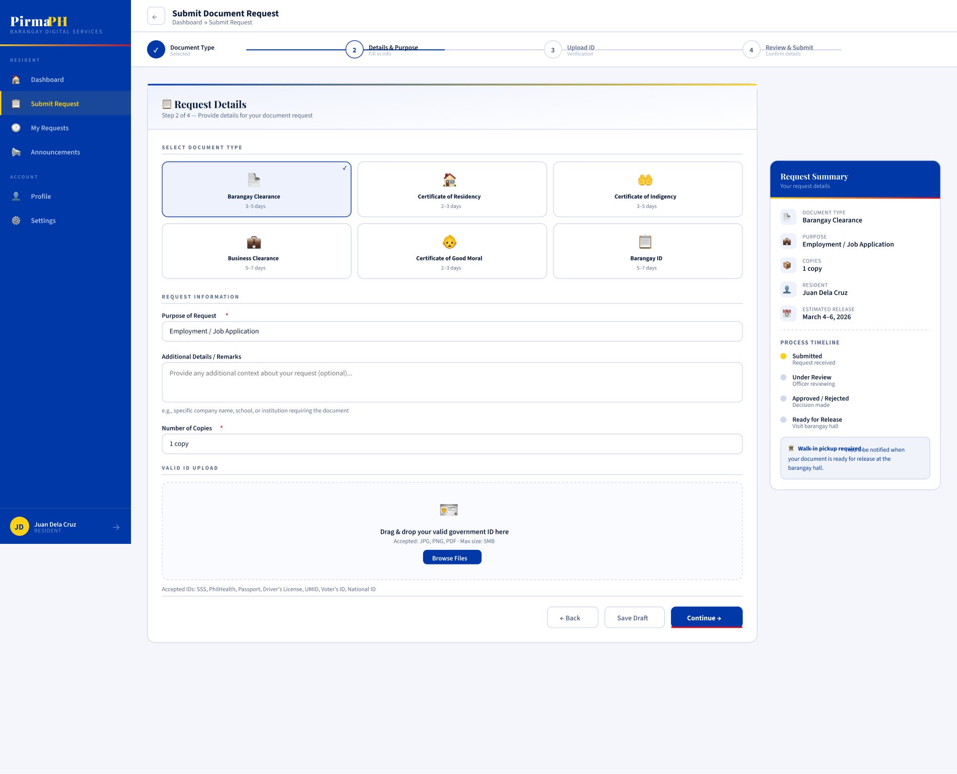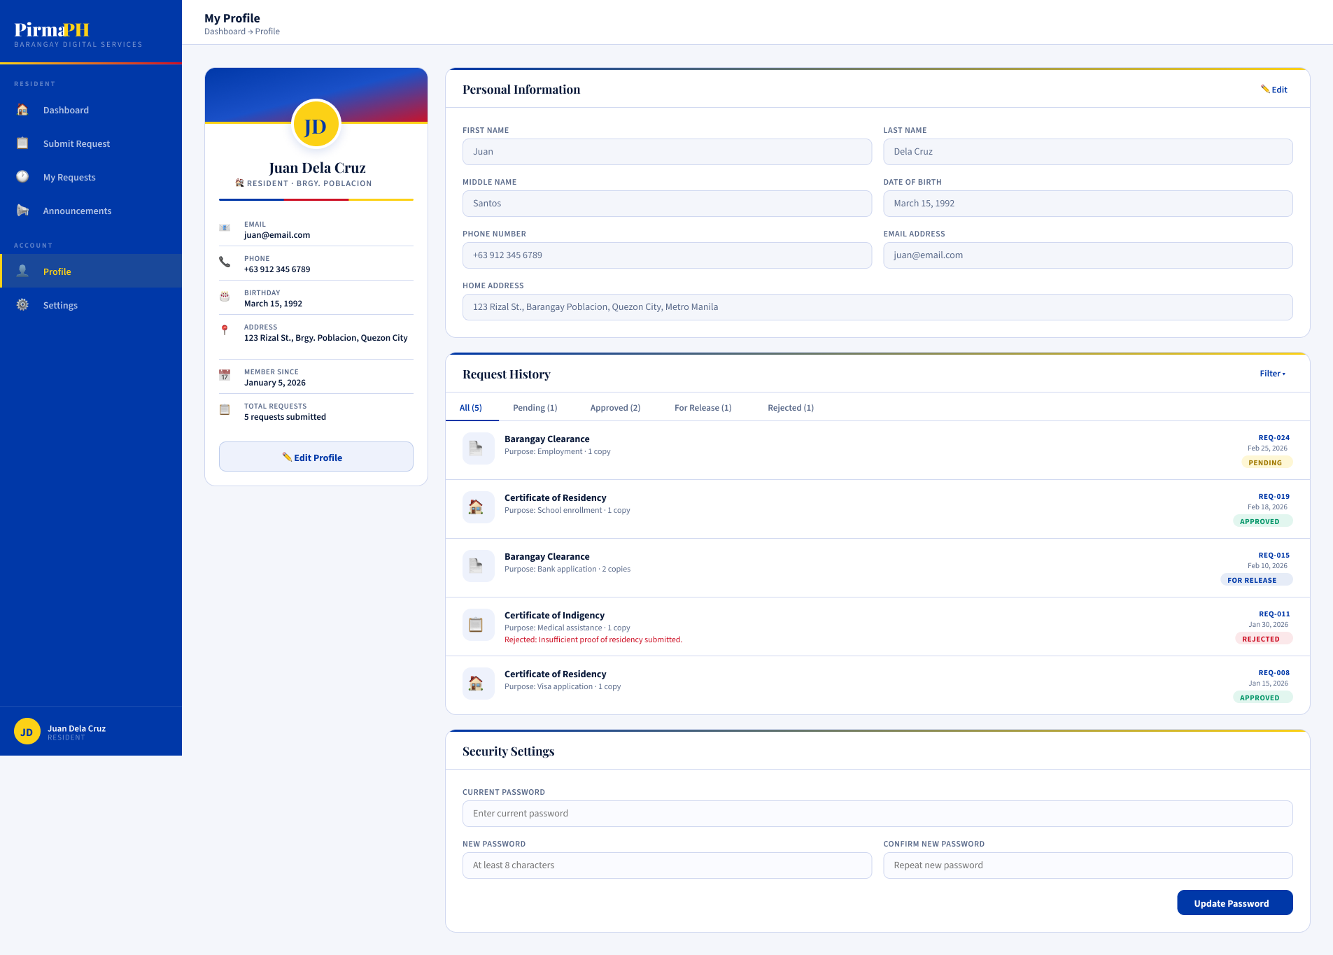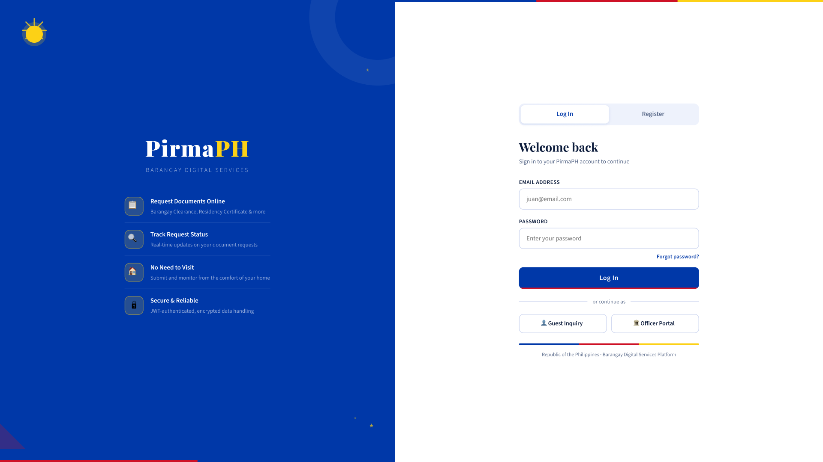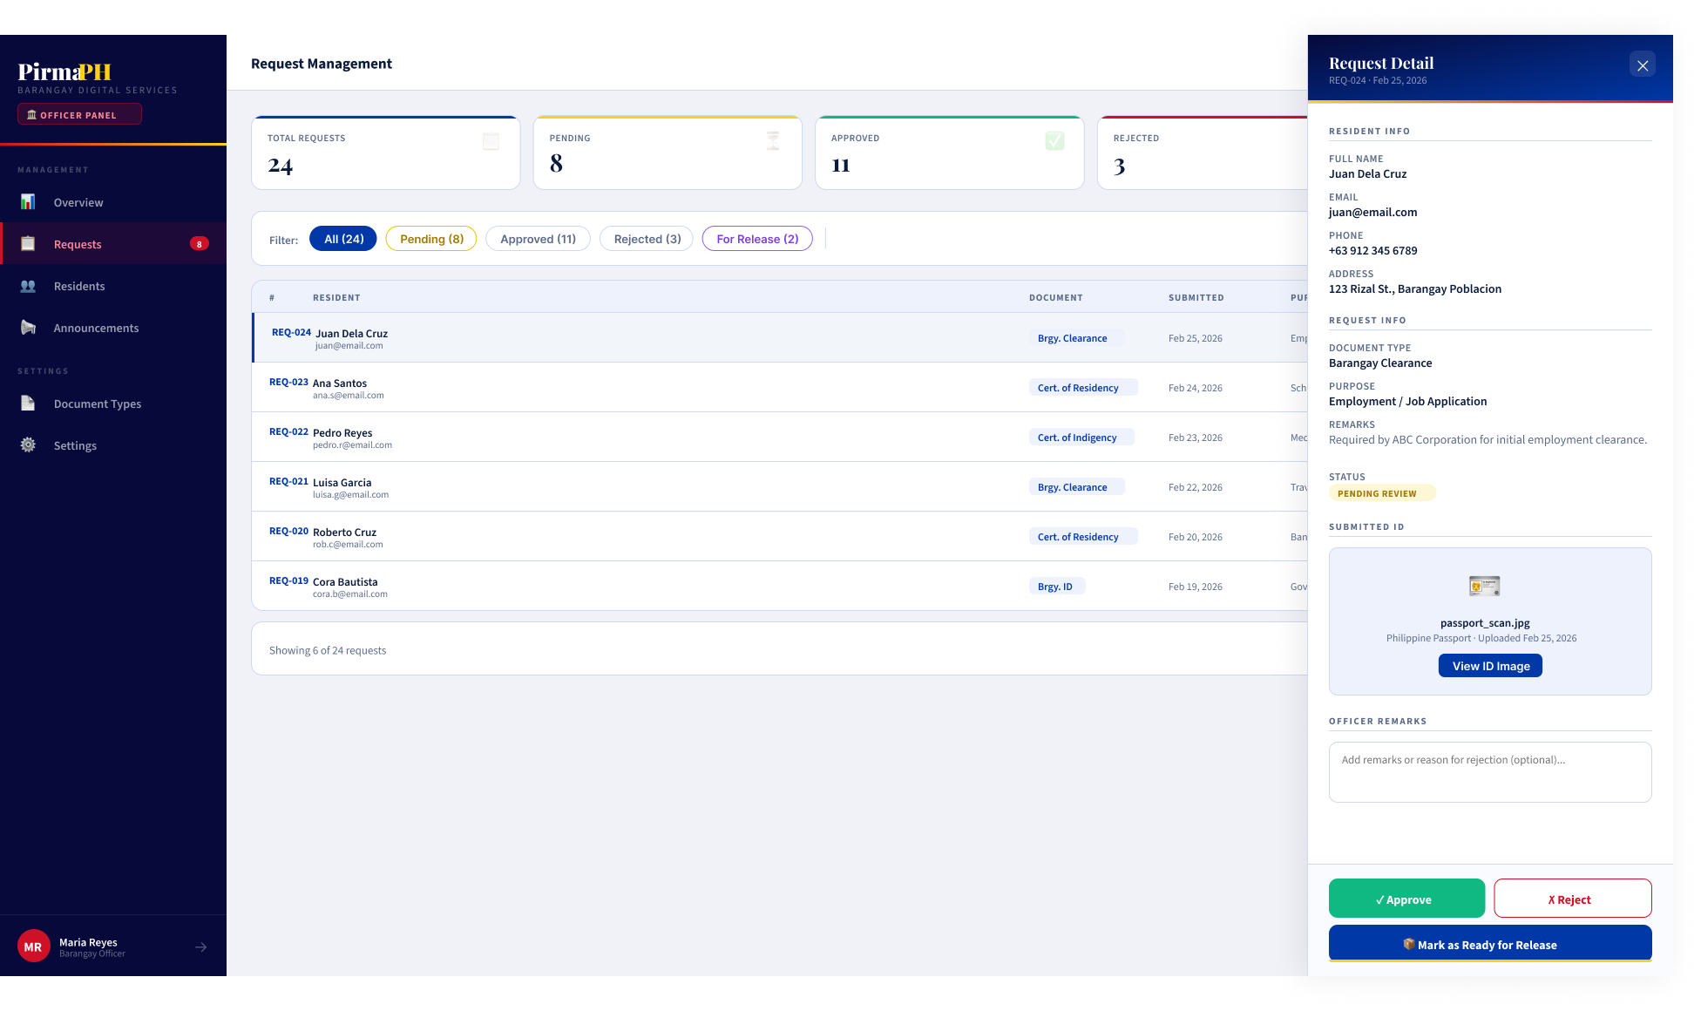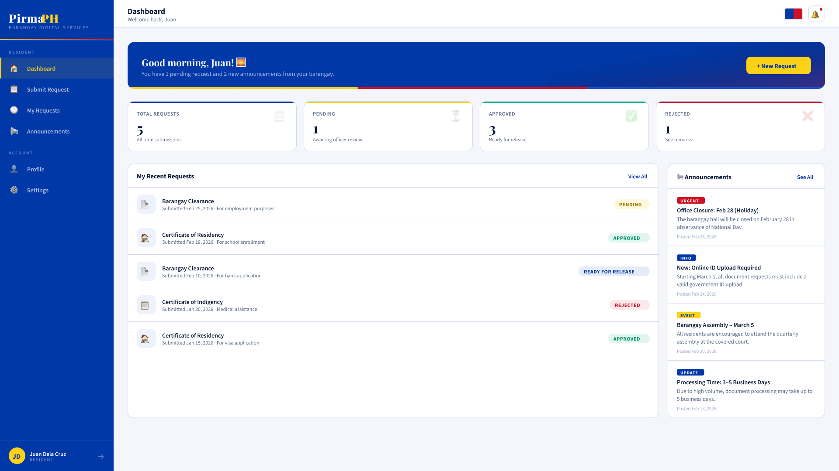
Authentication Pages
- Login Page: Email input, password input, “Sign In” button, “Sign in with Google” button, “Register” link
- Registration Page: Full form with personal info, address fields, role selection, password validation
- OTP Verification Page: 6-digit code input, auto-advance between fields, countdown timer, resend button
Resident Dashboard
- Header: Barangay logo, user menu, logout
- Sidebar: Dashboard, My Requests, Profile, Announcements
- Main Content: Request statistics, recent requests list, announcements
- Each Request Card: Document type, status badge, submission date, actions menu
Submit Request Page
- Document type dropdown
- Purpose text field
- File upload area
- Submit and cancel buttons
- Request preview before submission
Officer Request Management
- Request queue table with sorting/filtering
- Columns: Resident name, document type, submission date, status, actions
- Slide-over detail view: Full request info, file attachments, approval/rejection form
- Status update dropdown: Approve, Reject, Ready for Release
Admin Verification Panel
- Tabs: Pending Residents, Pending Officers, Officer Approvals, Admin Management
- Each queue shows pending items with approval/rejection actions
- Detailed review panel for each application
- Remarks/notes field for decisions
Admin Dashboards
- Barangay Admin: Overview cards (total requests, pending, approved, officers)
- Request queue for the barangay
- User management table (residents, officers)
- Super Admin: Nationwide statistics, barangay list, barangay creation form
Design System
Token | Value
Primary Color | Philippine flag blue (#003DA5)
Secondary Color | Philippine flag yellow (#FFD60A)
Success Color | #10B981
Error Color | #EF4444
Warning Color | #F59E0B
Typography | Inter font family for body, Playfair Display for headers
Spacing | 8px grid system (4px, 8px, 16px, 24px, 32px)
Responsive Breakpoints | 1200px (desktop), 768px (tablet), 360px (mobile)
Button Heights | 44px minimum (accessibility)
Form Fields | 40px height with 12px padding
Border Radius | 4px (inputs), 8px (cards), 12px (modals)

7.2 Mobile Application Wireframes
https://www.figma.com/design/op2CS0V3OlmLi5gG8GnvRk/Untitled?node-id=3-1706&t=FzyTytX5S1w6gb8C-1
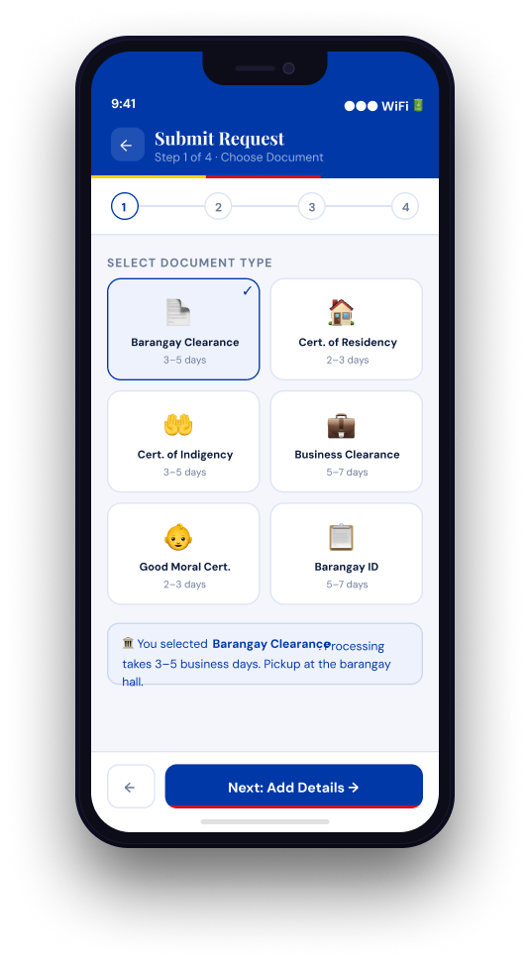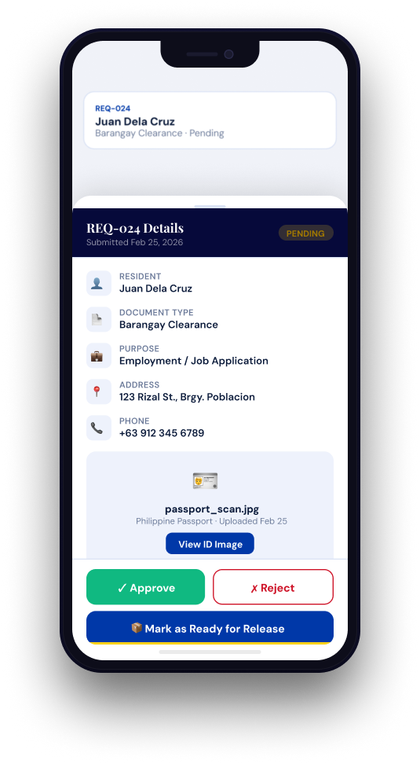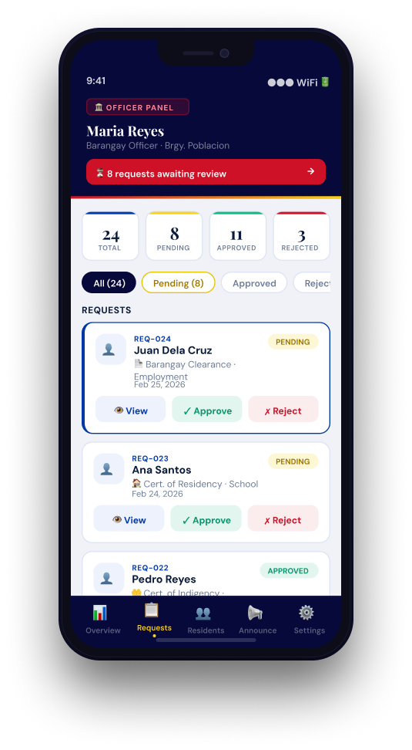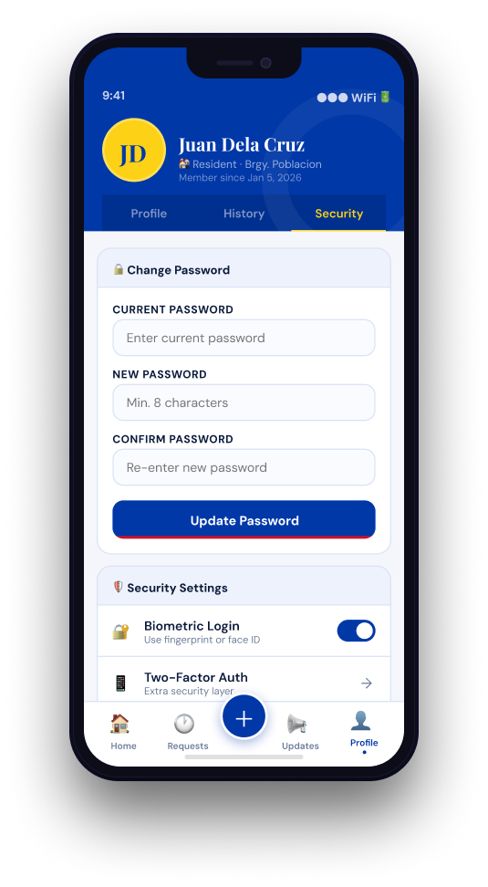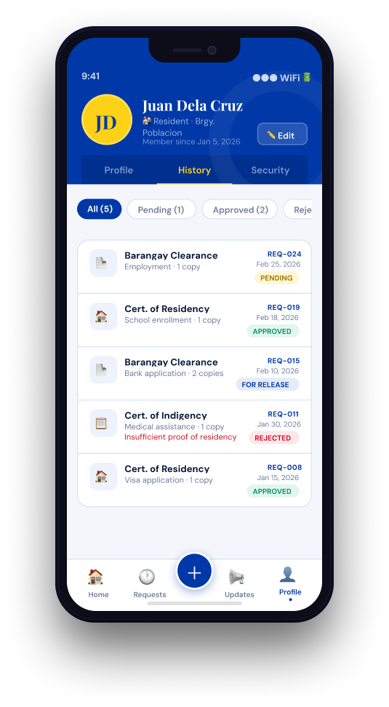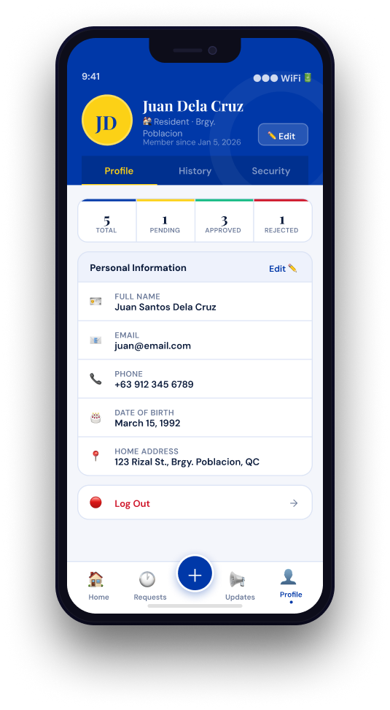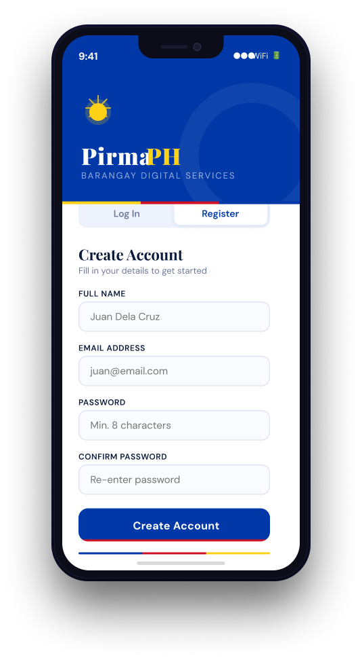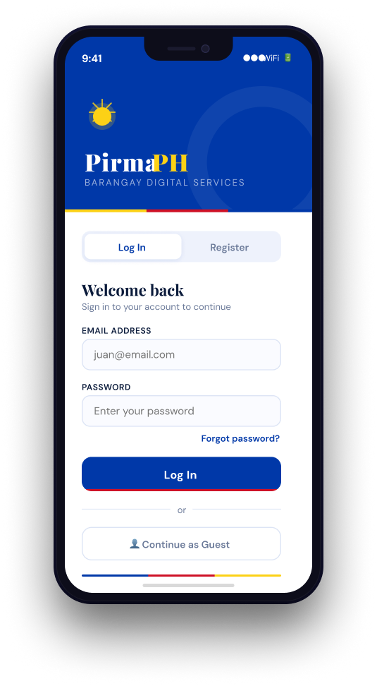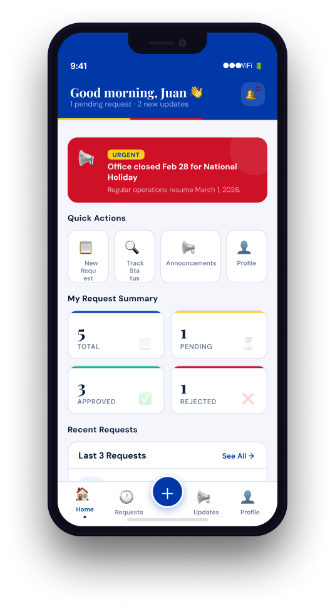
Mobile-Specific Features:
- Touch-optimized buttons (min 44x44px)
- Gesture support (swipe, pull-to-refresh)
- Offline caching for product images
- Bottom navigation for main actions
- Simplified forms for mobile input
Design System:
- Colors: Primary (#2563EB), Secondary (#7C3AED), Success (#10B981), Error (#EF4444)
- Typography: Inter font family, responsive sizing
- Spacing: 8px grid system
- Components: Consistent buttons, inputs, cards, modals
- Responsive: Mobile-first approach, breakpoints at 640px, 768px, 1024px

8.0 PLAN

Project Phases

Phase 1: Foundation & Design (Weeks 1-2, Completed Feb 2026)
Status: COMPLETE
- Requirements gathering and documentation
- System architecture design (3-tier)
- API specification and contract definition
- Database schema design
- UI/UX wireframe creation

Phase 2: Backend Foundation (Weeks 3-4, Completed March 2026)
Status: COMPLETE
Completed Components: - Spring Boot project setup (v3.5.11, Java 17) - Supabase (PostgreSQL) database configuration and connection setup - User entity with all required fields - JWT authentication (JwtUtil, SecurityConfig, JwtAuthenticationFilter) - User registration endpoint with validation - User login endpoint with authentication - Spring Security configuration with CORS - Password hashing with BCrypt - Role-based access control foundation

Phase 3: OAuth2 & Email Verification (Weeks 5-6, Completed March 2026)
Status: COMPLETE
Completed Components: - Google OAuth2 Sign-In integration (Spring OAuth2 Client) - CustomOAuth2UserService for Google user processing - OAuth2AuthenticationSuccessHandler for JWT generation - Auto-provisioning of Google users - Account linking for existing emails - Email OTP verification system (Resend API integration) - OTPService with 5-minute expiry and max attempts - Email OTP request and verification endpoints - Endpoint protection for unverified email users

Phase 4: Frontend - Authentication (Weeks 5-6, Completed March 2026)
Status: COMPLETE
Completed Components: - React project setup (v19.2, Vite v7.3.1) - Authentication context (AuthContext.jsx) with hooks - Login page with email/password validation - Registration page with full profile form - Google Sign-In button with official styling - OTP verification modal with 6-digit input - Protected routes (ProtectedRoute HOC) - API service layer with axios integration - Token management in localStorage - Error handling and user feedback

Phase 5: Document Request System (Weeks 7-8, Completed April 2026)
Status: COMPLETE
Completed Components: - Document request entity and repository - Document submission API (POST /requests) - Request status workflow (PENDING → APPROVED → READY_FOR_RELEASE) - Officer request queue endpoint - Request approval/rejection logic - File upload handling - Resident request history - Request detail view with file attachments

Phase 6: Admin & Verification System (Weeks 9-10, Completed April 2026)
Status: COMPLETE
Completed Components: - Officer verification workflow - ResidentFile entity for verification documents - Officer file upload and storage - Admin verification panel (resident, officer, admin queues) - Officer approval/rejection in admin panel - Officer onboarding flow - User role and status management - User suspension/reinstatement - Admin dashboard with request statistics

Phase 7: Barangay & Super Admin Features (Weeks 11-12, Completed May 2026)
Status: COMPLETE
Completed Components: - Barangay Admin Dashboard - Real-time request queue with resident info - Request approval/rejection from dashboard - User management (residents, officers) - Barangay statistics and metrics - Profile management
- Super Admin Dashboard
  - Nationwide statistics
  - Barangay management and creation
  - Barangay admin creation with auto-username generation
  - System-wide overview and monitoring
  - Multi-barangay support

Phase 8: Integration & Testing (Week 12, Completed May 2026)
Status: COMPLETE
Completed Components: - End-to-end integration testing - Cross-feature workflow testing - Authentication method testing (email/password, OAuth2, OTP) - Role-based access control verification - Frontend and backend API integration - Error handling and edge cases - Performance testing - Security validation (JWT, CORS, authorization)

Milestones
Milestone | Target Date | Status | Description
M1 | End Week 2 | Complete | Design documents finalized
M2 | End Week 4 | Complete | Backend authentication working
M3 | End Week 6 | Complete | OAuth2 + Email OTP implemented
M4 | End Week 8 | Complete | Document request system functional
M5 | End Week 10 | Complete | Admin verification system live
M6 | End Week 12 | Complete | Full system integrated and deployed

Deployment Status
- Backend: Deployed and running on Render
- Frontend: Built and optimized (vite build successful)
- Database: Supabase (PostgreSQL) configured and managing schema
- SSL/TLS: Configured for production
- Environment Variables: Configured for OAuth2 and API keys
- Testing: All endpoints functional and tested

Critical Path
- Authentication system (Week 3)
- Document request API (Week 3–4)
- Approval workflow (Week 4)
- Web dashboard integration (Week 6)
- Cross-platform integration testing (Week 9)

Risk Mitigation
- Start with core authentication and request submission first
- Test API endpoints independently before frontend integration
- Perform integration testing after each module completion
- Maintain version control with stable backups
- Prioritize core workflow (request → review → approve → release) before enhancements

