

IT342-G5
System Integration and Architecture

System Design Document (SDD)

Project Title: PirmaPH
Prepared By: Binagatan, Alexander Jr. Bersano

Version: 2.0
Date: 5/15/2026
Status: Final

REVISION HISTORY TABLE
Version | Date | Author | Changes Made | Status
0.1 | 2/20/2026 | Alexander Jr. Binagatan | Initial draft | Draft
0.2 | 2/27/2026 | Alexander Jr. Binagatan | Final review and corrections | Final
0.5 | 3/26/2026 | Alexander Jr. Binagatan | Backend auth + Google OAuth2 implemented | In Progress
0.8 | 4/15/2026 | Alexander Jr. Binagatan | Email OTP verification, admin/officer endpoints | In Progress
1.0 | 5/15/2026 | Alexander Jr. Binagatan | Full implementation complete | Draft
2.0 | 5/27/2026 | Alexander Jr. Binagatan | Final system documentation encompassing mobile app integrations, PayMongo payment gateway, and updated ERD | Final

TABLE OF CONTENTS
Contents
EXECUTIVE SUMMARY 4
1.0 INTRODUCTION 6
2.0 FUNCTIONAL REQUIREMENTS SPECIFICATION 6
2.5 Acceptance Criteria 11
3.0 NON-FUNCTIONAL REQUIREMENTS 12
4.0 SYSTEM ARCHITECTURE 14
5.0 API CONTRACT & COMMUNICATION 15
Authentication Endpoints 16
User Registration 16
6.0 DATABASE DESIGN 24
7.0 UI/UX DESIGN 29
8.0 PLAN 44
Project Phases 44

EXECUTIVE SUMMARY
1.1 Project Overview
PirmaPH is a digital service platform designed to streamline the process of requesting official barangay documents such as barangay clearance and certificate of residency. The system enables residents to submit document requests online, track request status, and receive updates without repeatedly visiting the barangay office.
The system includes a Spring Boot backend API with comprehensive RESTful endpoints, a React web application providing a responsive, user-friendly interface, and a native Android mobile application offering portable, on-the-go access. The backend manages authentication (email/password and Google OAuth2), email OTP verification, request processing, role-based access control (RESIDENT, OFFICER, BARANGAY_ADMIN, SUPER_ADMIN), and data storage on Supabase (PostgreSQL). The web and mobile applications provide intuitive interfaces for document request submission, status tracking, officer request queue management, and administrative monitoring, with the mobile app utilizing local caching and optimistic UI to deliver a fast and responsive user experience for mobile users.
This integrated architecture supports digital transformation initiatives in local government units (LGUs) by improving operational efficiency, transparency, and service accessibility.
1.2 Objectives
- Develop a fully functional digital barangay document request system with secure authentication, request submission, integrated document fee payments, status tracking, and a structured approval workflow.
- Implement a multi-platform architecture consisting of a Spring Boot backend API, a React web application, and a native Android mobile application.
- Create secure RESTful APIs utilizing JWT (JSON Web Token) authentication to enable seamless communication and data exchange between the backend, web client, and mobile client.
- Implement role-based access control (RBAC) across four distinct user levels—RESIDENT, OFFICER, BARANGAY_ADMIN, and SUPER_ADMIN—to manage permissions and workflow actions.
- Design responsive and consistent user interfaces across web and mobile platforms, utilizing local caching and optimistic UI patterns on the native mobile app to reduce server load and enhance responsiveness.
- Deploy the platform in production-ready environments integrated with a Supabase PostgreSQL database and Supabase Secure Object Storage for resident attachments and generated documents.
- Ensure secure data handling using BCrypt password hashing, email OTP verification, robust server-side input validation, security auditing, and encrypted data transit.
- Integrate a secure payment gateway (PayMongo) to handle document processing fees, enabling residents to pay online via card or e-wallet with real-time status synchronization.
1.3 Scope
Included Features:
- Multi-Platform Access: Native Android app and responsive React web interface for residents, officers, and administrators.
- User Registration and Authentication: Secure email/password login with Google OAuth2 and role-based access control.
- Email Security: Email OTP verification for account confirmation and password resets.
- Resident Dashboard: Real-time request tracking, document history, and barangay announcements.
- Online Request Submission: Digital request workflow with document selection, purpose input, and file uploads.
- Online Payment Gateway (PayMongo): Integrated online payment processing with real-time backend synchronization.
- Officer Panel & Workflow: Officer portal for reviewing, approving, rejecting, and releasing requests.
- On-the-go Mobile Officer Queue: Mobile officer interface with request lists, bottom sheets, and contact card integration.
- Performance Optimizations: In-memory caching and optimistic UI patterns for reduced mobile latency.
- Admin Verification Panel: Portal for approving resident, officer, and admin account requests.
- Barangay Admin Dashboard: Local management dashboard with request queues, user management, and statistics.
- Super Admin Dashboard: Nationwide dashboard with LGU statistics and barangay registry management.
- Structured Data & Storage: Supabase PostgreSQL database with Supabase Object Storage integration.
- Secure Data Handling: JWT authentication, BCrypt hashing, input validation, and security audit logging.
- Status Notifications: Email notifications for request lifecycle updates and confirmations.
Excluded Features:
- SMS Notification Integration: Notifications are limited to email and in-app updates.
- Automated PDF Document Generation: Officers manually upload finalized document files.
- QR Code-Based Document Claiming: Verification is handled manually by officers.
- Mobile Push Notification System: Uses background synchronization and email updates instead.
- Advanced Analytics & Financial Reporting: Limited to raw PayMongo transaction history tracking.
- Cloud-based Auto-scaling Infrastructure: Uses standard single-instance deployment architecture.

1.0 INTRODUCTION
1.1 Purpose
This document serves as the design specification for the PirmaPH system. It defines the system requirements, architecture, API structure, database design, and integration approach between the Spring Boot backend and React web application.
The purpose of this document is to guide development and ensure that all system components are properly designed, integrated, and implemented in a consistent and organized manner.

2.0 FUNCTIONAL REQUIREMENTS SPECIFICATION
2.1 Project Overview
Project Name: PirmaPH
Domain: E-Government / Local Government Services
Primary Users:
- Residents
- Barangay Officers
- Barangay Administrators
- Super Admin (Global)
Problem Statement: Residents need a convenient and efficient way to request official barangay documents without repeatedly visiting the barangay office, while officers need a structured system to manage and track document requests digitally.
Solution: A digital barangay service platform that enables residents to submit document requests online, track request status, and receive updates, while providing officers with a centralized management system accessible via web and mobile platforms.
2.2 Core User Journeys
Journey 1: First-Time Resident Request & Payment
- User visits the web application or launches the Android mobile app.
- Clicks “Register” and creates an account under the RESIDENT role.
- Logs in using email/password or Google Sign-In.
- Verifies their email via OTP (if using email/password registration).
- Navigates to Submit Request to request a document.
- Selects document type (e.g., Barangay Clearance, Certificate of Residency), sets the desired number of copies, and enters the purpose.
- Uploads a valid ID and/or supporting attachments (saved securely in Supabase Object Storage).
- Submits the request, moving its status to PENDING_PAYMENT.
- The resident triggers the online checkout, generating a secure PayMongo payment session.
- Completes payment online via credit/debit card or e-wallet (GCash, Maya, etc.).
- Upon payment verification, the status updates to SUBMITTED, notifying the barangay officers.
Journey 2: Returning Resident Tracking Request
- User logs into their existing account (web or mobile).
- Views the dashboard statistics and recent activity timeline.
- Checks the status of the submitted request.
- Sees the request progress through UNDER_REVIEW, APPROVED, and finally READY_FOR_RELEASE.
- Downloads or views any uploaded files or generated documents attached to the request.
- Logs out safely.
Journey 3: Officer Request Processing (Web & Mobile)
- Officer logs in on the web application or native Android app and lands directly on their Dashboard.
- Navigates to the Request Queue (mobile app uses optimized local cache and optimistic UI to ensure instant tab switching).
- Views the pending requests list.
- Opens a request detail view (in mobile, a slide-up bottom sheet containing complete resident name, contact details, and file attachments).
- Reviews files (taps to view uploaded documents).
- Approves the request, or rejects it (requiring officer remarks).
- If the request is approved, the officer processes the certificate and uploads the generated document file.
- Once finalized, the officer marks the request as READY_FOR_RELEASE (notifying the resident).

2.3 Feature List (MoSCoW)
MUST HAVE
- User Authentication: Register, login, logout, JWT-based security (24-hour expiry), and BCrypt password hashing.
- Security & OTP: Email-based registration with 6-digit OTP verification (delivered via Resend API).
- Google Sign-In: Seamless authentication using Google OAuth2.
- Role-Based Access Control: Strict access boundaries across four roles: RESIDENT, OFFICER, BARANGAY_ADMIN, and SUPER_ADMIN.
- Resident Portal: Document request submission, purpose fields, secure file attachments, and status tracking timeline.
- Online Payment System: PayMongo API integration for online card/e-wallet fee processing and payment webhooks.
- Officer Management Queue: View, review attachments, write remarks, change status, and upload generated files.
- Native Android Application: Native app supporting login, dashboards, queue monitoring, and request details for residents and officers.
- Performance Optimization: In-memory caching and optimistic UI updates on Android to guarantee instantaneous client transitions.
- Account Approvals: Registration review queues for residents, officers, and admins.
- Barangay Admin Panel: Request monitoring, officer control, and local LGU activity feeds.
- Super Admin Dashboard: Global dashboard managing nationwide LGUs and creating barangay admin credentials.
SHOULD HAVE
- Input validation, error feedback alerts, and session expiration warnings.
- Fully responsive web layout optimized for desktop, tablet, and mobile views.
- Search and status filters on request queues and lists.
- File management system utilizing Supabase Secure Object Storage.
COULD HAVE
- Live message history or remarks thread between residents and processing officers.
- User profile photo uploads.
- Custom document type templates and fee configuration panels.
WON'T HAVE
- Automated PDF generation (documents are generated externally and uploaded by officers).
- SMS notification gateway (delivery remains centered on email and dashboard updates).
- QR-code scan verification for claiming certificates.
- Multi-barangay capability per deployment (single tenant per LGU deployment configuration).

2.4 Detailed Feature Specifications
Feature: User Authentication & Onboarding
- Screens / Views: Web & Mobile Login, Register, Forgot Password, OTP Verification
- API Endpoints:
  - POST /api/auth/register (Register localized account)
  - POST /api/auth/login (Login local credentials)
  - POST /api/auth/logout (Log out current session)
  - POST /api/auth/email-otp/request (Trigger Resend OTP)
  - POST /api/auth/email-otp/verify (Validate OTP verification code)
  - POST /api/auth/oauth2/authorization/google (Initiate Google OAuth2 flow)
  - GET /api/auth/oauth2/callback (Google redirect callback)
  - GET /api/auth/me (Retrieve currently logged-in user profile)
Feature: Document Requests (Resident View)
- Screens / Views: Dashboard, Document Request Wizard, Request Detail, Profile
- API Endpoints:
  - POST /api/requests/resident (Create a new document request)
  - GET /api/requests/resident/mine (Fetch resident request history)
  - GET /api/requests/resident/{requestId} (Fetch specific request details)
  - POST /api/requests/resident/{requestId}/attachments (Upload ID or support attachments)
Feature: Request Queue & Operations (Officer View)
- Screens / Views: Officer Dashboard, Request Queue List, Request Details (Bottom Sheet on Android)
- API Endpoints:
  - GET /api/requests/officer/queue (Retrieve queue requests, optional status filter)
  - GET /api/requests/officer/{requestId} (Retrieve specific request with resident contact details)
  - PATCH /api/requests/officer/{requestId}/status (Change request status: Approved, Declined, Ready for Release)
  - POST /api/requests/officer/{requestId}/generated-documents (Upload completed generated document file)
Feature: Online Payments
- Integration: PayMongo Checkout API
- API Endpoints:
  - POST /api/v1/payments/checkout (Generates checkout session link for PENDING_PAYMENT request)
  - POST /api/v1/payments/webhook (Handles real-time webhook callbacks for paid checkouts)
  - POST /api/v1/payments/verify/{requestId} (Actively queries PayMongo API or manually confirms payment)
Feature: Account Verifications & Auditing
- Screens / Views: Verification Dashboard, File Upload review list
- API Endpoints:
  - GET /api/resident/verification-status (Check resident verification stage)
  - POST /api/resident/files/upload (Resident uploads verification files)
  - GET /api/resident/files (Retrieve uploaded resident documents)
  - GET /api/officer/verification-status (Check officer onboarding stage)
  - POST /api/officer/files/upload (Officer uploads appointment credentials)
  - GET /api/officer/files (Retrieve uploaded officer documents)
Feature: Barangay Admin Operations
- Screens / Views: Admin Dashboard, User Management Console, Action Log Feed
- API Endpoints:
  - GET /api/admin/dashboard (Barangay admin overview metrics and activity feeds)
  - GET /api/admin/residents/pending (List pending resident accounts)
  - PATCH /api/admin/residents/{userId}/approve (Approve resident registration status)
  - PATCH /api/admin/residents/{userId}/reject (Reject resident registration status)
  - GET /api/admin/officers/pending (List pending officer accounts)
  - PATCH /api/admin/officers/{userId}/approve (Approve officer account status)
  - PATCH /api/admin/officers/{userId}/reject (Reject officer account status)
  - PATCH /api/admin/users/{userId}/status (Change user suspension status)
  - PATCH /api/admin/users/{userId}/role (Manually change user role)
Feature: Super Admin Console
- Screens / Views: Super Admin Dashboard, Barangay Creator
- API Endpoints:
  - GET /api/admin/super-dashboard (Nationwide LGU overview metrics)
  - POST /api/admin/barangay-admins (Create new LGU and register first Barangay Admin account)

2.5 Acceptance Criteria
AC-1: Successful User Registration (Email/Password)
- Scenario: Successful account creation and email verification.
  - Given: I am a new resident on the registration page.
  - When: I enter valid personal details, address, email, and a strong password.
  - And: The password confirmation matches and I click "Register".
  - Then: My temporary account is created, and I am prompted to enter a 6-digit OTP code sent to my email.
  - When: I enter the correct OTP code and click "Verify".
  - Then: My account status changes to active, and I can successfully log in and access the dashboard.
  - Note: Residents registering via Google OAuth2 skip the OTP process and land directly on the active dashboard.
AC-2: Document Request Submission & Payment Flow
- Scenario: Resident submits request and completes online payment.
  - Given: I am logged in as an active resident.
  - When: I submit a document request with valid parameters (type, purpose, copies) and upload a valid ID image.
  - Then: The request is created in the database, with files securely uploaded to Supabase Object Storage.
  - And: The request status is set to PENDING_PAYMENT (not yet visible in the officer review queue).
  - When: I click "Pay Now" and complete a successful transaction via PayMongo (using credit card or GCash/Maya).
  - Then: The PayMongo webhook registers the successful payment, updating the request status to SUBMITTED.
  - And: The request immediately appears in my resident history and is pushed to the Officer's pending queue.
AC-3: Officer Request Processing (Web & Mobile)
- Scenario: Officer reviews, approves, and releases a document.
  - Given: I am logged in as a verified officer.
  - When: I access the pending request queue (which loads instantly using in-memory caches on the Android mobile app).
  - And: I view a request's details, verify the resident info and uploaded ID, and click "Approve".
  - Then: The request status is updated to APPROVED and logged in the security audit trail.
  - When: I upload the completed generated document file and click "Mark as Ready for Release".
  - Then: The request status transitions to READY_FOR_RELEASE.
  - And: The resident can view their request marked as ready and tap to download/view the released document from their dashboard.
AC-4: Officer Request Rejection
- Scenario: Officer rejects a request due to invalid files or reasons.
  - Given: I am logged in as a verified officer.
  - When: I review a pending request and choose to "Reject" it.
  - And: I enter the required explanation in the "Officer Remarks" text field and submit.
  - Then: The request status updates to DECLINED.
  - And: The resident sees the request marked as "Rejected" on their dashboard, along with the specified officer remarks.
AC-5: Mobile Cache & Optimistic UI (Android)
- Scenario: Instant navigation between queues on mobile app.
  - Given: I am logged in as an officer on the Android mobile app.
  - When: I navigate between the dashboard stats, pending request lists, and completed queues.
  - Then: The application should render the locally cached request records instantly without displaying a blocking loading screen.
  - And: A background API sync must execute silently to update the views once fresh server-side data is returned.
  - When: I complete a request state transition (such as Approve or Reject), the local cache must invalidate and prompt a fresh API sync with a visible loader.

3.0 NON-FUNCTIONAL REQUIREMENTS
3.1 Performance Requirements
- API Response Time: $\leq$ 2 seconds for 95% of standard RESTful operations (excluding external payment gateway redirection).
- Mobile Response Latency (Caching): Near-zero (instantaneous) request queue rendering on the Android app when using local cache (OfficerQueueCache with a 60-second Time-to-Live).
- Payment Synchronization: Real-time payment verification and status transition updates within 3 seconds of a successful PayMongo checkout event.
- Supabase File Retrieve/Upload: Uploads and downloads of attachments under 5MB completed within 2 seconds under standard network speeds.
- Concurrent Capacity: Support for up to 100 concurrent users without database request bottlenecks or server timeouts.
3.2 Security Requirements
- Secure Transit: HTTPS required for all client-to-backend API communications.
- Session Management: Stateless JWT-based authentication with 24-hour token expiration.
- Credential Protection: One-way password hashing using BCrypt (salt rounds = 12).
- OTP Verification: Single-use, 6-digit email OTPs with a 5-minute validation window to verify local account setups.
- Payment Webhook Verification: Signature validation verifying the paymongo-signature header on incoming PayMongo webhook payloads to prevent spoofing.
- File Upload Constraints: Server-side file validation enforcing type restrictions (images/PDFs only) and size limits (max 5MB) before writing to Supabase Secure Storage.
- Audit Logging: Security logging for account status shifts, role escalations, system errors, and administrative actions.
3.3 Compatibility Requirements
- Web Browsers: Chrome, Firefox, Safari, and Edge (latest 2 major versions).
- Android OS Support:
  - Compatible with Android API Level 26+ (Android 8.0+).
  - Compiled against Android 34 (Android 14) with strict layout constraints utilizing Material Design 3 and AndroidX compatibility libraries.
- Screen Responsiveness:
  - Web: Dynamic breakpoints supporting Mobile (360px+), Tablet (768px+), and Desktop (1024px+) layouts.
  - Mobile: Auto-scaling layouts, bottom sheet overlays, and scrollable containers fitting screens from 5.0 to 6.7 inches.
3.4 Usability Requirements
- Optimized Input Actions: Action buttons (such as Approve, Reject, and Create Account) employ loading spinner overlays when clicked to prevent double-submissions.
- Branded Interface Styling: Uniform branding utilizing the high-contrast Pirma navy blue (#0A1A3A), gold (#FCD116), and red (#CE1126) color schemes.
- Accessible Button Touch Targets: Touch targets in the Android application strictly adhere to a minimum size of 48×48dp.
- Clear Input States: Accessible custom forms featuring high-contrast borders and clear hints (required remarks fields when processing rejections).
- WCAG 2.1 Level AA Compliance: Text and background color contrast ratios on buttons and badges exceed standard requirements for web visual accessibility.

4.0 SYSTEM ARCHITECTURE
4.1 Component Diagram
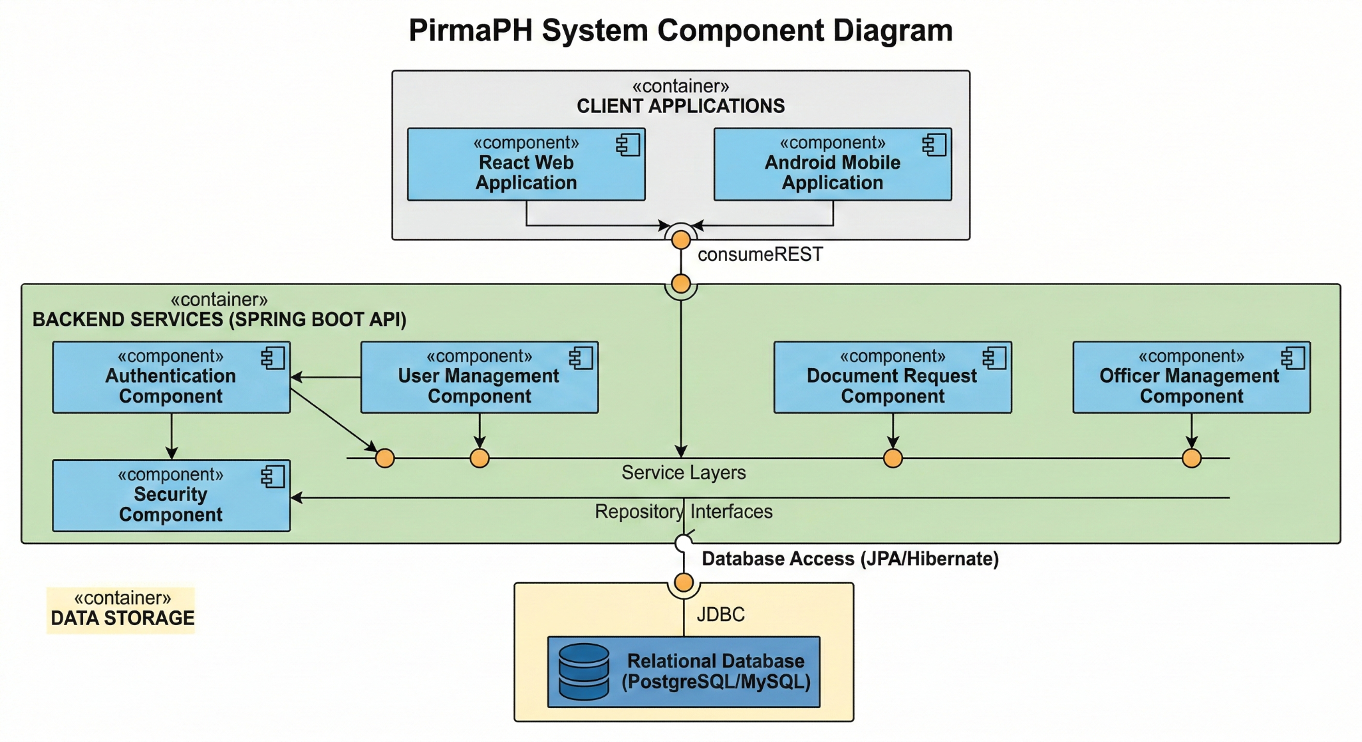
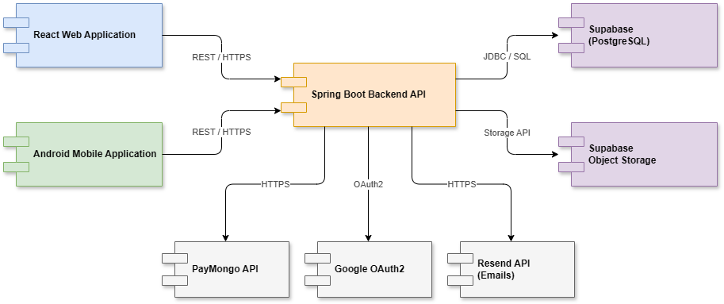
Technology Stack:
Layer | Technology | Version
Backend | Spring Boot | 3.5.11
Java Runtime | Java SE | 17 (LTS)
Database | Supabase (PostgreSQL) | Latest
Object Storage | Supabase Storage (File Attachments) | Latest
Web Frontend | React | 19.2.0
Mobile Frontend | Android (Kotlin, Native) | API 34+
Routing | React Router DOM | 7.13.1
CSS Framework | Tailwind CSS (Web) | Via Vite
HTTP Client | Axios (Web), Retrofit2 (Mobile) | -
Build Tools | Maven (Backend), npm (Web), Gradle (Mobile) | -
Frontend Build | Vite | 7.3.1
Authentication | Spring Security + JWT + Google OAuth2 | -
Email Service | Resend API | OTP & Notifications
Payment Gateway | PayMongo API | Card & E-Wallet
Backend Deployment | Render | -
Frontend Deployment | Vercel | -

5.0 API CONTRACT & COMMUNICATION
5.1 API Standards
Property | Value
Base URL | http://localhost:8080/api (development)
Format | JSON for all requests and responses
Authentication | Bearer token (JWT) in Authorization header, OR OAuth2 flow
CORS | Enabled for http://localhost:5173, localhost:5174, localhost:3000
Default Token Expiry | 24 hours
Standard Response Structure:
{
"id": "string | null",
"username": "string | null",
"email": "string",
"firstName": "string",
"lastName": "string",
"role": "RESIDENT | OFFICER | BARANGAY_ADMIN | SUPER_ADMIN",
"token": "JWT token string | null",
"message": "string",
"success": "boolean",
"status": "number",
"timestamp": "ISO8601 datetime"
}
Authentication Methods:
- JWT Bearer Token (for email/password users)
  - Header: Authorization: Bearer <jwt_token>
  - Generated on registration or login
  - Valid for 24 hours
  - Contains user ID and role claims
- OAuth2 Google Sign-In
  - Google authorization flow
  - Auto-creates account or links to existing email
  - Returns JWT token for subsequent requests
  - Users skipped OTP verification if using OAuth2
- Session Management
  - Client stores JWT token in localStorage
  - Token passed with each authenticated request
  - Logout clears client-side token

5.2 Endpoint Specifications

Authentication Endpoints

User Registration
Property | Value
Description | User Registration with Email & Password
API URL | POST /auth/register
HTTP Method | POST
Format | JSON
Authentication | None
Request Payload:
{
"username": "juan123",
"email": "juan@email.com",
"password": "SecurePass123!",
"confirmPassword": "SecurePass123!",
"firstName": "Juan",
"middleName": "Santos",
"lastName": "Dela Cruz",
"birthDate": "1990-05-15",
"sex": "Male",
"phoneNumber": "+63 912 345 6789",
"street": "123 Rizal Street",
"barangay": "Poblacion",
"city": "Quezon City",
"province": "Metro Manila",
"zipCode": "1100",
"role": "RESIDENT"
}
Success Response (201 Created):
{
"id": "uuid",
"username": "juan123",
"email": "juan@email.com",
"firstName": "Juan",
"role": "RESIDENT",
"emailVerified": false,
"token": "eyJhbGciOiJIUzI1NiIs...",
"message": "Registration successful. Please verify your email.",
"success": true
}
Error Response:
{
"status": 400,
"message": "Email already registered",
"success": false,
"timestamp": "2026-05-15T10:30:00Z"
}

Request OTP Code
Property | Value
Description | Request OTP code via email for verification
API URL | POST /auth/email-otp/request
HTTP Method | POST
Format | JSON
Authentication | None
Request Payload:
{
"email": "juan@email.com"
}
Success Response (200 OK):
{
"message": "OTP sent to j****@email.com. Valid for 5 minutes.",
"success": true
}

Verify OTP Code
Property | Value
Description | Verify OTP code and complete email verification
API URL | POST /auth/email-otp/verify
HTTP Method | POST
Format | JSON
Authentication | None
Request Payload:
{
"email": "juan@email.com",
"otpCode": "123456"
}
Success Response (200 OK):
{
"message": "Email verified successfully.",
"success": true
}

User Login (Email/Password)
Property | Value
Description | User Login with Email & Password
API URL | POST /auth/login
HTTP Method | POST
Format | JSON
Authentication | None
Request Payload:
{
"email": "juan@email.com",
"password": "SecurePass123!"
}
Success Response (200 OK):
{
"id": "uuid",
"username": "juan123",
"email": "juan@email.com",
"firstName": "Juan",
"role": "RESIDENT",
"emailVerified": true,
"token": "eyJhbGciOiJIUzI1NiIs...",
"message": "Login successful.",
"success": true
}
Error Response (401 Unauthorized):
{
"status": 401,
"message": "Invalid email or password.",
"success": false,
"timestamp": "2026-05-15T10:30:00Z"
}
Error Response (403 Forbidden - Email Not Verified):
{
"status": 403,
"message": "Please verify your email before logging in.",
"success": false,
"timestamp": "2026-05-15T10:30:00Z"
}

Google OAuth2 Authorization
Property | Value
Description | Initiate Google OAuth2 Sign-In flow
Frontend URL | Redirect to Google authorization endpoint
Callback URL | GET /auth/oauth2/callback (with code parameter)
OAuth2 Callback Handler:
The frontend receives the authorization code and exchanges it for JWT on the backend.
Success Response:
{
"id": "uuid",
"username": "juan.delacruz",
"email": "juan@gmail.com",
"firstName": "Juan",
"role": "RESIDENT",
"emailVerified": true,
"token": "eyJhbGciOiJIUzI1NiIs...",
"message": "Login successful via Google.",
"success": true
}

Get Current User
Property | Value
Description | Get authenticated user’s profile
API URL | GET /auth/me
HTTP Method | GET
Format | JSON
Authentication | Bearer Token (Required)
Success Response (200 OK):
{
"id": "uuid",
"username": "juan123",
"email": "juan@email.com",
"firstName": "Juan",
"lastName": "Dela Cruz",
"birthDate": "1990-05-15",
"phoneNumber": "+63 912 345 6789",
"role": "RESIDENT",
"emailVerified": true,
"createdAt": "2026-03-06T09:46:20"
}

Document Request Endpoints

Submit Document Request
Property | Value
Description | Submit new document request
API URL | POST /requests
HTTP Method | POST
Format | JSON
Authentication | Bearer Token (Required)
Request Payload:
{
"documentType": "BARANGAY_CLEARANCE",
"purpose": "For employment purposes",
"comments": "Urgent - needed within 3 days"
}
Success Response (201 Created):
{
"id": "req-uuid",
"userId": "user-uuid",
"documentType": "BARANGAY_CLEARANCE",
"status": "PENDING",
"purpose": "For employment purposes",
"createdAt": "2026-05-15T10:30:00",
"message": "Request submitted successfully.",
"success": true
}

Get User Requests
Property | Value
Description | Get all requests for authenticated user
API URL | GET /requests/user
HTTP Method | GET
Format | JSON
Authentication | Bearer Token (Required)
Success Response (200 OK):
[
{
"id": "req-uuid-1",
"documentType": "BARANGAY_CLEARANCE",
"status": "APPROVED",
"purpose": "For employment",
"createdAt": "2026-05-10T10:00:00",
"updatedAt": "2026-05-12T14:30:00"
},
{
"id": "req-uuid-2",
"documentType": "RESIDENCY_CERTIFICATE",
"status": "PENDING",
"purpose": "For school enrollment",
"createdAt": "2026-05-15T09:00:00",
"updatedAt": "2026-05-15T09:00:00"
}
]

Get Officer Request Queue
Property | Value
Description | Get pending/pending-review document requests (Officer access)
API URL | GET /requests/officer/queue
HTTP Method | GET
Format | JSON
Authentication | Bearer Token (Officer role required)
Success Response (200 OK):
[
{
"id": "req-uuid-1",
"residentName": "Juan Dela Cruz",
"residentEmail": "juan@email.com",
"documentType": "BARANGAY_CLEARANCE",
"status": "PENDING",
"purpose": "For employment",
"createdAt": "2026-05-15T09:00:00"
}
]

Approve Document Request
Property | Value
Description | Approve a pending document request
API URL | PUT /requests/officer/{id}/approve
HTTP Method | PUT
Format | JSON
Authentication | Bearer Token (Officer role required)
Request Payload:
{
"remarks": "Approved. Ready for processing."
}
Success Response (200 OK):
{
"id": "req-uuid",
"status": "APPROVED",
"message": "Request approved successfully.",
"success": true
}

Admin Endpoints

Get Barangay Admin Dashboard
Property | Value
Description | Get barangay admin overview data
API URL | GET /admin/dashboard
HTTP Method | GET
Format | JSON
Authentication | Bearer Token (Barangay Admin role required)
Success Response (200 OK):
{
"totalRequests": 45,
"pendingRequests": 8,
"approvedRequests": 30,
"rejectedRequests": 7,
"totalOfficers": 12,
"pendingOfficers": 2,
"totalResidents": 320,
"recentRequests": []
}

Get Super Admin Dashboard
Property | Value
Description | Get system-wide overview data
API URL | GET /admin/super-dashboard
HTTP Method | GET
Format | JSON
Authentication | Bearer Token (Super Admin role required)
Success Response (200 OK):
{
"totalBarangays": 15,
"totalRequests": 1240,
"pendingRequests": 120,
"approvedRequests": 980,
"totalOfficers": 180,
"totalResidents": 8500
}
5.3 Error Handling
HTTP Status Codes
HTTP Status Codes
Code | Meaning
200 | OK — Successful request completed
201 | Created — Resource successfully created
400 | Bad Request — Invalid input, validation failure, or business logic error
401 | Unauthorized — Authentication required or token invalid/expired
403 | Forbidden — Insufficient permissions or email not verified
404 | Not Found — Resource doesn’t exist
409 | Conflict — Duplicate resource (e.g., email already registered)
422 | Unprocessable Entity — Validation errors in request payload
500 | Internal Server Error — Unexpected server error
503 | Service Unavailable — External service error (e.g., Resend API)

Error Response Format
{
"success": false,
"status": 400,
"message": "Validation failed",
"details": {
"email": "Email must be valid",
"password": "Must be at least 8 characters"
},
"timestamp": "2026-05-15T10:30:00Z"
}

Common Error Codes
Scenario | HTTP Code | Message
Email already registered | 409 | Email already registered
Username already taken | 409 | Username already taken
Passwords don’t match | 400 | Passwords do not match
Invalid credentials | 401 | Invalid email or password
Email not verified | 403 | Please verify your email before logging in
Token expired | 401 | Token has expired. Please login again.
Invalid OTP | 400 | Invalid or expired OTP code
Max OTP attempts exceeded | 429 | Too many failed attempts. Please request a new OTP.
Insufficient permissions | 403 | You do not have permission to access this resource
Request not found | 404 | Request not found
User not found | 404 | User not found
Invalid document type | 400 | Invalid document type
Officer not verified | 403 | Officer account is not yet verified
Internal server error | 500 | An unexpected error occurred. Please try again later.

6.0 DATABASE DESIGN
DBMS: Supabase (PostgreSQL)
Database: pirmaPH_db (managed via Supabase dashboard)
JPA/Hibernate: Spring Data JPA with Supabase PostgreSQL connection
Connection: Supabase project URL and service role key via environment variables

6.1 Entity Relationship Diagram
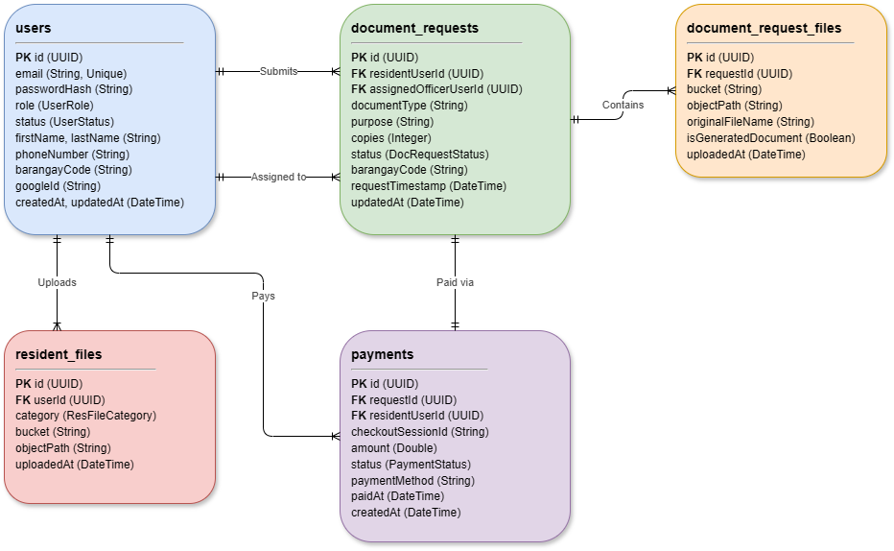

6.3 Relationships
One-to-Many Relationships
- User (Resident) → DocumentRequests: A resident can submit multiple document requests over time.
- User (Officer) → DocumentRequests: An officer can be assigned to process and approve multiple document requests.
- DocumentRequest → DocumentRequestFiles: A single document request can have multiple file attachments (e.g., resident ID uploads, system-generated certificates).
- User → ResidentFiles: A user can upload multiple verification documents (e.g., officer appointment proofs or resident IDs for onboarding).
- User → Payments: A resident can initiate multiple checkout sessions/payments.
One-to-One Relationships
- DocumentRequest ↔ Payment: Each document request is tied to a single primary PayMongo payment checkout transaction.
(Note: The roles of Resident, Officer, and Admin are consolidated into a unified users table via role enums rather than utilizing separate foreign-key tables. Approvals and activities are tracked via status transition fields and security audit logs respectively.)
6.4 Key Tables
- users — The central authentication and profile table for all residents, officers, barangay admins, and super admins.
- document_requests — Contains the core lifecycle, remarks, and status of document requests.
- document_request_files — Maps uploaded request attachments (IDs, completed certificates) to their exact paths in Supabase Object Storage.
- payments — Tracks PayMongo checkout session IDs, amounts, and transaction statuses for online fee processing.
- resident_files — Stores verification credentials and documents uploaded by users during their initial onboarding/approval phase.
6.5 Core Entities
users
- id: UUID (Primary Key)
- username: String (Unique)
- email: String (Unique, 100 chars)
- passwordHash: String (BCrypt hashed)
- authProvider: String (LOCAL or GOOGLE)
- googleId: String (Google OAuth2 ID)
- role: Enum (RESIDENT, OFFICER, BARANGAY_ADMIN, SUPER_ADMIN)
- status: Enum (PENDING_VERIFICATION, APPROVED, SUSPENDED, REJECTED)
- firstName, middleName, lastName, sex: String (Personal identification)
- phoneNumber: String (Contact information)
- street, barangay, city, province, region, zipCode: String (Address details)
- barangayCode: String (Regional LGU filter identifier)
- otpCode: String (BCrypt-hashed OTP code for email verification)
- otpExpiresAt: DateTime (When OTP expires)
- createdAt, updatedAt: DateTime
document_requests
- id: UUID (Primary Key)
- residentUserId: UUID (Foreign Key → users.id)
- assignedOfficerUserId: UUID (Foreign Key → users.id, nullable)
- barangayCode: String (LGU scope)
- documentType: String (e.g., BARANGAY_CLEARANCE, RESIDENCY_CERTIFICATE)
- purpose: String (Reason for request)
- copies: Integer (Quantity of documents)
- status: Enum (SUBMITTED, UNDER_REVIEW, PENDING_PAYMENT, APPROVED, DECLINED, READY_FOR_RELEASE, RELEASED)
- officerRemarks: String (Optional notes during approval/rejection)
- requestTimestamp: DateTime (Original submission time)
- updatedAt: DateTime
document_request_files
- id: UUID (Primary Key)
- requestId: UUID (Foreign Key → document_requests.id)
- bucket: String (Supabase bucket name, e.g., "documents")
- objectPath: String (Supabase storage path)
- originalFileName: String (Filename during upload)
- contentType: String (MIME type)
- isGeneratedDocument: Boolean (True if it's the final output certificate, False if it's a resident ID upload)
- uploadedAt: DateTime
payments
- id: UUID (Primary Key)
- requestId: UUID (Foreign Key → document_requests.id, Unique)
- residentUserId: UUID (Foreign Key → users.id)
- checkoutSessionId: String (PayMongo Session ID)
- paymentIntentId: String (PayMongo Intent ID)
- amount: Double (Total payment amount)
- fee, netAmount: Double (Gateway deduction calculations)
- status: Enum (PENDING, PAID, FAILED, CANCELLED)
- paymentMethod: String (e.g., paymaya, gcash, card)
- paidAt: DateTime (Webhook fulfillment time)
- createdAt, updatedAt: DateTime
resident_files
- id: UUID (Primary Key)
- userId: UUID (Foreign Key → users.id)
- category: Enum (e.g., ID_PROOF, APPOINTMENT_PROOF)
- barangayCode: String
- bucket, objectPath: String (Supabase storage references)
- originalFileName, contentType: String
- uploadedAt: DateTime

6.6 Key Features Implemented
- Email OTP Verification — 6-digit OTP codes with a 5-minute expiry delivered via the Resend API to ensure rigorous account creation verification.
- OAuth2 Google Sign-In — Seamless auto-provisioning, account linking, and automatic email verification allowing users to bypass manual OTP flows.
- Online Payment Gateway (PayMongo) — Integrated checkout sessions utilizing PayMongo to collect fees via credit card or e-wallets (GCash/Maya) prior to document processing. Real-time webhooks handle asynchronous status transitions.
- Cloud File Storage (Supabase) — Secure persistence of multipart file uploads (such as resident ID scans, officer appointment proofs, and system-generated final certificates) stored securely inside bucket-restricted Object Storage.
- Multi-Platform Consistency — Feature parity between the responsive React web application and the native Android mobile application.
- Mobile Optimistic UI & Caching — The Android application utilizes localized in-memory caching (OfficerQueueCache) to guarantee zero-latency queue navigation and background fetching.
- Role-Based Access Control (RBAC):
  - RESIDENT: Submit document requests, complete online payments, upload ID attachments, and track real-time statuses.
  - OFFICER: Review queues, inspect resident ID uploads, approve/reject requests (with required remarks), upload completed certificates, and manage request workflows.
  - BARANGAY_ADMIN: Manage resident/officer verifications, suspend user accounts, and oversee localized LGU request queues and activity feeds.
  - SUPER_ADMIN: Nationwide system management, creation of new LGU portals (Barangay Admins), and global usage statistics.
- Request Status Workflow — Automated state transitions flowing from PENDING_PAYMENT → SUBMITTED → UNDER_REVIEW → APPROVED / DECLINED → READY_FOR_RELEASE → RELEASED.
- Verification Onboarding System — Self-registration pipelines for Residents and Officers requiring file/credential uploads, routed to Barangay Admins for manual approval.
- Security Audit Logging — Granular backend tracking (SecurityAuditService) that securely logs administrative events such as role escalations, account suspensions, and verification actions.
- In-App Activity Feeds — Dashboard activity logs visualizing real-time LGU operations (e.g., account approvals and document requests) using color-coded status badges.

7.0 UI/UX DESIGN
7.1 Web Application Wireframes
https://www.figma.com/design/op2CS0V3OlmLi5gG8GnvRk/Untitled?node-id=3-1706&t=FzyTytX5S1w6gb8C-1
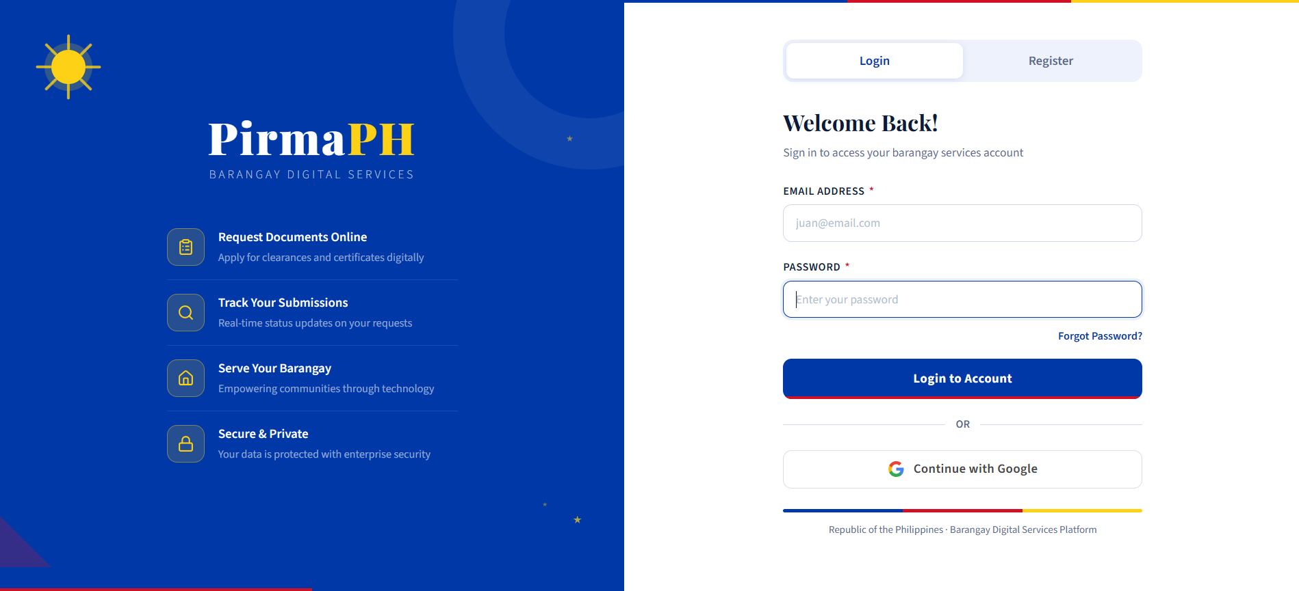
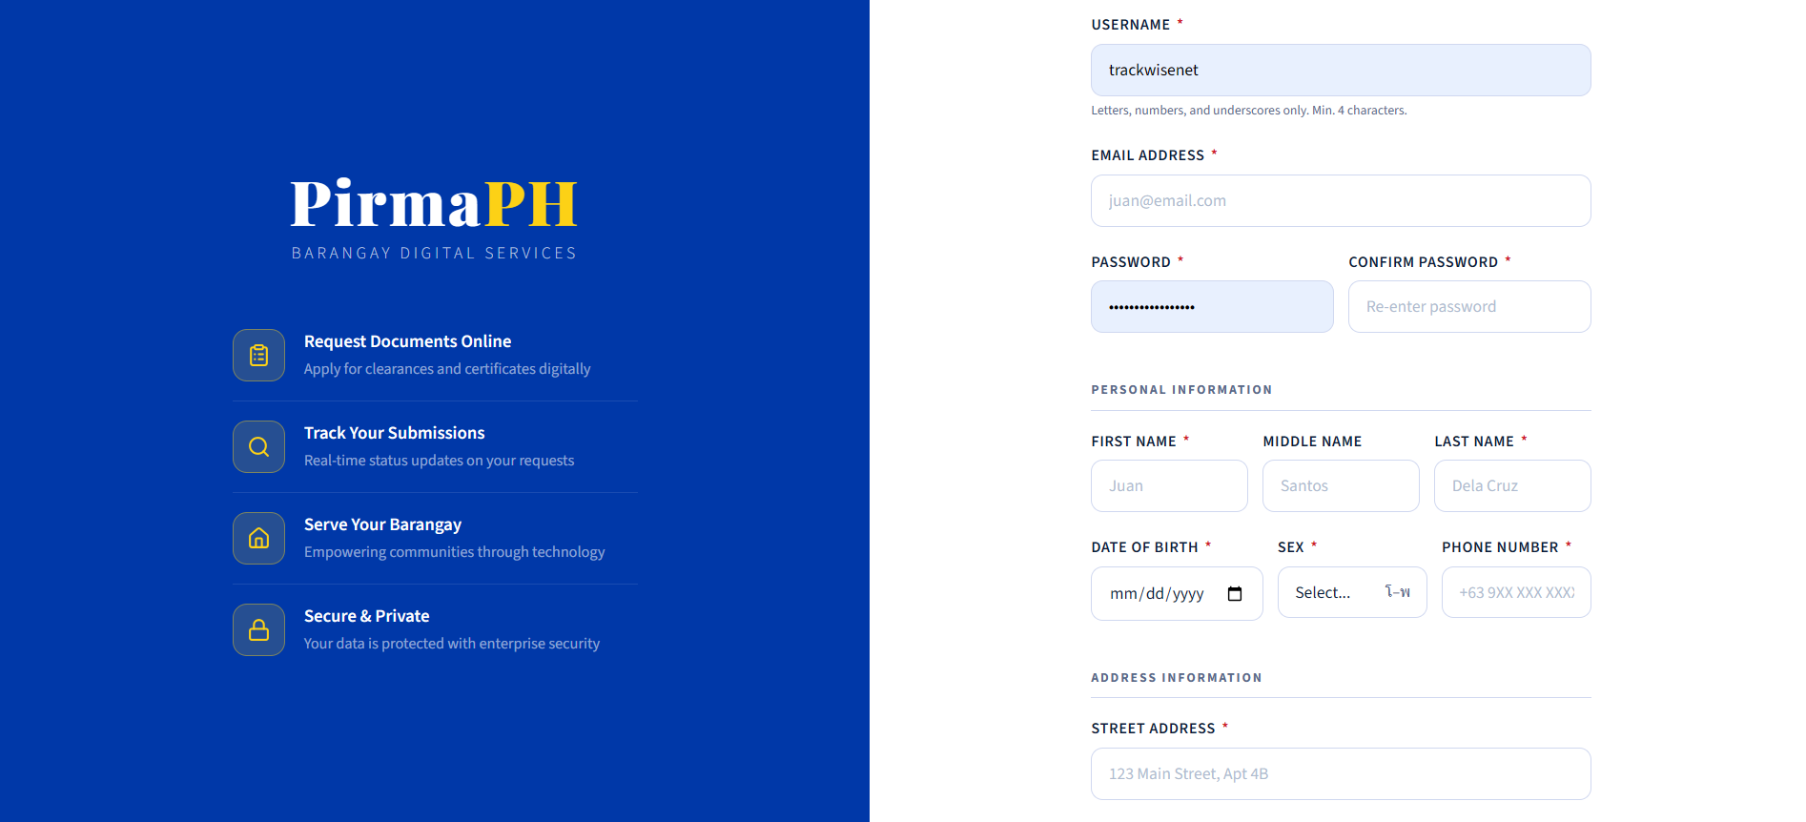
Authentication Pages
- Login Page: Email input, password input, “Sign In” button, “Sign in with Google” button, “Register” link
- Registration Page: Full form with personal info, address fields, role selection, password validation
- OTP Verification Page: 6-digit code input, auto-advance between fields, countdown timer, resend button
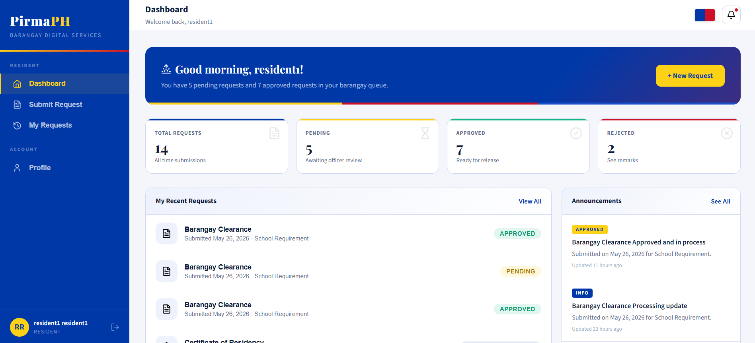
Resident Dashboard
- Header: Barangay logo, user menu, logout
- Sidebar: Dashboard, My Requests, Profile, Announcements
- Main Content: Request statistics, recent requests list, announcements
- Each Request Card: Document type, status badge, submission date, actions menu
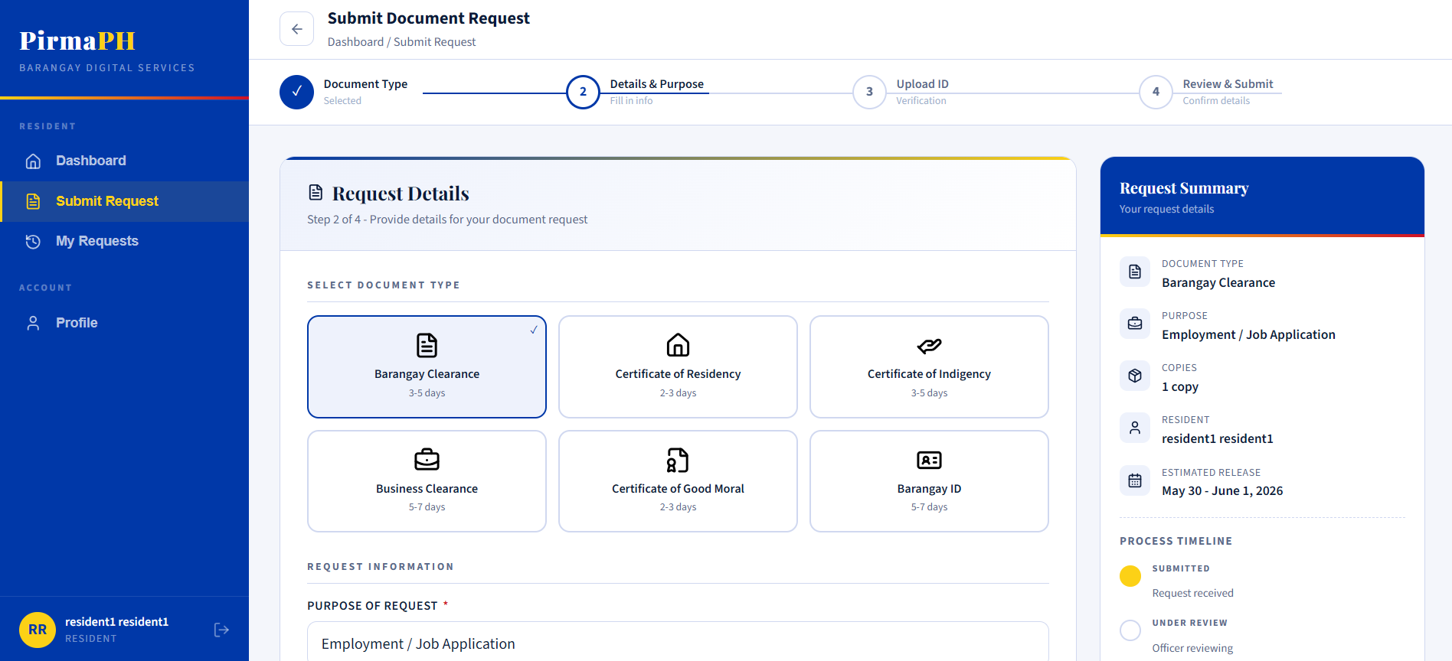
Submit Request Page
- Document type dropdown
- Purpose text field
- File upload area
- Submit and cancel buttons
- Request preview before submission
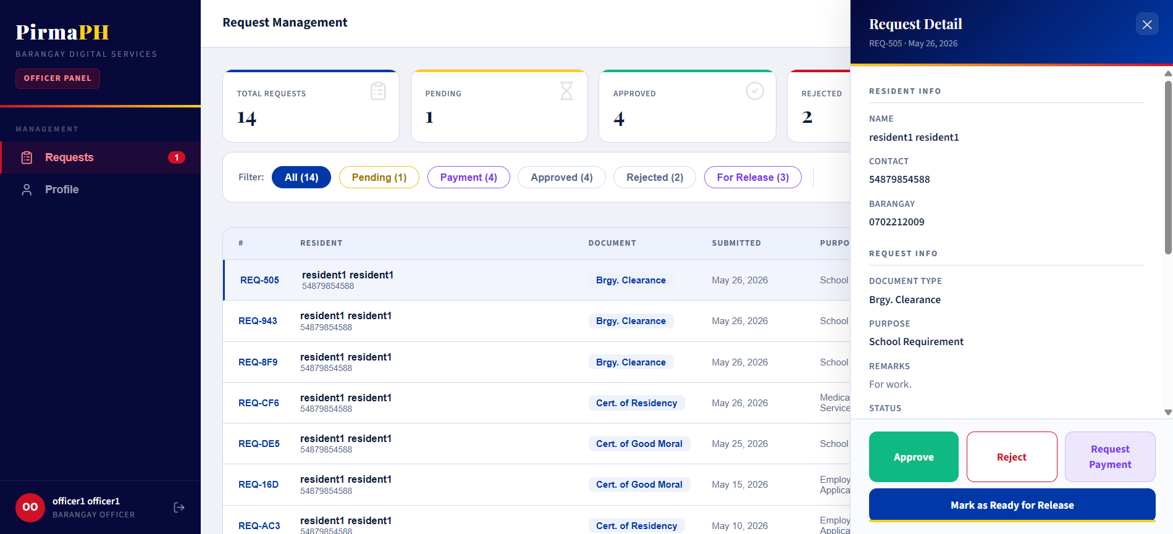
Officer Request Management
- Request queue table with sorting/filtering
- Columns: Resident name, document type, submission date, status, actions
- Slide-over detail view: Full request info, file attachments, approval/rejection form
- Status update dropdown: Approve, Reject, Ready for Release
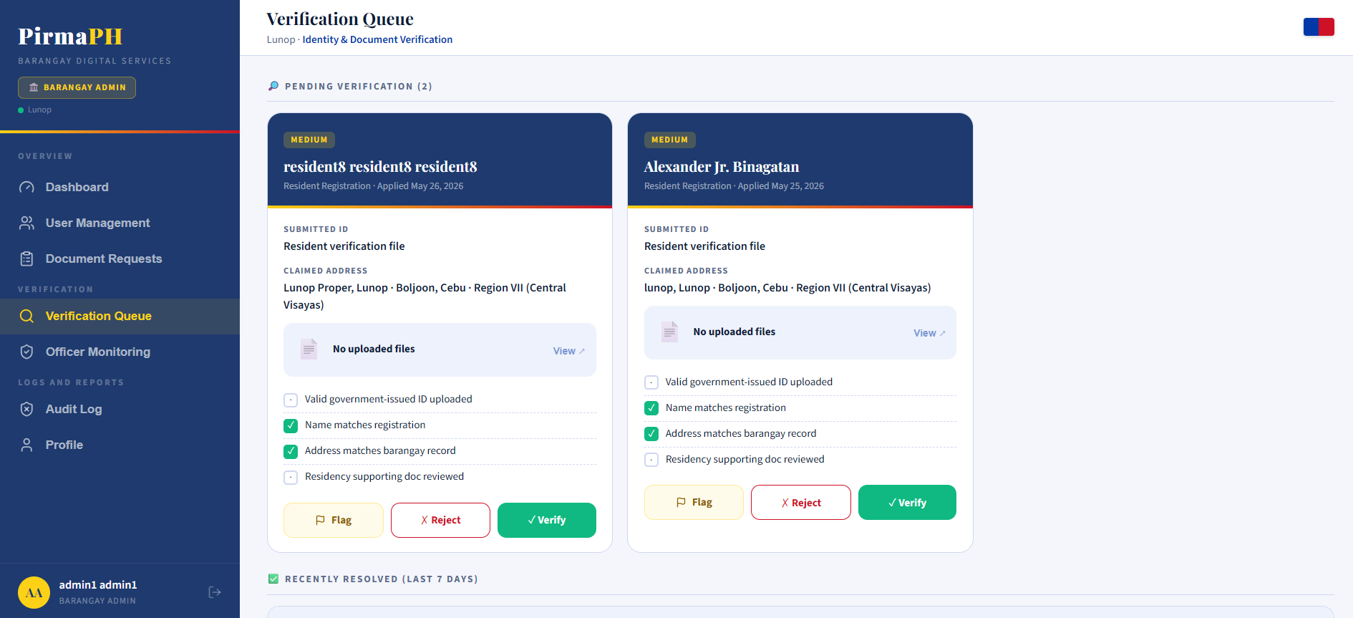
Admin Verification Panel
- Tabs: Pending Residents, Pending Officers, Officer Approvals, Admin Management
- Each queue shows pending items with approval/rejection actions
- Detailed review panel for each application
- Remarks/notes field for decisions
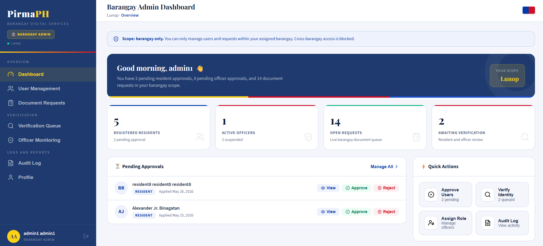
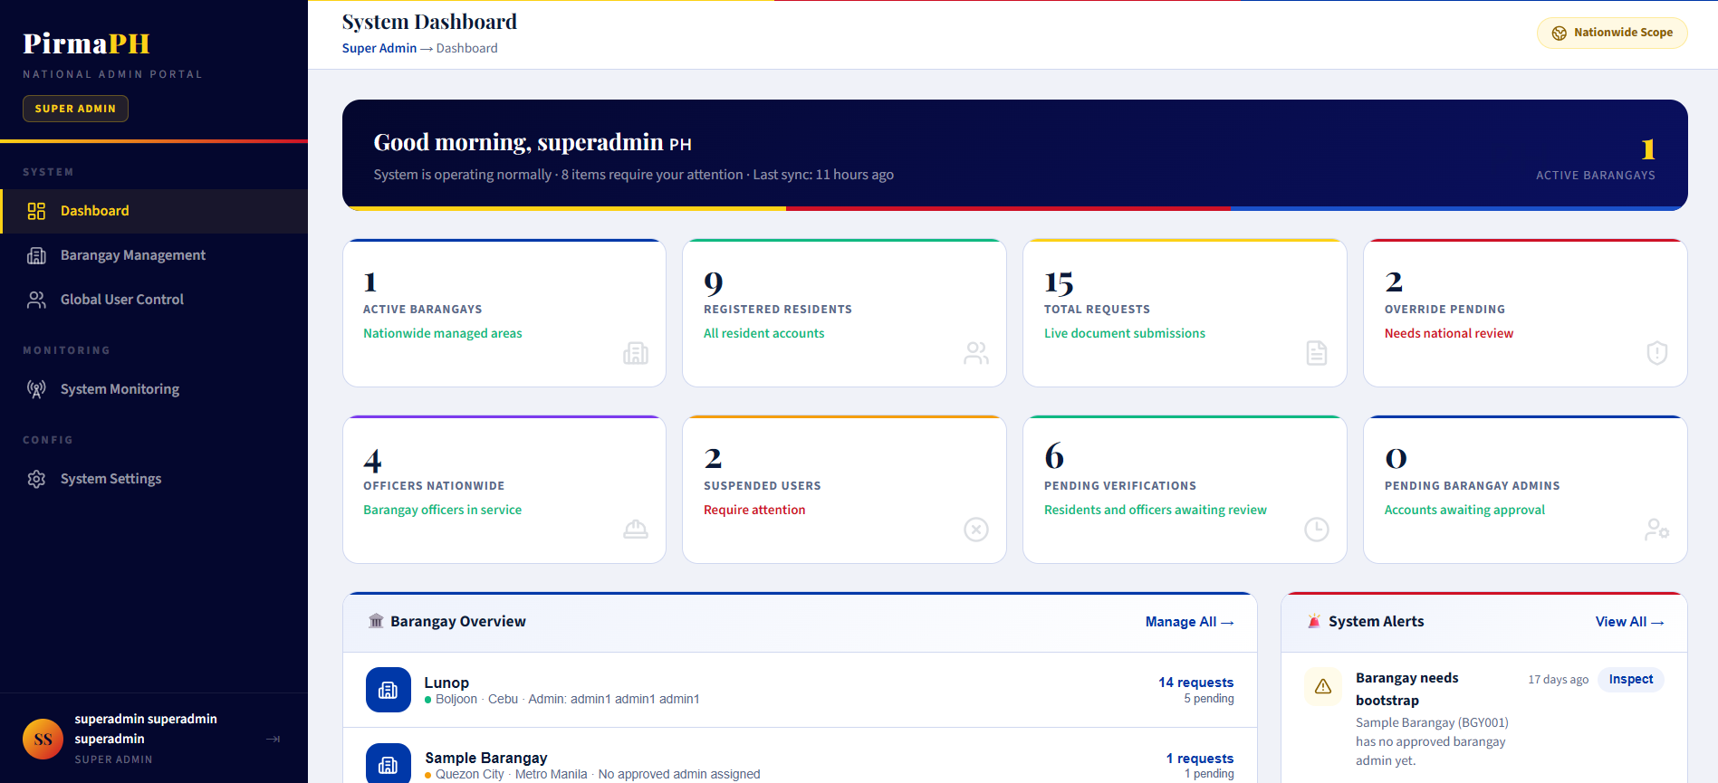
Admin Dashboards
- Barangay Admin: Overview cards (total requests, pending, approved, officers)
- Request queue for the barangay
- User management table (residents, officers)
- Super Admin: Nationwide statistics, barangay list, barangay creation form
Design System
Token | Value
Primary Color | Philippine flag blue (#003DA5)
Secondary Color | Philippine flag yellow (#FFD60A)
Success Color | #10B981
Error Color | #EF4444
Warning Color | #F59E0B
Typography | Inter font family for body, Playfair Display for headers
Spacing | 8px grid system (4px, 8px, 16px, 24px, 32px)
Responsive Breakpoints | 1200px (desktop), 768px (tablet), 360px (mobile)
Button Heights | 44px minimum (accessibility)
Form Fields | 40px height with 12px padding
Border Radius | 4px (inputs), 8px (cards), 12px (modals)

7.2 Mobile Application Wireframes
https://www.figma.com/design/op2CS0V3OlmLi5gG8GnvRk/Untitled?node-id=3-1706&t=FzyTytX5S1w6gb8C-1
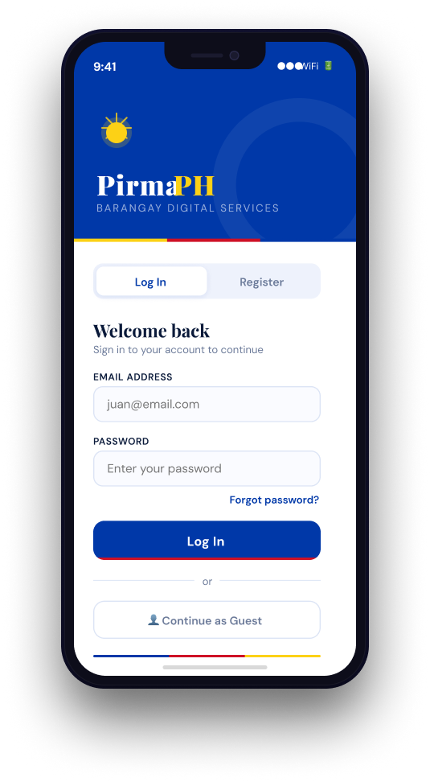
Login
- Standard email and password input fields with visibility toggle
- “Forgot Password” recovery link
- Prominent “Continue with Google” OAuth2 sign-in button
- Primary login button with built-in loading spinner to prevent duplicate submissions

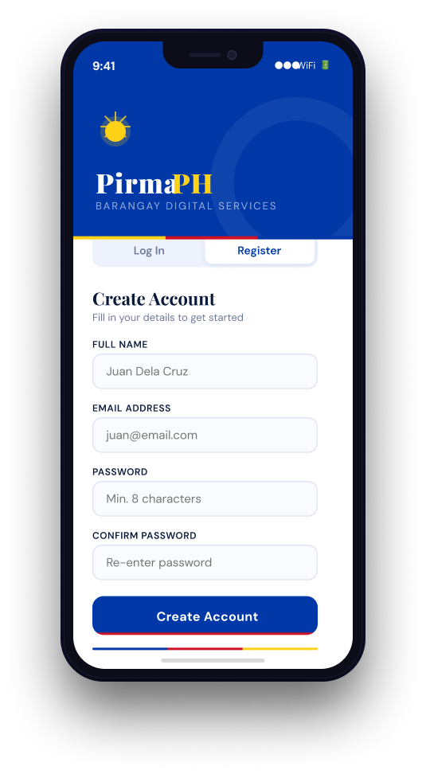
Register
- Multi-step sign-up wizard for personal details, contact info, and barangay address
- Password creation fields with strength indicator
- Google Sign-In alternative option
- Dedicated 6-digit OTP email verification screen after registration
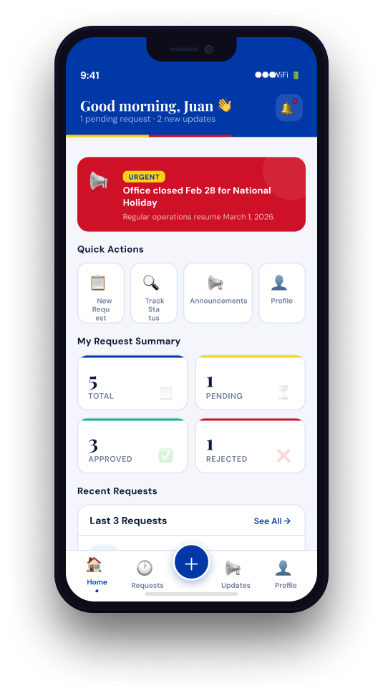
Resident Dashboard
- Summary cards showing active requests and urgent announcements
- Primary “Request Document” card or Floating Action Button (FAB)
- Recent activity timeline with real-time request status updates
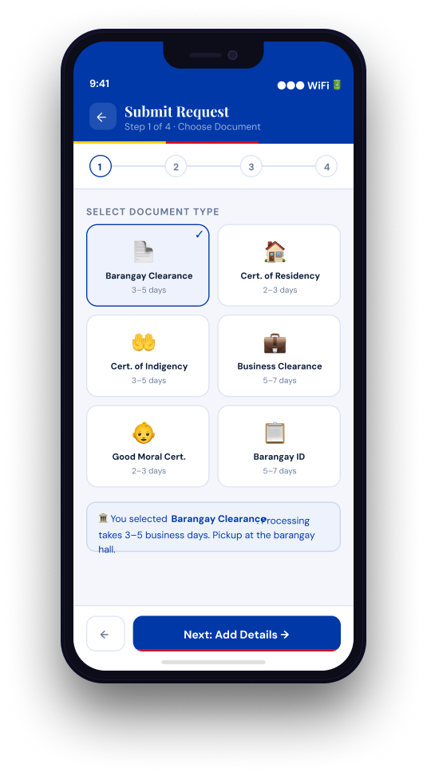
Resident Submit Request
- Dropdown for document type selection (e.g., Clearance, Residency)
- Input field for purpose and number of copies
- File upload component for valid ID attachment
- Submit button that redirects to PayMongo checkout flow
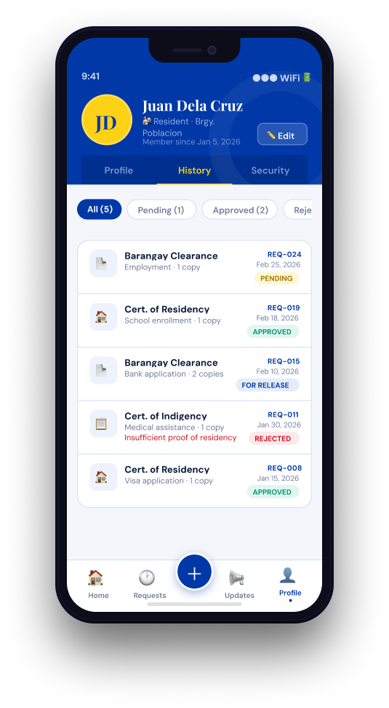
Resident History
- Scrollable list of past and ongoing requests
- Color-coded status indicators (Pending Payment, Under Review, Approved, Ready)
- Clickable request cards leading to detailed view and downloadable documents
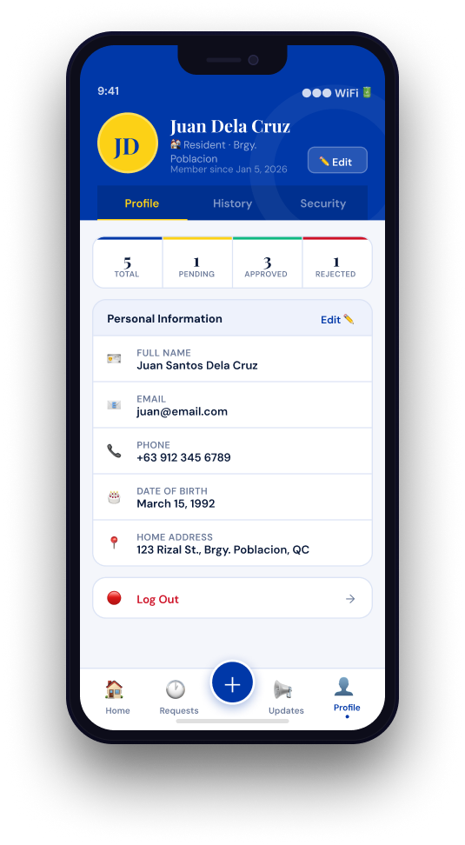
Resident Profile
- Personal details overview (name, address, contact info, barangay)
- Profile avatar with verified resident badge
- Quick links to security settings, history, and logout
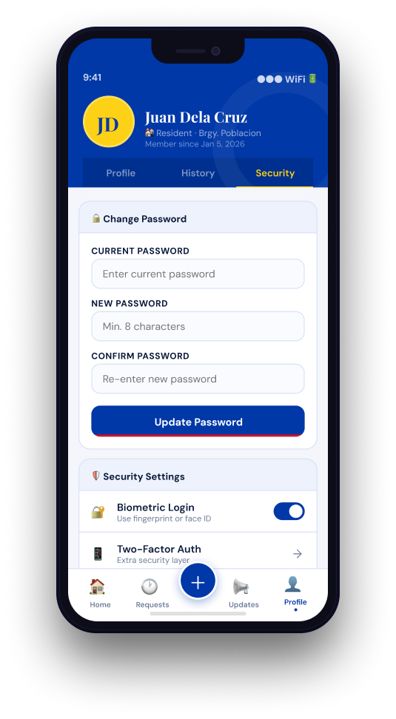
Resident Security
- Password update form with current and new password validation
- Email recovery and contact update fields
- Account management and secure logout controls
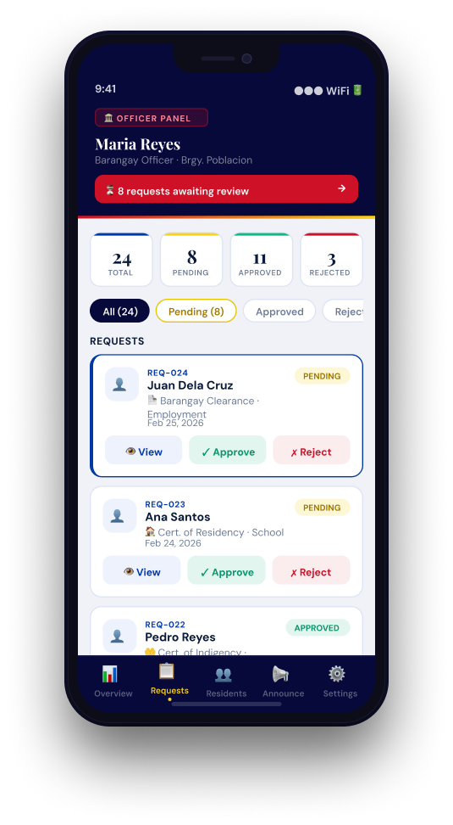
Officer Dashboard
- KPI cards showing request counts (Pending, Approved, Ready, Released)
- Real-time request queue with tab-based filtering and optimistic UI updates
- Background loading indicator for data refresh
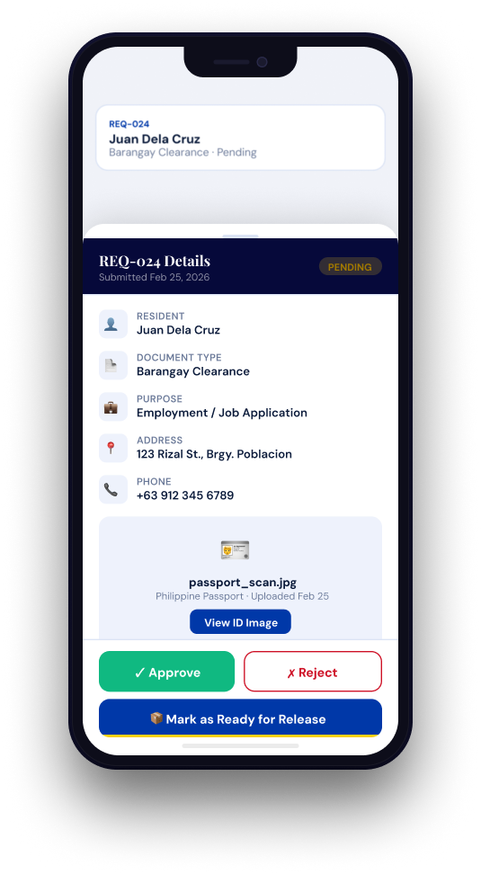
Officer Request Details
- Bottom sheet showing resident information and contact details
- Expandable document viewer for uploaded IDs and attachments
- Action buttons for Approve, Reject, and Mark Ready
- Required remarks field when rejecting a request

Mobile-Specific Features
- Touch-Optimized Interfaces: Strict adherence to Material Design standards, utilizing minimum 48x48dp touch targets for all interactive elements.
- Optimistic UI & Local Caching: In-memory caching (OfficerQueueCache) for request queues, ensuring zero-latency tab switching and offline-like instant load times.
- Non-Intrusive Loading States: Top-aligned progress spinners and button-embedded loading indicators to prevent UI blocking and accidental double-submissions.
- Bottom Sheet Dialogs: Extensive use of slide-up bottom sheets (e.g., Request Details) to keep users grounded in their primary context without navigating away to new screens.
- Gesture Support: Standardized pull-to-refresh mechanisms on dashboard feeds and swipe-enabled tab navigation.
- Simplified Input Forms: Native Android input types customized for mobile keyboards (e.g., numeric pads for OTPs, email-optimized keyboards during login).
Design System
- Colors: Strict adherence to the PirmaPH brand identity.
  - Primary (Navy Blue): #0A1A3A (Used for headers, primary buttons, and active states)
  - Secondary (Gold): #FCD116 (Used for pending status tags and highlights)
  - Accent (Red): #CE1126 (Used for rejected tags, destructive actions, and button shadow borders)
  - Backgrounds: Light theme backgrounds (#F5F5F5 to #FFFFFF) to maintain high contrast.
- Typography: Modern, readable font families (Inter / Roboto) with responsive sizing and dynamic text scaling support on Android.
- Spacing: Strict 8dp (mobile) / 8px (web) grid system to ensure consistent padding and margins across all platforms.
- Components:
  - Mobile: AppCompatButton implementations bypassing default Material themes to preserve custom brand shadows and borders.
  - Web: Tailwind-driven modular React components (consistent cards, modals, and input fields).
- Responsiveness: Mobile-first approach on the web utilizing standard breakpoints at 640px (Mobile), 768px (Tablet), and 1024px (Desktop). Android application utilizes constraint-based scaling to adapt to 5.0" to 6.7" screens.

8.0 PLAN

Project Phases
Phase 1: Foundation & Design (Weeks 1-2, Completed Feb 2026) Status: COMPLETE
- Requirements gathering and documentation
- System architecture design (3-tier)
- API specification and contract definition
- Database schema design
- UI/UX wireframe creation
Phase 2: Backend Foundation (Weeks 3-4, Completed March 2026) Status: COMPLETE
- Completed Components:
  - Spring Boot project setup (v3.5.11, Java 17)
  - Supabase (PostgreSQL) database configuration and connection setup
  - User entity with all required fields
  - JWT authentication (JwtUtil, SecurityConfig, JwtAuthenticationFilter)
  - User registration and login endpoints with validation
  - Password hashing with BCrypt
  - Role-based access control (RBAC) foundation
Phase 3: OAuth2 & Email Verification (Weeks 5-6, Completed March 2026) Status: COMPLETE
- Completed Components:
  - Google OAuth2 Sign-In integration (Spring OAuth2 Client)
  - CustomOAuth2UserService for auto-provisioning and account linking
  - Email OTP verification system (Resend API integration)
  - OTPService with 5-minute expiry and max attempts lockouts
  - Endpoint protection for unverified email users
Phase 4: Frontend - Web Authentication (Weeks 5-6, Completed March 2026) Status: COMPLETE
- Completed Components:
  - React project setup (v19.2, Vite v7.3.1)
  - Authentication context (AuthContext.jsx) and Protected routes
  - Login/Registration pages with complete validation
  - Google Sign-In button and 6-digit OTP verification modal
  - API service layer with Axios interceptors and token management
Phase 5: Document Request System (Weeks 7-8, Completed April 2026) Status: COMPLETE
- Completed Components:
  - Document request entity, repository, and submission API
  - File upload handling (Supabase Storage integration)
  - Request status workflows and officer queue endpoints
  - Officer request approval/rejection logic and remarks
  - Resident request history and detail views
Phase 6: Admin & Verification System (Weeks 9-10, Completed April 2026) Status: COMPLETE
- Completed Components:
  - Resident/Officer file uploads for verification credentials
  - Admin verification panel (Reviewing pending residents and officers)
  - User role, status management, and suspension/reinstatement flows
  - Automated security audit logging for administrative actions
Phase 7: Barangay & Super Admin Features (Weeks 11-12, Completed May 2026) Status: COMPLETE
- Completed Components:
  - Barangay Admin Dashboard (Real-time queue monitoring, local metrics)
  - Super Admin Dashboard (Nationwide statistics, LGU management)
  - Barangay admin creation with auto-username generation
  - Multi-barangay tenant support
Phase 8: Native Android Mobile Application (Week 13, Completed May 2026) Status: COMPLETE
- Completed Components:
  - Android Studio project setup (Kotlin, Target API 34)
  - Strict UI branding implementation (Custom AppCompatButton styles, colors)
  - Mobile authentication (JWT persistent storage, Google SSO hooks)
  - Resident Mobile Dashboard (Submitting requests, tracking history)
  - Officer Mobile Dashboard (Optimistic UI caching, slide-up bottom sheets for request processing, instant state transitions)
Phase 9: Online Payment Integration (Week 14, Completed May 2026) Status: COMPLETE
- Completed Components:
  - PayMongo API integration in Spring Boot (PayMongoService)
  - Checkout session generation for requests in PENDING_PAYMENT
  - HMAC Signature validation for secure webhook endpoints
  - Automated request status updates triggered by successful online payments
Phase 10: Final Integration & Polish (Week 15, Completed May 2026) Status: COMPLETE
- Completed Components:
  - End-to-end integration testing across Web, Mobile, and PayMongo
  - Resolution of mobile java.lang.ClassNotFoundException crashes and Core KTX dependency alignments
  - HTTP 500 error resolutions for cross-platform form-data submissions
  - Performance testing and cross-feature workflow verification

Milestones
Milestone | Target Date | Status | Description
M1 | End Week 2 | Complete | Foundation, Architecture, and Design documents finalized
M2 | End Week 4 | Complete | Core Backend authentication and RBAC functioning
M3 | End Week 6 | Complete | Web Frontend Auth, Google OAuth2, and Email OTP implemented
M4 | End Week 8 | Complete | Core Document Request system and storage handling functional
M5 | End Week 10 | Complete | Admin and Verification onboarding systems live
M6 | End Week 12 | Complete | Barangay & Super Admin Dashboards integrated and deployed
M7 | End Week 14 | Complete | Native Android Application and PayMongo payment gateway integrated
M8 | End Week 15 | Complete | Full multi-platform system (Web, Mobile, Backend) polished and tested
Deployment Status
- Backend: Deployed and running on Render.
- Frontend (Web): Built, optimized via Vite, and deployed on Vercel.
- Frontend (Mobile): Native Android APK successfully built and tested (compiled against Android API 34).
- Database: Supabase (PostgreSQL) fully configured for relational data; Supabase Object Storage active for attachments.
- SSL/TLS: HTTPS configured for production across all Web, Mobile, and Webhook communications.
- Environment Variables: Securely configured for Google OAuth2, Resend API, PayMongo API, and Supabase credentials.
- Testing: End-to-end multi-platform workflows (requests, payments, verifications) completely functional and tested.
Critical Path
- Core Authentication System & JWT (Week 3)
- Web Dashboard Integration & OAuth2 (Week 6)
- Document Request API & Workflow (Weeks 7–8)
- Officer/Admin Verification Workflows (Week 10)
- Android UI Implementation & Caching Optimization (Week 13)
- PayMongo Gateway Integration & Webhook Handling (Week 14)
- Cross-Platform Integration Testing (Week 15)
Risk Mitigation
- Data Integrity: Start with core authentication and request submission before implementing payment modules.
- Payment Security: Strictly validate HMAC signatures on all incoming PayMongo webhooks before authorizing request status transitions.
- Mobile Performance Latency: Implement aggressive local caching (OfficerQueueCache) on the Android client to guarantee instant UI rendering during network delays.
- Independent Validation: Test API endpoints (using Postman/Swagger) completely independently before connecting React or Android clients.
- Version Stability: Maintain version control with stable backups, specifically isolating breaking dependency upgrades (like AndroidX Core KTX version matching).
- Workflow Prioritization: Prioritize the core lifecycle (Submit → Pay → Review → Approve → Release) over auxiliary UI enhancements.

