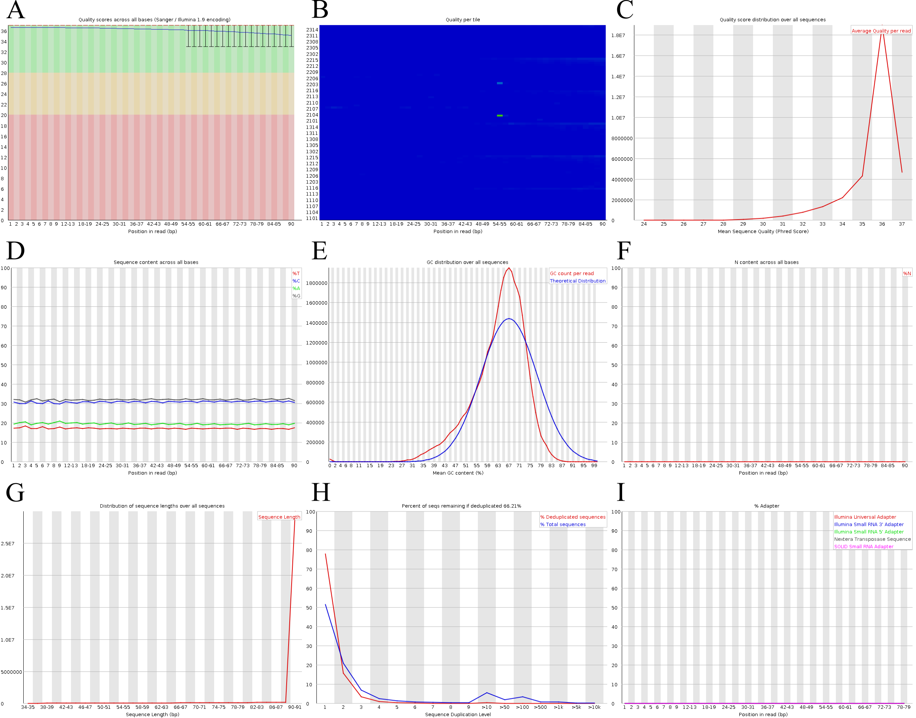

**Figure 2.** Images of the FastQC report of sample BS3-3’s backward reads. Graphs of (A) per base sequence quality, (B) per tile sequence quality, (C) per sequence quality scores, (D) per base sequence content, (E) per sequence GC content, (F) per base N content, (G) sequence length distribution, (H) sequence duplication levels and (I) adapter content.