Ejercicio 1.
Modelo$:$
$f (x, θ)= ωx+ β$ θ={ω,β}

  - Foward pass:
$$z_{1}=ωx$$

$z_{2}=z_{1}+$ $β$

Salida:
$$f=z_{2}$$

1.2. Loss:

$$l={\left(f-y\right)}^{2}$$

1.3. Forward computational graph

Foward pass:
+
-
^2
*
$$l$$
$$f_{0}$$
$$y$$
$$f_{1}$$
X
$$f_{0}=ω x$$
$$f_{1}=f_{0}+β$$
$$y =f_{1}$$
$$l={\left(f-y\right)}^{2}$$

1.4. Backward Pass:

$\frac{∂l}{∂f}$ = 2 ($f-y)$

Ahora
$$z_{1}=ωx$$

por lo tanto
$\frac{∂z_{1}}{∂ω}$ = x y $\frac{∂z_{1}}{∂x}$ = $ω$
Finalemente

$\frac{∂l}{∂ω}$ = 2 ($f-y) x$ y $\frac{∂l}{∂β}$ = 2 ($f-y)$

1.5.- Backward computational graph

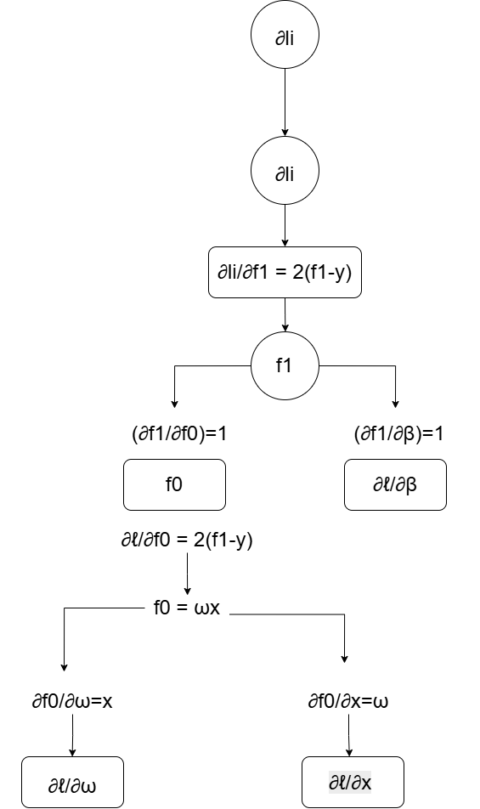

1.6.- Compute the gradients with respect to all learnable parameters in θ.

θ={ω,β}

$\frac{∂l}{∂ω}$ = 2 ($f-y) x$ y $\frac{∂l}{∂β}$ = 2 ($f-y)$

Sustituyendo
$$f = ωx + β$$
Es igual a:
$\frac{∂l}{∂ω}$ = 2 ($ωx + β-y) x$ y $\frac{∂l}{∂β}$ = 2 ($ωx + β-y)$

Ejercicio 2. One Nonlinear Activation
Model: $f (x, θ)= tanh(ωx+ β)$ $θ = (ω,β)$

  - Foward pass:
$$f_{0}=ωx$$

$f_{1}=f_{0}+$ $β$

Salida
$$f={tanh(z}_{2})$$
2.2 Loss

$$l={\left(f-y\right)}^{2}$$

$$f=tanh(ωx+ β)$$

$$l={\left(tanh(ωx+ β)-y\right)}^{2}$$
2.3 Forward computational graph
X
tanh $Escriba aquí la ecuación.$
(h₁-y)²
+ $β$
$$ωx$$

$$l$$
$$f_{0}$$
$$h1$$
$$f_{1}$$
$f_{0}=ω x$
$$f_{1}=f_{0}+β$$
$$h1 =tanh(f1)$$
$$l={\left(h1-y\right)}^{2}$$

2.4 Backward pass

$$l={\left(h1-y\right)}^{2}$$

derivando
$\frac{∂l}{∂f}$ = 2 ($h_{1}-y)$

$$h1 =tanh(f1)$$

$\frac{d}{df_{1}}tanh\left(f1\right)=1-$ $tanh^{2}(f1)$

$$h1 =tanh(f_{1})$$

$$entonces$$

$\frac{∂h1}{∂f_{1}}$ = $1-$ $h1^{2}$

Regla de la cadena

$\frac{∂l}{∂f_{1}}$ = $2(h1-y)(1-$ $h1^{2})$

Suma

$$f_{1}=f_{0}+β$$

$\frac{∂f_{1}}{∂f_{0}}$ = $1$

$\frac{∂f_{1}}{∂β}$ = $1$

$\frac{∂l}{∂β}$ = $\frac{∂l}{∂f_{1}}$ $∙$ $\frac{∂f_{1}}{∂β}$ = $2(h1-y)(1-$ ${h_{1}}^{2})$

$\frac{∂l}{∂f_{0}}$ = $\frac{∂l}{∂f_{1}}$ $∙$ $\frac{∂f_{1}}{∂f_{0}}$ = $2(h1-y)(1-$ ${h_{1}}^{2})$
Considerando que
$$f_{0}= ωx$$

$\frac{∂f_{0}}{∂ω}$ = $x$

$\frac{∂f_{0}}{∂x}$ = $ω$
Regla de la cadena
$\frac{∂l}{∂ω}$ = $\frac{∂l}{∂f_{0}}$ $∙$ $\frac{∂f_{0}}{∂ω}$ = $2(h1-y)(1-$ ${h_{1}}^{2})$x

2.5 Backward computational graph
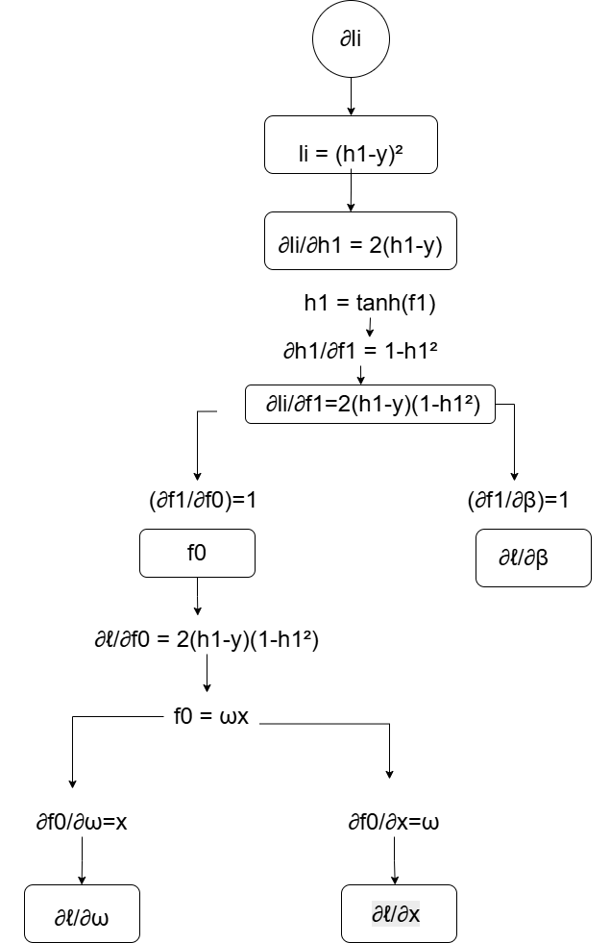

2.6.- Compute the gradients with respect to all learnable parameters.

θ = {ω, β}

$\frac{∂l}{∂β}$ = $2(h1-y)(1-$ ${h_{1}}^{2})$

$\frac{∂l}{∂ω}$ = $2(h1-y)(1-$ ${h_{1}}^{2})$x

Exercise 3: One Hidden Neuron with Sine
Model:
$$f(x,θ=ω_{1}sin\left(ω_{0}x+β_{0}\right)+β_{1}$$
$$θ=ω_{0},β_{0},ω_{1},β_{1}$$
3.1 Foward Pass
$$f_{0}=ω0x$$
Suma
$$f_{1}=f_{0}+β_{0}$$
Seno
$$h_{1}=sin\left(f_{1}\right)$$
Multipicacion
$$f_{2}=ω_{1}h_{1}$$
Entonces
$$f_{3}=f_{2}+β_{1}$$
Por lo tanto
3.2 Loss:

$$l={\left(f_{3}-y\right)}^{2}$$

3.3. Forward Computational Graph
$$f_{0}=ω_{0} x$$
$$f_{1}=f_{0}+β_{0}$$
$$h1 =sin(f1)$$
$$f_{2}=ω_{2}h_{1}$$
$$f_{3}=f_{2}+β_{1}$$
$$l={\left(f_{3}-y\right)}^{2}$$
+$β_{1}$
*$ω_{1}$
$$sin$$

+$β_{0}$
*$ω_{0}$
$$l$$
$$f_{3}$$

$$f_{2}$$

$$h_{1}$$

$$f_{1}$$
$$f_{0}$$
X

3.4 Backward Pass
$$l={\left(f_{3}-y\right)}^{2}$$

$\frac{∂l}{∂f_{3}}$ = $2\left(f_{3}-y\right)$

Tomando en cuenta que
$$f_{3}=f_{2}+β_{1}$$

$\frac{∂f_{3}}{∂f_{2}}$ = $1$

$\frac{∂f_{3}}{∂β_{1}}$ = $1$

Regla de la cadena
$\frac{∂l}{∂f_{2}}$ = $2\left(f_{3}-y\right)$

$\frac{∂l}{∂β_{1}}$ = $2\left(f_{3}-y\right)$

Multiplicación
$$f_{2}=ω_{1}h_{1}$$

$\frac{∂f_{2}}{∂ω_{1}}$ = $h_{1}$

$\frac{∂f_{2}}{∂h_{1}}$ = $ω_{1}$

Regla de la cadena

$\frac{∂l}{∂ω_{1}}$ = $2\left(f_{3}-y\right)h_{1}$

$\frac{∂l}{∂h_{1}}$ = $2\left(f_{3}-y\right)ω_{1}$

Fucion seno

$$h_{1}=sin\left(f_{1}\right)$$

$\frac{∂h_{1}}{∂f_{1}}$ = $cos\left(f_{1}\right)$
Regla de la cadena
$\frac{∂l}{∂f_{1}}$ = $2\left(f_{3}-y\right)ω_{1}cos\left(f_{1}\right)$

Suma:
$$f_{1}=f_{0}+β_{0}$$
$\frac{∂f_{1}}{∂f_{0}}$ = $1$

$\frac{∂f_{1}}{∂β_{0}}$ = 1
Regla de la cadena
$\frac{∂l}{∂β_{0}}$ = $2\left(f_{3}-y\right)ω_{1}cos\left(f_{1}\right)$

$\frac{∂l}{∂f_{0}}$ = $2\left(f_{3}-y\right)ω_{1}cos\left(f_{1}\right)$

Mutiplicacion
$$f_{0}=ω_{0} x$$
Entonces
$\frac{∂f_{0}}{∂ω_{0}}$ = $x$
$\frac{∂f_{0}}{∂x}$ = $ωx$
Regla de la cadena
$\frac{∂l}{∂ω_{0}}$ = $2\left(f_{3}-y\right)ω_{1}cos\left(f_{1}\right)x$

3.5 Backward Computational Graph
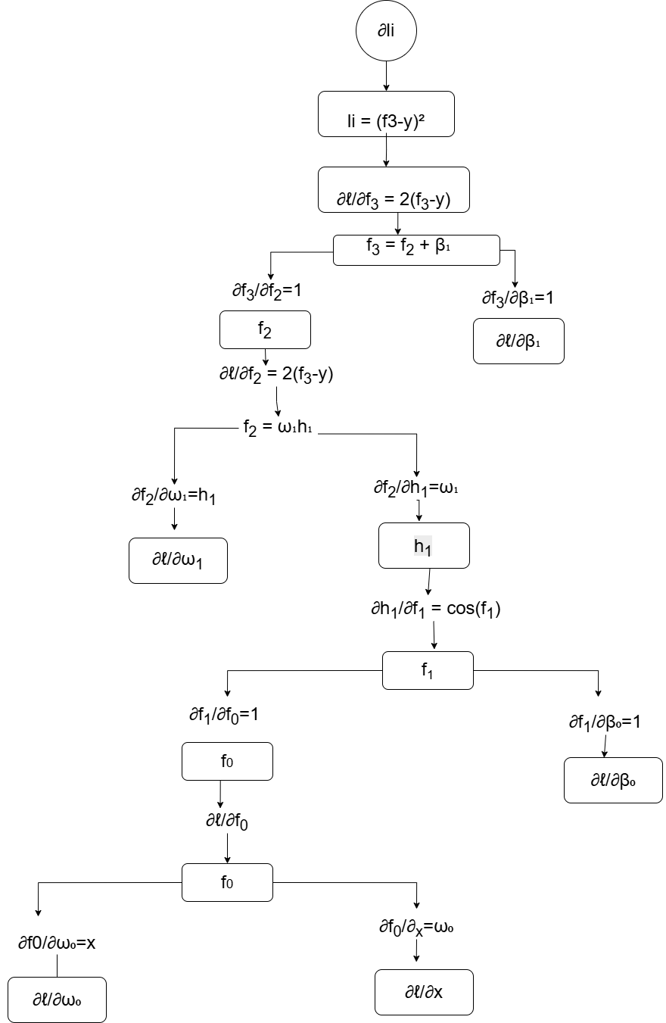

3.6 Compute the gradients with respect to all learnable parameters in θ

$$θ=ω_{0},β_{0},ω_{1},β_{1}$$

$\frac{∂l}{∂ω_{0}}$ = $2\left(f_{3}-y\right)ω_{1}cos\left(f_{1}\right)x$

$\frac{∂l}{∂β_{0}}$ = $2\left(f_{3}-y\right)ω_{1}cos\left(f_{1}\right)$

$\frac{∂l}{∂ω_{1}}$ = $2\left(f_{3}-y\right)h_{1}$

$\frac{∂l}{∂β_{1}}$ = $2\left(f_{3}-y\right)$

Exercise 4: Scalar Deep MLP
Model:
$$f\left(x,θ\right)=ω_{2}tanh\left(ω_{1}sin\left(ω0x+β_{0}\right)+β_{1}\right)+β_{2}$$
$$θ=ω_{0},{ β}_{0},{ ω}_{1},β_{1},{ ω}_{2},{ β}_{2}$$

4.1 Foward Pass
$$f_{0}=ω_{0}x$$
$$f_{1}=f_{0}+β_{0}$$

Seno
$$h_{1}=sin\left(f_{1}\right)$$
Multiplicación
$$f_{2}=ω_{1}h_{1}$$
Suma
$$f_{3}=f_{2}+β_{1}$$
Tangente
$$h_{2}=tanh\left(f_{3}\right)$$Multiplicación
$$f_{4}=ω_{2}h_{2}$$
Suma
$$f_{5}=f_{4}+β_{2}$$
4.2 Loss
$$l={\left(f_{5}-y\right)}^{2}$$

4.3. Forward Computational Graph
$$f_{0}=ω_{0} x$$
$$f_{1}=f_{0}+β_{0}$$
$$h_{1} =sin(f1)$$
$$f_{2}=ω_{2}h_{1}$$
$$f_{3}=f_{2}+β_{1}$$
$$h_{2} =tanh(f_{3})$$
$$f_{4}=ω_{2}h_{2}$$
$$f_{5}=f_{4}+β_{2}$$
$$l={\left(f_{5}-y\right)}^{2}$$
$$l$$
$$f_{5}$$

$$h_{2}$$

$$f_{3}$$

$$f_{2}$$

$$h_{1}$$

$$f_{1}$$
$$f_{0}$$
X

*$ω_{2}$
+$β_{1}$
*$ω_{1}$
$$sin$$

+$β_{0}$
*$ω_{0}$
+$β_{2}$

4.4 Backward Pass

$$l={\left(f_{5}-y\right)}^{2}$$

$\frac{∂l}{∂f_{5}}$ = $2\left(f_{5}-y\right)$
Derivada de la suma final

$$f_{5}=f_{4}+β_{2}$$

$\frac{∂f_{5}}{∂f_{4}}$ = $1$

$\frac{∂f_{5}}{∂β_{2}}$ = $1$

Regla de la cadena

$\frac{∂l}{∂f_{4}}$ = $2\left(f_{5}-y\right)$

$\frac{∂l}{∂β_{2}}$ = $2\left(f_{5}-y\right)$
Multiplicación
Tomando en cuenta que
$$f_{4}=ω_{2}h_{2}$$
Las derivadas son
$\frac{∂f_{4}}{∂ω_{2}}$ = $h_{2}$

$\frac{∂f_{4}}{∂h_{2}}$ = $ω_{2}$

Regla de la cadena
$\frac{∂l}{∂ω_{2}}$ = $2\left(f_{5}-y\right)h_{2}$

$\frac{∂l}{∂h_{2}}$ = $2\left(f_{5}-y\right)ω_{2}$

Tanh
$$h_{2}=tanh\left(f_{3}\right)$$
Derivada

$$\frac{∂h_{2}}{∂f_{3}}=1-h_{2}^{2}$$

Regla de la cadena

$\frac{∂l}{∂f_{3}}$ = $2\left(f_{5}-y\right)ω_{2}\left(1-h_{2}^{2}\right)$
Suma
$$f_{3}=f_{2}+β_{1}$$

$\frac{∂f_{3}}{∂f_{2}}$ = $1$

$\frac{∂f_{3}}{∂β_{1}}$ = $1$
Regla de la cadena
$\frac{∂l}{∂β_{1}}$ = $2\left(f_{5}-y\right)ω_{2}\left(1-h_{2}^{2}\right)$

$\frac{∂l}{∂f_{2}}$ = $2\left(f_{5}-y\right)ω_{2}\left(1-h_{2}^{2}\right)$

Multiplicación
Tomando en cuenta que
$$f_{2}=ω_{1}h_{1}$$
Las derivadas son
$\frac{∂f_{2}}{∂ω_{1}}$ = $h_{1}$

$\frac{∂f_{2}}{∂h_{1}}$ = $ω_{1}$
Regla de la cadena
$\frac{∂l}{∂ω_{1}}$ = $2\left(f_{5}-y\right)ω_{2}\left(1-h_{2}^{2}\right)h_{1}$

$\frac{∂l}{∂h_{1}}$ = $2\left(f_{5}-y\right)ω_{2}\left(1-h_{2}^{2}\right)ω_{1}$

Funcion seno
$$h1 =sin(f1)$$

$\frac{∂h_{1}}{∂f_{1}}$ = $cos\left(f_{1}\right)$
Regla de la cadena
$\frac{∂l}{∂f_{1}}$ = $2\left(f_{5}-y\right)ω_{2 }\left(1-h_{2}^{2}\right)ω_{1}cos\left(f_{1}\right)$

Suma
$$f_{1}=f_{0}+β_{0}$$

$\frac{∂f_{1}}{∂f_{0}}$ = $1$

$\frac{∂f_{1}}{∂β_{0}}$ = 1
Regla de la cadena
$\frac{∂l}{∂β_{0}}$ = $2\left(f_{5}-y\right)ω_{2}\left(1-h_{2}^{2}\right)ω_{1}cos\left(f_{1}\right)$

$\frac{∂l}{∂f_{0}}$ = $2\left(f_{5}-y\right)ω_{2}\left(1-h_{2}^{2}\right)ω_{1}cos\left(f_{1}\right)$

Multiplicación $f_{0}=ω_{0} x$
Entonces
$\frac{∂f_{0}}{∂ω_{0}}$ = $x$
$\frac{∂f_{0}}{∂x}$ = $ωx$
Regla de la cadena
$\frac{∂l}{∂ω_{0}}$ = $2\left(f_{5}-y\right)ω_{2}\left(1-h_{2}^{2}\right)ω_{1}cos\left(f_{1}\right)x$
4.5 Backward Computational Graph

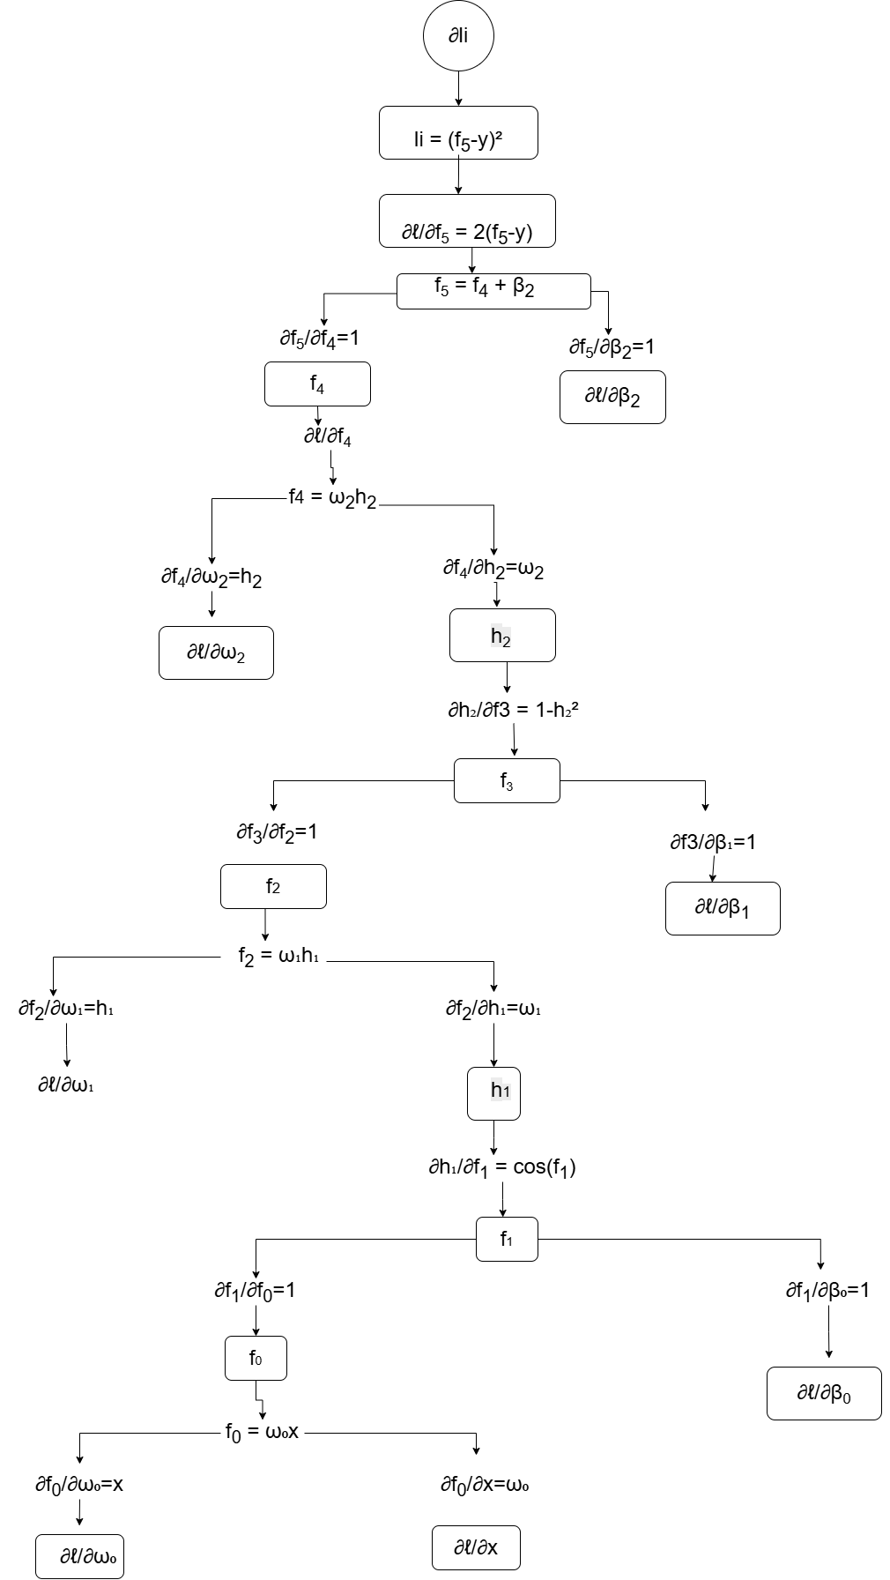

4.6 Compute the gradients with respect to all learnable parameters in θ
$$θ=ω_{0},{ β}_{0},{ ω}_{1},β_{1},{ ω}_{2},{ β}_{2}$$

$\frac{∂l}{∂ω_{0}}$ = $2\left(f_{5}-y\right)ω_{2}\left(1-h_{2}^{2}\right)ω_{1}cos\left(f_{1}\right)x$
$\frac{∂l}{∂β_{0}}$ = $2\left(f_{5}-y\right)ω_{2}\left(1-h_{2}^{2}\right)ω_{1}cos\left(f_{1}\right)$
$\frac{∂l}{∂ω_{1}}$ = $2\left(f_{5}-y\right)ω_{2}\left(1-h_{2}^{2}\right)h_{1}$
$\frac{∂l}{∂β_{1}}$ = $2\left(f_{5}-y\right)ω_{2}\left(1-h_{2}^{2}\right)$
$\frac{∂l}{∂ω_{2}}$ = $2\left(f_{5}-y\right)h_{2}$
$\frac{∂l}{∂β_{2}}$ = $2\left(f_{5}-y\right)$

Exercise 5: Two Hidden Neurons, One Input
Model: $f\left(x,θ\right)=ω_{4}tanh\left(ω_{0}x+β_{0}\right)+ω_{5}sin\left(ω_{1}x+β_{1}\right)+β_{2}$
$$θ=ω_{0},β_{0},ω_{1},β_{1},ω_{4},ω_{5},β_{2}$$
5.1 Foward Pass
Rama1 (tanh)
$$f_{0}=ω_{0}x$$
$$f_{1}=f_{0}+β_{0}$$

$$h_{1}=tanh\left(f_{1}\right)$$
Multiplicación
$$f_{2}=ω_{4}h_{1}$$

Rama2 (sin)
$$f_{3}=ω_{1}x$$
$$f_{4}=f_{3}+β_{1}$$

$$h_{2}=sin\left(f_{4}\right)$$
Multiplicación
$$f_{5}=ω_{5}h_{2}$$

Union de ramas
$$f_{6}=f_{2}+f_{5}$$
Suma total
$$f_{7}=f_{6}+β_{2}$$
5.2 Loss
$$l={\left(f_{7}-y\right)}^{2}$$
5.3. Forward Computational Graph
$$f_{0}=ω_{0} x$$
$$f_{1}=f_{0}+β_{0}$$
$$h_{1} =tanh(f1)$$
$$f_{2}=ω_{4}h_{1}$$
$$f_{3}=ω_{1} x$$
$$f_{4}=f_{3}+β_{1}$$
$$h_{2} =sin(f_{4})$$
$$f_{5}=ω_{5}h_{2}$$
$$f_{6}=f_{2}+f_{5}$$
$$f_{7}=f_{6}+β_{2}$$
$$l={\left(f_{7}-y\right)}^{2}$$
Rama 1
$$f_{2}$$

$$h_{1}$$

$$f_{1}$$
$$f_{0}$$
X

+$β_{0}$
*$ω_{0}$
$$f_{7}$$

$$l$$

$$f_{6}$$

+$β_{2}$
*$ω_{5}$
Rama 2
$$f_{5}$$

$$f_{3}$$

$$h_{2}$$

$$f_{4}$$
X

*$ω_{1}$
+$β_{1}$

5.4 Backward Pass
$$l={\left(f_{7}-y\right)}^{2}$$

Derivando
$\frac{∂l}{∂f_{7}}$ = $2\left(f_{7}-y\right)$
Suma
$$f_{7}=f_{6}+β_{2}$$

$\frac{∂f_{3}}{∂f_{2}}$ = $1$

$\frac{∂f_{3}}{∂β_{1}}$ = $1$
Regla de la cadena
$\frac{∂l}{∂f_{6}}$ = $2\left(f_{7}-y\right)$

$\frac{∂l}{∂β_{2}}$ = $2\left(f_{7}-y\right)$
Separación de ramas
$$f_{6}=f_{2}+f_{5}$$

$\frac{∂f_{6}}{∂f_{2}}$ = $1$

$\frac{∂f_{6}}{∂f_{5}}$ = $1$
Por lo tanto
$\frac{∂l}{∂f_{2}}$ = $2\left(f_{7}-y\right)$

$\frac{∂l}{∂f_{5}}$ = $2\left(f_{7}-y\right)$

$$f_{2}=ω_{4}h_{1}$$

$\frac{∂f_{2}}{∂ω_{4}}$ = $h_{1}$

$\frac{∂f_{2}}{∂h_{1}}$ = $ω_{4}$

Regla de la cadena
$\frac{∂l}{∂ω_{4}}$ = $2\left(f_{7}-y\right)h_{1}$

$\frac{∂l}{∂h_{1}}$ = $2\left(f_{7}-y\right)ω_{4}$

Tanh
$$h_{1}=tanh\left(f_{1}\right)$$
Derivada

$$\frac{∂h_{1}}{∂f_{1}}=1-h_{1}^{2}$$

Regla de la cadena

$\frac{∂l}{∂f_{1}}$ = $2\left(f_{7}-y\right)ω_{4}\left(1-h_{1}^{2}\right)$

Suma
$$f_{1}=f_{0}+β_{0}$$

$\frac{∂l}{∂β_{0}}$ = $2\left(f_{7}-y\right)ω_{4}\left(1-h_{1}^{2}\right)$

$\frac{∂l}{∂f_{0}}$ = $2\left(f_{7}-y\right)ω_{4}\left(1-h_{1}^{2}\right)$

Regla de la cadena
$\frac{∂l}{∂β_{1}}$ = $2\left(f_{7}-y\right)ω_{4}\left(1-h_{1}^{2}\right)$

$\frac{∂l}{∂f_{2}}$ = $2\left(f_{7}-y\right)ω_{4}\left(1-h_{1}^{2}\right)$

Multiplicacion
$$f_{0}=ω_{0} x$$

$\frac{∂l}{∂ω_{0}}$ = $2\left(f_{7}-y\right)ω_{4}\left(1-h_{2}^{2}\right)x$

Rama 2 (sin)
$$f_{0}=ω_{5}xh_{2}$$

$\frac{∂f_{5}}{∂ω_{5}}$ = $h_{2}$

$\frac{∂f_{5}}{∂h_{2}}$ = $ω_{5}$
Regla de la cadena
$\frac{∂l}{∂ω_{5}}$ = $2\left(f_{7}-y\right)h_{2}$

$\frac{∂l}{∂h_{2}}$ = $2\left(f_{7}-y\right)ω_{5}$
Funcion seno
$$h_{2} =sin(f_{4})$$

$\frac{∂h_{2}}{∂f_{4}}$ = $cos\left(f_{4}\right)$
Regla de la cadena
$\frac{∂l}{∂f_{1}}$ = $2\left(f_{7}-y\right)ω_{5 }cos\left(f_{4}\right)$

Suma
$$f_{4}=f_{3}+β_{1}$$

$\frac{∂l}{∂β_{1}}$ = $2\left(f_{7}-y\right)ω_{5}cos\left(f_{4}\right)$
$\frac{∂l}{∂f_{3}}$ = $2\left(f_{7}-y\right)ω_{5}cos\left(f_{4}\right)$
Mutiplicacion
$$f_{3}=ω_{1} x$$

$\frac{∂l}{∂ω_{1}}$ = $2\left(f_{7}-y\right)ω_{5}cos\left(f_{4}\right)x$

5.5 Backward Computational Graph

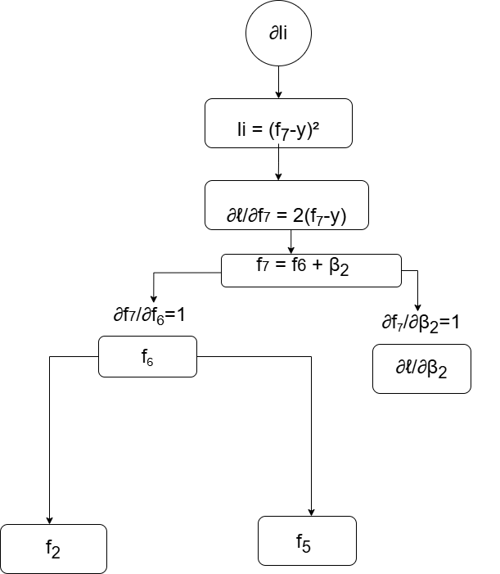

Rama 2

Rama 1

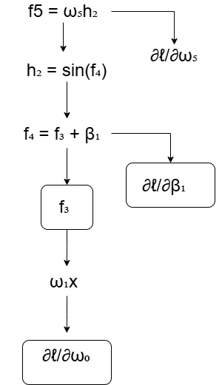
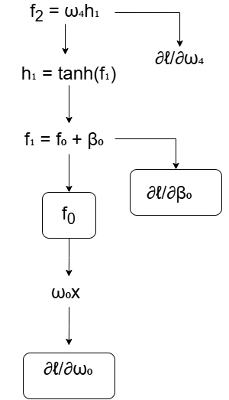

5.6 Compute the gradients with respect to all learnable parameters in θ
$$θ=ω_{0},β_{0},ω_{1},β_{1},ω_{4},ω_{5},β_{2}$$
Gadrientes finales

$\frac{∂l}{∂ω_{0}}$ = $2\left(f_{7}-y\right)ω_{4}\left(1-h_{2}^{2}\right)x$

$\frac{∂l}{∂β_{0}}$ = $2\left(f_{7}-y\right)ω_{4}\left(1-h_{1}^{2}\right)$
$\frac{∂l}{∂ω_{1}}$ = $2\left(f_{7}-y\right)ω_{5}cos\left(f_{4}\right)x$
$\frac{∂l}{∂β_{1}}$ = $2\left(f_{7}-y\right)ω_{5}cos\left(f_{4}\right)$
$\frac{∂l}{∂ω_{4}}$ = $2\left(f_{7}-y\right)h_{1}$
$\frac{∂l}{∂ω_{5}}$ = $2\left(f_{7}-y\right)h_{2}$

$\frac{∂l}{∂β_{2}}$ = $2\left(f_{7}-y\right)$

Exercise 6: MLP with Two Inputs
Model:
$$f\left(x,θ\right)=ω_{3}tanh\left(ω_{0}x_{1}+ω_{1}x_{2}+β_{0}\right)+β_{1}$$
$$θ=ω_{0},ω_{1},β_{0},ω_{3},β_{1}$$

6.1 Foward Pass
$$f_{0}=ω_{0}x$$
Multiplicacion
$$f_{1}=ω_{1}x_{2}$$
Suma de entradas
$$f_{2}=f_{0}+f_{1}$$
Sesgo
$$f_{3}=f_{2}+β_{0}$$

$$h_{1}=tanh\left(f_{3}\right)$$
Multiplcacion
$$f_{4}=ω_{3}h_{1}$$
Suma final
$$f_{5}=f_{4}+β_{1}$$
$$6.2 Loss$$
$$l={\left(f_{5}-y\right)}^{2}$$

6.3. Forward Computational Graph
$$f_{0}=ω_{0} x$$
$$f_{1}=ω_{1}x_{2}$$
$f_{2}=$ $f_{0}+f_{1}$
$f_{3}=$ $f_{2}+β_{0}$
$$h_{1} =tanh(f_{3})$$
$$f_{4}=ω_{3}h_{1}$$
$$f_{5}=f_{4}+β_{1}$$
$$l={\left(f_{5}-y\right)}^{2}$$

$$f_{0}$$
X₁

$$l$$

$$f_{5}$$

$$f_{4}$$
$$h_{1}$$

$$f_{3}$$

$$f_{2}$$

X₂
$$f_{1}$$

6.4 Backward Pass
$$l={\left(f_{5}-y\right)}^{2}$$

Derivada
$\frac{∂l}{∂f_{5}}$ = $2\left(f_{5}-y\right)$
Derivada de la suma final

$$f_{5}=f_{4}+β_{1}$$

$\frac{∂f_{5}}{∂f_{4}}$ = $1$

$\frac{∂f_{5}}{∂β_{1}}$ = $1$

Regla de la cadena

$\frac{∂l}{∂f_{4}}$ = $2\left(f_{5}-y\right)$

$\frac{∂l}{∂β_{1}}$ = $2\left(f_{5}-y\right)$
Multiplicación
Tomando en cuenta que
$$f_{4}=ω_{3}h_{1}$$
Las derivadas son
$\frac{∂f_{4}}{∂ω_{3}}$ = $h_{1}$

$\frac{∂f_{4}}{∂h_{1}}$ = $ω_{3}$

Regla de la cadena
$\frac{∂l}{∂ω_{3}}$ = $2\left(f_{5}-y\right)h_{1}$

$\frac{∂l}{∂h_{1}}$ = $2\left(f_{5}-y\right)ω_{3}$

Tanh
$$h_{1}=tanh\left(f_{3}\right)$$
Derivada

$$\frac{∂h_{1}}{∂f_{3}}=1-h_{1}^{2}$$

Regla de la cadena

$\frac{∂l}{∂f_{3}}$ = $2\left(f_{5}-y\right)ω_{3}\left(1-h_{1}^{2}\right)$
Suma
$$f_{3}=f_{2}+β_{0}$$

$\frac{∂f_{3}}{∂f_{2}}$ = $1$

$\frac{∂f_{3}}{∂β_{0}}$ = $1$
Regla de la cadena
$\frac{∂l}{∂β_{0}}$ = $2\left(f_{5}-y\right)ω_{3}\left(1-h_{1}^{2}\right)$

$\frac{∂l}{∂f_{2}}$ = $2\left(f_{5}-y\right)ω_{3}\left(1-h_{1}^{2}\right)$

Multiplicación $f_{0}=ω_{0}x_{1}$

Entonces
$\frac{∂f_{0}}{∂ω_{0}}$ = $x_{1}$
$\frac{∂f_{0}}{∂x_{1}}$ = $ω_{0}$

Regla de la cadena
$\frac{∂l}{∂ω_{0}}$ = $2\left(f_{5}-y\right)ω_{3}\left(1-h_{1}^{2}\right)x_{1}$

Multiplicación $f_{1}=ω_{1}x_{2}$

Entonces
$\frac{∂f_{0}}{∂ω_{1}}$ = $x_{2}$
$\frac{∂f_{0}}{∂x_{2}}$ = $ω_{1}$

Regla de la cadena
$\frac{∂l}{∂ω_{1}}$ = $2\left(f_{5}-y\right)ω_{3}\left(1-h_{1}^{2}\right)x_{2}$

6.5 Backward Computational Graph

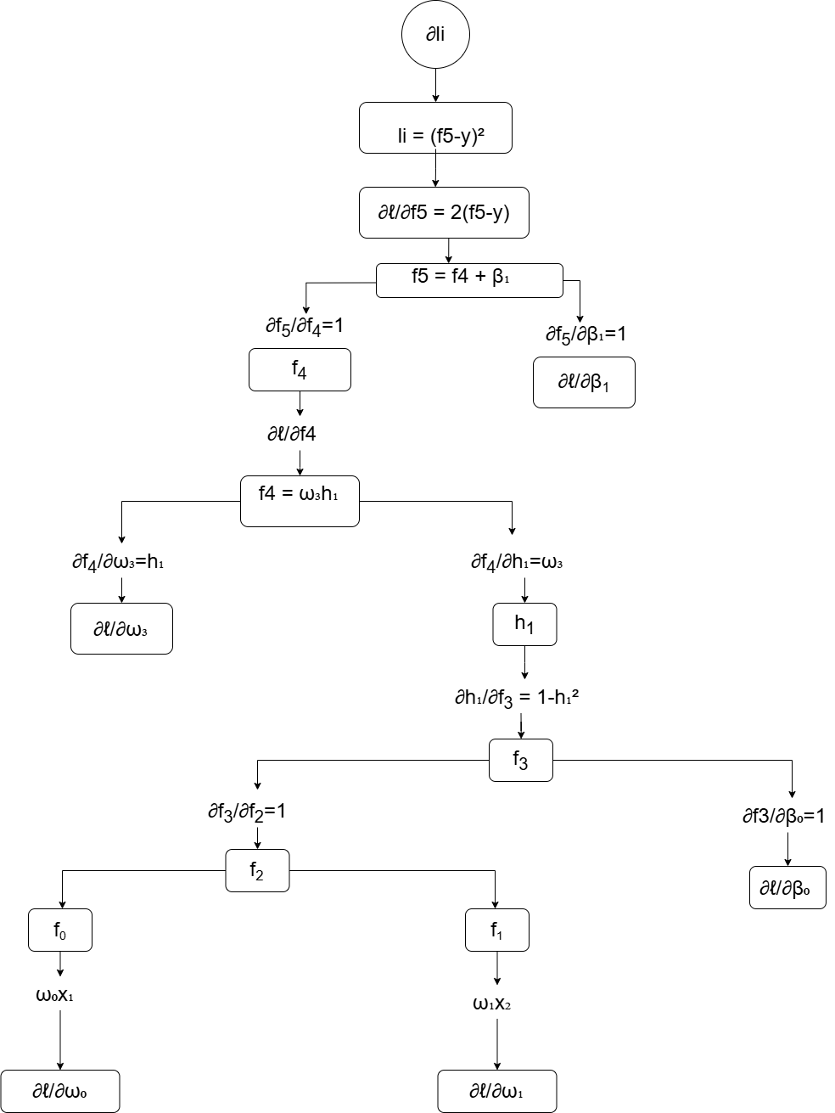

6.6 Compute the gradients with respect to all learnable parameters in θ
$$θ=ω_{0},ω_{1},β_{0},ω_{3},β_{1}$$

$\frac{∂l}{∂ω_{0}}$ = $2\left(f_{5}-y\right)ω_{3}\left(1-h_{1}^{2}\right)x_{1}$
$\frac{∂l}{∂ω_{1}}$ = $2\left(f_{5}-y\right)ω_{3}\left(1-h_{1}^{2}\right)x_{2}$
$\frac{∂l}{∂β_{0}}$ = $2\left(f_{5}-y\right)ω_{3}\left(1-h_{1}^{2}\right)$
$\frac{∂l}{∂ω_{3}}$ = $2\left(f_{5}-y\right)h_{1}$
$\frac{∂l}{∂β_{1}}$ = $2\left(f_{5}-y\right)$

Exercise 7: MLP 2–2–1
Input: $x\left(x_{1},x_{2}\right)$
Model:
$$f\left(x,θ\right)=ω_{5}tanh\left(ω_{0}x_{1}+ω_{1}x_{2}+β_{0}\right)+ω_{6}ReLU\left(ω_{2}x_{1}+ω_{3}x_{2}+β_{1}\right)+β_{2}$$
$$θ=ω_{0},ω_{1},β_{0},{ω_{2}ω}_{3},β_{1},ω_{5},ω_{6},β_{2}$$

7.1 Forward Pass
Rama 1
$$f_{0}=ω_{0}x_{1}$$
Multiplicacion
$$f_{1}=ω_{1}x_{2}$$
Suma de entradas
$$f_{2}=f_{0}+f_{1}$$

$$f_{3}=f_{2}+β_{0}$$

$$h_{1}=tanh\left(f_{3}\right)$$
Multiplcacion
$$f_{4}=ω_{5}h_{1}$$

Rama 2 ReLU
$$f_{5}=ω_{2}x_{1}$$
Multiplicacion
$$f_{6}=ω_{3}x_{2}$$
Suma de entradas
$$f_{7}=f_{5}+f_{6}$$

$$f_{8}=f_{7}+β_{1}$$

$$h_{2}=ReLU\left(f_{8}\right)$$
Multiplcacion
$$f_{9}=ω_{6}h_{2}$$
Union
$$f_{10}=f_{4}+f_{9}$$

$$f_{11}=f_{10}+β_{2}$$

7.2 Loss
$$l={\left(f_{11}-y\right)}^{2}$$

7.3. Forward Computational Graph
$$f_{0}=ω_{0} x$$
$$f_{1}=ω_{1}x_{2}$$
$f_{2}=$ $f_{0}+f_{1}$
$f_{3}=$ $f_{2}+β_{0}$
$$h_{1} =tanh(f_{3})$$
$$f_{4}=ω_{5}h_{1}$$
$$f_{5}=ω_{2}x_{1}$$
$$f_{6}=ω_{3}x_{2}$$
$f_{7}=$ $f_{5}+f_{6}$
$f_{8}=$ $f_{7}+β_{1}$
$$h_{2} =Relu(f_{8})$$
$$f_{9}=ω_{6}h_{2}$$
$f_{10}=$ $f_{4}+f_{9}$
$f_{11}=$ $f_{11}+β_{2}$
$$l={\left(f_{11}-y\right)}^{2}$$

Rama tanh
X ₁
$$f_{0}$$

$$f_{4}$$
$$h_{1}$$

$$f_{3}$$

$$f_{2}$$

$$f_{1}$$
X₂ v

$$l$$

$$f_{11}$$

$$f_{10}$$

X ₁
Rama ReLU
$$f_{9}$$
$$h_{2}$$

$$f_{8}$$
$$f_{7}$$
$$f_{5}$$
$$f_{6}$$
X₂ v

7.4 Backward Pass
$$l={\left(f_{11}-y\right)}^{2}$$

Derivando
$\frac{∂l}{∂f_{11}}$ = $2\left(f_{11}-y\right)$
Suma
$$f_{11}=f_{10}+β_{2}$$
Regla de la cadena

$\frac{∂l}{∂f_{10}}$ = $2\left(f_{11}-y\right)$

$\frac{∂l}{∂β_{2}}$ = $2\left(f_{11}-y\right)$
Separación de ramas
$$f_{10}=f_{4}+f_{9}$$
Por lo tanto
$\frac{∂l}{∂f_{4}}$ = $2\left(f_{11}-y\right)$
$\frac{∂l}{∂f_{9}}$ = $2\left(f_{11}-y\right)$

Rama 1 (tanh)
$$f_{4}=ω_{5}h_{1}$$

$\frac{∂f_{4}}{∂ω_{5}}$ = $h_{1}$

$\frac{∂f_{4}}{∂h_{1}}$ = $ω_{5}$

Regla de la cadena
$\frac{∂l}{∂ω_{5}}$ = $2\left(f_{11}-y\right)h_{1}$

$\frac{∂l}{∂h_{1}}$ = $2\left(f_{11}-y\right)ω_{5}$

Tanh
$$h_{1}=tanh\left(f_{3}\right)$$
Derivada

$$\frac{∂h_{1}}{∂f_{3}}=1-h_{1}^{2}$$

Regla de la cadena

$\frac{∂l}{∂f_{3}}$ = $2\left(f_{11}-y\right)ω_{5}\left(1-h_{1}^{2}\right)$

Suma
$$f_{3}=f_{2}+β_{0}$$

$\frac{∂l}{∂β_{0}}$ = $2\left(f_{11}-y\right)ω_{5}\left(1-h_{1}^{2}\right)$

$\frac{∂l}{∂f_{2}}$ = $2\left(f_{11}-y\right)ω_{5}\left(1-h_{1}^{2}\right)$

Suma de entradas
$$f_{2}=f_{0}+f_{1}$$

$\frac{∂l}{∂f_{0}}$ = $2\left(f_{11}-y\right)ω_{5}\left(1-h_{1}^{2}\right)$

$\frac{∂l}{∂f_{1}}$ = $2\left(f_{11}-y\right)ω_{5}\left(1-h_{1}^{2}\right)$

Multiplicacion

$\frac{∂l}{∂ω_{0}}$ = $2\left(f_{11}-y\right)ω_{5}\left(1-h_{1}^{2}\right)x_{1}$
$\frac{∂l}{∂ω_{1}}$ = $2\left(f_{11}-y\right)ω_{5}\left(1-h_{1}^{2}\right)x_{2}$

Rama 2 (ReLU)
$$f_{9}=ω_{6}h_{2}$$

$\frac{∂f_{9}}{∂ω_{6}}$ = $h_{2}$

$\frac{∂f_{9}}{∂h_{2}}$ = $ω_{6}$
Regla de la cadena
$\frac{∂l}{∂ω_{6}}$ = $2\left(f_{11}-y\right)h_{2}$

$\frac{∂l}{∂h_{2}}$ = $2\left(f_{11}-y\right)ω_{6}$
ReLU
$$h_{2} =ReLU(f_{8})$$

$\frac{∂h_{2}}{∂f_{8}}$ $=\left\{\begin{aligned}-1, &f_{8}<0 \\ 0, &f_{8}≥0\end{aligned}\right.$
Regla de la cadena
$\frac{∂l}{∂f_{8}}$ = $\frac{∂l}{∂h_{2}} ∙\frac{∂h_{2}}{∂f_{8}}$

Suma
$$f_{8}=f_{7}+β_{1}$$

$\frac{∂l}{∂β_{1}}$ = $\frac{∂l}{∂f_{8}}$
$\frac{∂l}{∂f_{7}}$ = $\frac{∂l}{∂f_{8}}$
Suma de entradas
$$f_{7}=f_{5}+f_{6}$$

$\frac{∂l}{∂f_{5}}$ = $\frac{∂l}{∂f_{8}}$

$\frac{∂l}{∂f_{6}}$ = $\frac{∂l}{∂f_{8}}$

Multiplicaciones
$$\frac{∂l}{∂ω_{2}}=\frac{∂l}{∂f_{8}}x_{1}$$

$$\frac{∂l}{∂ω_{3}}=\frac{∂l}{∂f_{8}}x_{2}$$

7.5 Backward Computational Graph
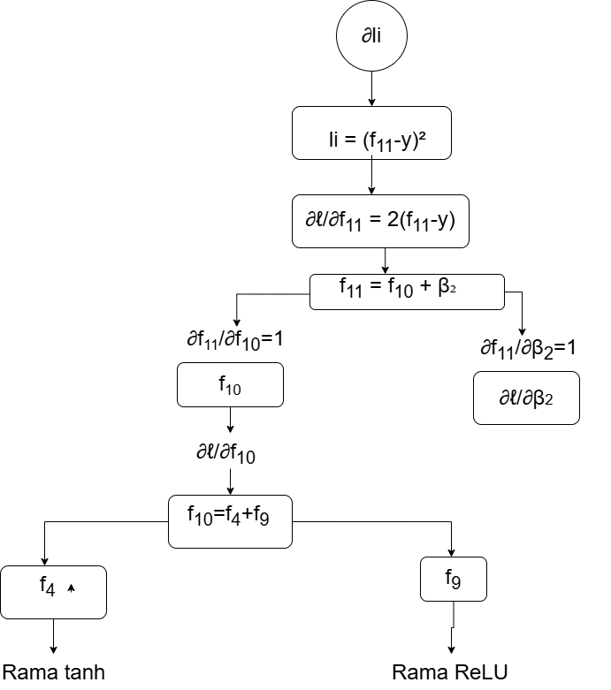

Rama 1 (tanh)
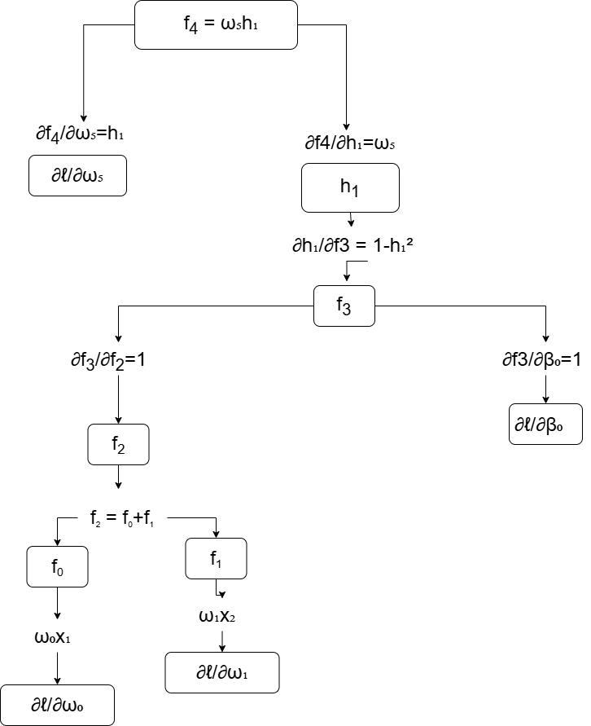

Rama 2 (ReLU)
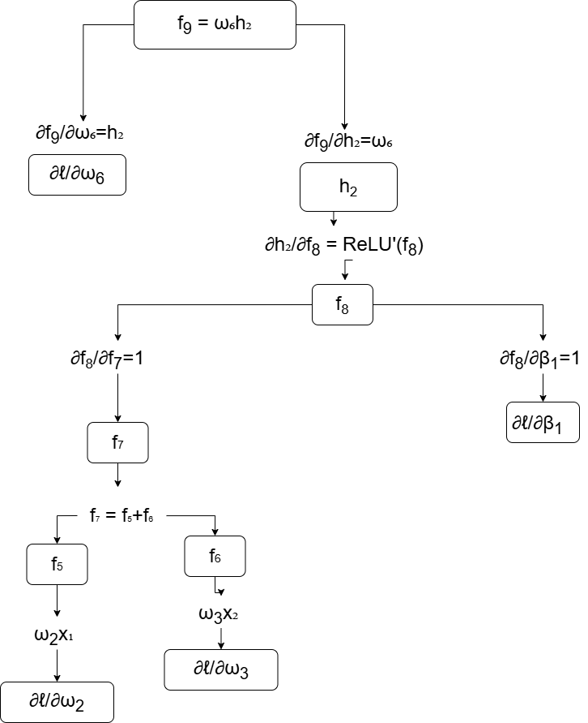

7.6 Compute the gradients with respect to all learnable parameters in θ

$$θ=ω_{0},ω_{1},β_{0},{ω_{2}ω}_{3},β_{1},ω_{5},ω_{6},β_{2}$$

$\frac{∂l}{∂ω_{0}}$ = $2\left(f_{11}-y\right)ω_{5}\left(1-h_{1}^{2}\right)x_{1}$
$\frac{∂l}{∂ω_{1}}$ = $2\left(f_{11}-y\right)ω_{5}\left(1-h_{1}^{2}\right)x_{2}$
$\frac{∂l}{∂β_{0}}$ = $2\left(f_{11}-y\right)ω_{5}\left(1-h_{1}^{2}\right)$
$$\frac{∂l}{∂ω_{2}}=\frac{∂l}{∂f_{8}}x_{1}$$

$$\frac{∂l}{∂ω_{3}}=\frac{∂l}{∂f_{8}}x_{2}$$

$\frac{∂l}{∂β_{1}}$ = $\frac{∂l}{∂f_{8}}$

$\frac{∂l}{∂ω_{5}}$ = $2\left(f_{11}-y\right)h_{1}$
$\frac{∂l}{∂ω_{6}}$ = $2\left(f_{11}-y\right)h_{2}$

$\frac{∂l}{∂β_{2}}$ = $2\left(f_{11}-y\right)$

Exercise 8: Branching Model with Shared Pre-Activation
Model:
$$f\left(x,θ\right)=ω_{3}sin(ω_{0}x+β_{0})+ω_{4}cos\left(ω_{0}x+β_{0}\right)+β_{1}$$
$$θ=ω_{0},β_{0},ω_{3},{ω_{4},β}_{1}$$

8.1 Forward Pass
Multiplicación
$$f_{1}=ω_{1}x_{2}$$
Suma (nodo compartido)
$$f_{1}=f_{0}+β_{0}$$
Rama Seno

$$h_{1}=sin\left(f_{1}\right)$$
$$f_{2}=ω_{3}h_{1}$$
Rama coseno
$$h_{2}=cos\left(f_{1}\right)$$
$$f_{3}=ω_{4}h_{2}$$

Union
$$f_{4}=f_{2}+f_{3}$$

$$f_{5}=f_{4}+β_{1}$$

8.2 Loss

$$l={\left(f_{5}-y\right)}^{2}$$

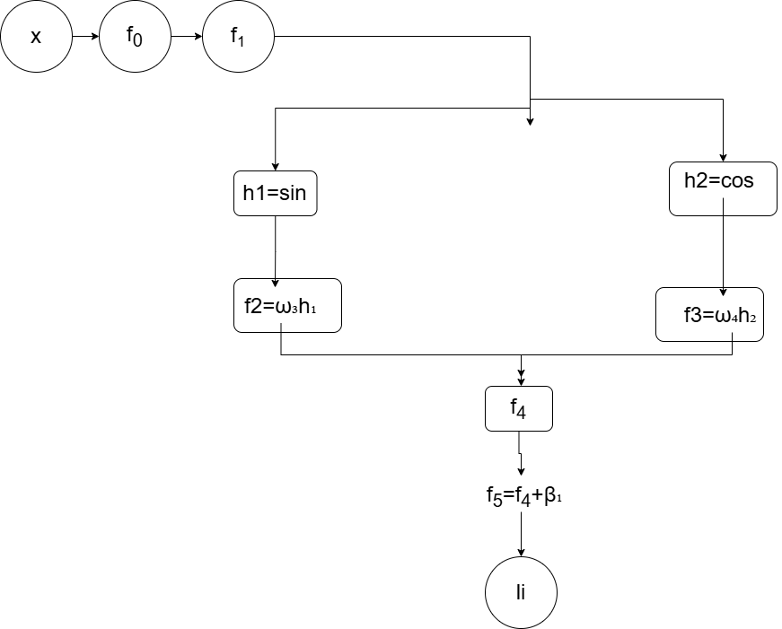
8.3. Forward Computational Graph
$$f_{0}=ω_{0} x$$
$$f_{1}=f_{0}+β_{0}$$
$h_{1} =sin(f_{1}$)
$f_{2}=$ $ω_{3}h_{1}$
$$h_{2} =cos(f_{1})$$
$f_{3}=$ $ω_{4}h_{2}$
$$f_{4}=f_{2}+f_{3}$$
$$f_{5}=f_{4}+β_{1}$$
$$l={\left(f_{5}-y\right)}^{2}$$

8.4 Backward Pass
$$l={\left(f_{5}-y\right)}^{2}$$

$\frac{∂l}{∂f_{5}}$ = $2\left(f_{5}-y\right)$
Derivada de la suma final

$$f_{5}=f_{4}+β_{1}$$

$\frac{∂l}{∂f_{4}}$ = $2\left(f_{5}-y\right)$

$\frac{∂l}{∂β_{1}}$ = $2\left(f_{5}-y\right)$

Separacion de ramas
$$f_{4}=f_{2}+f_{3}$$

$\frac{∂l}{∂f_{2}}$ = $2\left(f_{5}-y\right)$

$\frac{∂l}{∂f_{3}}$ = $2\left(f_{5}-y\right)$

Rama Seno
$$f_{2}=ω_{3}h_{1}$$

$\frac{∂f_{2}}{∂ω_{3}}$ = $h_{1}$

$\frac{∂f_{2}}{∂h_{1}}$ = $ω_{3}$

Regla de la cadena

$$\frac{∂l}{∂ω_{3}}=2\left(f_{5}-y\right)h_{1}$$
$$\frac{∂l}{∂h_{1}}=2\left(f_{5}-y\right)ω_{3}$$

Seno

$$h_{1}=sin\left(f_{1}\right)$$

$$\frac{∂h_{1}}{∂f_{1}}=cos\left(f_{1}\right)$$

Regla de la cadena
$\frac{∂l}{∂f_{1} }$ _{sin =} $2\left(f_{5}-y\right)ω_{3}cos\left(f_{1}\right)$

Rama coseno
$$f_{3}=ω_{4}h_{2}$$

$\frac{∂f_{3}}{∂ω_{4}}$ = $h_{2}$

$\frac{∂f_{3}}{∂h_{2}}$ = $ω_{4}$

$$\frac{∂l}{∂ω_{4}}=2\left(f_{5}-y\right)h_{2}$$

$$\frac{∂l}{∂h_{2}}=2\left(f_{5}-y\right)ω_{4}$$
Coseno
$$h_{2}=cos\left(f_{1}\right)$$

$$\frac{∂h_{2}}{∂f_{1}}=-sin\left(f_{1}\right)$$
Regla de la cadena
$\frac{∂l}{∂f_{1} }$ _{cos =} $-2\left(f_{5}-y\right)ω_{4}cos\left(f_{1}\right)$

Acumulación de Gradientes

Dado
$$f_{1}=ω_{0}x+β_{0}$$
$\frac{∂l}{∂f_{1} }=$ $\frac{∂l}{∂f_{1} }$ _{sin +} $\frac{∂l}{∂f_{1} }$ _{cos}

$$\frac{∂l}{∂f_{1} }=2\left(f_{5}-y\right)\left[ω_{3}cos\left(f_{1}\right)-ω_{4}sin\left(f_{1}\right)\right]$$
Nodo compartido
$$f_{1}=f_{0}+β_{0}$$

$\frac{∂l}{∂β_{0}}=$ $\frac{∂l}{∂f_{1} }$

$\frac{∂l}{∂f_{0}}=$ $\frac{∂l}{∂f_{1} }$

Multiplicación inicial
$$f_{0}=ω_{0}x$$

$\frac{∂l}{∂ω_{0}}=$ $\frac{∂l}{∂f_{1} }x$

8.5 Backward Computational Graph
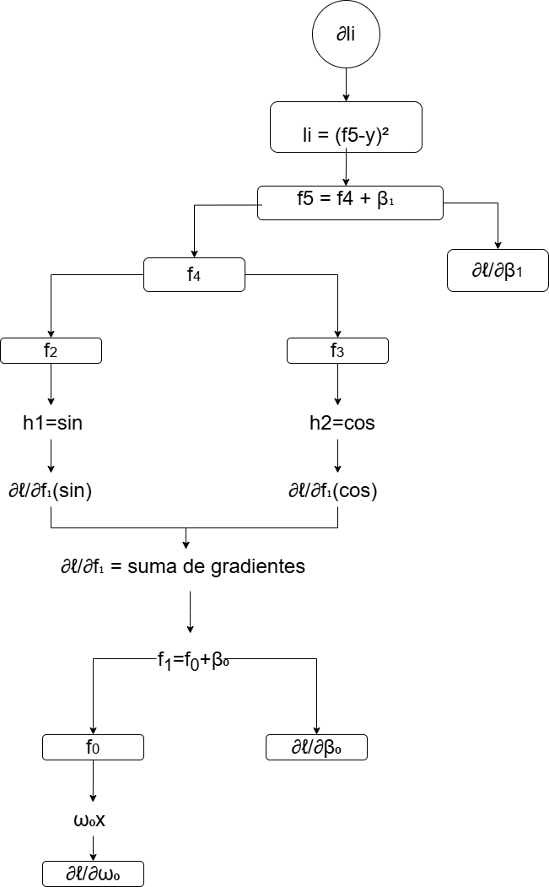

8.6 Compute the gradients with respect to all learnable parameters in θ

$$θ=ω_{0},β_{0},ω_{3},{ω_{4},β}_{1},$$

$$\frac{∂l}{∂ω_{0}}= 2\left(f_{5}-y\right)\left[ω_{3}cos\left(f_{1}\right)-ω_{4}sin\left(f_{1}\right)\right]x$$
$$\frac{∂l}{∂β_{0}}=2\left(f_{5}-y\right)\left[ω_{3}cos\left(f_{1}\right)-ω_{4}sin\left(f_{1}\right)\right]$$
$$\frac{∂l}{∂ω_{3}}=2\left(f_{5}-y\right)h_{1}$$
$$\frac{∂l}{∂ω_{4}}=2\left(f_{5}-y\right)h_{2}$$

$\frac{∂l}{∂β_{1}}$ = $2\left(f_{5}-y\right)$

