Application in process:
School | Requirements/What’s yet to be done | Status
Wayne State University | Ms Data Science and Business Analytics(Advanced Analytics)  - Fee Waived  - 1 recommendation letter  - Statement of Purpose (Please upload a paper of approximately 300 words describing your academic and professional goals. )  - CV (Upload a copy of your most recent resume in a single-file upload.)  - Provide any documents you would like considered during the admissions process (e.g. personal statement, projects, publications, etc.) | Done
University of Virginia  Status: Mid Done  Reach out:  thomas.stewart@virginia.edu( enquiries on PhD in data science)  pa5jg@virginia.edu( enquiries on MSc Data Science) | Phd in Data Science  - Application fee of $85  - CV  - 3 recommendation letters  - Fully funded | Done, left with payment
Illinois Institute of Technology  Professor I prefer to work under:  Name: Mustafa Bilgic  Link: https://www.iit.edu/directory/people/mustafa-bilgic  email:mbilgic@iit.edu | Awaiting recommendation.  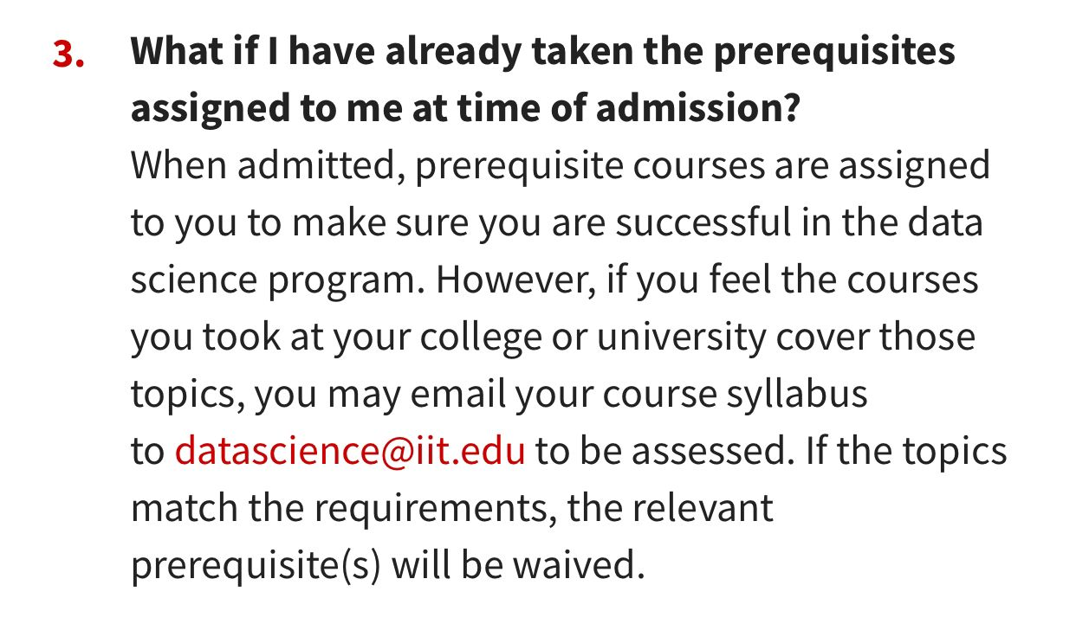 | Done
Clarkson University | - Join session for application fee waiver  - 3 Letters of recommendation  - Statement of purpose  - A copy of passport | Done.
University of San Francisco | - Requested for few waiver  - Banks statement  - 2 letters of recomendation
LeHigh | - Fee waived from 1-7 Dec  - SOP  - 2 LOR  - English proficiency waiver letter from university  - Transcripts  - External Funding Opportunities tracked by the college: https://engineering.lehigh.edu/academics/graduate/admissions/support/scholarships | Done

