AI-Based Course Guidance Assistant
Submitted by: Alen | Computer Science, Viswajyothi College | Roll No. 6

1. Project Title
AI-Based Course Guidance Assistant

2. Use Case Selected
A course guidance chatbot/assistant that helps students pick suitable courses based on their interests, existing skills, career goals, and available study time.

3. Problem Statement
Students, especially beginners, often struggle to choose the right course from many available options. They may not know which courses match their interests, what skills are needed beforehand, or how much time a course will realistically take. Academic advisors are not always available for one-on-one guidance. This project builds a simple assistant that gives instant, explainable course recommendations, while still pointing students toward human advisors for final decisions.

4. Target Users
- College/university students exploring elective or skill-building courses
- Self-learners deciding which online course to start with
- Academic advisors, as a quick first-pass triage tool before a counselling session

5. Assistant Workflow
Step 1 - Input: The student enters their interests, existing skills, career goal, and weekly study time through a simple form.
Step 2 - Matching: The assistant compares this input against a stored course dataset (courses.json) using rule-based keyword matching across interests, career goal alignment, prerequisite/skill fit, and time fit.
Step 3 - Scoring & Ranking: Each course gets a score out of 100 based on weighted matches. The top 3-5 scoring courses are selected.
Step 4 - Explanation: For each recommended course, the assistant shows the specific reasons it was chosen (matched interest, career alignment, skills fit, time fit) along with prerequisites and a suggested learning path.
Step 5 - Follow-up: The student can ask follow-up questions (e.g. "What are the prerequisites for X?") and the assistant answers using the same underlying course data.
Step 6 - Human Review: The assistant displays a visible limitations notice recommending confirmation with an academic advisor before final enrollment.

6. Tools Used
- Python 3 - core application logic
- Streamlit - simple web-based user interface
- JSON - sample course dataset storage (12 sample courses)
- Rule-based keyword matching - transparent, explainable recommendation logic (no external AI API required, so the prototype runs immediately offline)

7. Example Prompts/Queries
- Interests: machine learning, data analysis | Skills: python | Career goal: data scientist | Study time: 5 hrs/week
- Interests: web development | Skills: (none) | Career goal: frontend developer | Study time: 5 hrs/week
- Follow-up: "What are the prerequisites for Machine Learning Basics?"
- Follow-up: "What skills will I learn from React for Frontend Development?"

8. Example Responses (Live Prototype Screenshots)
The screenshots below were captured directly from the running Streamlit application.

8.1 Initial Input Form
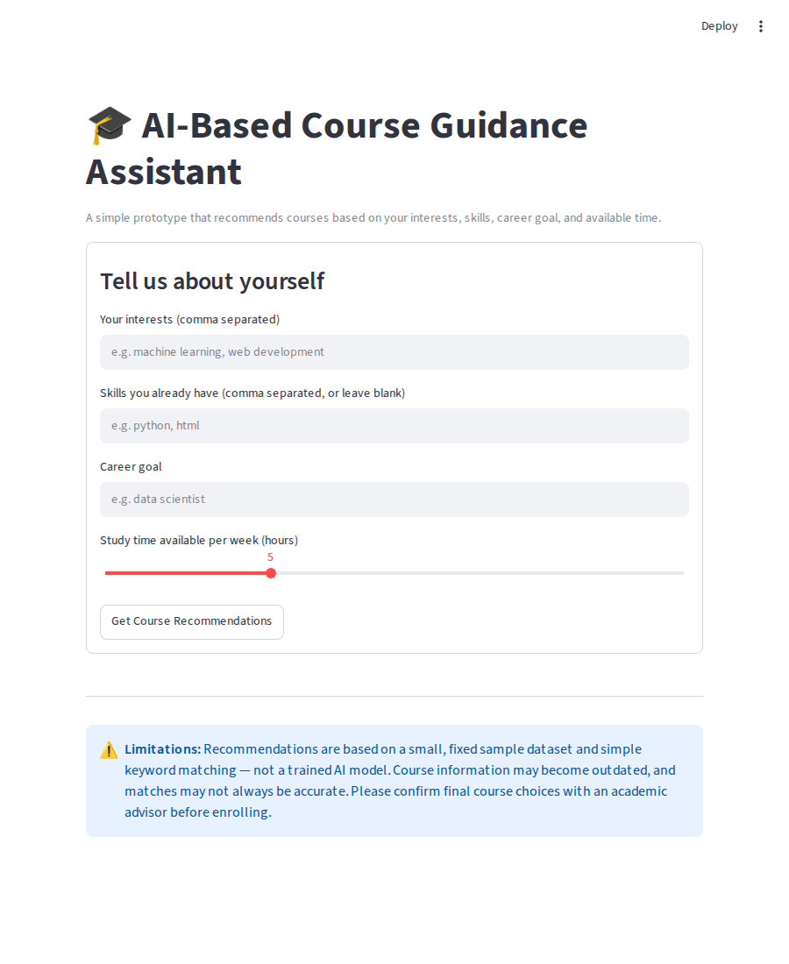

8.2 Recommendations for: interests = machine learning, data analysis | skills = python | goal = data scientist
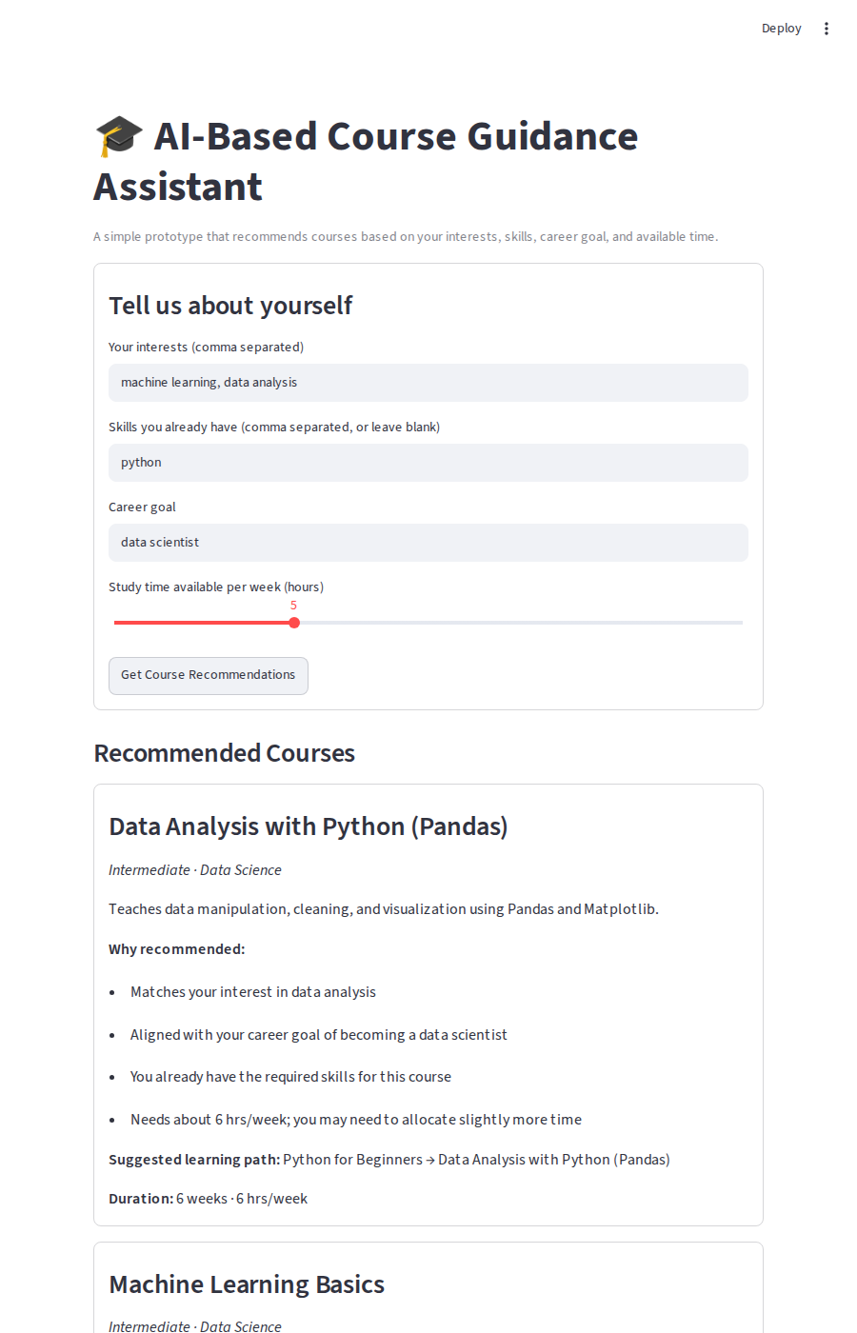

8.3 Follow-up Question and Answer
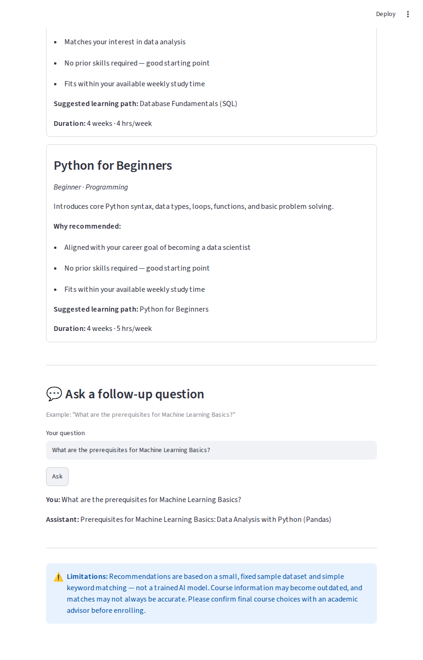

9. Limitations
- Uses simple rule-based keyword matching, not a trained machine learning model, so recommendations can be inaccurate or miss nuanced interests.
- The course dataset is small and fixed (12 sample courses) and may become outdated; it does not reflect a real, live course catalog.
- Free-text interests/skills that don't match the exact keywords in the dataset may not be recognized correctly.
- Follow-up question handling is rule-based and works best when the exact course name is mentioned.
- Final course selection should always be reviewed and confirmed with a human academic advisor.

10. Final Summary
This prototype demonstrates a focused, easy-to-understand AI-assisted workflow for course guidance: collecting student input, matching it against a course dataset, ranking and explaining recommendations, suggesting a learning path, and supporting follow-up questions. It intentionally uses simple, transparent logic suitable for a college project rather than a complex production system, while clearly stating its limitations and the continued need for human academic advisor review.

Appendix A: Setup & Run Instructions
1. Install dependencies:
pip install -r requirements.txt

2. Run the application:
streamlit run app.py

3. Open the local URL shown in the terminal (usually http://localhost:8501).
4. Enter interests, skills, career goal, and study time, then click 'Get Course Recommendations'. Ask follow-up questions in the chat box below the results.
Note: The application works fully offline and requires no API key, since it uses rule-based keyword matching rather than a hosted AI model.

Appendix B: Source Code — app.py
"""
AI-Based Course Guidance Assistant
A simple Streamlit prototype that recommends courses based on a
student's interests, existing skills, career goal, and available study time.

Run with: streamlit run app.py
"""

import json
import re
import streamlit as st

# ---------------------------------------------------------------------
# Load course data
# ---------------------------------------------------------------------
@st.cache_data
def load_courses():
with open("courses.json", "r", encoding="utf-8") as f:
return json.load(f)

COURSES = load_courses()

# ---------------------------------------------------------------------
# Helper functions
# ---------------------------------------------------------------------
def split_terms(text):
"""Split a comma/space separated string into lowercase clean terms."""
if not text:
return []
parts = re.split(r"[,/]", text)
return [p.strip().lower() for p in parts if p.strip()]

def score_course(course, interests, skills, career_goal, study_hours):
"""
Simple rule-based scoring (0-100).
This is not a machine-learning model - it is transparent, explainable
keyword matching, which is appropriate for a small prototype.
"""
score = 0
reasons = []

# 1. Interest match (highest weight)
interest_hits = [i for i in interests if i in course["interests"]]
if interest_hits:
score += 40
reasons.append(f"Matches your interest in {', '.join(interest_hits)}")

# 2. Career goal match
if career_goal and career_goal in [c.lower() for c in course["career_goals"]]:
score += 30
reasons.append(f"Aligned with your career goal of becoming a {career_goal}")

# 3. Existing skills -> ready for this course (prerequisite satisfied)
required = course["skills_required"]
if required:
have_all = all(r in skills for r in required)
if have_all:
score += 15
reasons.append("You already have the required skills for this course")
else:
missing = [r for r in required if r not in skills]
reasons.append(f"You may need to learn first: {', '.join(missing)}")
else:
score += 5
reasons.append("No prior skills required — good starting point")

# 4. Study time fit
if study_hours:
if study_hours >= course["hours_per_week"]:
score += 15
reasons.append("Fits within your available weekly study time")
else:
reasons.append(
f"Needs about {course['hours_per_week']} hrs/week; "
f"you may need to allocate slightly more time"
)

return score, reasons

def recommend_courses(interests, skills, career_goal, study_hours, top_n=5):
results = []
for course in COURSES:
score, reasons = score_course(course, interests, skills, career_goal, study_hours)
if score > 0:
results.append({"course": course, "score": score, "reasons": reasons})
results.sort(key=lambda x: x["score"], reverse=True)
return results[:top_n]

def build_learning_path(course):
"""Return a simple ordered list of prerequisite course names -> this course."""
path = list(course["prerequisites"]) + [course["name"]]
return path

def answer_followup(question, last_recommendations):
"""
Very simple rule-based follow-up question handler.
Looks for keywords in the question and answers using the
already-recommended course data (no external API required).
"""
q = question.lower()

if not last_recommendations:
return "Please get course recommendations first, then ask a follow-up question."

# Try to find which recommended course the question refers to
target = None
for rec in last_recommendations:
if rec["course"]["name"].lower() in q:
target = rec
break

if "prerequisite" in q or "before" in q:
if target:
prereqs = target["course"]["prerequisites"]
return (f"Prerequisites for {target['course']['name']}: "
f"{', '.join(prereqs) if prereqs else 'None'}")
return "Please mention the exact course name to check its prerequisites."

if "duration" in q or "how long" in q or "weeks" in q:
if target:
c = target["course"]
return f"{c['name']} takes about {c['duration_weeks']} weeks ({c['hours_per_week']} hrs/week)."
return "Please mention the exact course name to check its duration."

if "why" in q:
if target:
return "Reasons this was recommended: " + "; ".join(target["reasons"])
return "Please mention the exact course name you're asking about."

if "skill" in q or "learn" in q:
if target:
gained = target["course"]["skills_gained"]
return f"Skills you'll gain from {target['course']['name']}: {', '.join(gained)}"
return "Please mention the exact course name to check the skills covered."

if "path" in q or "order" in q or "sequence" in q:
if target:
path = build_learning_path(target["course"])
return "Suggested learning path: " + " -> ".join(path)
return "Please mention the exact course name to see its learning path."

return ("I can answer questions about prerequisites, duration, skills gained, "
"or the reason a course was recommended. Please mention the course name, "
"e.g. \"What are the prerequisites for Machine Learning Basics?\"")

# ---------------------------------------------------------------------
# Streamlit UI
# ---------------------------------------------------------------------
st.set_page_config(page_title="AI Course Guidance Assistant", page_icon="🎓", layout="centered")

st.title("🎓 AI-Based Course Guidance Assistant")
st.caption("A simple prototype that recommends courses based on your interests, skills, career goal, and available time.")

if "recommendations" not in st.session_state:
st.session_state.recommendations = []
if "chat_history" not in st.session_state:
st.session_state.chat_history = []

with st.form("student_form"):
st.subheader("Tell us about yourself")
interests_input = st.text_input(
"Your interests (comma separated)",
placeholder="e.g. machine learning, web development"
)
skills_input = st.text_input(
"Skills you already have (comma separated, or leave blank)",
placeholder="e.g. python, html"
)
career_goal_input = st.text_input(
"Career goal",
placeholder="e.g. data scientist"
)
study_hours_input = st.slider(
"Study time available per week (hours)", min_value=1, max_value=15, value=5
)
submitted = st.form_submit_button("Get Course Recommendations")

if submitted:
interests = split_terms(interests_input)
skills = split_terms(skills_input)
career_goal = career_goal_input.strip().lower()

if not interests and not career_goal:
st.warning("Please enter at least your interests or a career goal.")
else:
recs = recommend_courses(interests, skills, career_goal, study_hours_input)
st.session_state.recommendations = recs
st.session_state.chat_history = [] # reset chat for new recommendations

if st.session_state.recommendations:
st.subheader("Recommended Courses")
for rec in st.session_state.recommendations:
c = rec["course"]
with st.container(border=True):
st.markdown(f"### {c['name']} \n*{c['level']} · {c['field']}*")
st.write(c["description"])
st.markdown("**Why recommended:**")
for r in rec["reasons"]:
st.markdown(f"- {r}")
path = build_learning_path(c)
st.markdown(f"**Suggested learning path:** {' → '.join(path)}")
st.markdown(f"**Duration:** {c['duration_weeks']} weeks · {c['hours_per_week']} hrs/week")

st.divider()
st.subheader("💬 Ask a follow-up question")
st.caption('Example: "What are the prerequisites for Machine Learning Basics?"')

followup = st.text_input("Your question", key="followup_input")
if st.button("Ask"):
if followup.strip():
answer = answer_followup(followup, st.session_state.recommendations)
st.session_state.chat_history.append((followup, answer))

for q, a in reversed(st.session_state.chat_history):
st.markdown(f"**You:** {q}")
st.markdown(f"**Assistant:** {a}")

st.divider()
st.info(
"⚠️ **Limitations:** Recommendations are based on a small, fixed sample dataset and "
"simple keyword matching — not a trained AI model. Course information may become "
"outdated, and matches may not always be accurate. Please confirm final course "
"choices with an academic advisor before enrolling."
)

Appendix C: Sample Dataset — courses.json
[
{
"id": 1,
"name": "Python for Beginners",
"field": "Programming",
"interests": ["programming", "coding", "software"],
"skills_required": [],
"skills_gained": ["python", "problem solving"],
"career_goals": ["software developer", "data scientist", "web developer"],
"duration_weeks": 4,
"hours_per_week": 5,
"level": "Beginner",
"prerequisites": [],
"description": "Introduces core Python syntax, data types, loops, functions, and basic problem solving."
},
{
"id": 2,
"name": "Web Development Fundamentals (HTML/CSS/JS)",
"field": "Programming",
"interests": ["web development", "design", "coding"],
"skills_required": [],
"skills_gained": ["html", "css", "javascript"],
"career_goals": ["web developer", "frontend developer"],
"duration_weeks": 6,
"hours_per_week": 6,
"level": "Beginner",
"prerequisites": [],
"description": "Covers building responsive web pages using HTML, CSS, and basic JavaScript."
},
{
"id": 3,
"name": "Data Analysis with Python (Pandas)",
"field": "Data Science",
"interests": ["data analysis", "statistics", "programming"],
"skills_required": ["python"],
"skills_gained": ["pandas", "data cleaning", "data visualization"],
"career_goals": ["data analyst", "data scientist"],
"duration_weeks": 6,
"hours_per_week": 6,
"level": "Intermediate",
"prerequisites": ["Python for Beginners"],
"description": "Teaches data manipulation, cleaning, and visualization using Pandas and Matplotlib."
},
{
"id": 4,
"name": "Machine Learning Basics",
"field": "Data Science",
"interests": ["machine learning", "ai", "data analysis"],
"skills_required": ["python", "pandas"],
"skills_gained": ["scikit-learn", "regression", "classification"],
"career_goals": ["data scientist", "machine learning engineer"],
"duration_weeks": 8,
"hours_per_week": 8,
"level": "Intermediate",
"prerequisites": ["Data Analysis with Python (Pandas)"],
"description": "Covers supervised learning basics including regression, classification, and model evaluation."
},
{
"id": 5,
"name": "React for Frontend Development",
"field": "Programming",
"interests": ["web development", "coding"],
"skills_required": ["javascript"],
"skills_gained": ["react", "component design"],
"career_goals": ["frontend developer", "web developer"],
"duration_weeks": 6,
"hours_per_week": 7,
"level": "Intermediate",
"prerequisites": ["Web Development Fundamentals (HTML/CSS/JS)"],
"description": "Builds interactive user interfaces using React components, props, and state."
},
{
"id": 6,
"name": "Backend Development with Node.js",
"field": "Programming",
"interests": ["web development", "backend", "coding"],
"skills_required": ["javascript"],
"skills_gained": ["node.js", "express", "rest apis"],
"career_goals": ["backend developer", "web developer", "full stack developer"],
"duration_weeks": 6,
"hours_per_week": 7,
"level": "Intermediate",
"prerequisites": ["Web Development Fundamentals (HTML/CSS/JS)"],
"description": "Covers building REST APIs and server-side logic using Node.js and Express."
},
{
"id": 7,
"name": "Database Fundamentals (SQL)",
"field": "Data / Backend",
"interests": ["databases", "backend", "data analysis"],
"skills_required": [],
"skills_gained": ["sql", "database design"],
"career_goals": ["backend developer", "data analyst", "database administrator"],
"duration_weeks": 4,
"hours_per_week": 4,
"level": "Beginner",
"prerequisites": [],
"description": "Introduces relational database concepts, SQL queries, and basic schema design."
},
{
"id": 8,
"name": "Introduction to Cybersecurity",
"field": "Security",
"interests": ["security", "networking", "ethical hacking"],
"skills_required": [],
"skills_gained": ["network security basics", "risk assessment"],
"career_goals": ["security analyst", "network administrator"],
"duration_weeks": 5,
"hours_per_week": 5,
"level": "Beginner",
"prerequisites": [],
"description": "Covers fundamental security concepts, common threats, and basic defensive practices."
},
{
"id": 9,
"name": "UI/UX Design Basics",
"field": "Design",
"interests": ["design", "user experience", "web development"],
"skills_required": [],
"skills_gained": ["wireframing", "prototyping", "design thinking"],
"career_goals": ["ui/ux designer", "product designer"],
"duration_weeks": 5,
"hours_per_week": 5,
"level": "Beginner",
"prerequisites": [],
"description": "Introduces user-centered design principles, wireframing, and prototyping tools."
},
{
"id": 10,
"name": "Cloud Computing Fundamentals (AWS)",
"field": "Cloud",
"interests": ["cloud computing", "backend", "devops"],
"skills_required": [],
"skills_gained": ["aws basics", "cloud deployment"],
"career_goals": ["cloud engineer", "devops engineer", "backend developer"],
"duration_weeks": 6,
"hours_per_week": 6,
"level": "Beginner",
"prerequisites": [],
"description": "Covers core AWS services, cloud deployment models, and basic infrastructure concepts."
},
{
"id": 11,
"name": "Mobile App Development with Flutter",
"field": "Programming",
"interests": ["mobile development", "coding", "design"],
"skills_required": [],
"skills_gained": ["dart", "flutter", "mobile ui"],
"career_goals": ["mobile developer", "app developer"],
"duration_weeks": 7,
"hours_per_week": 7,
"level": "Beginner",
"prerequisites": [],
"description": "Teaches cross-platform mobile app development using Flutter and Dart."
},
{
"id": 12,
"name": "Deep Learning with Neural Networks",
"field": "Data Science",
"interests": ["machine learning", "ai", "deep learning"],
"skills_required": ["python", "scikit-learn"],
"skills_gained": ["neural networks", "tensorflow/keras"],
"career_goals": ["machine learning engineer", "ai engineer", "data scientist"],
"duration_weeks": 8,
"hours_per_week": 9,
"level": "Advanced",
"prerequisites": ["Machine Learning Basics"],
"description": "Covers neural network architectures and hands-on model building with TensorFlow/Keras."
}
]

