KBK DONATION SYSTEM

Page Layout Design
A simple visual guide to the public pages, administrator workspace, and login

ONE WEBSITE | TWO EXPERIENCES | ONE SECURE ADMIN LOGIN
The public side helps visitors understand the organization, follow its work, donate, or ask for help. The administrator side is a private workspace for managing records and reviewing submissions. This document maps the main page areas and shows how they fit together.

How the system is organized
PUBLIC PAGES  Home • About • Projects • Distributions • Updates • Impact • Transparency • Donate • Track donation • Assistance • Contact | ADMIN PAGES  Dashboard • Donors • Beneficiaries • Donations • Projects • Distributions • Inventory • Expenses • Reports • Requests • Accounts • Settings
Visitors can browse public information and submit forms. Only an active administrator account can open the dashboard and manage private records.

Main user journeys
VISITOR  Open Home → browse projects and impact → donate or submit a request → use Track Donation for a status update | ADMIN  Open Login → authenticate → review Dashboard → manage records from the sidebar → review Requests and reports

1. Public user pages
Public pages share a consistent header, navigation links, readable content area, and footer. Forms explain what information is needed and provide a clear submit action.
PUBLIC SITE HEADER | KBK LOGO HOME ABOUT PROJECTS IMPACT TRANSPARENCY DONATE CONTACT

WELCOME / HERO  Organization introduction, campaign message, and primary buttons such as Donate or Learn More | QUICK ACTIONS  Donate  Track Donation  Ask for Assistance
CURRENT WORK  Campaign cards, project progress, distributions, and community updates | PUBLIC IMPACT  Summary figures and stories that explain how donations help
TRUST AND TRANSPARENCY  Donation information, public records, and organization details | FOOTER  Contact details, social links, privacy information

Important public forms
DONATE  Donor details, donation amount, project choice, and payment or proof instructions. Visitors can submit a donation record. | TRACK DONATION  A donor enters the tracking details requested by the page to check a donation status.
ASK FOR ASSISTANCE  Collects a contact method, assistance type, and short description. A name and quantity are optional. | CONTACT  Collects a name (optional), contact method, subject, and message for the organization.
The assistance and contact forms are intended to use a security check before accepting a submission. Form data is private and should be reviewed by an administrator.

2. Login and administrator dashboard
The login page is the entry point to private records. After authentication, the administrator lands in a dashboard with navigation on the left and the selected page on the right.
LOGIN PAGE

KBK ADMIN SIGN IN  Email or username  [________________________]  Password Show  [________________________]  [ Sign In ]  Forgot password? Use the account recovery option if enabled. | ACCESS RULE  Only active administrator accounts can enter the private workspace.  Passwords are handled by Supabase Authentication and are not stored in the website code.

ADMIN DASHBOARD

SIDEBAR  Dashboard  Donors  Beneficiaries  Donations  Projects  Distributions  Inventory  Expenses  Reports  Requests  Accounts  Settings  Sign out | TOP BAR  Page title • current user • sign out  OVERVIEW CARDS  Donation totals • active projects • beneficiaries helped • recent activity  MAIN CONTENT  Charts, campaign summaries, recent records, and quick links to commonly used admin actions
NAVIGATION  Choose a page to manage or review that part of the system. | PAGE CONTENT AREA  Tables, filters, forms, status controls, and details are shown here. The content changes when the administrator selects a page.

Dashboard purpose
The dashboard gives the administrator a quick view of the system. Detailed edits happen on the matching management pages. Requests is the inbox for public assistance forms and contact messages.

3. Administrator page layout
Most management pages follow the same pattern so records are easier to find and maintain.
ADMIN PAGE TEMPLATE

PAGE TITLE AND SHORT DESCRIPTION | Example: Donations
ACTIONS | Add a record, export a report, upload a receipt, or open a related page
SEARCH AND FILTERS | Find records by name, date, category, project, or status
RECORD TABLE / DETAILS | Review, edit, verify, archive, or delete records according to the page

Administrator pages and their purpose
PAGE | WHAT THE ADMINISTRATOR DOES
Donors and Beneficiaries | Maintain people records and contact details.
Donations | Record, verify, and review donations and proof.
Projects and Distributions | Plan campaigns and record items or support delivered.
Inventory and Expenses | Track supplies, spending, and uploaded expense receipts.
Reports | Review totals and download summaries.
Requests | Search public assistance and contact submissions; update their status.
Accounts and Settings | Review account guidance and system options.

Public visitor versus administrator
PUBLIC VISITOR  Can browse public information, submit allowed forms, and track a donation. Cannot open private records or the admin dashboard. | ADMINISTRATOR  Can sign in and manage shared records, review submissions, and access administrative reports.
This layout guide describes the pages in the current KBK system. The exact information shown on a page depends on its records and the administrator’s access.

Visual preview of the public page
The public home screen introduces KBK, highlights current work, and links to donation, tracking, and assistance actions.
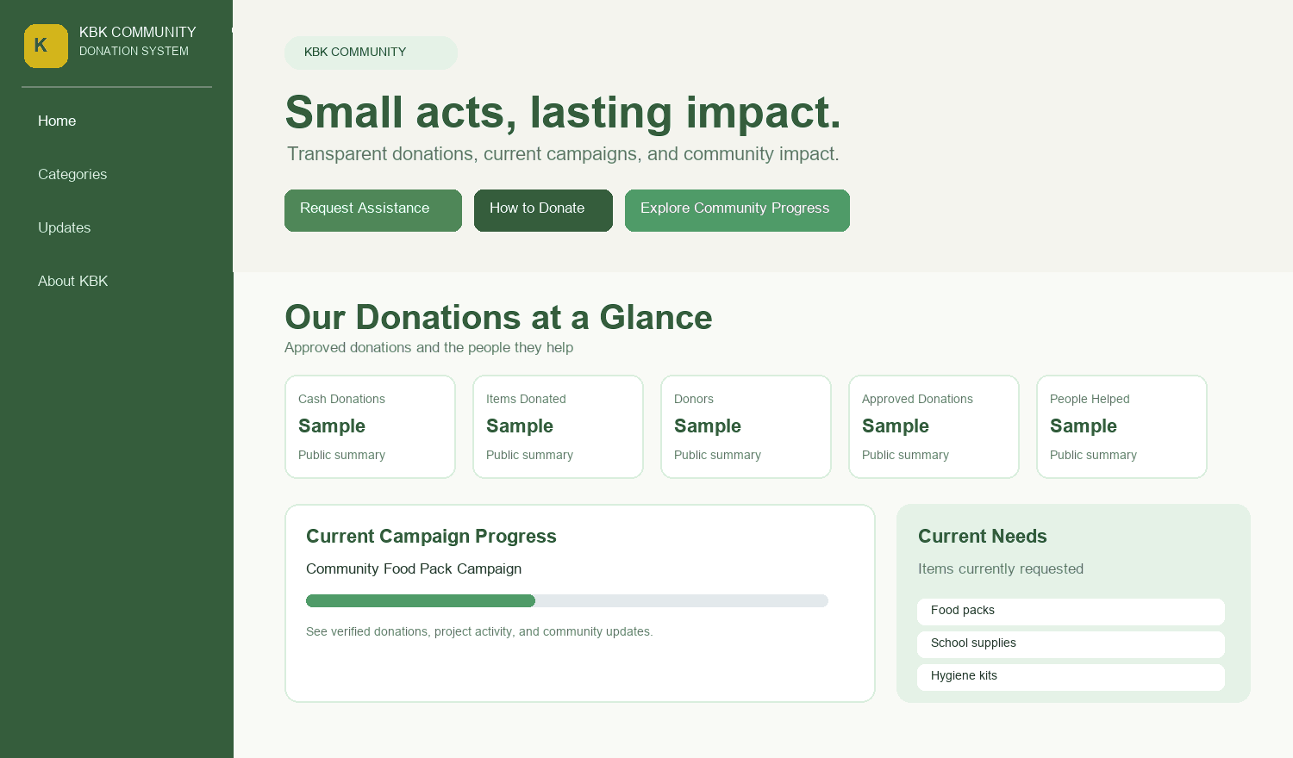
Illustrative screen preview. Example numbers and account details are placeholders.

Visual preview of administrator login
The login screen is for active administrators. Visitors can return to the public site from this page.
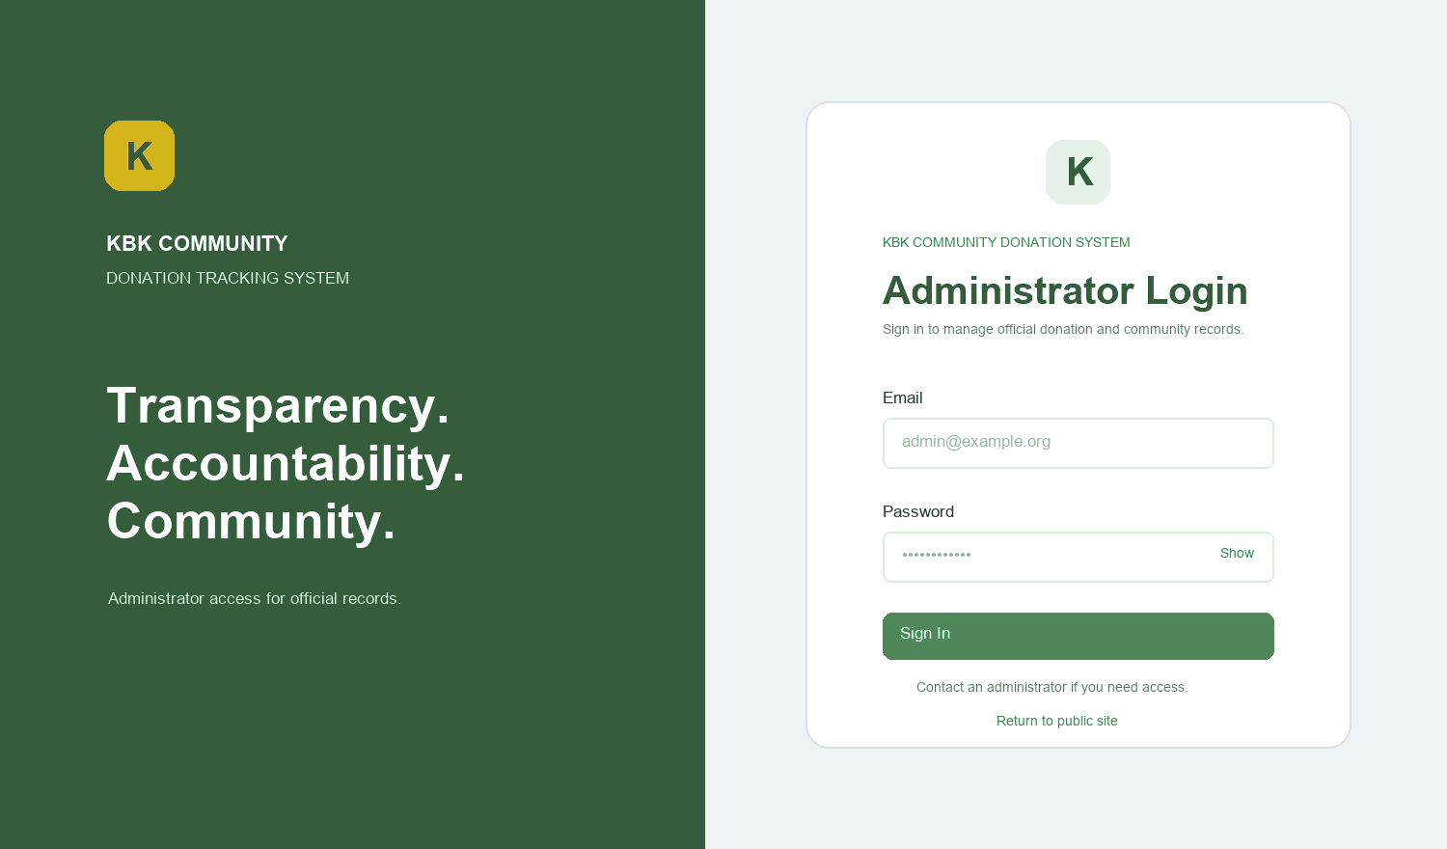
Illustrative screen preview. Example numbers and account details are placeholders.

Visual preview of the admin dashboard
The dashboard combines the navigation menu, summary cards, recent donations, activity, and shortcuts.
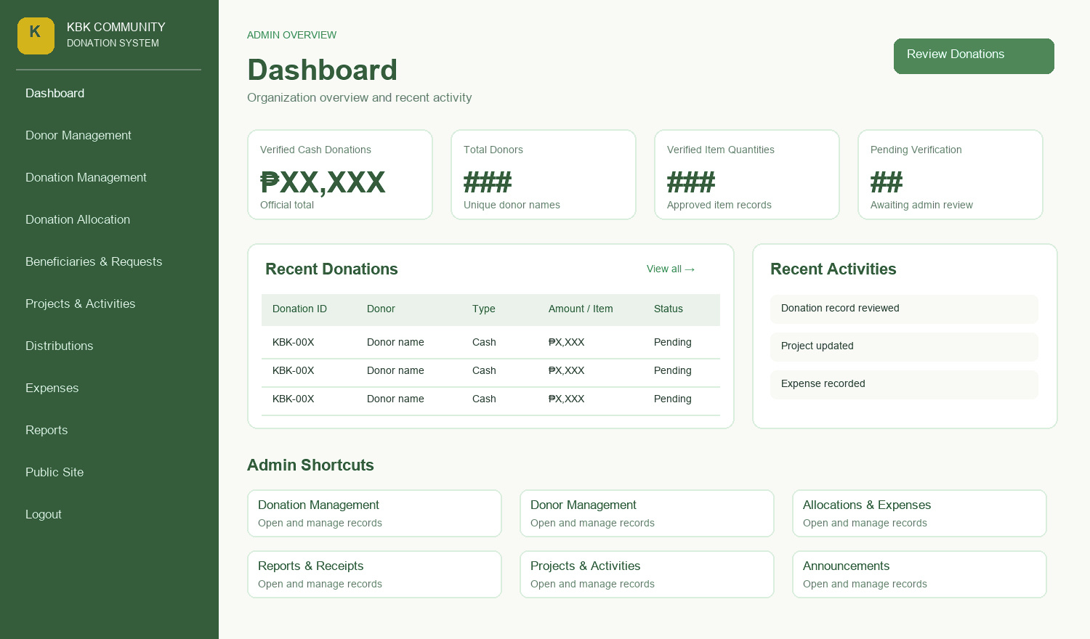
Illustrative screen preview. Example numbers and account details are placeholders.

