**Title: Application API endpoint doesn’t return ‘instance private IP’ field in EC2 metadata response for PRIVATE instance**

**Bug id:** #1

**Environment:** cloudxinfo

**Version:** 2

**Requirement id:** CXQA-EC2-04

**Steps to reproduce:**

1. Download pem certificate from Parameter Store
2. Update permissions to current user only
3. Login to public instance over ssh using downloaded certificate and “ec2-user” as a user. Use public IP to access.
4. In the opened console view execute ‘curl < private instance private IP address>’ command

**Expected result:** Response body contains 3 fields:   
availability_zone   
private_ipv4   
region

**Actual result:** Response body contains 2 fields:   
availability_zone   
region

**Attachments:** 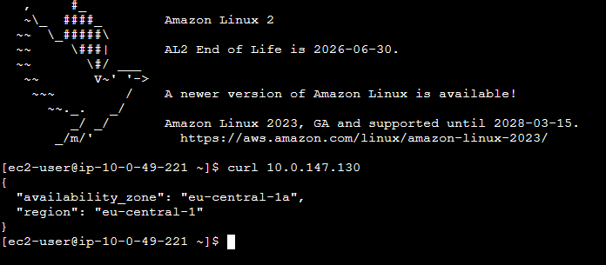

**Title: Application API endpoint doesn’t return ‘instance private IP’ field in EC2 metadata response for PUBLIC instance**

**Bug id:** #2

**Environment:** cloudxinfo

**Version:** 2

**Requirement id:** CXQA-EC2-04

**Steps to reproduce:**

1. Launch Postman
2. Connect to public API on port 80 and using public IP address of instance

**Expected result:** Response body contains 3 fields:   
availability_zone   
private_ipv4   
region

**Actual result:** Response body contains 2 fields:   
availability_zone   
region

**Attachments: 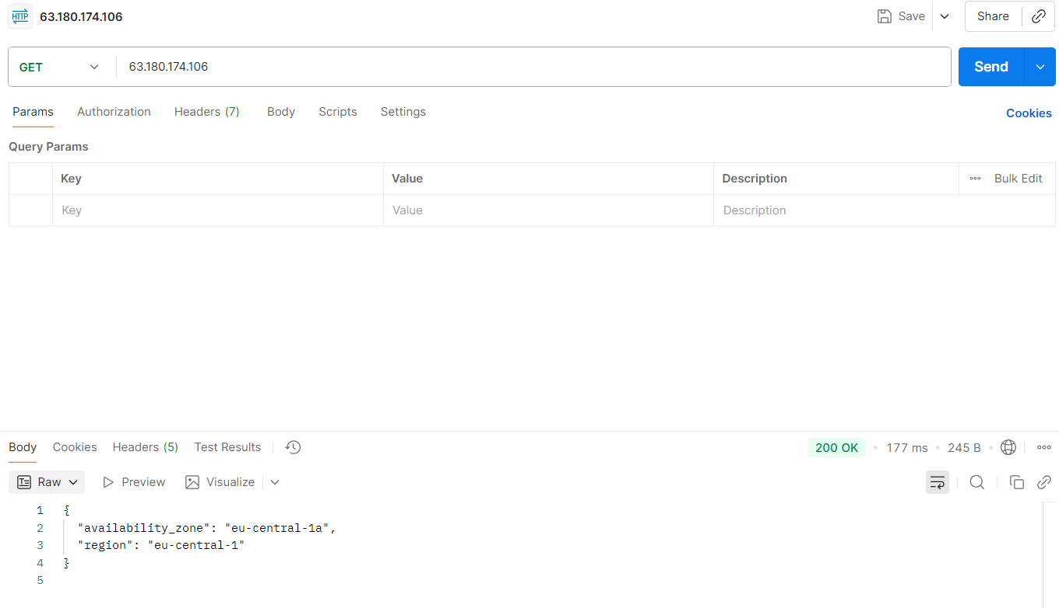Automated tests screenshot**

