**Title: FullAccessPolicyEC2 doesn’t allow all actions**

**Bug id:** #1

**Environment:** cloudxiam

**Version:** 2

**Requirement id:** CXQA-IAM-01

**Steps to reproduce:**

1. Sign in to IAM console with IAM user creds
2. IAM dashboard menu: Access management > Policies
3. Search ‘FullAccessPolicyEC2’
4. Click ‘FullAccessPolicyEC2’ “+” btn to expand the preview

**Expected result:** The policy allows to perform all actions on all resources

**Actual result:** The policy doesn’t allow ‘ec2:StartInstances’ action

**Attachments:** 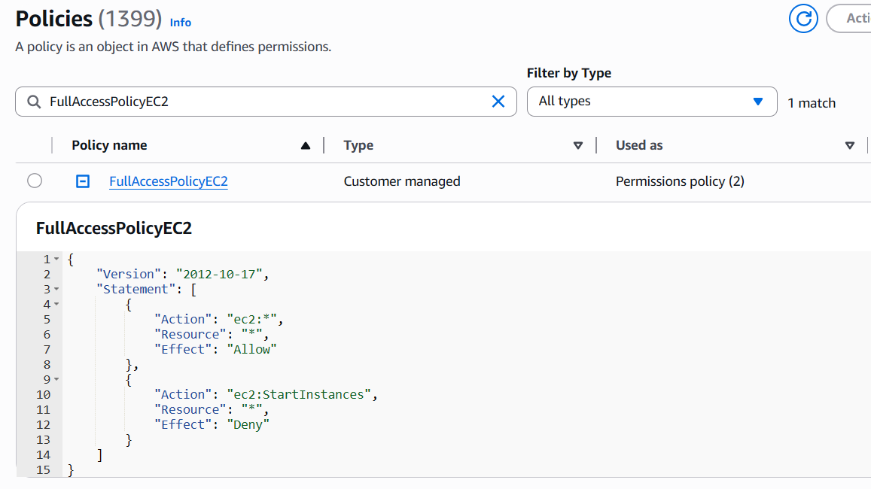

**Automated tests screenshot**

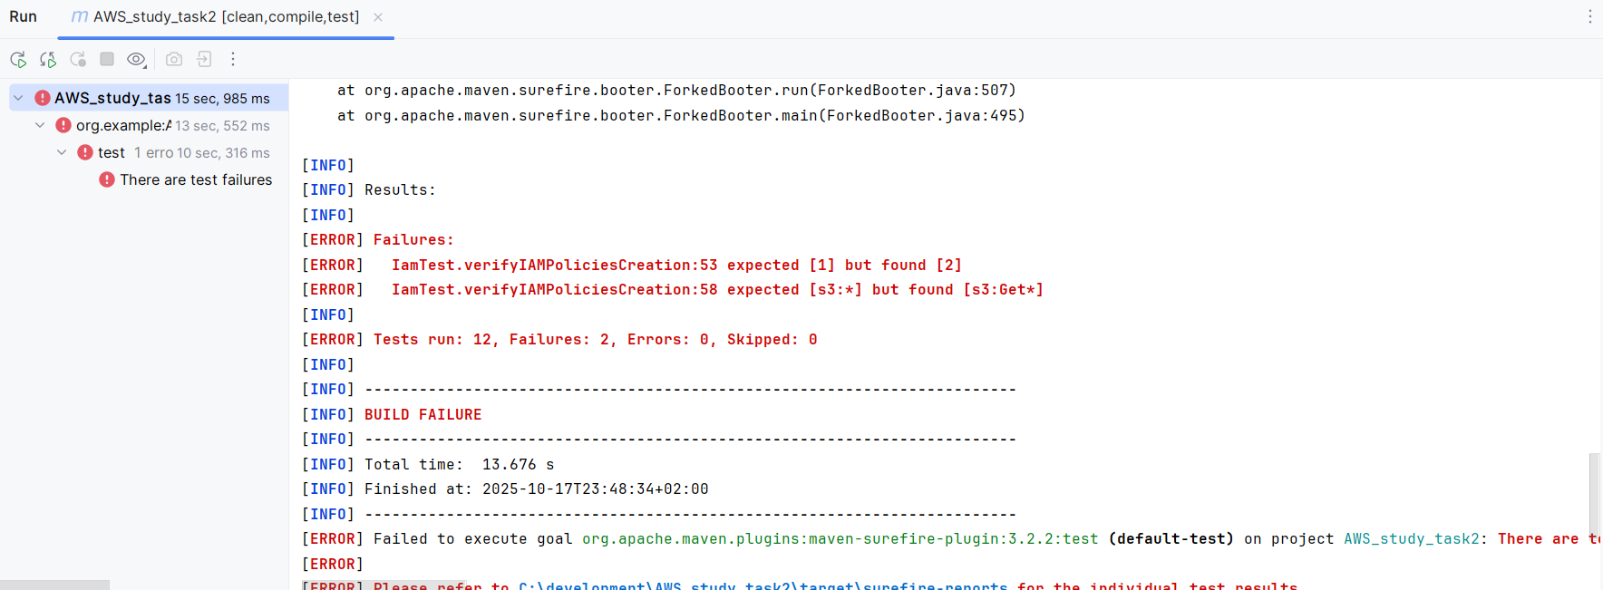

**Title: FullAccessPolicyS3 allows only ‘s3:Get’ actions**

**Bug id:** #2

**Environment**: cloudxiam

**Version:** 2

**Requirement id:** CXQA-IAM-01

**Steps to reproduce**:

1. Sign in to IAM console with IAM user creds
2. IAM dashboard menu: Access management > Policies
3. Search ‘FullAccessPolicyS3’
4. Click FullAccessPolicyS3 “+” btn to expand the preview

**Expected result:** The policy allows to perform all actions on all resources

**Actual result:** The policy allows only ‘s3:Get’ actions

**Attachments:**

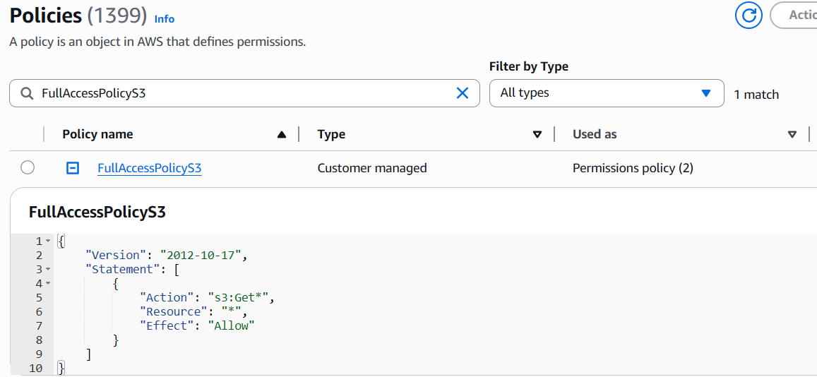

Automated tests screenshot

