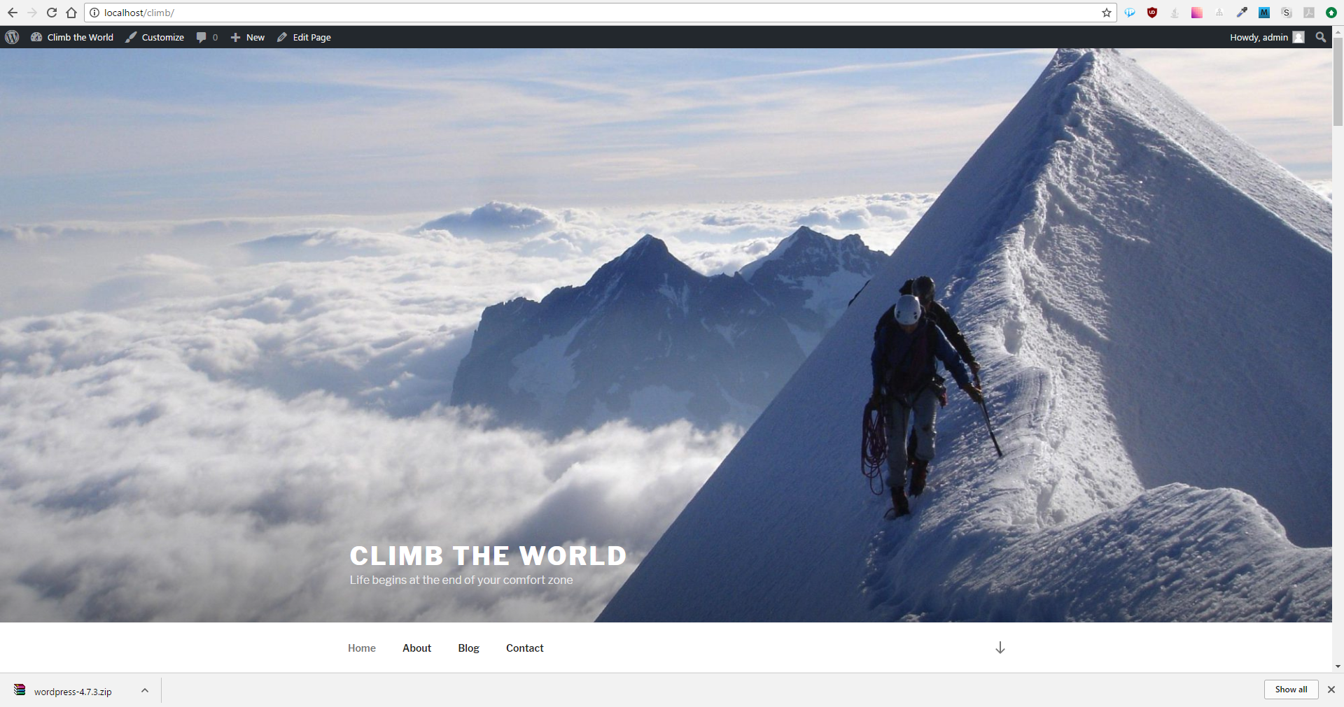

http://alps-4000.website.tk/wp/

alps-4000.cf

italy.alps-4000.cf