Билет 2

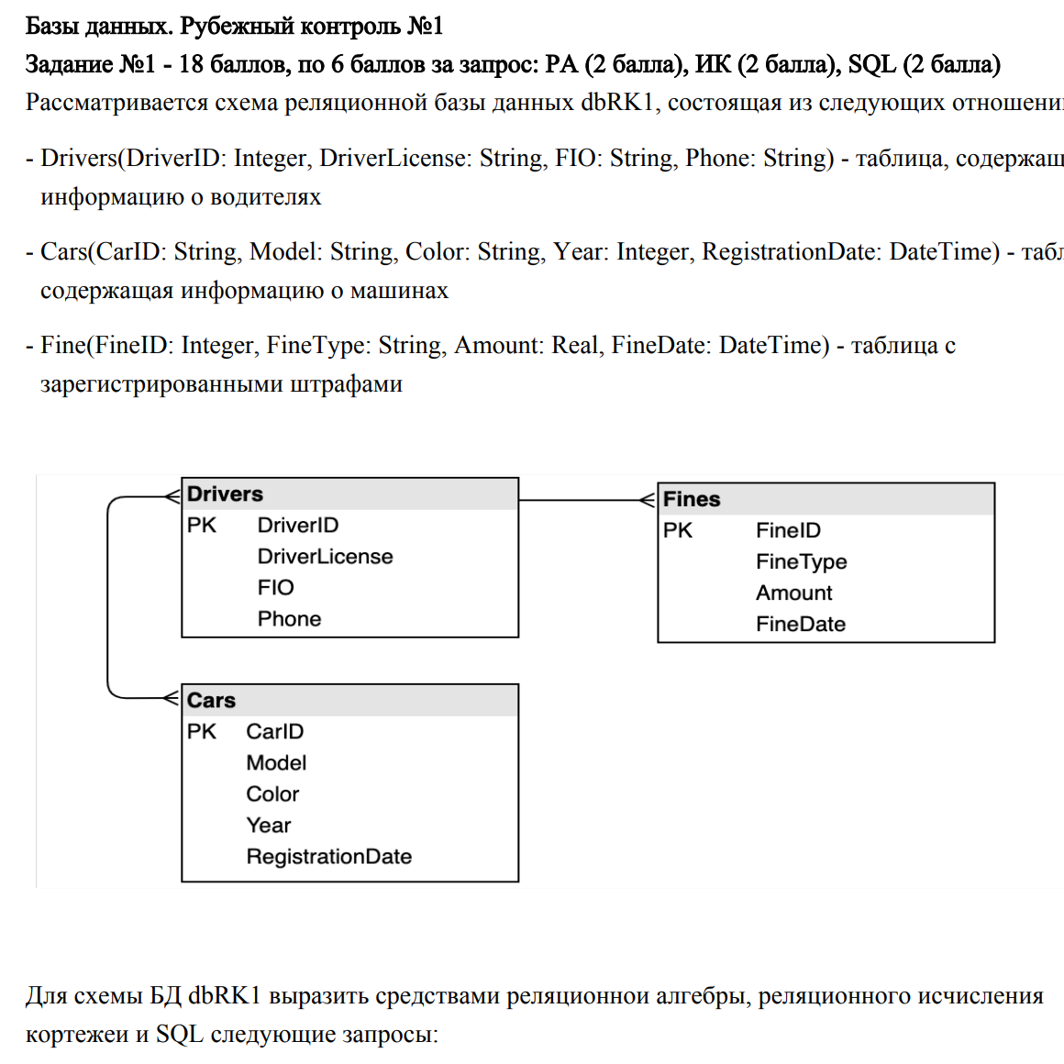

DC = (DriverID, CarID)  
FD = (DriverID(один), FineID (много))

1. **Найти все тройки вида <водительские права, цвет автомобиля, модель автомобиля>**

**SQL**

Select Drivers.DriverLicense, Cars.Color, Cars.Model

From Driver join DC on Driver.DriverID=DC.DriverID

Join Cars on DC.CarID=Cars.CarID

**РА**

((Drivers) join DC) join Cars)[DriverLicense, Color, Model]

**РИК**

Range of DX is Drivers

Range of CX is Cars

Range of DCX is DC

(DX.DriverLicense, CX.Color, CX.Model) where exists DCX(Driver.DriverId=DCX.DriverID and exists CX(DCX.CarID=CX.CarID))

1. **Найти все модели автомобилей, владельцем которых являются водители с номерами телефонов, заканчивающихся цифрой 5**

**SQL**

Select Cars.Model

From Driver join DC on Driver.DriverID=DC.DriverID

Join Cars on DC.CarID=Cars.CarID

Where Driver. Phone like '%5'

**РА**

((Drivers where Phone like '%5') join DC) join Cars)[Model]

**РИК**

Range of DX is Drivers where Phone like '%5'

Range of CX is Cars

Range of DCX is DC

CX.Model where exists DCX(CX.CarID=DCX.CarID and exists DX(DCX.DriverID=DX.DriverID))

1. **Найти водителей, получивших более 3х штрафов**

**SQL**

Select *

From Drivers

Where Drivers.DriverID in

(select DriverID

From DF

Group by DriverID

Having count(FineID) > 3)

**РА**

((Drivers join (Summarize FD per FD{DriverID} add Count(FineID) as FAmount)) where FAmount > 3)

**РИК**

Range of DX is Drivers

Range of FDX is FD

DX where count(FDX where FDX.DriverID=DX.DriverID) > 3