I solved 5 tasks on <https://py.checkio.org/> and here are screenshots that show the proper work of my tasks:

* Solve Sy Hi



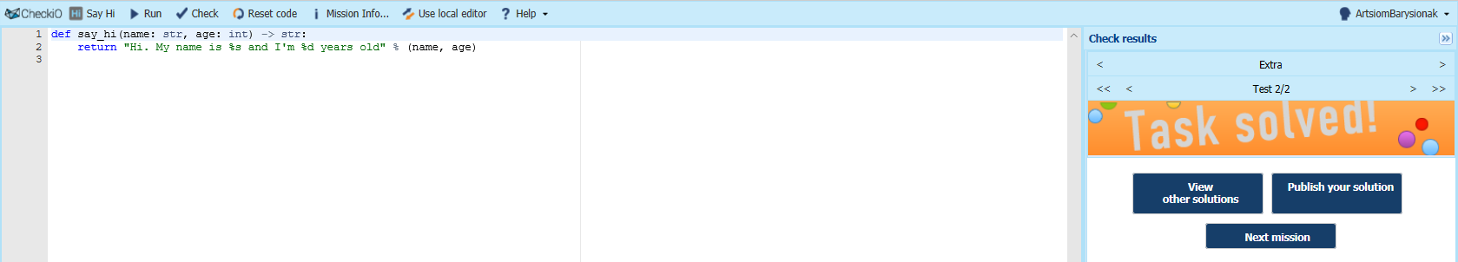

* Correct Sentence

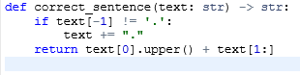

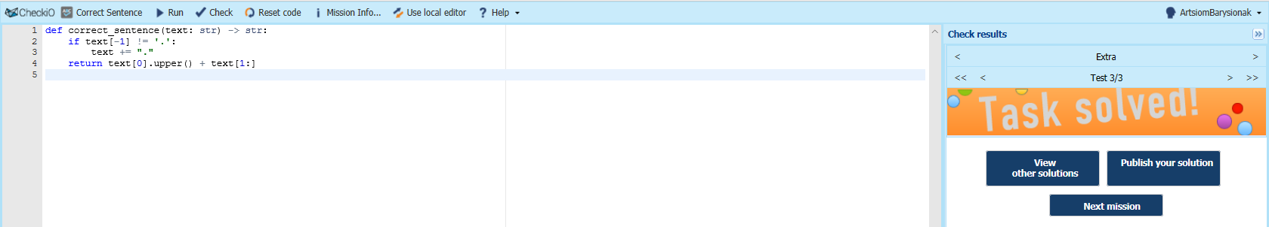

* First Word



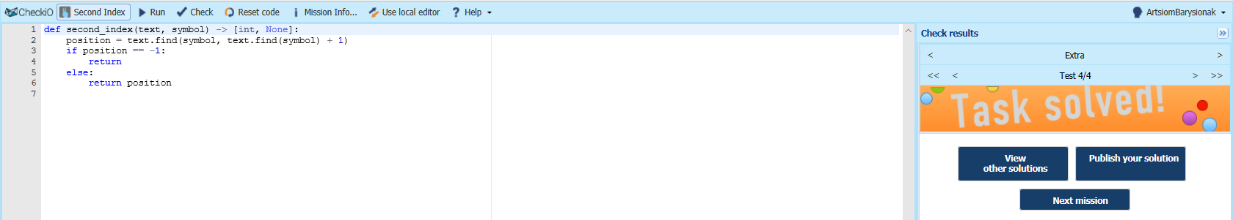

* Second Index

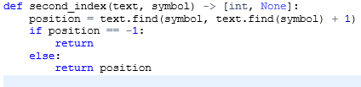

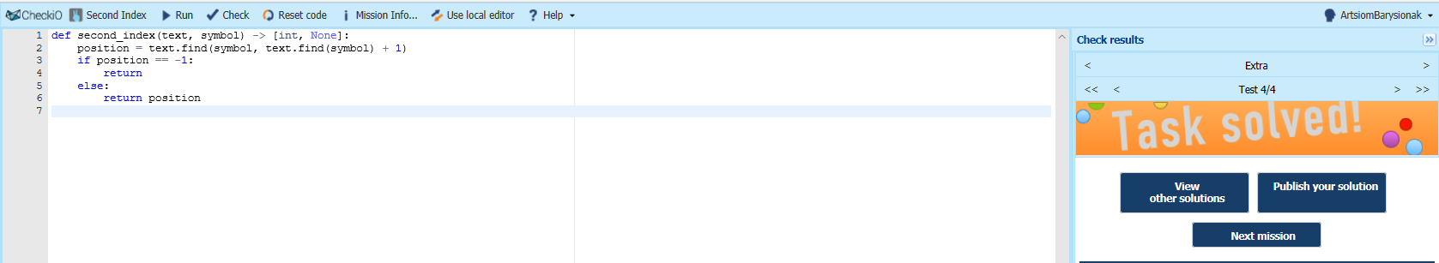

* Between Markers

