Retail Sales Performance Analysis and Revenue Prediction
IBM SkillsBuild Data Analytics with AI Academic Internship
Prepared by: Alen Aby

1. Introduction
This project analyzes retail transaction data using Python. It applies data validation, exploratory data analysis, visualization and machine-learning techniques to investigate revenue patterns and evaluate daily revenue prediction.

2. Project Objectives
- Inspect and validate the retail sales dataset.
- Prepare data for reliable analysis.
- Analyze revenue trends and customer purchasing patterns.
- Visualize revenue by month, category and gender.
- Compare regression models using a chronological test split.
- Communicate findings and limitations.

3. Tools and Technologies
Python, Pandas, NumPy, Matplotlib, Seaborn, Scikit-learn, Jupyter Notebook and Visual Studio Code.

4. Dataset Description
The dataset contains 1,000 rows and 9 columns. The available fields include transaction ID, date, customer ID, gender, age, product category, quantity, price per unit and total amount.
Revenue was analyzed using the Total Amount field. The transaction amount was also checked against quantity multiplied by price per unit.

5. Data Cleaning and Validation
Exact duplicate rows in the original dataset: 0.
Data types, missing values, category consistency, date validity and revenue calculations were examined before analysis. Any assumptions or limitations identified during these checks should be considered when interpreting the findings.

6. Exploratory Data Analysis
Figure 1. Monthly Revenue Trend
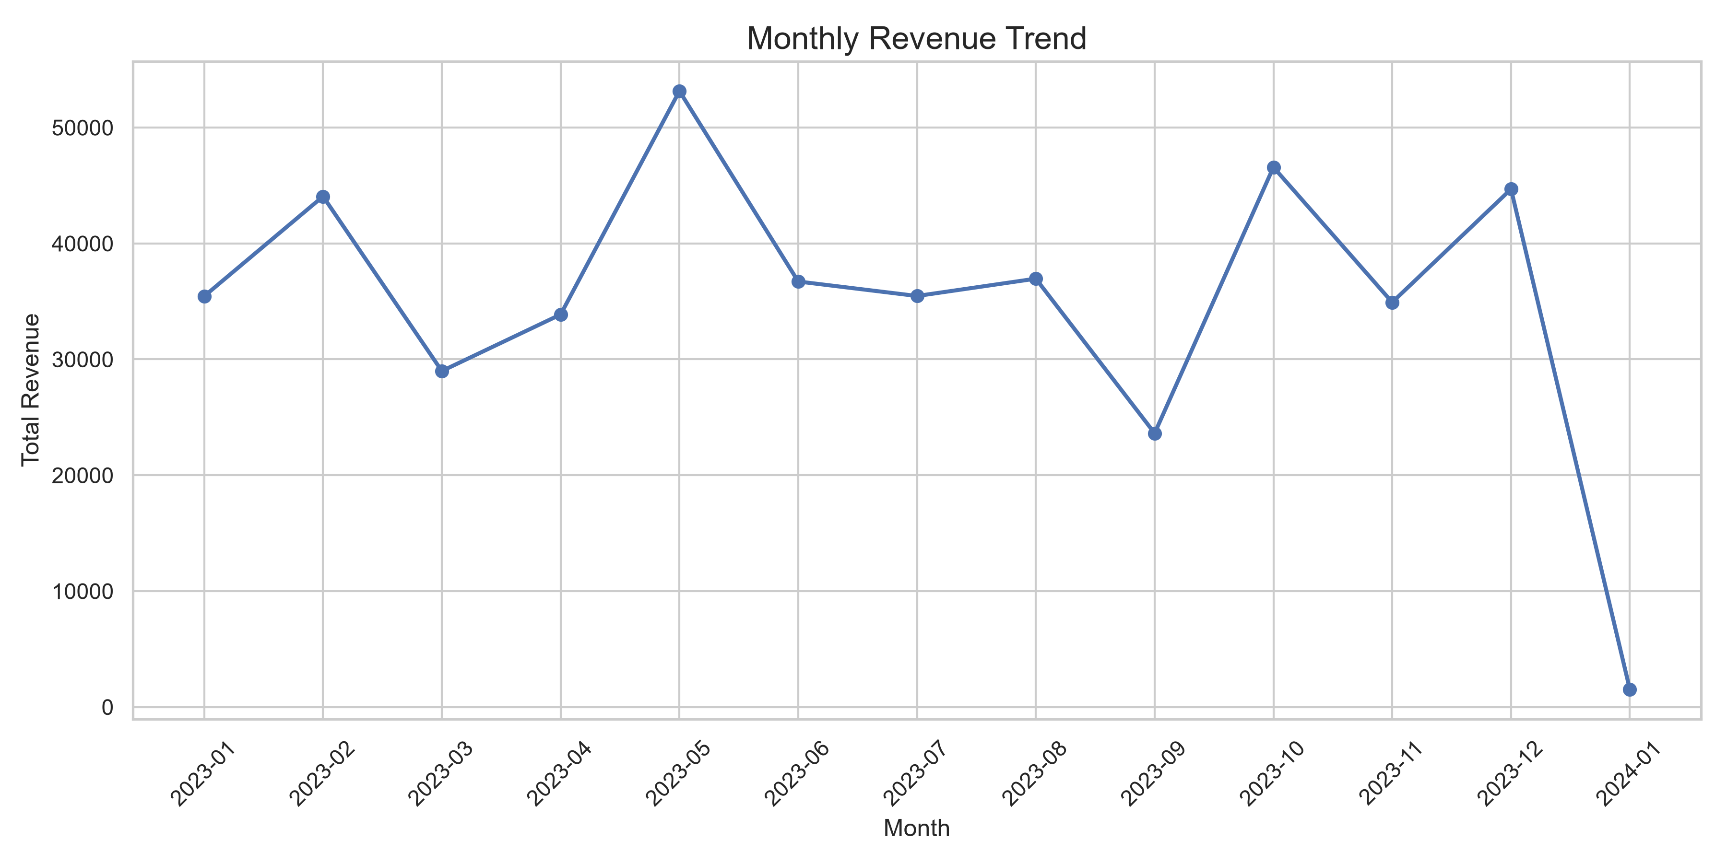
Figure 2. Revenue by Product Category
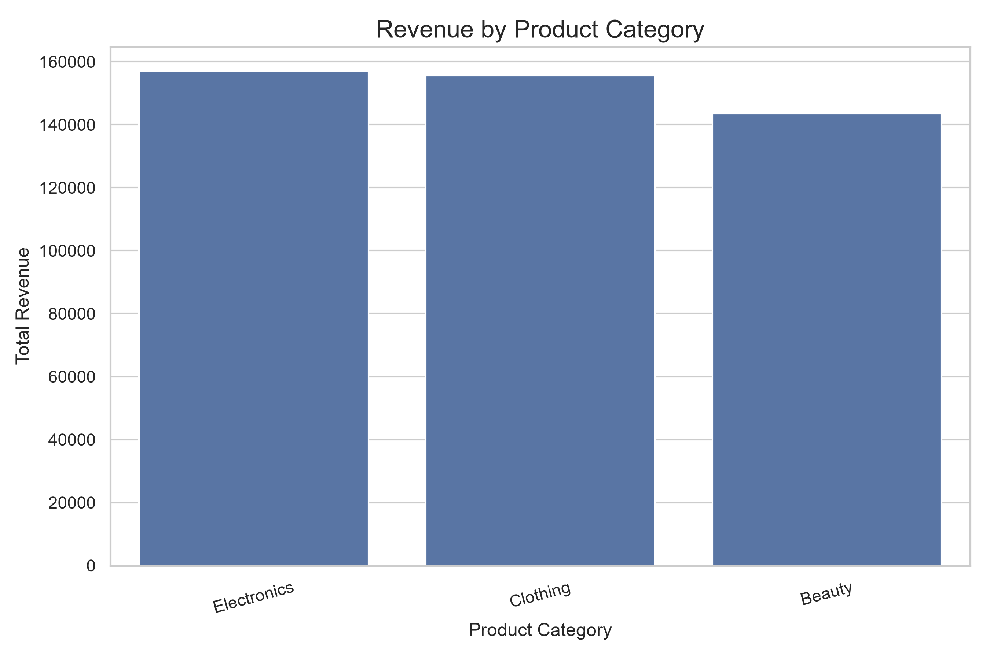
Figure 3. Revenue by Customer Gender
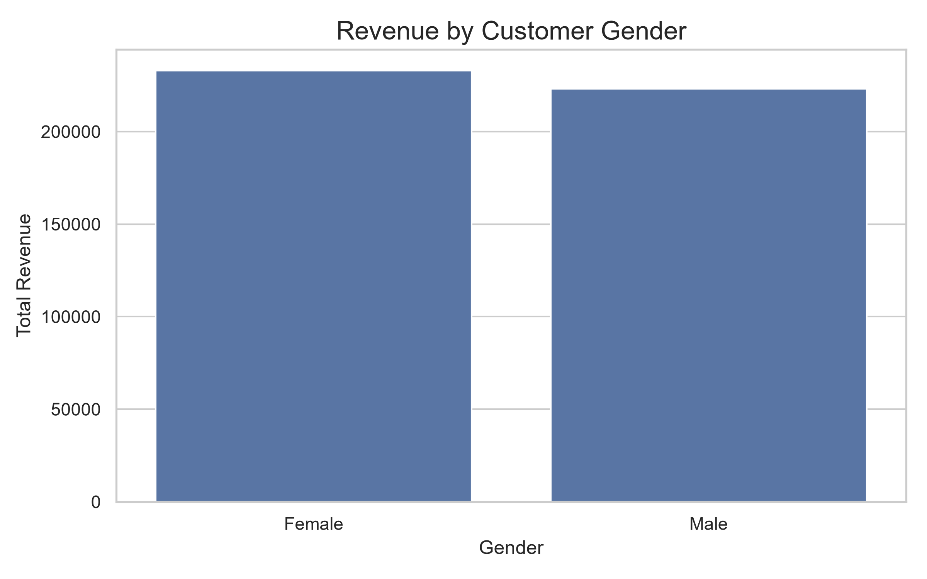
Figure 4. Customer Age Distribution
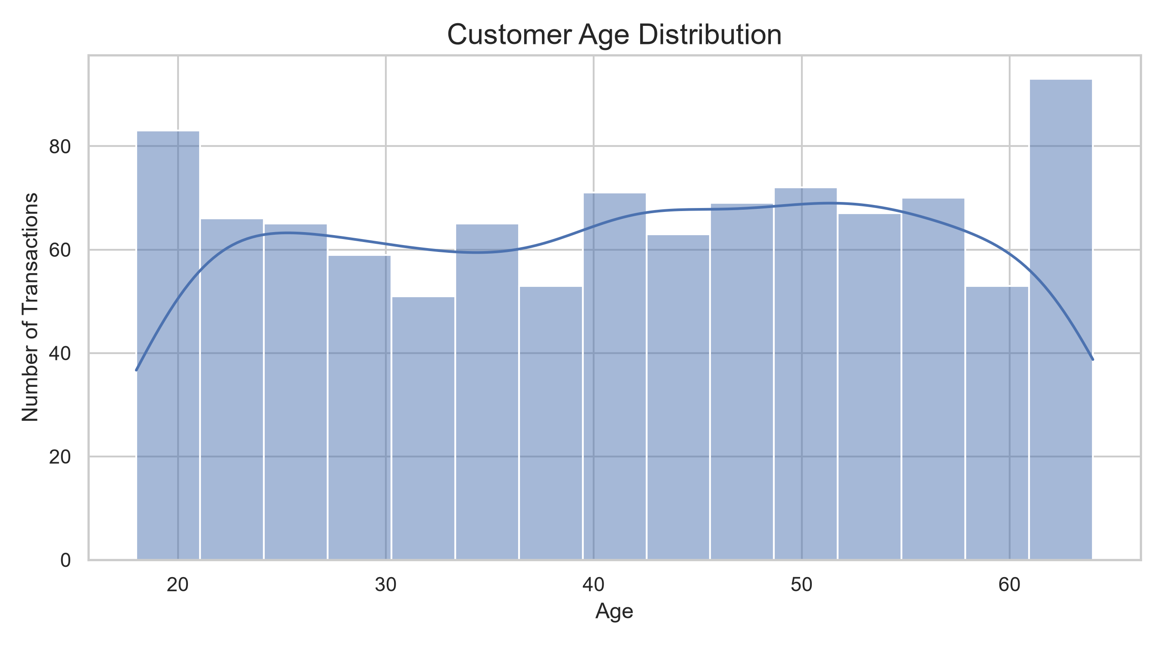
Figure 5. Actual vs Predicted Daily Revenue
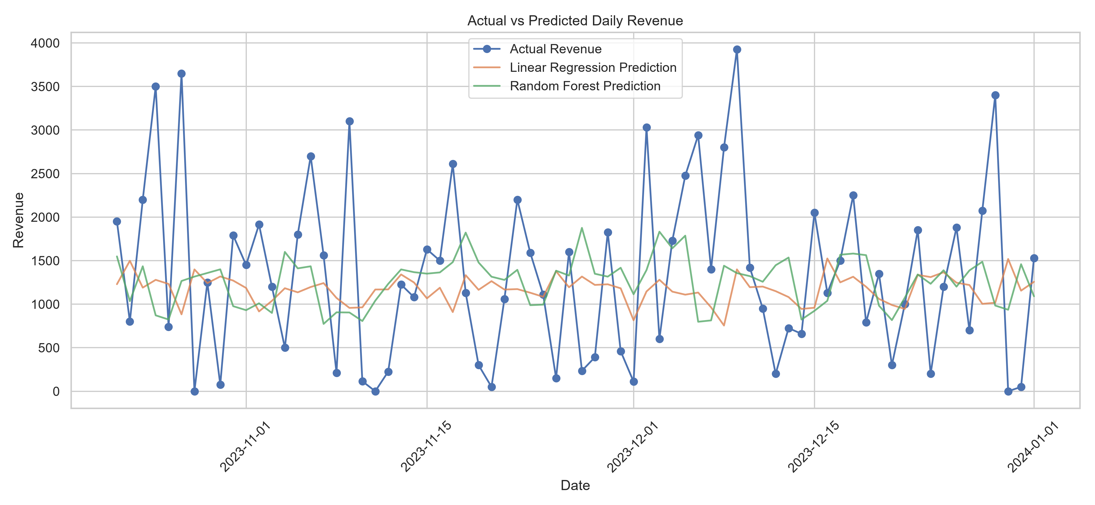

7. Revenue Prediction Methodology
Daily revenue was calculated by aggregating transaction amounts by date. Calendar variables and lagged revenue features were prepared. The data was split chronologically into training and testing periods to avoid randomly mixing future observations into the training set.
A mean-prediction baseline, Linear Regression and Random Forest Regressor were compared. Model performance was evaluated using Mean Absolute Error (MAE), Root Mean Squared Error (RMSE) and R-squared.

8. Model Evaluation Results
Model | MAE | RMSE | R2
Baseline | 802.3217 | 1002.1210 | -0.0170
Random Forest | 832.1450 | 1042.7365 | -0.1011
Linear Regression | 844.1500 | 1055.4346 | -0.1281
The best-performing model should be selected based on its test-set performance relative to the baseline. Lower MAE and RMSE indicate smaller prediction errors; R-squared should be interpreted alongside these metrics.

9. Business Insights and Recommendations
The highest-revenue category in the analyzed data was Electronics, with revenue of 156,905.00.
The highest-revenue month in the analysis was 2023-05, with revenue of 53,150.00.
Businesses can use these results to investigate category performance, review sales trends and support planning. Recommendations should be based on the actual charts and model results.

10. Limitations
The dataset contains a limited historical period and transaction records rather than a verified complete daily sales series. Dates without transactions may not necessarily represent zero sales. The forecasting results are exploratory and should not be treated as reliable future forecasts without further validation on additional historical data.

11. Conclusion
This project demonstrates a complete introductory analytics workflow, from data validation and visualization to machine-learning evaluation. The findings and model metrics provide a basis for understanding retail revenue patterns while highlighting the importance of data quality and appropriate model validation.

