# Preface

In the 21st century, people are used to travel as never before. Thanks to globalization, ability to speak foreign languages, especially English, it is easy to visit places that our older generation could just dream about. The trend living like local is becoming more and more desirable and platforms for shared accommodation seem to be a way, how to achieve this desire. It is not all about shared accommodation but about shared economy in general. People want to share cars, bikes, tools and so one.

This thesis is focused primarily on shared accommodation, the research itself is focused just on AirBnB.

The first part of the thesis describes tourism prerequisites, localization, selective and realization assumptions. The next part of the paper is focused on the basic concept of a shared economy, advantages and disadvantages. The thesis contains a description of key players of shared economy in the Czech Republic such as Uber, SharyGo and Rekola. Big part of the theoretical part is dedicated to shared accommodation, especially AirBnB, Homeaway and Couchsurfing. The two biggest providers of shared accommodation, AirBnB and Homeaway are compared and the last part is focused on the regulation of AirBnB and future of AirBnB in Prague as a case study for future use.

The thesis continues with practical part firstly providing information about the area of research, Madeira, and all the assumptions mentioned in the paragraph above. Next, the paper continues with the research. The research itself was divided into a few sections. The first section was based on online questionings and the second on individual interviews. Online questionnaire survey was split up into two parts, the first part was focused on providers of shared accommodation on the island of Madeira, and the second part was focused on visitors from all over the world, who use shared accommodation. The base of individual interviews was similar to the questionnaire for visitors, but it was directed more in-depth.

# Literature review

The literature review offers the basic understanding about tourism itself followed by information about shared economy, bigger focus is then on shared accommodation. The literature review also targets on the regulation of AirBnB in the world and the situation with AirBnB in the capital of the Czech Republic, Prague.

## Tourism

The idea of travelling is known for thousands of years. People were travelling no matter war, hunger, suitable routes. For some nations, travelling has become a way of life, they were traveling because of climate change, food, water. One of the first famous travellers is Marco Polo, but the beginnings of modern tourism are dated from the 18th century when Thomas Cook started to organize tours for people. (Beránek, 2013) Tourism is one of the world's most important economic sectors, that create opportunities often without big investment and adds values in many ways. Tourism is a cross-sectional sector, that means that tourism has an effect on many other sectors, for example, transportation, agricultural, construction, translator services, hospitality. (Ryglová, Burian & Vajčnerová, 2011)

Tourism has many definitions. The basic understanding of tourism is the short-term movement of people to other places than their homes to spend their time with enjoyable activity. The definition sounds simple, but does not include all the aspect of tourism, for example travelling for work is not considered as tourism. It is also not easy to determine how far has the person travel or how much time people spend in the destination. (Horner & Swarbrooke, 2003) UNWTO defines tourism as following *„Tourism comprises the activities of persons travelling to and staying in places outside their usual environment for not more than one consecutive year for leisure, business and other purposes.”* Second, more extensive definition of UNWTO says *“Tourism is a social, cultural and economic phenomenon which entails the movement of people to countries or places outside their usual environment for personal or business/professional purposes. These people are called visitors (which may be either tourists or excursionists; residents or non-residents) and tourism has to do with their activities, some of which imply tourism expenditure”* (UNWTO, 2019)

## Tourism prerequisites

In tourism, there are prerequisites that affect the existence and development of tourism. Assumptions are localization, selective and realization.

### Localization assumptions

Localization assumptions decide about function of tourism in a specific area, from a natural and cultural point. They are limited and have a positive or negative influence for next development. These assumptions include the place where tourism can be developed, and it depends on geography and historical evolution of the area.

Natural conditions are relatively stable, cannot be changed. Climate is one of the main conditions of tourism realization (temperature, sunshine, humidity) and dependent on geography.

* Geography
* Climate
* Fauna and Flora
* Hydrological conditions

Cultural conditions are attractivities that has been made by people

* Cultural and historical monument
* Cultural facilities and events (museums, theatres, galleries)
* Sports facilities and events (stadiums, aqua-parks, Olympic games) (Hamarnehová, 2012)

### Selective assumptions

Selective assumptions could be marked as stimulating, they stimulate the development of tourism based on demand. These assumptions express the competence of the area to participate in tourism, passively or actively and are divided into objective and subjective.

* Objective - Factors that influence tourism in the area
* Subjective - Factors that influence tourist decision about participation in tourism

Table 1 Selective assumptions

|  |  |
| --- | --- |
| Objective | Subjective |
| Policy | Social and professional group |
| Economy | Language barrier |
| Demography | Influence of advertising of tourism agencies |
| Environment |  |

Source (Hladká, 1997)

Between fundamental political factors belong peaceful disposition of the world, without war conflicts, internal political situation and the character of the political system. The key factors from the economic point of view are standard of living and fund of free time. The standard of living is based on the stage of development of the productive forces, that are shown in healthcare, living, education, nourishment, culture, working conditions, the length of working time, salary etc. Demographic characteristics are mainly employment, education and age structure of the population. (Hamarnehová, 2012)

### Realization assumptions

Realization assumptions ensure the realization of tourism in specific areas and create conditions for the use of localization assumptions. They can be divided into accommodation services and infrastructure. Between accommodation services but also belong to catering, exchange offices and insurance services.

Conditions that enable tourist requirements in tourism.

* Transportation and infrastructure
* Accommodation (Hladká, 1997)

## Sharing economy

Sharing economy, also known as peer-to-peer based sharing, is a concept that emphasizes ability and preferences of people who prefer to rent or borrow something instead of owning things. This type of sharing became a trend at the turn of the 21st century.

People have always exchanged goods or services but nowadays thanks to technologies and free information, there is a new market model. There are three forces that started this model – modern trust, technologies and economic pressure. (Siuskaite, Pilinkiene, & Zvirdauskas, 2019) Modern trust - the concept of sharing economy depends on something that previously seemed foolish or unthinkable, trust. People rely on other people cars (e.g. Uber), welcome strangers into their homes (e.g. AirBnB, Homeaway) or lend their belongings to the strangers. (Stemler, 2016) For someone, it might seem inconceivable to let strangers stay in your place or to accommodate yourself by strangers, but surprisingly, it works very well.

Technology – technology is necessary for the development of the sharing economy in three ways – free information, lower transactions costs and it regulates behaviour. In the 21st century, many people have access to the internet (2018, 55 % of the population), (Statista, 2019) and it is incredibly easy to contact someone when you have free bedroom or spot in a car. Thanks to high-speed internet and lower costs of smartphones (the average price of smartphones is 250 €, (GfK Czech Republic)).

Economic pressure - economic pressure greatly participated in the formation of the sharing economy. Many of the sharing economy companies were founded between 2008 and 2010, in the aftermath of the global financial crisis. In this time, people were looking for different ways to save money and for ways how to make money. *“With fewer full-time jobs, Americans were forced to take temporary work, and the sharing economy provided many sources of temporary work.“* (Stemler, 2016)

## Where can we find sharing economy?

Sharing economy surrounds all of us and sometimes we do not even know about that. Most known is probably apartment renting or car sharing, but sharing economy appears in more and more fields today. We can find the elements of the sharing economy in knowledge and talent-sharing, peer-to-peer lending, reselling and trading, co-working or even healthcare. (Sundararajan, 2016) The basic concept of peer to peer sharing shows the picture number 1 bellow.

Picture The concept of peer-to-peer sharing

#### 

Source: (Business Model Toolbox, 2019)/

#### Advantages

Cheaper goods and services – it is very usual that people need a specific thing only one time per year or even one time per decade, for example a tool for renovation. In that case, it is not very practical to own that thing and it is more reasonable to borrow it, pay a much smaller amount of money and save the rest of the money instead of buying a brand new thing. Extra income for providers – this is the opposite example from the text above. When people do not need something all year round, they can simply offer it and gain some extra income. New and better opportunities – people often want/need to own something, but they are not sure about that. In that case, they can easily borrow it, try it and then decide whether or not want to buy it. Stronger communities – the sharing economy has built up a strong community because the most important aspect of the sharing economy is building a trust amongst community members. Many sharing companies provide ratings that can help other people to decide and to help keep all participants honest.

#### Disadvantages

Privacy/Safety concerns – safety might be a big concern for a lot of people, especially in accommodating field. It might be scary for someone to accept a stranger into their home. No or few guarantees - as was already mentioned, the sharing economy depends on trust. Because of that, there will be always risk that people will not get paid or the borrowed item will be destroyed or never returned. Market Distortions - this disadvantage is focused especially on accommodating because, in cities, where there are many places to find accommodation throw sharing economy, the prices of rents and houses is growing fast. (Martucci, 2018)

### Uber

Uber is a location-based app launched in San Francisco, California, that allows people to hire a driver when they need. The service is presented as a convenient, inexpensive and safe taxi service. Uber currently operates in more than 675 cities in 77 countries and is valued at roughly $70 billion. User, who has an app on his/her smartphone can easily hire a driver to pick him up and take him to the destination with the tap of a button. A driver who is nearby will pick him up in a minute. As a user, a person will see drivers nearby and can choose who he/she would like to drive with. As an uber driver, a person needs to have own car, own car insurance, no criminal history and drivers’ licence for at least a year. Uber offers drivers to set their own hours, so they can work as much as they want to. The car needs to meet Uber's requirements about the type, size, year and sometimes about drivers look too. (UberEstimate.com, 2018)

Uber offers these groups so far

* UberX – most popular, referred as a low-cost option, the year 2006 or newer, must have at least 4 doors, working A/C and Heat.
* UberBLACK – very first car service, luxury version of UberX, the year 2010 or newer, black colour, must have black leather interior.
* UberSELECT – similar to UberBLACK, but the car does not have to be black, the year 2007 or newer, leather interior, working A/C.
* UberXL – inexpensive car service, the year 2006 or newer, space to fit at least 6 riders.
* UberSUV – similar to UberXL but with higher comfort for passengers, the year 2010 or newer, exterior must be black, leather interior.
* UberLUX – most luxurious, the year 2012 or newer, 4+ doors, leather interior (UberEstimate.com, 2018).

Currently, Uber is facing an issue about price discrimination due to surge pricing. Customers are being charged differently, based on the demand in the location. The cost of the trip in the certain areas can be even triple than normal price of the trip. This causing a loss for drivers outside the specific areas. Price discrimination is normally prohibited by the Robinson-Patman Price Discrimination Act of 1936.

This act says that product cannot be given a price advantage for customers, but the loophole of Uber is, that Uber is no a product, Uber is a technology platform. Because of that, Uber is not affected by the Act from 1936. (Griffith, 2019)

### Liftago

Liftago is a Czech start-up that provided taxi services. The communication with drivers is through mobile app and works on a similar principle as Uber. The main difference is that Liftago offers services only with certified taxi drivers. As a user, a person can choose a driver based on his/her portfolio, that includes his/her picture, type of car, arrival time or price. (Liftago, 2017)

### Blabla Car

Blabla car is sharing company, founded during Christmas in France in 2006. The idea came from Frédéric Mazzella, in that time Stanford student. The story says that Frédéric wanted to go visit a family in the countryside of France, there were no train tickets and in that time he realized how many people drive alone in their car. Together with two friends, they have built a world’s leading carpooling platform that connects people who are going the same way. Nowadays, Blabla car operates in 22 countries and has over 80 million members. (BlaBlaCar, c2019)

The difference between Uber, Liftago and Blabla car is that Blabla car is not profitable for the driver. He/She is paid the amount that covers fare costs such as fuel. Because of that, Blabla car is not a part of difficulties with taxi drivers such as the strike in spring 2019. Even the founders say that they do not want drivers to have a profit, because if they do, the driver would need a licence and Blabla car could face a regulation issues. (De pommereau, 2014)

### SharyGo

SharyGo is another Czech star-up, founded in 2015, that is focused on sharing economy. Unlike other companies, this start-up is not focused on only one product (car, bike, etc.). SharyGo offers a huge number of products that people use in daily life. It could be bikes and cars, but also electronics, tools, furniture, constructions, things for gardening, travelling and camping or even clothes. SharyGo is one of the quickest growing companies on the Czech market. (SharyGo, 2018) All goods have to be described and valued before someone can rent them. Customer chooses the product, dates and then send the tentative order. The owner has 24 hours to respond but it usually takes only a few minutes. The next step is payment and after receiving the right amount, the goods are ready for handover that is usually realized the same day. (Divinová, 2017)

### Rekola

The company was founded in 2013 with thought, that every city deserves own system of bike-sharing, without millions on accounts. They share the idea that bike is useful and entertaining transport in cities. In the beginning, bikes were old, from people who have had forgotten bikes in the basement. Group of volunteers has spent hours with servicing and painting bikes. (Bikes are pink – less stealing and they are more visible) Nowadays, bikes are available in bigger cities in the Czech Republic, such as Prague, Brno, České Budějovice etc. In 2016, Rekola had 95 000 borrowings. (Rekola Bikesharing s.r.o., n.d.) Bikes borrowing is very simple. All a person needs is an app on the phone, there he/she will see a map where all the bikes are with their current location. After finding the bike, it is necessary to put the code that is written on the bike into the app and then a person will get the code for unlocking the bike. After riding, it is necessary to lock the bike and take a picture of it. The location is then saved, and the bike is ready for the next user. The money will be deducted from the rider account according to the time spent on the bike.

## Shared accommodation

The principle of shared accommodation is known for many years, when people share their living with people that are not family members. The reason for this type of living is growing rents and basically unaffordability to rent for example whole apartment. The majority of people who live like this are single, mostly young people, for example students. (Heath, Davies, Edwards, & Scicluna, 2017) However, shared accommodation on which this thesis focused, has different principle.

While the principle from a paragraph above is long-term, modern shared accommodation is mostly short-term, for holiday rent, business trip etc. Shared economy in general experienced rapid growth in the past five years and expressly shared accommodation is growing due to demand preferences changes. Travelers prefer to organize their own program, they are not seeking for support of travel companies and they like the benefit of the apartment, feeling like being at home. (Surugiu, Surugiu, & Mazilescu, 2019) The following part of the thesis describes the most known companies. Some of them are international, some of them operate just in the Czech Republic.

### AirBnB

AirBnB is probably the most famous portal for sharing accommodation. The company was founded in 2008 by schoolmates, Brian Chesky, Joe Gebbia and Nathan Blecharczyk. The company is headquartered in San Francisco, California and currently has about 3100 employees. *“Airbnb’s mission is to create a world where people can belong through healthy travel that is local, authentic, diverse, inclusive and sustainable.”* AirBnB offers more than 5 million places to stay, operates in more than 81000 cities in 191 countries in the whole world. The access to the service is via the website and mobile app. (Airbnb, 2018)

Largest Airbnb cities outside of the US are Paris (47 000 places), London (31 000), Rome, Rio de Janeiro, Barcelona, all about 19 000 places, Copenhagen (15 000), Milan (14 000), Sydney and Amsterdam (13 000). The most money makes hosts in London, Dubai, Zermatt, Cannes, Venice and Sydney and the cheapest accommodation can offer Salvador, Havana, Sarajevo, Bucharest, Sochi and Sofia. The highest AirBnB demand is in Tokyo, Melbourne, Osaka, Vancouver, Lisbon, Berlin and Amsterdam. (Shatford, c2015-2018) Booking home on AirBnB is very simple. Guests can search for a place using filters such as size, location, price and dates. Before booking, personal and payment information is necessary to provide to the host and after that, a person just has to wait for the message of acceptance. Hosts choose which dates they would like to accommodate someone and then it is time to wait for guests.

While some people really love the idea of AirBnB, AirBnB is becoming a quite controversial topic to discuss. For tourist, the idea of cheaper accommodation might sounds phenomenal, but for people who live in the cities such as Amsterdam, Berlin or others often visited, AirBnB is becoming a bit a nightmare. The prices of apartments are growing rapidly fast, AirBnB owners sometimes do not pay taxes, especially young tourist on holiday might be loud, so having an apartment next to the AirBnB place might not be very pleasant. (Heckman, 2017)

#### AirBnB advantages vs disadvantages for users

Table 2 Advantages and disadvantages of shared accommodation

|  |  |
| --- | --- |
| Advantages | Disadvantages |
| Sometimes cheaper accommodation | Trustworthiness |
| Mostly more space than in hotel | Security |
| Local neighborhood | Communication with host |
| The feel being at home |  |

Source Author

### Couchsurfing

Couchsurfing was founded in 2004 by a small group of people who love travelling, exploring and meeting new people on their journeys around the world. They wanted to change the world by providing opportunities to cultural exchange, meeting locals and not spending an enormous amount of money on accommodation. The platform has grown rapidly and in January 2018 there were 15 000 000 members (including hosts and visitors). Couchsurfing is accessible via website and mobile app as well. The main point of this platform is a gift economy. People offer their couch to the travelers and they are not allowed to charge anything for lodging. That makes travelling accessible to a lot of people. Couchsurfing does not offer only lodging but also organize events for people with the same hobbies, dreams or current location. (Couchsurfing International, 2018)

Both visitors and hosts need to set up an online identity, they share how they live, what they do in life, hobbies etc. A visitor will search for lodging in the destination and him/she can choose host by sending the request. A host can accept you or not, that depends on her/his decision. Reviews are powerful tools for finding accommodation and for finding a suitable visitor. In the beginning, it might be difficult for both hosts and visitors, because it seems a little dangerous to invite home completely stranger, or to accommodate in someone else's home if a person does not know anything about the other person.

### Flatio

Flatio is a Czech company founded in 2015 and the idea is to offer medium terms rentals. They offer fully furnished flats with fair prices, you can rent a flat from 1 month to 1 year. This idea is for people who must travel, and they do not want to give up their home, they can rent it for a certain time and then return home. (Flatio, 2017)

A temporary renter can stay in this flat and meanwhile looking for long term rental, that would suit him/her perfectly. It is not worthy to hurry up with choosing the right place for long term rental, sometimes the time helps to avoid problems in the future. On the other hand, if a person knows that the stay in the city is only for a certain time, it might be a good option to rent a flat with Flatio, because it is not a secret that property owners prefer long term rental than few months rental. Before choosing the right apartment, visitors can take a virtual tour, view photos, read reviews and landlord’s profile. If a person is not happy with the place, they will pay a hotel room for him and find another place that suits him more. After choosing the place, a guest can book it, after that 19 € will be blocked on the credit card as a registration fee and the need is to set up a personal profile that really matters. The landlord makes decisions according to people ́s profile. Landlord has 24 hours to approve the reservation, then it is necessary to conclude the contract and after that, the flat is guest ́s. (Flatio, 2018)

### Flatmates.com

Flatmates is another peer-to-peer listing site for people who are looking for shared homes or for those who are looking for a flatmate. The company is based in Melbourne, Australia and operates only there. The way to find a flatmate is like the others, already mentioned. The first step is to set up a profile with requirements, personality and so one. After that people can search for the right place or for the right flatmate. They can get in touch with the person and then decide whether they want to live with that person. (Flatmates, 2018). Some other cities also provide this concept, for example in UK it is Flatmate.com. (flatmate.com, c1998-2019

### HomeAway

HomeAway was founded in 2005 by Brian Sharples and Carl Shepherd and has a very similar concept as AirBnB. On this platform, people can find many options for accommodation, beach houses, cabins and condos. The company operates in 190 countries with more than 2 million places to stay. (HomeAway, 2018) Probably the biggest difference between AirBnB and Homeaway is that Homeaway does not allows shared places, so travellers will not be sharing the space with the owner or other travellers. The second difference is damage insurance, while AirBnB security deposits are not charged in advance, Homeaway enable take refundable damage deposit that can be collect together with the price of rent, and after the stay, if no damage is made, the deposit will be returned. (INFO GLOBAL SERVICES, c2019) HomeAway is a member of HomeAway Family, the others are VRBO, VactionRentals.com, Homelidays, Toprural, Stayz and more. The concept is always the same. (HomeAway, 2018)

## HomeAway vs AirBnB

In this industry, there is a big competition right now and two biggest competitors are HomeAway and AirBnB. Although they have very similar concept, they still have a few differences. In this paper, there are described more types of shared accommodation, but only these two seem to be comparable thanks to worldwide coverage.

In the table below we can see a comparison between companies. Even though HomeAway was founded earlier than AirBnB, AirBnB is a clear winner of size and growing popularity. We can assume, that the main reason for fast growth for AirBnB is the option to rent only room, not necessarily the whole house. HomeAway seem to be more helpful, because they offer support to the host and visitors no matter situations, but AirBnB only when really needed, otherwise they leave host and visitor to try to solve the issue. Also, HomeAway offer much longer period to leave a review than AirBnB.

Table HomeAway and AirBnB comparison

|  |  |  |
| --- | --- | --- |
|  | **HomeAway** | **AirBnB** |
| Size | 2 million places to stay | 7 million places to stay |
| Foundation | 2005 | 2008 |
| Customer service | * offer support no matter the situation * 1 year to leave the review and rate the host | * offer support only in press situations * 2 weeks to leave the review and rate the host |
| Fee | 7,16 % | 9,19 % |
| Conclusion | * more traditional rentals * for big groups, families * offer only entire houses | * offer entire houses but also rooms for individuals * option to be in touch with locals * bigger offer of rentals |

Source (Lodgify, c2012-2019)

### Regulation of AirBnB

Through the last few years, the main concept of AirBnB has changed greatly. It is not only about offering spare place anymore, it has become a huge business opportunity. That causes a problem for many cities. People choose to rent their property through AirBnB because of bigger income rather than renting the property to locals. Some cities have already decided to regulate renting because basically, locals do not have a place to stay anymore.

San Francisco

The hometown of AirBnB has decided to regulate the amount of renting days. The renting is unlimited in case of host present in the property, but only 90 days per year if the host is not present. (Steinmetz, 2015) The area of the city is 121 km2and there are currently (7.12.2018) 5 778 rentals with average daily rate 229$. (AirDNA, c2015-2018) We can see the map of listings in the picture number 3.

Picture Map of AirBnB, San Francisco

#### 

Source: AirDNA, 2019

Paris

There are also rules for renting in Paris. The host can offer the property only 120 days per year. The other problem is that more than 43 000 places listed on AirBnB are unregistered with the government, so Paris took AirBnB to the court. (Carey, 2019) The map of listing is presented in the picture number 4. In Paris there are 38 385 active rentals on AirBnB, the area of the city is 105 km2.

#### 

Picture Map of AirBnB, Paris

Source: AirDNA, 2019

Berlin

Berlin has probably the strictest rules for AirBnB. The decision about regulations was made in 2016, that forbids renting unless the hosts occupied at least 50 % of the home themselves. In the case of infraction, the fine is 100 000$. As you can see from the graph below, number or listing (entire homes) has fallen but at the same time number of listings (shared homes) has grown rapidly. Before May 2016, correlation was 99 % and from that time, the correlation is only about 22 %. (AirDNA, c2015-2019)

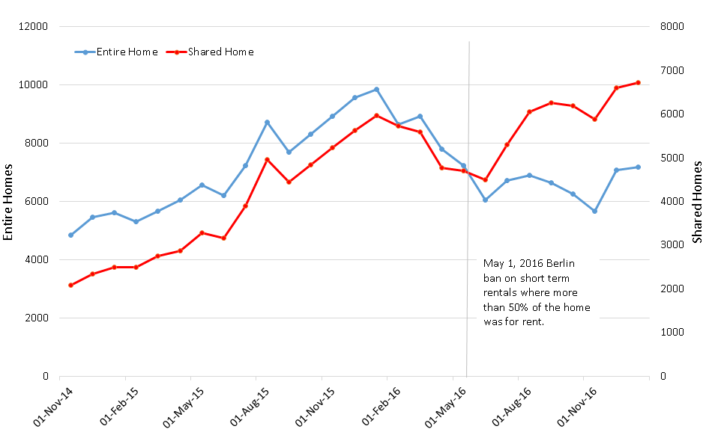

Picture Number of listings, Berlin

Source: AirDNA, 2019

London

The limit of renting days in London is 90 days per year. If someone wants to rent for a longer period, it is necessary to apply for a planning permit at the local council. (LuckeyHomes, 2018) The area of London is 1 572 km2 and the number of active rentals is 60 979. The next picture, number 6, shows that the offers of accommodation are mostly in the center of the city as is common also in other cities.

*Source: AirDNA*

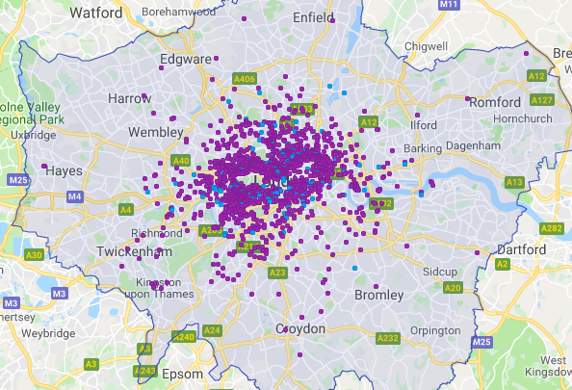

Picture Map of AirBnB, London

Source: AirDNA, 2019

Amsterdam

In 2018 there was a limit for renting 60 days per year, however, the city has decided to reduce the number to halve in 2019, 30 days per year. (Locklear, 2019) In Amsterdam, there are now 11 795 active rentals, on the area 219 km2, as we can see from picture number 7.

Picture Map of AirBnB, Amsterdam

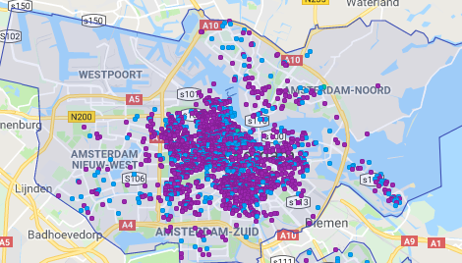

Source: AirDNA, 2019

Barcelona

The cosmopolitan Catalan capital Barcelona has decided to do some relatively extreme steps in regulations. The city fights against overcrowded parts of the city. All types of holiday accommodation need a licence and in 2015, Barcelona’s new mayor Ada Colau suspended all new accommodation licences. Not only AirBnB but also hotels and hostels. Before this decision, there were already suspended license in specific parts in the city, that was congested with tourists. For example, L’Eixample, Vila de Gràcia, Poblenou, Camp d’en Grassot and Gràcia Nova and few others. (AirDNA, c2015-2019) Because of that step, the number of listings is limited, and all hosts need to pay an annual fee to the government. Listings on the website are checked frequently and if they do not have a licence, they are removed from the site. The city tries hard, but there are still many rentals illegal. (Rodés, 2017) The area of the city is 101 km2 and has 17 719 active rentals, which seems too many already from the map below.

Picture Map of AirBnB, Barcelona

#### 

Source: AirDNA, 2019

#### AirBnB in Prague, Czech Republic

AirBnB also found popularity in the Czech Republic, currently (January 2019) there are 12 859 active rentals with 5 615 active hosts. 80 % of supply is an entire house, only 2 % of rentals offer shared room. The average daily rate is about 2 089 Kč (82 €). (AirDNA, c2015-2019) As you can see from the map below, it is obvious that the highest offer is in the centre of Prague.

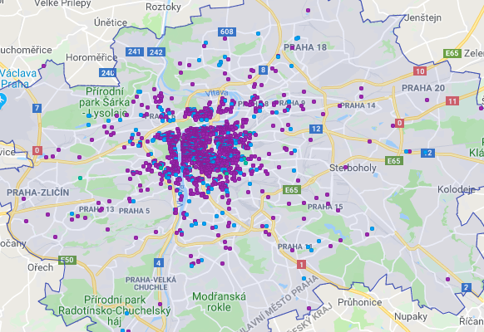

Picture Map of AirBnB, Prague

Source: AirDNA, 2019

In the last few years, there was a massive increase of rentals. From 2014, the number of rentals was growing very fast, the annual growth is now 27 % as we can see from the graph number 1.

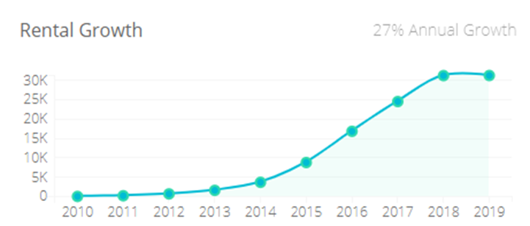

Graph The rental growth

Source: AirDNA, 2019

AirBnB has turn into business as in many other cities. Picture number 11 shows that 70 % of hosts offer more places than just one.

Picture The situation in Prague

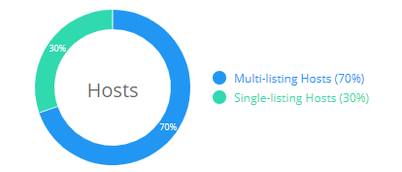

Source: AirDNA, 2019

#### Future of AirBnB in Prague

AirBnB has often discussed the topic in policy, mostly because of problems that AirBnB is responsible for. There is not any regulation yet and neighbours are often unhappy with these rentals. The main problem is that there are often more people in the apartment then it is allowed, they are noisy and is no exception that the apartment is damaged after visitors. Prague is visited by young people a lot, who drinks, and when they are staying for 2-3 days, they are not very considerate about neighbours. (Tomanka, 2018) Neighbours are not the only one, who are unhappy with the growth of AirBnB. Hotel owners are also complaining because Prague visitors prefer private accommodation than nights in hotels. The hoteliers request regulations as in another European metropolis. (Tomanka, 2018) Prague wants a change of law because now they cannot fight against this problematic. The idea is that owners of apartments will have to provide information about accommodated and the number of days per year when the apartment can be rented through AirBnB or forbid this service in specific areas in the city. (Bukovský, 2018)

At the end of the year 2019, the government made a decision about accommodation fees, which are actual from the January 2020. The fee in the height of 21Kč/0,84€ per night will now have an effect on each place listed on AirBnB. The fee should grow in 2021 up to 50Kč/2€ per person per night. These fees could increase the yield of the city by 14%. (ČTK, 2020)

# The goals of research and methodology

## The goals of research

The aim of the thesis is to analyze current state and identify the potential for the development of shared accommodation in Madeira island. Next goal is to identify barriers of its development based on the results of research about this type of accommodation and reduce them.

## The Methodology

The first step of the thesis was the study of theoretical background and elaboration of literature review based on printed publications, web portals and professional publications. The literature review is related to shared economy in general, next more specifically in shared accommodation.

The next part of the thesis focus on qualitative research, that consist of two kinds of survey, interviews, the analysis of data and suggestions for owners that offer places through AirBnB.

The first survey was aimed to the visitors, to find out, how travelers evaluate this specific type of accommodation. The number of respondents that were engaged in data collection was 157. The questionnaire was shared mostly through social media, through Google Form, because the aim was to gain as many different cultures as possible. At the end of the research, people from 40 countries were engaged, 68% women and 32% men.

The second survey was focused on providers of accommodation that offer place on Madeira island. This segment was much smaller, so the number of questionnaires was estimated to 30. It is impossible for researcher who does not have access to details of AirBnB to find out the exact number of home providers. The number of listing in Madeira is about 5000, but some properties are owned by the same person or even a company, so the exact number remains a mystery. Owners were contacted through AirBnB portal. The gender representation was 47% women and 53 % men.

The structure of both surveys was very similar. The questionnaire included open-ended and closed-ended questions, obviously demographic questions and also Likert scale questions.

The data provided by questionnaires were collected in the year 2018 and the beginning of the year 2019. The data from both surveys were processed in program PSPP that enable to sort the data and to make contingency tables. For the graphical representation, Microsoft Excel was used.

To find out more opinions about shared accommodation, it was communicated with 10 individuals. The individuals were asked questions, which were similar as in the first survey, but more in depth. Respondents were asked for reasons and any thoughts about AirBnB.

After all the information which have been gained, some tips were suggested for AirBnB providers, how to make a stay for visitors more enjoyable.

# Results of research and analyses

In this part of the thesis, the information about the destination, Madeira island is presented, followed by the analyze of demand and analyze of supply.

## Tourism resources

This part describes tourism prerequisites, localization, selective and realization assumptions such as tourist attractivities, geography, climate, economy, demography etc. in the destination.

### Localization assumptions

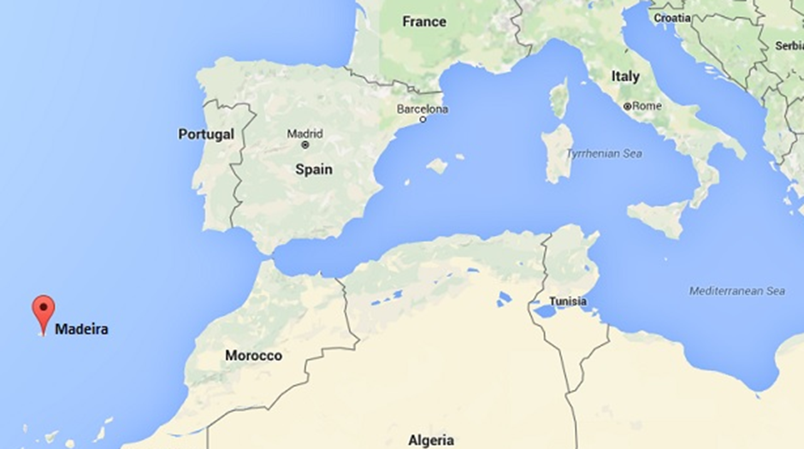Madeira is an archipelago surrounded by the Atlantic Ocean. It comprises the islands of Madeira (736km2), Porto Santo (43km2), Desertas (14km2) and Selvagens (4km2). Only Madeira and Porto Santo are inhabited. The archipelago belongs to Portugal, 978km southwest of Lisbon. (NEWCO, 2013)

Picture Map of the location

Source: https://www.google.com/maps/place/Madeira

The archipelago is of volcanic origin but nowadays there is not any volcanic activity. The island is about 57 km long and around 22 km wide. (MadeiraWeb, c1997-2019) It seems like a small island but there are so many places to explore. As a result, from volcanic activity, it is not very easy to find access to the ocean. There are a few beaches (mostly with pebbles) with gradual access but very often it is necessary to use ladders into the ocean. The second result of volcanic activity is that this island is very often sought after by hike lovers.

Madeira offers so many peaks with stunning views, hiking tours and much more. For tourists who would rather enjoy sandy beaches, there is an island Porto Santo with 9 km long coast with golden sand. The main island has a sub-tropical climate which is very influenced by altitude. The northern part of the island is more often rainy then the south part. (GlobalSecurity, c2000-2019)

Most days, there is sunny in Funchal (the capital) in the morning but after midday, the clouds are coming from the north and the rest of the days is cloudy in Funchal. The weather in Madeira is unfathomable. When it is sunny in the north, south is probably cloudy and conversely. The island is called an island of eternal spring because the temperature is not very high even during the high season.

The following table describes the average temperature on the island

Source Climates to Travel, 2017

Table Average temperatures

Rainfalls are usual during the period from October to mid-April and during summer it almost never rains. (Climates to Travel, 2017)

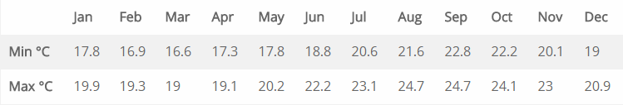The island is surrounded by the Atlantic Ocean, average temperatures show the table below.

Table The average temperature of the ocean

Source World sea temperatur, c2019

Madeira does not have any lakes or rivers but has many tiny lagoons with waterfalls around the whole island. The island is interlaced with levadas. Levadas are channels of water that has been built in the past, mostly in the 15th century. The reason for creating them was to have access to water in the south of the island. Northern part of the island is more humid, and this was to way to get water to fields with plantation of sugar. Nowadays, levadas are one of the most famous ways for exploring the island. The network of levadas is now 1,400km long and these routes are often followed by tourists, but also by locals. (Quintal, 2010)

Madeira is a unique island with impressive biodiversity. It is no coincidence that Madeira is also known as the pearl of the Atlantic or as a botanical garden in the middle of the Ocean. You can find here Laurel Forest classified as a World Heritage by UNESCO where plants and animals cohabit in complete interdependence. On the island there are thousands of plants species and thanks to Madeira climate you can enjoy beautiful flowers throughout the year. About 16 % of plants are endemic, which means that these species exist only in Madeira and it is impossible to find them in any other place in the entire world. (Madeira A - Z, c2008-2017)

Fauna on the island is also very rich. The island is famous for smaller species of animals such as birds, insects, and reptiles. Many tourists coming here for bird watching or for biology studies. There are about 700 species of insects, many of them are endemic as well. The ocean offers many species of fishes, dolphins and whales. (Madeira A - Z, c2008-2017)

Nature attractivities

Vereda da Ponta de São Lourenço

The trail follows the eastern peninsula of Madeira island with completely unique landscape compared to the rest of the island. This part is without any trees, bushes and is classified as a partial natural reserve. At the end of the trail, there is a viewpoint and this point is considered as the most eastern point on Madeira at all. In the past, this land was longer but with time and increasing water level, the island was separated. (Madeira Islands Guide, 2019)

Picture Vereda da Ponta de São Lourenço

Source visitmadeira.pt, 2020

Pico Ruivo

The highest peak of Madeira Pico Ruivo (1861 m) offers a stunning view after a not very easy hike. Together with Pico Areero this is one of the most recommend hikes on Madeira island. The hike is about 10 km long, exhausting but definitely worthy. (Madeira Regional Tourism Board, 2018)

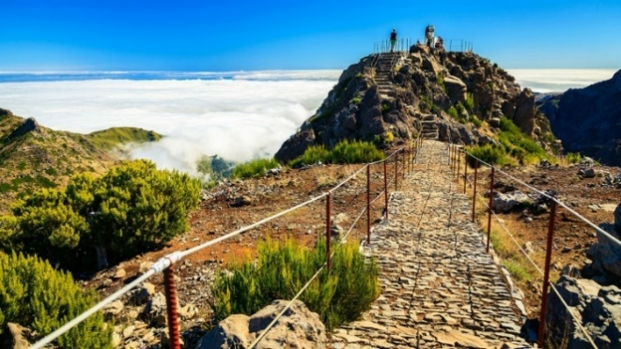

Picture Pico Ruivo

Source visitmadeira.pt, 2020

Levada das 25 Fontes

Another amazing spot on the island and one of the most sought-after walks for tourists. This walk leads through a narrow path surrounded by trees which form natural tunnels. At the end of the trail, there is a huge waterfall with lagoon. Only one big disadvantage of this trail is that it is number one in all walking guides and it is very often crowded with tourists.

Picture Levada das 25 Fontes

Source visitmadeira.pt, 2020

Vereda do Fanal

This trail is part of the Laurel forest and is about 10 km long. Big advantage of this trail is that is not well known by tourists, so it is great for travelers who do not like crowded places. This place is located very high, it is very usual that it is foggy, that just helps to justify the atmosphere about a mystical forest. In the forest, there are trees that are more than 100 years old covered with moss.

Picture Vereda do Fanal

Source visitmadeira.pt, 2020

Porto Moniz

Porto Moniz is a small city located in the north of the island. It is known mostly because of huge natural swimming pools. Pools were created by cooling lava and offers amazing experience for tourists.

Picture Porto Moniz

Source visitmadeira.pt, 2020

Madeira offers much more natural attractivities, more than 60 levada walks, amazing beaches and many hidden nooks.

Culture assumptions

Monuments

* Tristão Vaz Statue – statue located in Machico that has been built in honor of the discoverer Tristão Vaz.
* Garajau Christ King Statue – the statue with open arms facing the ocean located on the viewpoint

Museums

* Vine and Wine Museum – the museum is located in Santana and shows tools which have been used over the years for wine production
* Funchal Municipal Museum Natural History – a museum located in the capital shows many kinds of animal collection, plants and rocks
* CR7 Cristiano Ronaldo Museum – a museum built in honor of the football player Cristiano Ronaldo, who was born in Madeira
* Whale Museum – a museum located in Canical offers interesting tours about whale hunting years ago (*Průvodce Madeira*, 2014)

Picture Whale Museum

Source visitmadeira.pt, 2020

Events and festivals

Flower festival

Madeira organizes many famous festivals and events all year round. One of them is the Flower Festival in April, which signifies the celebration of spring. Flower carpets are made on the main road in Funchal and you can see flowers all over the city. The part of this festival is a parade where people are wearing costumes made from flowers. (Turismo de Portugal, 2013)

Atlantic festival

Atlantic festival celebrates the beginning of summer with excellent performances and huge fireworks every Saturday. (Quinta da Casa Branca, 2019)

Madeira Carnival

One of the biggest street festivals in Europe looks a bit similar to in Rio de Janeiro. The whole festival takes about 2 weeks including the main parade with fantastic costumes. (MadeiraWeb, c1997-2018)

Picture Flower festival

Source visitmadeira.pt, 2020

### Selective assumptions

Madeira is considered as an autonomous region of Portugal since 1976. The President, Miguel Albuquerque, has been elected in 2015. Madeira is part of OECD and EU. The participation in the last election was the lowest ever, with 49,6 % voters. (NEWCO, 2013) Madeira, as a part of Portugal, participates in both elections, national and regional. National elections take place at least every four years. The local government consists of 47 members. (MadeiraWEB, 1997-2018) The government is composed of the presidency and eight regional departments. The departments are the following:

* Parliamentary and European affairs
* Finance and public administration
* Inclusion and social affairs
* Economy, tourism and culture
* Education
* Environment and natural resources
* Health
* Agriculture and fisheries

Economy of Madeira is mainly focused on the tertiary sector. It provides jobs for 72,6 % of the population. 84,4% of the regional Gross Value Added (GVA) comes from the tertiary sector, 13.3% from the secondary sector, and 2.3% from the primary sector. The island is highly dependent on tourism, restaurants, hotels and vehicle trade generate 28.4 % of total employment. According to June 2018, the unemployment rate was 8.8%, down 1.6% from the previous year. (European Commission, 2019) Even today, the economics of Madeira is very dependent on the ocean. The port of Funchal is very important for trade but also for cruise shipping companies because they consider this as their main dock. This port is responsible for 88% of imports and 12% of exports. (ToMadeira, 2017) The export is also very important for the island, mainly of agricultural commodities (sugar, wine, fruit, flowers). Even though the emigration to the mainland, Madeira is not completely self-sufficient, it is necessary to import meat, corn and so one. (EURES, 2018)

Madeira has about 260.000 inhabitants, 75% of all inhabitants live in 35% of the island. This populated part is on the south on the island, mainly in the capital, Funchal. In Funchal live about 45% of the whole population in Madeira. In 2014, there were 46,8% of males and 53,2% of females. The average age on the island is 40 years. (Direção Regional de Estatística da Madeira, 2018) In Madeira, there are 69 % of people with age between 15 – 64 years, 19 % are older than 64 years old and 12 % of people with age less than 15 years. The island is inhabited mainly with Portuguese (97 %). (CityPopulation, c1998-2019)

### Realization assumptions

As Madeira is an island, the most common way to get there is by plane. The airport is named by Cristiano Ronaldo and was opened in 1964. At the beginning the runway was only 1600 m long but after a huge accident, the runway was extended and now is 2781 m long. The airport is considered as one of the most challenging because of the winds so it is necessary for pilots to have special training for landing in this area. (MadeiraWEB, c1997-2018)

Main cities on the island are connected by highway, that adds many benefits for travelling. Madeira is also famous for the number of bridges and tunnels (in total about 100) through huge rocks, that have been mostly built in the 19th century. The total highway network is 140 km, it does not seem like a lot, but it is important to mention, that the island measure only 57 km in length, 23 km in width. (The Escape Hunter, 2014)

Madeira offers plenty of options for accommodation. Booking.com offers on their websites nearly 2,500 places to accommodate. AirBnB.com offers about 5,000 rentals (mentioned in detail later). Hotelscanner.com offers more than 2,000 hotels in Madeira and about 1,000 only in Funchal. In Madeira, there is a huge network of hotels. Some of the biggest group are Pestana Hotels or PortoBay Hotels. These hotels belong to the 4* or 5* hotels on the island and the price according to (Booking.com) can be 120€ per night but also 300€ per night. Most of the hotels are not located in the old town, but a little further, in part of the town called LIDO. In Funchal, there is also a cheaper way to accommodate, for example in hostels or apartments. The price according to (Booking.com) can be about 12€.

## Madeira shared accommodation situation April 2018

Madeira is very open to shared accommodation, on the 18th of April 2018, there were **4,604 rentals** including Porto Santo with 110 rentals. The visitor can choose an entire home, private room (shared common areas) or shared room (with someone else). The most extended offer is to rent the **entire home** (4 220 rentals, **92%**). There are 350 private rooms (7%) and only 34 shared rooms (1%). Each rental has a different size. The most common rental (entire home) is with two bedrooms (32,5%) and one-bedroom (32,5%), the others (35%) - studio 2%, three-bedroom 22%, more bedrooms 11%. Price of the rental obviously depends on the choice of visitor (entire house, only room etc.). The average pricing for entire home is 58 €, private room 37 € and shared room 16 €. The month, which generates the most revenue per available rental, is August, followed by July and September. The second half of January and the first half of December are the weakest parts of the year. During March 2018, 2 221 rentals had at least one booked night. That means that the occupancy was 55 %.

Naturally, the most rentals are in the capital, Funchal, but whole south seaside is full of rentals. In the north there are rentals only in bigger cities such as Porto Moniz, Sao Vicente, Santana or Porto da Cruz. (AirDNA, c2015-2019)

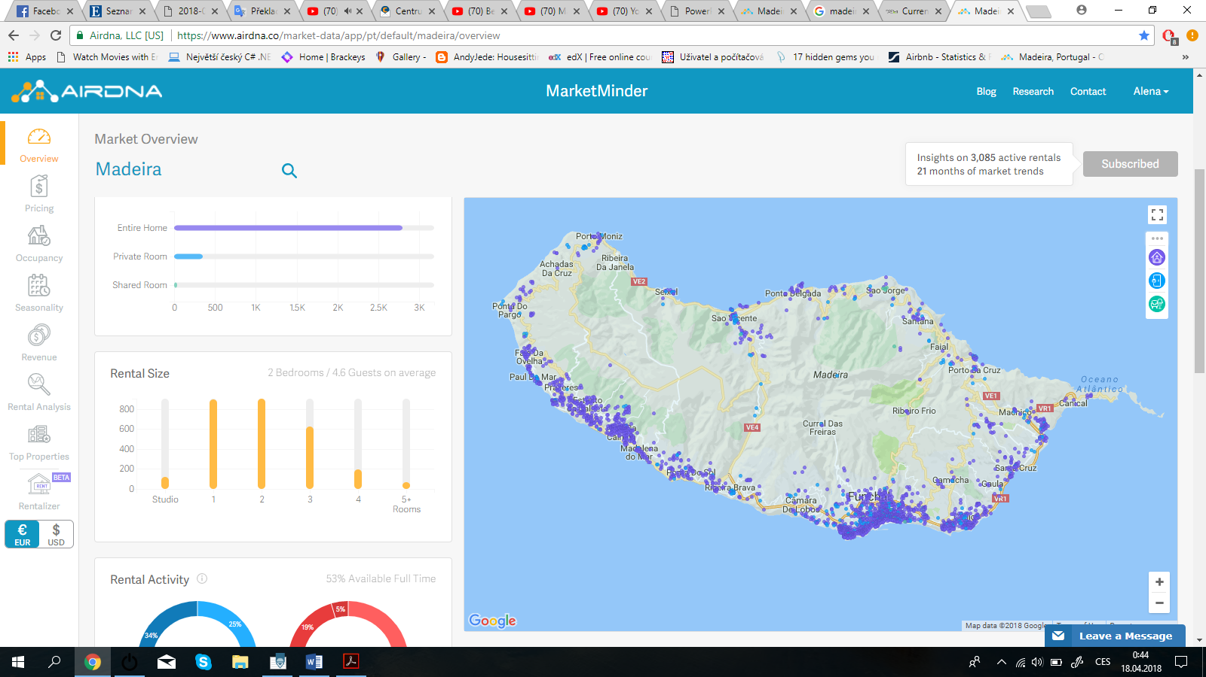The number of rentals is growing rapidly fast. In 2010 there were only 3 rentals, in 2014 already 624 rentals and in 2018 4,604 rentals. That means **annual growth of 59%.**

Picture Map of AirBnB, Madeira

Source AirDNA, 2019

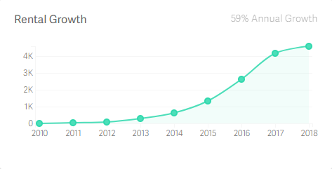

Picture The rental growth

Source AirDNA, 2019

The following graph shows how many days in advance people are doing their reservation for their stay in Madeira.

Picture Booking time in advance

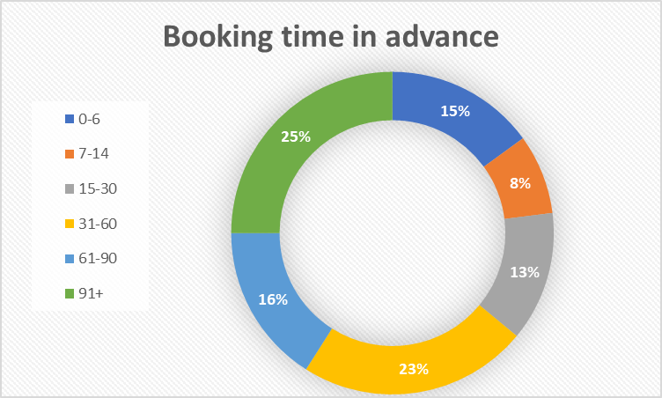

Source AirDNA, 2019

We can see from the graph that most people (25 %) are booking their accommodation for more than 3 months in advance. 23 % of reservations were made 31-60 days in advance, 15 % of reservations were done less than one week in advance. On average, people are booking their accommodation for 66 days in advance. (AirDNA, c2015-2019)

## Madeira shared accommodation situation August 2019

On the 18th of August 2019, the number of active rentals was 5,292. The structure of rentals remains similar. The most extended offer is still to rent the entire home (92%). There are 7,7% of private rooms and only 0,3 % of shared rooms. Size of rentals and seasonality remain the same as in 2018. Prices stayed nearly the same as in 2018, except the price for entire home, which has risen from 58 € up to 70 €. The price for private room is 34 € and 15 € for shared room. The occupancy rate has increased from 55% to 65%. Most visitors that came to Madeira in august 2019 were from London. 97% of all visitors are international and the number of arrivals in June 2019 was 2,352. The biggest website for booking accommodation online (Booking.com, 2019) offers over 2,500 places in Madeira, including 1170 apartments, 164 hotels and 625 holiday homes. From this information it seems that AirBnB offers more places to stay, but it is not possible to find exact numbers, because often Booking.com and AirBnB.com offer the same places on their sites.

Booking time has changed, more visitors are booking the rental more ahead. In 2018 only 25% of people were booking rental more than 3 months in advance, in 2019 the number increased to 45%.

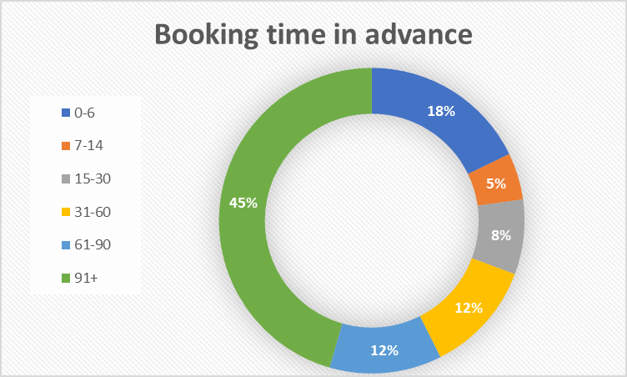

Picture Booking time in advance

Source AirDNA, 2019

## Comparison April 2018 and August 2019

In the table below, we can see a comparison in years 2018 and 2019. The biggest differences are in pricing of entire home, which has risen by 20 %, on the other hand, prices for private and shared room has decreased circa by 8 %. As was already mentioned above, the number of rental has risen, specifically by 15 %. The biggest difference was however in number of shared rooms. The number has decreased by unbelievable 50 %.

Table 4 AirBnB comparison in time

|  |  |  |  |
| --- | --- | --- | --- |
| **Period** | **April 2018** | **August 2019** | **Results** |
| **Pricing** |  |  |  |
| Entire home | 58 € | 70 € | + 20% |
| Private room | 37 € | 34 € | -9% |
| Shared room | 16 € | 15 € | -7% |
| Occupancy | 55 % | 65 % | +18% |
| **Number of rentals** | 4 604 | 5 292 | +15% |
| Entire home | 4 220 | 4 850 | +14% |
| Private room | 350 | 425 | +21% |
| Shared room | 34 | 17 | -50% |

Source AirDNA, 2019

## The Analysis

In this chapter, the results of the research will be presented. It will be divided into a few parts. The first part is focused on the analysis of demand, the second part is based on the analysis of supply. The last part, the third, presents the results of individual interviews.

### The analysis of demand

At the beginning of the research, respondents were asked where they found the option of accommodation with AirBnB. Graph number 1 shows that most frequent answers was the internet with 49 %, the next was a friend with 31 %, social media with 15 % and 5 % of respondents have chosen the other option. We can see the difference between ages especially with the answer social media, nobody older than 50 years has answered this source. The answer social media was mostly recorded from respondents within 21-30 years, specifically 17 respondents.

Graph : The way of finding AirBnB according to the age of respondent

Source: Own elaboration, 2019

The next question focuses on the year of becoming a member of the AirBnB community. The graph below shows, that this style of travelling is still quite young, many people joined the community just a few years ago. The most answered year was 2016 with 39 responds, 2017 and 2018 with 28 responds. Only 7 % of respondents joined the community earlier than in 2013. In comparison between genders, we can see that the most females joined AirBnB in 2016 (28 females), meanwhile most males joined AirBnB one year earlier, in 2015 (11 males).

Graph : The year of joining AirBnB according to the gender of respondent

Source: Own elaboration, 2019

The graph number 3 shows the reason for joining the community. The majority answered “Cheaper accommodation” with 70 %. 14 % respondents chose “other” that includes local experiences, bigger accommodation than just a hotel room, accommodation with a kitchen and living room, options for travelling with a group, residential neighborhood. Another 12 % chose “I wanted to try something new” and almost 5 % wanted to meet more locals. The most students choose AirBnB for cheaper accommodation, the same choose workers, but workers have bigger impact in section “I wanted to try something new.”, meanwhile students do not.

Table The reason for joining the AirBnB community according to the status of respondent

|  |  |  |  |  |  |  |  |  |
| --- | --- | --- | --- | --- | --- | --- | --- | --- |
|  | **Student** | | **Worker** | | **Self-employed** | | **Retirement** | |
|  | **Abs.** | **Rel.** | **Abs.** | **Rel.** | **Abs.** | **Rel.** | **Abs.** | **Rel.** |
| **Cheaper accommodation** | 45 | 82% | 48 | 72% | 11 | 52% | 4 | 36% |
| **I wanted to try …** | 5 | 9% | 10 | 15% | 3 | 14% | 2 | 18% |
| **Meeting locals** | 1 | 2% | 4 | 6% | 1 | 5% | 0 | 0% |
| **Other** | 4 | 7% | 5 | 7% | 6 | 29% | 5 | 45% |

Source: Own elaboration, 2019

Graph The reason for joining the AirBnB community according to the status of respondent

Source: Own elaboration, 2019

The next question focus on the frequency of using AirBnB. 43,9 % of visitors use AirBnB only 1 time per year, 37,6 % 2-3 times per year, 11,5 % 4-5 times per year. We can guess that majority of respondents use AirBnB for the bigger holiday, which are commonly one time per year.

Graph The frequency of using AirBnB according to the status of respondent

Source: Own elaboration, 2019

#### Visitor´s preferences

In the graph below, we can see the preferences about separated and shared accommodation. The results are quite one-sided, most people would rather choose separated accommodation (88 %) than sharing the place with the host (12 %). This might be a little surprising, because one of the main purposes of AirBnB is to live like local and meet locals that is easier when you live in the house with one.

Graph : Guest´s preferences about type of accommodation

Source: Own elaboration, 2019

The next graph shows results from the question asking about preferences about the gender of the host. 83 % do not mind about gender, 15 % prefers female as a host. We can assume that it is because in most cases, there is separated accommodation and the contact with the host might be very small. However, when someone prefers a gender of the host, it is mostly the case that woman prefer woman rather than a man as a host.

Graph : Gender preferences

Source: Own elaboration, 2019

The few following questions deals with reviews. The graph number 10 demonstrates, that the majority of respondents (96,2 %) do care about reviews and only 3,8 % do not. The next question about reviews was asking if people would accommodate themselves in a room without review, 47,1 % would not, 19,1 % would, and the rest is not sure.

Graph : Do you care about reviews?

Source: Own elaboration, 2019

Graph : Would you accommodate yourself in the room without review?

Source: Own elaboration, 2019

The last question in this review set was asking if people would accommodate themselves in a room with bad review, 13, 4 % would and 86, 6 % would not. In comparison between genders we can see, that more males are willing to accommodate themselves in a room with bad review and thereby give a host a second chance.

Graph : Would you accommodate yourself in the room with bad review?

Source: Own elaboration, 2019

#### Experiences

The aim of this shorter block was to find out positive and negative experiences. The question was asking if people have a negative experience with AirBnB and the answers were about even, 53 % of respondents did not face any negative experience so far, 47 % did.

The negative experiences are mostly smell, noise, dirty place or host who does not speak English, then the cat in the house without warning, keys that did not work, flat above noisy pub, fake pictures, not so professional approach of the host, high service fees and lack of support from the company.

Graph : Negative experience

Source: Own elaboration, 2019

On the other hand, visitors also have positive experiences such as a box of chocolate or fruits as a welcoming surprise, nice talkative hosts, pleasant accommodation, cheap price, cleanliness, meeting wonderful people, home feeling, privacy, fully equipped kitchen and so one.

#### Visitor´s perceptions

The following set of questions offered respondents to answer, “Definitely yes”, “Rather yes “, „Rather not” and “Definitely not” depending on their discretion.

Respondents were asked if AirBnB offers a better experience than hotels. More than 70 % of respondents said, “Definitely yes” or “Rather yes”, 30 % said “Definitely not” or “Rather not”. In this case, males tend to positive perception more than females.

Table 6 Hotel vs AirBnB according to the gender

|  |  |  |  |  |
| --- | --- | --- | --- | --- |
|  | **Female** | | **Male** | |
|  | **Abs.** | **Rel.** | **Abs.** | **Rel.** |
| **Definitely not** | 1 | 1% | 1 | 2% |
| **Rather not** | 27 | 25% | 8 | 17% |
| **Rather yes** | 50 | 46% | 27 | 56% |
| **Definitely yes** | 31 | 28% | 12 | 25% |

Source: Own elaboration, 2019

Graph : Hotels vs AirBnB according to the gender

Source: Own elaboration, 2019

The next question in this set was about the recommendation for friends. The exact question was “Would you recommend using AirBnB to your friends?” 97 % said “Definitely yes” or “Rather yes”. Only 3 % said “Rather not”, nobody said “Definitely not”, we can assume that there are more positive experiences than negative ones.

Table Recommendation according to the gender

|  |  |  |  |  |
| --- | --- | --- | --- | --- |
|  | **Female** | | **Male** | |
|  | **Abs.** | **Rel.** | **Abs.** | **Rel.** |
| **Definitely not** | 0 | 0% | 0 | 0% |
| **Rather not** | 4 | 4% | 1 | 2% |
| **Rather yes** | 34 | 31% | 17 | 35% |
| **Definitely yes** | 71 | 65% | 30 | 63% |

Source: Own elaboration, 2019

Graph : Recommendation according to the gender

Source: Own elaboration, 2019

Respondents were also asked if they think that AirBnB helps to develop tourism in destination. 82 % said “Definitely yes” or “Rather yes”, 18 % said “Definitely no” or “Rather no”.

Graph : Tourism development according to the age

Source: Own elaboration, 2019

The next question focuses on the safety of AirBnB. 89 % of respondents consider AirBnB safe, but 11 % said “Rather not”. We can guess that it might be because the location of the accommodation could be in a busy area or in not a very popular part of the city. Little distrust was recorded especially between ages 21-30 and also between ages 31-40.

Graph : AirBnB safety according to the age

Source: Own elaboration, 2019

The last question in this section was asking if AirBnB is turning mainly into business nowadays. 87 % of respondents said “Definitely yes” or “Rather yes”, 13 % does not think that.

Graph : AirBnB as business

Source: Own elaboration, 2019

#### Respondent´s characteristic

The last section focus on respondent’s age, gender, status, language ability and country of living.

The survey participated 109 females and 48 males, the majority was between 21-30 years old (60 %), then 31-40 years old (24 %), 12 % of people between 41-50 years old. The smaller representation was between 51-61 years (5,7 %), 5,1 % of respondents were older than 60 years and 1,9 % were younger than 20 years old. The status of respondents was mainly worker (48 %), students (33 %), self-employed (11 %). There was also 5 % of retirement, 0,6 % of unemployed and 2 respondents answered “other”. We can see the specific number in the table below.

Table Respondents characteristic

|  |  |
| --- | --- |
| **The characteristic of the sample of the survey** | |
| **Gender** | |
| Female | 109 |
| Male | 48 |
| **Status** | |
| Student | 52 |
| Worker | 76 |
| Self employed | 18 |
| Unemployed | 1 |
| Retirement | 8 |
| Other | 2 |
| **Age** | |
| < 20 | 3 |
| 21-30 | 80 |
| 31-40 | 38 |
| 41-50 | 19 |
| 51-60 | 9 |
| 60+ | 8 |

Source: Own elaboration, 2019

The countries of living were Czech Republic (28 %), Germany, Austria, England, Ireland, Scotland, Poland, Netherlands, Slovakia, Slovenia, France, Hungary, China, Taiwan, Sri Lanka, Malta, United States, Australia, Denmark, Croatia, Finland, New Zealand, Norway, Portugal, South Africa, Turkey, Sweden, Kenya, Hong Kong, Serbia, Spain, Italy, Canada, Brazil, Fiji, Mexico, Switzerland, Jordan, Greece, Egypt. The total number of countries of living is 40.

Many people who participated in the survey can speak at least two foreign languages, specifically 62 %. From this result, we can suppose that people who enjoy travelling have passion for learning new languages and thanks to that, they probably enjoy the travel even more.

Graph : Language ability

Source: Own elaboration, 2019

Graph : Language ability according to the age

Source: Own elaboration, 2019

### The analysis of supply

The analysis of supply is based on answers from respondents from Madeira, who offer their accommodation through AirBnB channel.

#### General Info

At the beginning, respondents were asked when they became a part of the rental community. We can see from the graph below that 33 % of respondents answered the year 2017, 27 % answered 2016, 20 % said 2015 and 17 % became a member earlier than 2015. The last 3% of respondents joined the community in 2018. It is obvious from the graph below, that the number of providers is growing with time and second thing we can see is, that males joined the joined AirBnB earlier than females.

Graph The year of becoming AirBnB host

Source: Own elaboration, 2019

The aim of the next question was to find out the reason for joining the rental community. The majority said income (80 %), 20 % chose the answer “Meeting new people”.

Graph The reason for joining AirBnB

Source: Own elaboration, 2019

From the comparison between genders, it turned out that the reason for males was income with 94 %, and only for 6 % males was the reason meeting new people. The situation is different with females. 64% of them started with renting because of the income, but 36% of females wanted to meet new people.

Graph The reason for joining AirBnB according to the age of provider

Source: Own elaboration, 2019

In the graph number 22 below, we can see answers of the question “Where did you find this option of accommodation?”. The majority, 54 % said the Internet, 36 % were informed by a friend and 10 % found this option on social media. In this case, the way of finding AirBnB remains the same as for the visitors, so for the providers.

Graph The way of finding AirBnB according to the gender of provider

Source: Own elaboration, 2019

Graph The way of finding AirBnB according to the age of provider

Source: Own elaboration, 2019

In the following question, providers were asked, what type of accommodation they provide. 90 % of respondents provide an entire home and 10 % provide a private room in their home. We can say that nearly the same ration was detected with visitor’s preferences.

Graph Type of accommodation

Source: Own elaboration, 2019

Respondents were also asked if they use AirBnB as visitors. As we can say from graph number 25, 74 % use this option of accommodation, 26 % do not. In comparison with age, the graph shows that 7% (2) of respondents older than 65 years old do not use AirBnB meanwhile other age groups do use AirBnB as visitors. We can only guess, that maybe people started to offer their places, because they used AirBnB as visitors before.

Graph Using AirBnB as a visitor

Source: Own elaboration, 2019

The following question focuses on income. The income from renting is the main income for 30 % of providers, the rest 70 % do not count renting as a main income, but just as an extra earning. We can see from the graph number 25, that the income from renting is the main income in most cases for self-employed people.

Graph Rental as the main income

Source: Own elaboration, 2019

#### Experiences

As visitors, providers were asked for their negative and positive experiences about renting. More than 50 % of respondents did not face any negative experience, the rest mentioned, for example, rude clients, bureaucracy, the taxes and jealousy of the customers because of the host´s home and also guests who do not speak any other language than their own and they expect the host to understand that language.

Positive experiences are primarily meeting new interesting people from over the world, quick payment, reliability, presents from visitors and many bookings.

#### Provider´s perceptions

From the graph number 27, we can see the guesses of how many AirBnB is in Madeira. 30 % of providers did not share their guess, 17 % said less than 500, 23 % said between 1000 - 15000, the same percentage said between 2000 - 4000 and only 7 % said more than 5000, which is correct. (The current number of active rentals is 5292). From these results, we can see that the majority of providers does not have any idea, of how many AirBnB are in the area.

Graph The guess of number of AirBnB

Source: Own elaboration, 2019

As in the analysis of demand, also in analysis of supply were respondents asked if shared accommodation offers better quality than hotels. When we compare the opinions of females and males, we can say that 79% of females says that AirBnB offers better quality than hotel, meanwhile males think that only in 69%.

Graph AirBnB vs Hotels according to the gender of provider

Source: Own elaboration, 2019

Next, people were asked if there is enough shared accommodation in Madeira. 70 % of respondents answered “Definitely yes” or “Rather yes”, 30 % said “Rather not” or “Definitely not”. In detailed evaluation, it is clear that people who answered “Rather not” or “Definitely not” were not even close about theirs guess how many Airbnb’s are in Madeira in one of the previous questions. Their guesses were often lower than 1000.

Graph AirBnB in Madeira

Source: Own elaboration, 2019

The last question from this section is focused on thoughts if this type of accommodation helps to develop tourism in Madeira. The results from this question are pretty one-sided. 90 % of providers said “Definitely yes” and 10 % said, “Rather yes”. Nobody has doubts about this question. It is obvious that AirBnB helps to develop tourism in Madeira, but we can ask ourselves, when it is enough or even too much. There might be a thin border between developing tourism and destroying the city as you can read about AirBnB situation in literature overview at the beginning of this thesis.

Graph The development of tourism

Source: Own elaboration, 2019

#### Extras

Respondents were also asked, if they provide any other service for the guests. 73 % of providers answered “No” and 27 % said “Yes”. The services are breakfast and dinners, car hire, or help with hiring, island tours or laundry and welcome pack.

One question was also focusing on the nationalities that providers that participated in this survey accommodate at most. The most frequent answers were Germans, French and British.

Also, one question was aiming at the AirBnB community and the aim was to find out if providers know anyone else who offer rentals through this channel. 90 % or providers know other people, 10 % do not know anyone else who offer rentals. We can assume that the community is quite strong from this point.

#### Respondent´s characteristic

The last following part is again focused on the identification of respondents, their gender, country of born, status, language ability and their age.

The survey participated 14 females and 16 males, the majority (37 %) is between 34 - 44 years old, there is 23 % that are between 45 - 54 years old. Other groups of age have little numbers, younger than 24 years is 1 respondent, 3 respondents are between 24 - 34 years old, 4 people are between 55 - 64 years old and 2 respondents are older than 65 years.

50 % of respondents are workers, 37 % are self-employed, 10 % is already retired and 1 respondent is currently unemployed. It is not surprising that there is no student between answers.

In the question of about education, 83 % of providers answered that they have finished university and 17 % have finished high school. The fields of study were very diverse, e.g. accounting, marketing, history, anthropology, architecture, biochemistry, engineering, philosophy, hotel business, mathematics, tourism.

The question about the country of born has presumed answers. The majority of providers was born and raised in Madeira (73 %), but also countries as the United Kingdom, France and Germany were mentioned. This trio of countries is not that much surprising, because these countries belong to the countries that hosts accommodate at most. South Africa was also mentioned as a place of born, but with no country specification.We can see specific number in the table below.

The last question is focused on languages ability. 50 % of providers can speak 2 foreign languages, 23 % can speak 3 foreign languages, 20 % can speak 1 foreign language and 2 respondents can speak only their native language (which is English).

Table Respondents characteristic

|  |  |
| --- | --- |
| **The characteristic of the sample of the survey** | |
| **Gender** | |
| Female | 14 |
| Male | 16 |
| **Education** |  |
| High school | 5 |
| University | 25 |
| **Place** **of** **born** | |
| Madeira | 22 |
| United Kingdom | 2 |
| France | 1 |
| Germany | 2 |
| South Africa | 3 |
| **Status** | |
| Worker | 15 |
| Self employed | 11 |
| Unemployed | 1 |
| Retirement | 3 |
| **Age** | |
| < 24 | 1 |
| 24-34 | 3 |
| 35-44 | 11 |
| 45-54 | 7 |
| 55-64 | 4 |
| 65+ | 2 |

Source: Own elaboration, 2019

All of the respondents included English in their language ability and many providers who were not born in Portugal can speak Portuguese.

Graph Language ability

Source: Own elaboration, 2019

### Individual interviews

In this part, the individual answers will be presented. The information were collected from 10 respondents. The interviews were structured similar as the questionnaire for travelers, but the aim was to gain more personal opinions and experiences, depending on the flow of the interview.

At the beginning, respondents were asked, where did they start using AirBnB. Most respondents answered 2015 or 2016, the only exception was respondent Milton who said 2014 and Carolina who said 2018. It emerged during the interview that most visitors found the option of shared accommodation on the internet (6). Three respondents found the information from a friend. Only respondent Simon got the information on social media. Three respondents who said, they found out about shared accommodation on the internet mentioned, that they saw an advertisement of AirBnB during watching videos on YouTube and that was the first motive to do a research about that. Most respondents (6) started using shared accommodation because they were looking for cheaper accommodation. Two respondents just wanted to try something new, respondent Dimitar answered, *“I was looking for a long-term accommodation when I moved to Italy for a few months”* and Anna, who travel a lot because of her job, said, *“I was looking for a place with kitchen and other important things for me, while I have business trips”*. During the individual interviews turned out, that kitchen accessibility is important or a big benefit for many people, especially for people whose reason for choosing AirBnB was the price.

In the next flow of questions, respondents were asked about their preferences, about place itself and the host´s gender. Most respondents definitely prefer separated accommodation, specifically 8 respondents. When they were asked for the reason, all of them mentioned the privacy. Student Marie said she prefers shared accommodation, because it is cheaper and 26 years old Grace answered, *“Separated when I travel with someone, shared when I travel alone”*. Already from the analysis of demand, it was noticed that people do not really care about the gender of the host. However, it transpired from the Grace´s answer “I do not care if it is separated, I might prefer lady or couple if shared” that the case is that most people prefer separated accommodation, so they do not have a reason make a differences between genders.

No one had such a negative experience that would stop him/her to use AirBnB anymore. Nevertheless, six respondents have experienced something more less negative. For example, Mohamed said, *“I was not provided the correct information about the distance to the underground, I had to walk about 20 minutes instead of having a stop in front of the building”*, Dimitar has experience with blocked drain, Milton had a little uncomfortable stay because of little mess in the apartment and two ladies experienced noisy place. Grace has experienced a cancellation of reservation just few days before her arrival to the destination. Four respondents said that they did not face any negative experience so far.

On the other hand, each respondent had something positive to say about his or her stay. The frequent things were price, recommendation from hosts, location in the center, but the most often mentioned was meeting nice people. For example, Simon said, *“Meeting locals, when I shared a house with an older couple, they invited me for dinner with them, I also stayed in very nice cottage in the mountains, that was magical”*, Katharina mentioned cleanliness and feeling like at home. Jan said *“Access to places that are super interesting, cozy cottages and so one, hotels do not provide this*” and Caroline said she enjoys living more like a local, also Anna shared her experience “*One night I arrived late, and the host prepared a meal for me that was very nice. I also met many nice people, got good recommendation”.*

The frequency of using AirBnB was diverse. About five respondents use AirBnB   
1-2 per year, mostly for holiday that last about one week, with growing number of frequency the time spend in the destination is getting shorter. Two women said they use AirBnB 4-5 per year, but the duration of the stay is most often a weekend period. Two respondents also mentioned higher number (about 4-5 per year) but the main reason is business trips.

All respondents care about reviews, they consider reading reviews as some kind of preparation, especially as a way to find out some negative experiences of other travelers. On the other hand, three respondents mentioned that they do not believe the reviews 100%. It has turned out, that nearly nobody would accommodate themselves in a room without review or they are not sure, so it seems like a vicious circle for the host. If they do not have reviews, hardly anybody would accommodate in theirs place and they do not even have a chance to get some reviews.

In my honest opinion, that is the reason, why is AirBnB experiencing issues with fake reviews. Often mentioned reason for not accommodating in a place without review was the risk, for example, Grace said, *“I would not probably accommodate myself there because I do not want to take a risk”*, Marie also said it seems risky for her and Simon said, *“I would accommodate there only alone, not with my wife”*. After these answers, it was more than clear that nobody would accommodate themselves in a room with bad review.

Five respondents consider AirBnB as a definitely better option of accommodation than hotels. Often they like that they can feel more comfortable, more like at home and they like the variety of places they can accommodate themselves in. Carolina said *“…, some places offered on AirBnB are just so amazing, better than simple hotel”*. Sometimes respondents were not quite sure, what they prefer, for example, Grace said, *“I always feel like at home in AirBnB, but I also like hotel service and big breakfast”*. Dimitar and Simon had similar opinion, both of them think that hotels offer more service and Dimitar also likes the fact that hotels already have a reputation. All of respondents would recommend using AirBnB to their friends, even though they themselves might prefer hotels, they still think AirBnB is a good option for accommodation. The topic about development of tourism in the destination caused a bit stronger emotions by some respondents. Most respondents (8) said that they think AirBnB helps to develop tourism but two respondents think that it is the opposite. Grace said *“It used to think that it helps, but nowadays, there are sometimes too many AirBnB and I believe that locals are not happy about that, and also the city is crowded afterwards”*, Dimitar said *“It is destroying the tourism. Too many people arrive in the areas and it ruins the city”*. He also mentioned that the fact he has a strong opinion about this is, that he is currently living in the area where AirBnB is very extended so he sees that from other perspective. Nobody of respondents has ever felt unsafe in conjunction with AirBnB, but they often said that safety depends on individuals and also on the area. One respondent mentioned that even though he thinks AirBnB is safe, hotels are even safer in his opinion. The opinions about turning AirBnB mainly into business were surprisingly quite one-sided. Six respondents have a strong opinion that AirBnB is turning into business and it is not about sharing home anymore.

Two respondents were not sure what to think about this issue and other two respondents also think that AirBnB is turning mainly into business but without strong conviction. Jan added *“…not that sure about villages, I think it is not such a big business for people who live in small villages”*

From the participating respondents, most of them (6) can speak two foreign languages, three respondents can speak one foreign language and respondent Anna, who travels a lot because of her job is fluent in three foreign languages. The age scale of respondents was from 22 years up to 43 years. Five men and five women were participating in the interviews, from nine countries (Sudan, Bulgaria, New Zealand, Belgium, Portugal, Italy, Czech Republic, Germany and UK). One student Marie was participating, two self – employed and seven workers from different fields (programmer, marketing, administrative, business).

At the end of the interview, each respondent was asked for any thoughts or suggestions. Mohamed – *“I read hosts complain from App managers, it's all about making money, like UBER but instead they use people's houses. AirBnB let people like me from low economy countries to spend a wonderful stay abroad in very reasonable prices.”* Dimitar – *“I mainly use Airbnb with my family. It is more comfortable for us when we can rent a guest house with a kitchen and a place for them to play safely outside.”* Grace – *“I like the idea of AirBnB, to feel like home, but I think it should be better controlled, especially the amount of AirBnB in main cities.”* Milton – *“I think the fact that many hosts have turned AirBnB into a commercial business is taking away from the original intention of the AirBnB experience and hurting local people in terms of removing market rentals from the marketplace. I am currently looking for alternatives to AirBnB in my travels.”* Jan – *“I think, in bigger cities, the regulation is necessary, it brings more problems than positive things. On the other hand, I have experienced older couple as a host and I think that the option really helps them to “be part of the world”. I think it is not that much about money for them but about helping people and show them their world.”* Anna – *“I use AirBnB quite often for my business trips and I have to say I am very pleased with the service. I appreciate the freedom of having own apartment, be able to cook for myself, everything is just perfect. I had also a luck that my hosts were always very kind.”* Simon – *“To be honest, I prefer hotel accommodation, but when I want to escape to the quiet area, there are not usually hotels, so I choose AirBnB. But I have to say that I have very good experience as I mentioned before, nice cottage, nice people, but still I like the service that hotels offer.”*

# Suggestions

AirBnB has definitely impact in many different fields. For the economy, AirBnB has significant role. It brings even more tourists in the area and with theirs spending, the economy can grow. However, there is also a place for reflection. Is the higher number of incoming tourist good for the island? Is it good for the beautiful nature? The frequent answer from the survey was, that AirBnB helps to develop tourism in the area. But as we can see the situation in other cities, without any limitation, tourism could get massive and it could slowly destroy the whole place. Especially with this beautiful island, it is important to realize that too many people will not have a positive effect on the nature and probably not even on the island itself. If the number of listings on AirBnB or other sites grows, I would definitely suggest some kind of regulation, possibly the number of days people can rent. I think that especially island should be aware about the danger of massive tourism.

AirBnB and the other types of shared accommodation are still growing in popularity. However, definitely some places might be improved. Respondents themselves proposed some of the suggestions, the others came to my mind while I was talking to them or finding information about AirBnB in general. Both groups, providers and visitors have a big impact on future of AirBnB. When respondents want to provide amazing stay to their visitor, they should follow some rules and tips, because happy visitor is the best rating. On the other hand, visitors should also behave in a specific way, so they could have a pleasant stay. The following part suggest some tips for providers, what to do to make their visitor pleased, so they could give the host a good rating.

1. **Being nice and honest** – this suggestion might seem obvious, but it was often mentioned by respondents, so it is probably not that common.
2. **Little snack** – having a bit of food is a big benefit, especially when guests arrive late in the evening/at night. Someone might argue about the costs, but it is not necessary to have a full fridge, it would be enough to offer a piece of bread with cheese or some crackers. Another suggestion is also connected with food and that is baking. Little cake is never a wrong step, guests will love it and it will make the place smell amazing.
3. **Good quality pictures** – pictures are what decide if people accommodate in the place or not, so it is desirable to have quality pictures or even a video to show the place. Sometimes the place looks good in person, but the pictures are very bad, and the host is losing the booking thanks to that.
4. **Cleanliness** – another obvious suggestion, but it is definitely worthy to take a time to properly clean the place, no one wants to find a hair in the bathroom or anywhere else.
5. **Make the place smell nice** – I would guess that many people do not know, how much can smell of the place affect the guests. It would be nice to light an aroma lamp or candle with nice comforting smell, but it is important not to choose very strong smells, that could have the opposite effect.
6. **Cooperation** – if possible, cooperation with other business might be beneficial. For example, offering a coupon for breakfast in nearby coffee shop
7. **Recommendation –** travelers usually appreciate recommendation from locals, places to visit, to eat out…

This part will be focused also on suggestions but now for visitors, what they should or could do. Some tips are highly suggested, like being respectful, other are just recommendation, like bringing a present.

1. **Being nice and honest.**
2. **Bring a little present –** especially when visiting a foreign country, it is really nice to let the host know a little bit about your country. It might be a traditional sweet, little coffee or anything else you like, or you are proud of.
3. **Do not make too much noise and be thoughtful about neighbors –** nobody wants to listen to the loud noise from the other side of the wall. Be respectful, not everyone is having a holiday and they just want to sleep calmly during the night.
4. **Do not leave a mess –** in my opinion, this should be common. Do not leave dirty dishes in the sink, clean after yourself.
5. **Take your time when choosing the place –** if you can, do not rush, take your time to read all evaluations.
6. **Trust in yourself –** if you are not sure about the place, trust your intuition and search for another place.

# Conclusion

During the research, I have had many conversations about AirBnB (face to face or through the internet). Thanks to that, I had a chance to see the point of view from other perspective.

…

# References

Airbnb, . (2018). About Us - Airbnb Press Room [Online]. *Airbnb News*. Airbnb. Retrieved from https://press.airbnb.com/en-uk/about-us/

AirDNA, . (c2015-2018). AirDNA MarketMinder [Online]. *AirDNA: Short-Term Vacation Rental Data*. AirDNA. Retrieved from https://www.airdna.co/vacation-rental-data/app/us/california/san-francisco/overview

AirDNA, . (c2015-2019). Is Airbnb Regulation Impacting Short-Term Rental Growth? [Online]. *AirDNA | Short-Term Rental Data & Analytics*. AirDNA. Retrieved from https://www.airdna.co/blog/effects-airbnb-regulation

AirDNA, . (c2015-2019). AirDNA MarketMinder [Online]. *AirDNA | Short-Term Rental Data & Analytics*. AirDNA. Retrieved from https://www.airdna.co/vacation-rental-data/app/cz/default/prague/overview

Beránek, J. (2013). *Ekonomika cestovního ruchu*. Praha: Mag Consulting.

BlaBlaCar. (c2019). About Us - BlaBlaCar [Online]. Retrieved October 17, 2019, from https://blog.blablacar.com/about-us

Bukovský, J. (2018). Praha chce regulovat Airbnb, poskytovatelé budou mít nové povinnosti | E15.cz [Online]. *E15.cz - Byznys, politika, ekonomika, finance, události*. CZECH NEWS CENTER a.s. Retrieved from https://www.e15.cz/byznys/obchod-a-sluzby/praha-chce-regulovat-airbnb-poskytovatele-budou-mit-nove-povinnosti-1351327

Business Model Toolbox. (2019). Sharing Economy - Business Model Toolbox [Online]. In *Business Model Toolbox - Design and Challenge your Business Model*. Retrieved from https://bmtoolbox.net/patterns/sharing-economy/

Carey, M. (2019). Paris Could Pull 43,000 Airbnb Listings the City Says Are Illegal by This June - Condé Nast Traveler [Online]. *Condé Nast Traveler - Travel Reviews, News, Guides & Tips - Condé Nast Traveler*. Condé Nast. Retrieved from https://www.cntraveler.com/story/paris-could-pull-43000-airbnb-listings-by-this-june

Climates to Travel, . (2017). Climate in Madeira: temperature, precipitation, when to go, what to pack [Online]. *Climates to Travel - world climate guide*. Climatestotravel.com. Retrieved from https://www.climatestotravel.com/climate/madeira

ČTK. (2020). Praha schválila ubytovací poplatek 21 korun za noc, platit se bude i v Airbnb - Aktuálně.cz [Online]. Retrieved February 06, 2020, from https://zpravy.aktualne.cz/ekonomika/praha-schvalila-ubytovaci-poplatek-pro-airbnb-21-korun-prist/r~8f5f14081d8211ea8776ac1f6b220ee8/

De pommereau, I. (2014). *Move over Uber: BlaBlaCar brings a different kind of ride-sharing to Europe* [Online]. Christian Science Monitor, N.PAG.

Direção Regional de Estatística da Madeira, . (2018). 16-06-2017 - Population of the Autonomous Region of Madeira maintained downward trend in 2016, but the decline was less pronounced than in 2015 [Online]. *UrbiStat.it - Statistics, socio-demographic and economic data by municipalities, provinces and regions*. UrbiStat. Retrieved from https://estatistica.madeira.gov.pt/en/download-now-3/social-gb/popcondsoc-gb/demografia-gb/demografia-noticias-gb/1274-16-06-2017-population-of-the-autonomous-region-of-madeira-maintained-downward-trend-in-2016-but-the-decline-was-less-pronounced-than-in-2015.html

Divinová, J. (2017). Lidé věci vždy sdíleli. Je to v nich zakotvené, říká šéf firmy na výpůjčky [Online]. *iDNES.cz – s námi víte víc*. MAFRA a.s. Retrieved from https://ekonomika.idnes.cz/sdilena-ekonomika-rozhovor-dfy-/ekoakcie.aspx?c=A170831_085454_ekoakcie_rts

EURES, . (2018). EURES - Labour market information - European Commission [Online]. *European Commission*. EURES. Retrieved from https://ec.europa.eu/eures/main.jsp?countryId=PT&acro=lmi&showRegion=true&lang=en&mode=text&regionId=PT0&nuts2Code=%20&nuts3Code=null&catId=438

Flatio, . (2018). How does Flatio work? | Flatio [Online]. *Flatio - a few-month-long accommodation*. Retrieved from https://www.flatio.com/page/how-it-works

Flatio, s. (2017). About us | Flatio [Online]. *Flatio - a few-month-long accommodation*. Flatio, s.r.o. Retrieved from https://www.flatio.com/page/about-us

flatmate.com, . (c1998-2019). Search for share accommodation and flatmates. Find student accommodation and roommates | flatmate.com [Online]. *Search for share accommodation and flatmates. Find student accommodation and roommates | flatmate.com*. flatmate.com. Retrieved from https://flatmate.com/

Flatmates, . (2018). Flatmates.com.au, how does it work? | Flatmates.com.au [Online]. *Share Accommodation | Flatmates.com.au*. Flatmates.com. Retrieved from https://flatmates.com.au/info/how-does-it-work

GlobalSecurity, . (c2000-2019). Madeira - Introduction [Online]. *GlobalSecurity.org*. GlobalSecurity.org. Retrieved from https://www.globalsecurity.org/military/world/atlantic/madeira-geography.htm

Griffith, K. (2019). THE UBER LOOPHOLE THAT PROTECTS SURGE PRICING [Online]. *Virginia Journal Of Social Policy*, *26*(1), 35-65.

Hamarnehová, I. (2012). *Geografie turismu: mimoevropská teritoria*. Praha: Grada.

Heckman, L. (2017). The Airbnb Story: How Three Ordinary Guys Disrupted an Industry, Made Billions...and Created Plenty of Controversy [Online]. *Library Journal*, *142*(5), 126-126.

Hladká, J. (1997). *Technika cestovního ruchu*. Praha: Grada.

Heath, S., Davies, K., Edwards, G., & Scicluna, R. (2017*). Shared Housing, Shared Lives: Everyday Experiences Across the Lifecourse*. Routledge.

HomeAway, . (2018). About HomeAway UK [Online]. *HomeAway.co.uk | Book your holiday lettings: villas, apartments, cottages*. HomeAway. Retrieved from https://www.homeaway.co.uk/info/about-homeaway?icid=IL_AnyStyle_PR_O__about-us_LPRO_hp_footer

Horner, S., & Swarbrooke, J. (2003). *Cestovní ruch, ubytování a stravování, využití volného času: aplikovaný marketing služeb*. Praha: Grada.

INFO GLOBAL SERVICES. (c2019). HomeAway vs Airbnb: Where to List your Rental Property? [Online]. Retrieved October 31, 2019, from https://motopress.com/blog/homeaway-vs-airbnb-to-list-your-rental-property/

Internet usage worldwide - Statistics Facts | Statista [Online]. *Statista - The Statistics Portal for Market Data, Market Research and Market Studies*. Statista. Retrieved from https://www.statista.com/topics/1145/internet-usage-worldwide/

Liftago, . (2017). Homepage - Liftago [Online]. *Homepage - Liftago*. Liftago. Retrieved from http://www.liftago.com/

Locklear, M. (2019). Amsterdam will limit Airbnb rentals to 30 days per year [Online]. *Engadget*. Oath Tech Network Aol Tech. Retrieved from https://www.engadget.com/2018/01/10/amsterdam-airbnb-rental-30-day-limit/?guccounter=1

Lodgify, . (c2012-2019). HomeAway vs Airbnb - Lodgify [Online]. *Vacation Rental Software & Website Templates - Lodgify*. lodgify.com. Retrieved from https://www.lodgify.com/vacation-rental-guide/homeaway/airbnb/

LuckeyHomes, . (2018). The Airbnb and short-let rental regulations in London [Online]. *Airbnb Property Management Company in France - Luckey Homes*. Luckey SAS. Retrieved from https://luckey.fr/en/tips/short-term-rental-regulations-london

Madeira A - Z, . (c2008-2017). Madeira: Flora [Online]. *Madeira Island Tourism A-Z: A Complete Holiday Information Guide*. Madeira A - Z. Retrieved from https://www.madeira-a-z.com/facts-and-essentials/geography/flora.html

Madeira A - Z, . (c2008-2017). Madeira: Fauna [Online]. *Madeira Island Tourism A-Z: A Complete Holiday Information Guide*. Madeira A - Z. Retrieved from https://www.madeira-a-z.com/facts-and-essentials/geography/fauna.html

Madeira Islands Guide, . (2019). Vereda Ponta de São Lourenço [Online]. *Welcome to Madeira Islands Guide - Madeira Islands Guide*. Retrieved from http://www.madeiraislandsguide.com/place/vereda-da-ponta-de-sao-lourenco-pr8/

Madeira Regional Tourism Board, . (2018). Vereda do Pico Ruivo [Online]. *Site oficial do Turismo da Madeira*. Madeira Regional Tourism Board. Retrieved from http://www.visitmadeira.pt/en-gb/what-to-do/walking-routes/pr1-2-vereda-do-pico-ruivo

MadeiraWeb, . (c1997-2018). Madeira island Events and Attractions 2017/2018 [Online]. *Madeira Island Portugal: The complete guide to Madeira Island*. MadeiraWeb. Retrieved from https://www.madeira-web.com/en/whats-on/madeira-events.html

MadeiraWeb, . (c1997-2019). Madeira Island Geography [Online]. *Madeira Island Portugal: The complete guide to Madeira Island*. MadeiraWeb. Retrieved from https://www.madeira-web.com/en/madeira/facts/geography.html

MadeiraWEB, . (1997-2018). Madeira Island: Government [Online]. *Madeira Island Portugal: The complete guide to Madeira Island*. MadeiraWEB. Retrieved from https://www.madeira-web.com/en/madeira/facts/government.html

MadeiraWEB, . (c1997-2018). Cristiano Ronaldo Madeira Airport Funchal (FNC) [Online]. *Madeira Island Portugal: The complete guide to Madeira Island*. MadeirsWEB. Retrieved from https://www.madeira-web.com/en/madeira/travel-info/getting-here/by-air/airport-fnc.html

Martucci, B. (2018). What Is the Sharing Economy - Example Companies, Definition [Online]. *Money Crashers - Personal Finance Blog*. SparkCharge Media, LLC. Retrieved from https://www.moneycrashers.com/sharing-economy/

NEWCO, . (2013). General Information about Madeira | NEWCO - Madeira [Online]. *NEWO - Madeira and Malt*. NEWCO. Retrieved from http://www.newco.pro/en/general-information

*Průvodce Madeira*. (2014). Lingea s.r.o.

Quinta da Casa Branca, . (2019). Atlantic Festival 2018 [Online]. *Home*. Alencastre.net. Retrieved from http://www.quintacasabranca.com/news-878.aspx?PID=2411&M=NewsV2&Action=1&NewsId=294

Quintal, R. (2010). *Levadas and Footpaths of Madeira*. Funchal: Francisco Ribeiro.

Rekola Bikesharing s.r.o., . Příběh Rekol - Rekola - sdílená kola [Online]. *Rekola - Sdílená kola pro rychlé přesuny po městě*. Rekola Bikesharing s.r.o. Retrieved from https://www.rekola.cz/faq-proc

Rodés, A. (2017). Barcelona crackdown on Airbnb: a model to follow? [Online]. *AL DÍA News | Multimedia news, Politics, Business, Philadelphia, Hispanic news, more*. AL DÍA NEWS Media. Retrieved from http://aldianews.com/articles/culture/barcelona-crackdown-airbnb-model-follow/52926

Ryglová, K., Burian, M., & Vajčnerová, I. (2011). *Cestovní ruch – podnikatelské principy a příležitosti v praxi*. Grada Publishing a.s.

SharyGo, . (2018). SharyGo - Pronájem věcí přes internet [Online]. *SharyGo - Pronájem věcí přes internet*. SharyGo. Retrieved from https://www.sharygo.cz/cs/o-nas

Shatford, S. (c2015-2018). The Biggest Airbnb Vacation Rental Cities in The World - AirDNA [Online]. *AirDNA: Short-Term Vacation Rental Data &amp; Analytics*. AirDNA,.Retrieved from https://www.airdna.co/blog/biggest_airbnb_cities_in_the_world

Siuskaite, D., Pilinkiene, V., & Zvirdauskas, D. (2019). *The Conceptualization of the Sharing Economy as a Business Model* [Online]. Engineering Economics, 30(3), 373-381. https://doi.org/10.5755/j01.ee.30.3.21253

Steinmetz, K. (2015). San Francisco Revamps Airbnb Regulations [Online]. *Time.com*, N.PAG.

Stemler, A. (2016). BETWIXT AND BETWEEN: REGULATING THE SHARED ECONOMY [Online]. *Fordham Urban Law Journal*, *43*(1), 1-39.

Sundararajan, A. ([2016]). *The sharing economy: the end of employment and the rise of crowd-based capitalism*. Cambridge, Massachusetts: The MIT Press.

Surugiu, C., Surugiu, M., & Mazilescu, R. (2019). *SHARING ECONOMY, ICT AND DIGITAL MARKETING IMPACT ON THE RECENT TOURISM DEVELOPMENTS* [Online]. Hyperion International Journal Of Econophysics, 12(1), 167-175.

The Escape Hunter, . (2014). Madeira's Impressive Infrastructure - Travel Story by Escape Hunter [Online]. *The Escape Hunter Travel Blog: Travel Guides, Reviews, Photos*. EscapeHunter.com. Retrieved from http://www.escapehunter.com/escapes/portugal/madeira-infrastructure-010908.php

Tomanka, . (2018). Airbnb nám bere zákazníky, stěžují si hoteliéři. Chtějí přísnější regulaci - iDNES.cz [Online]. *iDNES.cz – s námi víte víc*. MAFRA. Retrieved from Tomanka, M. (c1999-2019). Popularita Airbnb stále roste, stejně jako počet stížností sousedů - iDNES.cz [Online]. Retrieved January 21, 2019, from https://www.idnes.cz/ekonomika/domaci/airbnb-ubytovani-hotel-platforma-pronajem-praha.A180723_210940_ekonomika_linv

Tomanka, M. (2018). Popularita Airbnb stále roste, stejně jako počet stížností sousedů - iDNES.cz [Online]. *iDNES.cz – s námi víte víc*. MAFRA. Retrieved from https://www.idnes.cz/ekonomika/domaci/airbnb-ubytovani-hotel-platforma-pronajem-praha.A180723_210940_ekonomika_linv

Turismo de Portugal, . (2013). Madeira Flower Festival | www.visitportugal.com [Online]. *Homepage | www.visitportugal.com*. Turismo de Portugal. Retrieved from https://www.visitportugal.com/en/node/155972

UberEstimate.com, . (2018). What Is Uber Exactly? Here's How It Works. [Online]. *Uber Fare Estimator & Surge Prices | Estimate Rides*. UberEstimate.com. Retrieved from http://uberestimate.com/about-uber/

UberEstimate.com, . (2018). What is UberLUX? Here's A Detailed Overview [Online]. *Uber Fare Estimator & Surge Prices | Estimate Rides*. UberEstimate.com. Retrieved from http://uberestimate.com/what-is-uber-lux/

UNWTO Tourism Definitions | Publications [Online]. *World Tourism Organization UNWTO | Specialized agency of the United Nations*. UNWTO. Retrieved from http://publications.unwto.org/publication/UNWTO-Tourism-definitions