Business Template

Subject areas
Logo / Image

Contents
1 Business Description 3
1.1 Business background 3
1.2 Problems. Current Situation 3
1.3 The benefits of implementing a database. Project Vision 3
2 Model description 3
2.1 Definitions & Acronyms 3
2.2 Logical Scheme 3
2.3 Objects 3

Business Description

Business background
The date of the beginning and end of each climb, the names and addresses of the climbers involved, the name and height of the mountain, the country, and the area where the mountain is located must be recorded in the database. Give descriptive names to the tables and fields in which the information will be entered.

Problems. Current Situation
We need to store information about mountains, climbers and different climbs.

the Benefits of implementing a database. Project Vision
A large amount of data needs to be stored. For ease of organization and access, it is recommended to use databases.

Model description

Definitions & Acronyms
SK – Surrogate Key,
PK – Primary Key,
FK – Foreign Key.

Logical Scheme
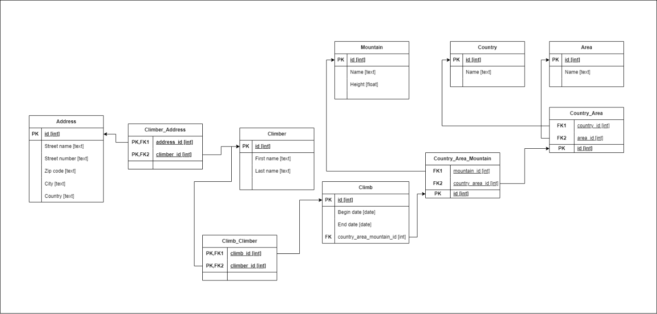

Objects

Table | Field name | Field Description | Data Type
Climber | id | SK, PK | Int
Climber | First name | Climber's name | Text
 | Last name | Climber's name | Text

Table | Field name | Field Description | Data Type
Address | id | SK, PK | Int
 | Street name | Address street | Text
 | Street number | Address number | Text
 | Zip code | Zip code [5 numbers] | Text
 | City | Address city | Text
 | Country | Address city | Text

Table | Field name | Field Description | Data Type
Mountain | id | SK, PK | Int
 | Name | Mountain’s name | Text
 | Height | Mountain’s height | Float

Table | Field name | Field Description | Data Type
Country | id | SK, PK | Int
 | Name | Country’s name | Text

Table | Field name | Field Description | Data Type
Area | id | SK, PK | Int
 | Name | Area’s name | Text

Table | Field name | Field Description | Data Type
Climb | id | SK, PK | Int
 | Begin date | Date of climb beginning | Date
 | End date | Date of climb ending | Date
 | Montain_Country_Area_id | FK | Int

Tables represents entities: Climber, Mountain, Country, Area, Address and Climb.
These tables connected with the help of Country_Area, Country_Area_Mountain, Climber_Address, Climb_Climber tables.

Example with data

Table | id | Name
Country | 166678 | Georgia

