Assignment 1

1. Write a stepwise process to create an app using React JS to print “Hello World”.

Ans:
To create a react application, Node.js version of at least 10 or higher need to be installed on your system.
If it is installed you can check by using the following command in your command line: “node -v”

To build a react application follow the below steps:

Step 1: Create a react application using the following command:
“npx create-react-app hello-world”
Step 2: Once it is done change your directory to the newly created application using the following command: “cd hello-world”
Step 3: Now inside App.js and write down the following code as shown below:
“import logo from './logo.svg';
import './App.css';

function App() {
return (
<div className="App">
<header className="App-header">
<img src={logo} className="App-logo" alt="logo" />
<p>
Hello World <code>src/App.js</code> and save to reload.
</p>
<a
className="App-link"
href="https://reactjs.org"
target="_blank"
rel="noopener noreferrer"
>
Learn React
</a>
</header>
</div>
);
}

export default App;”

Step 4: Enter the following command to run the application: “npm start”

Output:
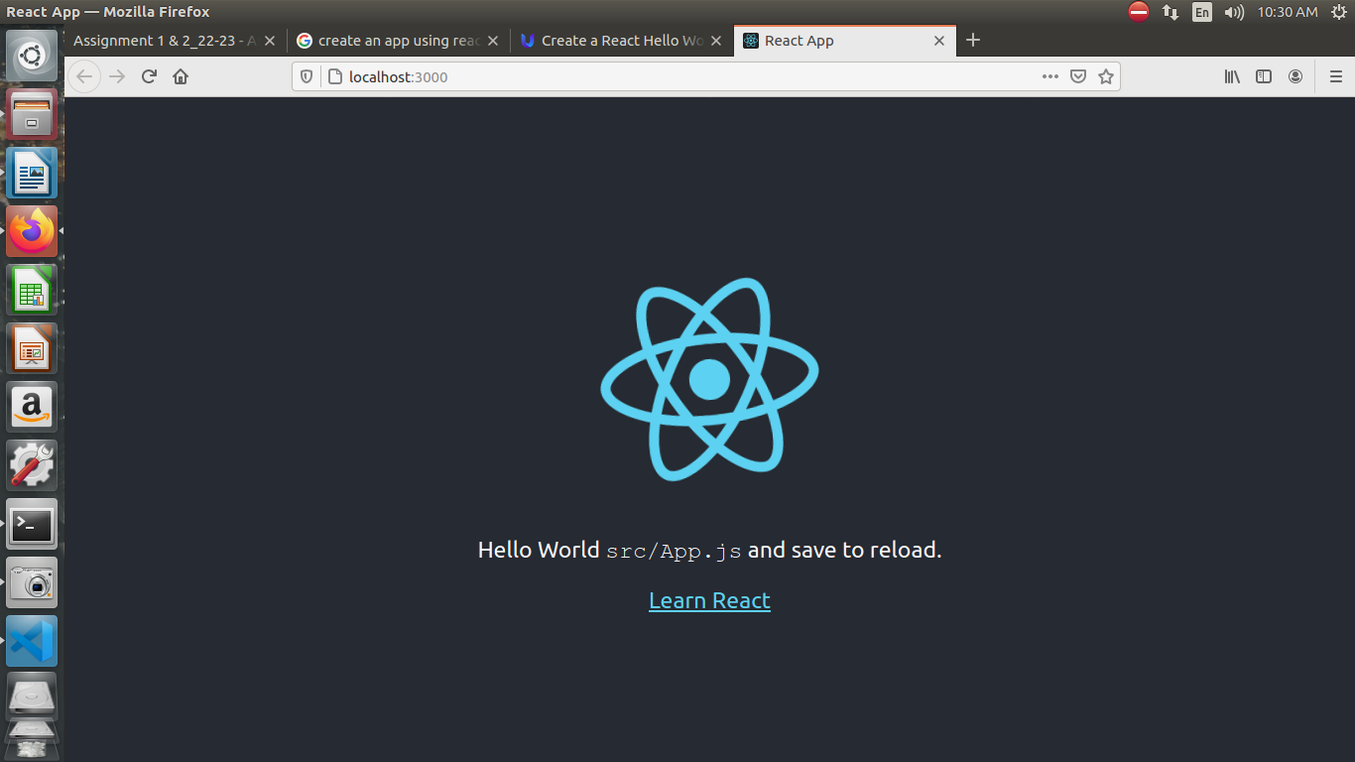

2. What are the components of React JS and components lifecycle of React JS?

Ans:
Lifecycle of Components:
Each component in React has a lifecycle which you can monitor and manipulate during its three main phases.
The three phases are:
- Mounting
- Updating
- Unmounting
Mounting: Mounting means putting elements into the DOM.
Updating: The next phase in the lifecycle is when a component is updated. A component is updated whenever there is a change in the component's state or props.
Unmounting: The next phase in the lifecycle is when a component is removed from the DOM, or unmounting as React likes to call it.

3. Explain in detail with examples about ReactJs Animation.

Ans:
The animation is a technique in which images are manipulated to appear as moving images.
It is one of the most used technique to make an interactive web application.
In React, we can add animation using an explicit group of components known as the React Transition Group.
React Transition Group is an add-on component for managing component states and useful for defining entering and exiting transitions.
It is not able to animate styles by itself. Instead, it exposes transition states, manages classes and group elements, and manipulates the DOM in useful ways.
It makes the implementation of visual transitions much easier.
React Transition group has mainly two APIs to create transitions.
They are:
- ReactTransitionGroup: It uses as a low-level API for animation.
- ReactCSSTransitionGroup: It uses as a high-level API for implementing basic CSS transitions and animations.

