Code analysis shows that refer and token values are not added to validate the information
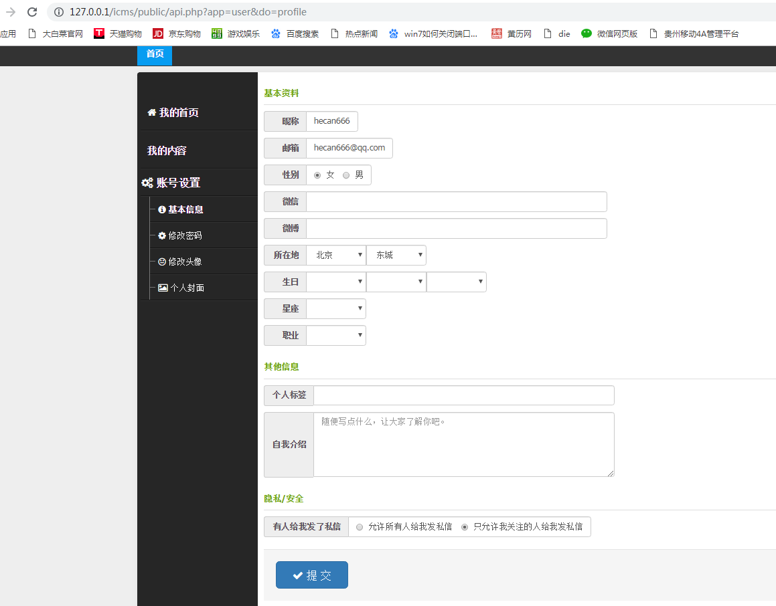
Testing opens exp for CSRF
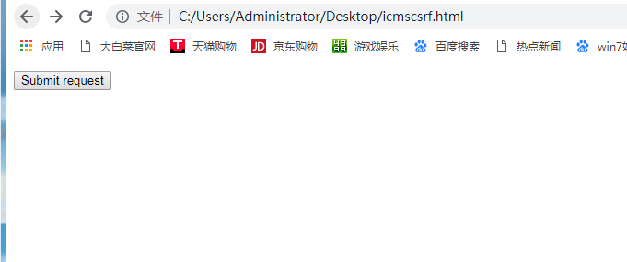

Visible Personal Information Modified to Hello CVE

