Unsupervised Threat Clustering of SSH and HTTP Telemetry via Emulated Service Sandboxes
Keshav Agarwal  B.Tech. Student  School of Computer Science and Engineering (SCOPE), Vellore Institute of Technology, Vellore, India | Yuvraj Agrawal  B.Tech. Student  School of Computer Science and Engineering (SCOPE), Vellore Institute of Technology, Vellore, India | Alen Varghese Soji  B.Tech. Student  School of Computer Science and Engineering (SCOPE), Vellore Institute of Technology, Vellore, India | Sudha S  Faculty Supervisor  School of Computer Science and Engineering (SCOPE), Vellore Institute of Technology, Vellore, India

Abstract—Automated network attacks are getting harder to catch with signature-based tools, which can only recognize attacks they have already seen. Studying attackers on live systems is also risky. This paper presents a self-contained deception framework that safely captures and groups attacker behavior. The framework runs decoy SSH and HTTP services that look vulnerable and records every login guess and typed command inside an isolated environment. A pseudo-filesystem replies to commands in a believable way, so attackers stay connected longer. The recorded text is converted into numbers using Term Frequency–Inverse Document Frequency (TF-IDF), combined with timing features such as the delay between commands, and grouped with the K-Means clustering algorithm. Each group forms a threat profile, such as reconnaissance, credential brute-forcing, or payload delivery, without predefined signatures or manual labels. Results are shown on a local dashboard. The whole pipeline uses lightweight open-source tools, needs no external APIs or GPU, and can run on modest edge hardware. This paper describes the design, requirements, and planned evaluation of the framework.
Index Terms—honeypot, network deception, SSH, TF-IDF, K-Means clustering, threat intelligence, attacker profiling

I. INTRODUCTION

A. Background
Cyberattacks are increasingly automated. Brute-force tools, credential-stuffing bots, and scripts that deliver malicious payloads can probe thousands of machines a day. Traditional signature-based intrusion detection systems (IDS) compare traffic with a list of known attack patterns. This makes them reactive: they struggle with new or changing attacks, and they say little about what an attacker is actually trying to do [7].
Honeypots offer a complementary approach. A honeypot is a decoy system that imitates a real, vulnerable service so that researchers can watch attackers at work without putting real assets at risk [5]. The problem is that honeypot logs are raw, unstructured text. Reading them by hand does not scale.
Natural Language Processing (NLP) and unsupervised machine learning can help. TF-IDF turns text into numeric vectors, and clustering algorithms such as K-Means can find groups in those vectors without labeled training data. This paper combines these ideas with a decoy environment to build a framework that captures attacker activity safely and sorts it into meaningful threat profiles.

B. Motivation
Security teams need to study attackers without endangering production systems. Doing forensic work on a live server exposes critical assets while the investigation is still under way. At the same time, signature-based tools fall behind attackers who keep changing their tools and techniques.
Unsupervised learning is attractive here because labeled data on attacker behavior is hard to obtain. If commands and credential guesses can be grouped automatically, analysts can quickly separate reconnaissance from payload delivery and focus on what matters. We also want the whole system to run locally, with no external APIs, so it stays cheap, private, and usable on small devices.

C. Contributions
- A lightweight, stateful SSH and HTTP decoy that keeps attackers engaged while remaining isolated from the host system.
- A telemetry pipeline that captures both what attackers type (commands, credentials) and how they type it (delay between commands).
- An unsupervised TF-IDF and K-Means method that turns raw attacker text into interpretable threat profiles.
- An offline dashboard that shows attack clusters, connection times, and attacker origin without third-party services.

II. RELATED WORK
Research on intrusion detection has moved from static signatures toward behavior-based and context-aware methods. We review four representative studies (summarized in Table I).
Shafi et al. [1] introduced NTLFlowLyzer, which builds intrusion datasets and attacker behavior profiles from network- and transport-layer flows without deep packet inspection. This protects production systems and gives useful visualizations, but flow metadata limits how much detail can be recovered compared with packet-level analysis.
Dong et al. [2] proposed C-BEDIM and S-BEDIM to detect lateral movement in enterprise networks by measuring how far behavior drifts from a normal baseline. They achieved high precision and fewer false alarms than typical anomaly detectors, but at the cost of heavy computation and a need for large amounts of baseline data.
Pendyala et al. [3] modeled network traffic as graphs and extracted graph-based features for classification. Their method improved context awareness and zero-day detection on the CIC-IDS2017 dataset, though building graphs becomes difficult in larger networks.
Hans et al. [4] used large language models (LLMs) to analyze Suricata IDS logs and map events to MITRE ATT&CK techniques, which helps explain attacker intent. However, the method relies on passively collected alerts and inherits the reliability and bias limits of the LLM. Broader surveys of insider and machine-learning-based detection are given in [6] and [7].
TABLE I. SUMMARY OF RELATED WORK
Work | Main idea | Limitation
Shafi et al. [1] | Flow-based attacker profiling | Metadata only; no command or credential content
Dong et al. [2] | Lateral movement via behavior deviation | Heavy compute; needs baseline data
Pendyala et al. [3] | Graph-based features for IDS | Graph building scales poorly
Hans et al. [4] | LLM maps IDS alerts to ATT&CK | Depends on LLM; passive alerts
This work | Active decoys + TF-IDF + K-Means | Evaluated in simulation only

Research Gap
These studies analyze data that was passively collected from existing networks or IDS alerts. None of them actively builds an isolated environment to draw out attacker behavior, and none applies lightweight unsupervised text analysis (TF-IDF with clustering) directly to raw attacker commands and credential guesses. Existing decoys also tend to look only at the words in a command and ignore timing, which makes it hard to tell an automated bot from a human. Static decoys often lose the attacker early, leaving incomplete data. Finally, many threat-intelligence stacks need heavy logging infrastructure that does not fit edge or IoT devices. Our work targets these gaps.

III. PROBLEM STATEMENT AND OBJECTIVES
The goal is to design a network deception framework that safely captures and classifies automated attacks. By offering vulnerable-looking SSH and HTTP services, the framework lures attackers into interacting with it and records the commands they enter and the credentials they try. The objectives are:
- Stateful, edge-friendly decoy. Build a lightweight listener that imitates SSH and HTTP and uses dynamic pseudo-filesystem replies to keep attackers engaged without any risk to the host operating system.
- Multidimensional telemetry. Extract both lexical data (commands and credentials) and temporal data (delay between commands) so that bots and humans can be told apart.
- Unsupervised clustering. Convert terminal logs into numeric matrices with TF-IDF and group sessions with K-Means into profiles such as credential brute-forcing, reconnaissance, or payload delivery.
- Offline dashboard. Present clusters, connection timestamps, and attacker origin locally, with low computational cost and no third-party APIs.

IV. PROPOSED FRAMEWORK

A. Architecture Overview
The framework has four layers, shown in Fig. 1. An attacker connects to the decoy listener layer. Everything the attacker does is passed to the telemetry extraction layer. The extracted features are vectorized and clustered, and the resulting threat profiles are displayed on the dashboard. Each layer is a separate module, so any one of them can be replaced or upgraded without touching the others.
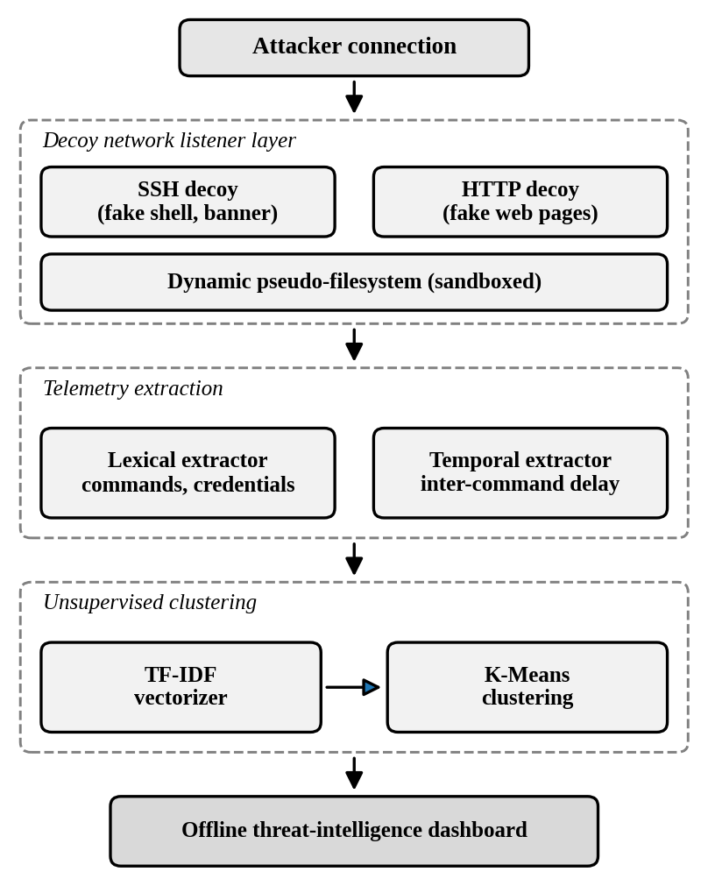
Fig. 1. System architecture of the proposed framework.

B. Decoy Network Listener
The listener is an asynchronous TCP server that offers an SSH-like fake shell (with a realistic banner) and fake HTTP endpoints. It does not give access to the real system. Instead, a dynamic pseudo-filesystem keeps track of the session state, so that commands such as directory listings or file reads receive consistent, believable answers. This stateful behavior matters because attackers that notice a static or broken decoy disconnect early, leaving little data. A tarpitting mechanism that slows responses can further extend the interaction. All activity stays inside the sandbox.

C. Telemetry Extraction
Two extractors run on every session. The lexical extractor records usernames, passwords, and shell commands or HTTP requests. The temporal extractor timestamps each command and computes the delay between consecutive commands. Machine-driven scripts tend to send commands at fast, regular intervals, while humans pause and vary, so timing gives a useful second view of the same session. Data is stored persistently in append-only CSV files for later analysis.

D. Vectorization and Clustering
Raw logs are first cleaned (for example, lowercased, with extra whitespace and session-specific noise removed). Each session is then treated as one document and converted into a TF-IDF vector. TF-IDF gives high weight to terms that are frequent in a session but rare across all sessions, so distinctive commands (such as a download-and-execute command) stand out from common ones. Timing features are appended to these vectors.
The combined vectors are grouped with K-Means, which assigns each session to the nearest of k cluster centers. The number of clusters can be chosen with standard measures such as the elbow method and the silhouette score. Because the method is unsupervised, no labeled attack data or predefined signatures are needed. An analyst then reads the top-weighted terms of each cluster and assigns a descriptive name, such as reconnaissance or payload delivery.

E. Offline Threat-Intelligence Dashboard
A locally hosted dashboard shows the clusters in a two-dimensional view, along with connection timestamps and the geographic origin of attackers, which is resolved from a local database rather than an online service. Analysts can use it to view the dashboard and examine each threat profile. The dashboard runs entirely offline.

F. Data Flow
Attack traffic enters the decoy emulation process, which writes raw interaction logs to a store. The vectorization process reads these logs and produces TF-IDF vectors. The clustering process labels the vectors and saves the threat profiles to a second store, from which the dashboard builds visual reports for the security analyst.

V. REQUIREMENTS AND FEASIBILITY

A. Functional Requirements
- Deploy emulated SSH and HTTP services that appear vulnerable.
- Log all commands and credential attempts, with a timestamp for each command.
- Clean the logs, convert them with TF-IDF, and cluster them with K-Means.
- Classify clusters into categories such as reconnaissance and payload delivery.
- Display results on a local dashboard and store data persistently.

B. Non-Functional Requirements
Security: attacker interactions must be isolated from production assets. Performance: low overhead, suitable for edge or IoT devices. Scalability: handle growing log volumes without major slowdown. Reliability: stable decoys that limit early disconnection. Availability: the dashboard is reachable locally whenever the system runs. Maintainability: modular components that can be updated independently. Portability: no dependence on external APIs or cloud services.

C. Feasibility
Technical: SSH/HTTP emulation, TF-IDF, and K-Means are mature techniques with strong open-source support (Python and scikit-learn). No special hardware, GPU, proprietary API, or large labeled dataset is required, and the skills needed are within standard academic experience. Economic: the system uses only open-source tools, runs on a single local machine or virtual machine, and has no recurring API fees. Social: the decoy runs in an isolated environment, poses no risk to real users or data, and only interacts with parties who choose to connect to it. It may also help smaller organizations that cannot afford enterprise-scale security tools.

VI. IMPLEMENTATION ENVIRONMENT
The minimum hardware is a quad-core processor (Intel Core i5 10th generation or AMD Ryzen 5 class), 8 GB of RAM (16 GB recommended), and a 256 GB SSD. No GPU is needed because TF-IDF and K-Means run efficiently on a CPU.
The system is written in Python 3.10 or later and developed on Windows, though the asynchronous TCP server also runs on Linux and Unix. Pandas and NumPy handle telemetry processing, scikit-learn provides TF-IDF, K-Means, and dimensionality reduction, Streamlit and Plotly build the dashboard, and flat CSV files store the append-only logs. Custom bot scripts that imitate brute-force, reconnaissance, and payload-delivery attackers are used to test and validate the system.

VII. PROJECT PLAN AND PLANNED EVALUATION
The work is organized in three phases over June to October 2026. Concept development covers competitor analysis, user needs, research goals, and a technical feasibility study. Prototype development covers engineering, component selection, building the prototype, and testing with feedback collection. Pre-production covers final adjustments and compliance checks.
Evaluation will be carried out in the isolated environment using the scripted bots described above, so that the true attack type of each session is known. We plan to measure (i) how well the clusters match the known attack types, using the silhouette score and the adjusted Rand index; (ii) whether adding timing features improves the separation of bots from human-like sessions; (iii) how long attackers stay connected with and without the stateful pseudo-filesystem; and (iv) CPU and memory use on the minimum hardware. Results will be reported in later work.

VIII. SCOPE AND LIMITATIONS
This project covers the design, development, and evaluation of the decoy, the analysis pipeline, and the dashboard within a simulated environment. It does not cover deployment on production networks or active response and mitigation. Because K-Means needs the number of clusters in advance and works best with roughly compact groups, some attack behaviors may be split or merged, and the cluster names still need a human to confirm them.

IX. CONCLUSION
This paper presented a self-contained deception framework that attracts automated SSH and HTTP attacks, records what attackers type and how fast they type it, and groups the sessions into threat profiles using TF-IDF and K-Means. By avoiding external APIs, heavy models, and exposure of live systems, the design stays practical for small organizations and edge devices. Future work includes building and testing the full prototype, reporting quantitative results, and extending the approach to more protocols.

REFERENCES
[1] M. Shafi, A. H. Lashkari, and A. Haghighian Roudsari, “NTLFlowLyzer: Towards generating an intrusion detection dataset and intruders behavior profiling through network and transport layers traffic analysis and pattern extraction,” Comput. Secur., 2025.
[2] C. Dong, J. Yang, S. Liu, Z. Wang, Y. Liu, and Z. Lu, “C-BEDIM and S-BEDIM: Lateral movement detection in enterprise network through behavior deviation measurement,” Comput. Secur., 2023.
[3] G. S. Pendyala, T. Mukherjee, and N. P. Shetty, “Intrusion detection using graph inspired insights,” Int. J. Comput. Appl., 2025.
[4] S. Hans, S. Marsella, S. Hirschmann, and N. Gurney, “Security logs to ATT&CK insights: Leveraging LLMs for high-level threat understanding and cognitive trait inference,” arXiv:2510.20930, 2025.
[5] S. C. Sethuraman, T. G. Jadapalli, D. P. V. Sudhakaran, and S. P. Mohanty, “Flow based containerized honeypot approach for network traffic analysis: An empirical study,” Comput. Sci. Rev., 2023.
[6] N. T. N. and D. Pramod, “Insider intrusion detection techniques: A state-of-the-art review,” J. Comput. Inf. Syst., 2024.
[7] A. Salih, S. T. Zeebaree, S. Ameen, A. Alkhyyat, and H. M. Shukur, “A survey on the role of artificial intelligence, machine learning and deep learning for cybersecurity attack detection,” in Proc. 7th Int. Eng. Conf. Research & Innovation amid Global Pandemic (IEC), 2021, pp. 61–66.

